Table S1. Identity and ADS activity levels of plaque bacterial strains [Huang et al., 2015].

STUDY CODE | ACCESSION NUMBER | HOT no.✚ | cLOSEST RELATIVE | SOURCE | ADS ACTIVITY  (Mean ±SD)
 |  |  | Streptococcus gordonii DL1 | Lab strain | 339.3±33.0
 |  |  | arcA-deficient strains of S. gordonii | Lab strain | 0
Streptococcus parasanguinis A1 | KF733681.1 | 721 | Streptococcus parasanguinis ChDC B356 | CF | 688.0±57.1*
Streptococcus intermedius A2 | KF733728.1 | 644 | Streptococcus intermedius ChDC B589 | CF | 390.1±17.3*
Streptococcus intermedius A3 | KF733728.1 | 644 | Streptococcus intermedius ChDC B589 | CF | 476.9±43.8*
Streptococcus intermedius A4 | KF733728.1 | 644 | Streptococcus intermedius ChDC B589 | CF | 233.1±15.7
Streptococcus intermedius A5 | KF733728.1 | 644 | Streptococcus intermedius ChDC B589 | CF | 252.85±61.79
Streptococcus intermedius A6 | KF733728.1 | 644 | Streptococcus intermedius ChDC B589 | CF | 237.5±11.5
Streptococcus gordonii A7 | CP000725.1 | 622 | Streptococcus gordonii str. Challis substr. CH1 | CA | 283.3±5.2
Streptococcus gordonii A8 | NR_074516.1 | 622 | Streptococcus gordonii str. Challis substr. CH1 | CF | 431.9±15.4*
Streptococcus gordonii A9 | NR_115242.1 | 622 | Streptococcus gordonii ATCC 10558 | CA | 244.8±10.7
Streptococcus gordonii A10 | NR_115242.1 | 622 | Streptococcus gordonii ATCC 10558 | CA | 241.3±15.9
Streptococcus gordonii A11 | NR_115242.1 | 622 | Streptococcus gordonii ATCC 10558 | CF | 354.8±20.9*
Streptococcus australis A12 | NR_036936.1 | 073 | Streptococcus australis AI-1★ | CF | 309.2±1.4
Streptococcus australis A13 | NR_036936.1 | 073 | Streptococcus australis AI-1★ | CF | 287.3±12.7
Streptococcus sanguinis A14 | CP000387.1 | 758 | Streptococcus sanguinis SK36 | CF | 129.0±5.6
Streptococcus sanguinis A15 | CP000387.1 | 758 | Streptococcus sanguinis SK36 | CF | 119.7±3.7
Streptococcus sanguinis A16 | CP000387.1 | 758 | Streptococcus sanguinis SK36 | CF | 129.1±10.4
Streptococcus sanguinis A17 | CP000387.1 | 758 | Streptococcus sanguinis SK36 | CF | 94.1±4.3
Streptococcus sanguinis A18 | CP000387.1 | 758 | Streptococcus sanguinis SK36 | CF | 107.1±9.1
Streptococcus sanguinis A19 | CP000387.1 | 758 | Streptococcus sanguinis SK36 | CF | 98.0±5.7
Streptococcus sanguinis A20 | CP000387.1 | 758 | Streptococcus sanguinis SK36 | CF | 93.1±1.4
Streptococcus sanguinis A21 | CP000387.1 | 758 | Streptococcus sanguinis SK36 | CF | 116.8±14.0
Streptococcus sanguinis A22 | CP000387.1 | 758 | Streptococcus sanguinis SK36 | CF | 88.9±10.0
Streptococcus sanguinis A23 | NR_113260.1 | 758 | Streptococcus sanguinis SK1284_K2-1 | CA | 127.6±1.1
Streptococcus sanguinis A24 | NR_113260.1 | 758 | Streptococcus sanguinis JCM 5708 | CF | 45.2±6.0
Streptococcus sanguinis A25 | NR_113260.1 | 758 | Streptococcus sanguinis JCM 5708 | CF | 50.2±3.4
Streptococcus sanguinis A26 | NR_113260.1 | 758 | Streptococcus sanguinis JCM 5708 | CF | 46.0±0.3
Streptococcus sanguinis A27 | NR_113260.1 | 758 | Streptococcus sanguinis JCM 5708 | CF | 63.4±0.0
Streptococcus sanguinis A28 | NR_113260.1 | 758 | Streptococcus sanguinis JCM 5708 | CF | 56.4±13.0
Streptococcus sanguinis A29 | NR_113260.1 | 758 | Streptococcus sanguinis JCM 5708 | CF | 187.1±20.3
Streptococcus sanguinis A30 | NR_113260.1 | 758 | Streptococcus sanguinis JCM 5708 | CF | 173.3±4.0
Streptococcus sanguinis A31 | NR_113260.1 | 758 | Streptococcus sanguinis JCM 5708 | CF | 246.2±2.4
Streptococcus sanguinis A32 | NR_113260.1 | 758 | Streptococcus sanguinis JCM 5708 | CF | 227.3±0.0
Streptococcus sanguinis A33 | NR_113260.1 | 758 | Streptococcus sanguinis JCM 5708 | CF | 199.2±8.3
Streptococcus sanguinis A34 | NR_113260.1 | 758 | Streptococcus sanguinis JCM 5708 | CF | 200.6±14.6
Streptococcus sanguinis A35 | NR_113260.1 | 758 | Streptococcus sanguinis JCM 5708 | CF | 201.9±15.2
Streptococcus sanguinis A36 | NR_113260.1 | 758 | Streptococcus sanguinis JCM 5708 | CF | 263.4±29.9
Streptococcus sanguinis A37 | NR_113260.1 | 758 | Streptococcus sanguinis JCM 5708 | CF | 227.9±89.7
Streptococcus sanguinis A38 | NR_113260.1 | 758 | Streptococcus sanguinis JCM 5708 | CF | 167.7±9.9
Streptococcus sanguinis A39 | NR_113260.1 | 758 | Streptococcus sanguinis JCM 5708 | CF | 198.1±5.1
Streptococcus sanguinis A40 | NR_113260.1 | 758 | Streptococcus sanguinis JCM 5708 | CF | 212.5±0.6
Streptococcus sanguinis A41 | NR_113260.1 | 758 | Streptococcus sanguinis JCM 5708 | CF | 144.0±10.0
Streptococcus sanguinis A42 | NR_113260.1 | 758 | Streptococcus sanguinis JCM 5708 | CF | 190.1±10.6
Streptococcus sanguinis A43 | NR_113260.1 | 758 | Streptococcus sanguinis JCM 5708 | CF | 106.4±4.0
Streptococcus sanguinis A44 | NR_113260.1 | 758 | Streptococcus sanguinis JCM 5708 | CF | 104.3±4.1
Streptococcus sanguinis A45 | NR_113260.1 | 758 | Streptococcus sanguinis JCM 5708 | CA | 161.3±3.3
Streptococcus sanguinis A46 | NR_113260.1 | 758 | Streptococcus sanguinis JCM 5708 | CA | 169.8±6.4
Streptococcus sanguinis A47 | NR_113260.1 | 758 | Streptococcus sanguinis JCM 5708 | CA | 221.3±4.8
Streptococcus sanguinis A48 | NR_113260.1 | 758 | Streptococcus sanguinis JCM 5708 | CA | 136.9±4.3
Streptococcus sanguinis A49 | NR_113260.1 | 758 | Streptococcus sanguinis JCM 5708 | CA | 238.2±31.1
Streptococcus sanguinis A50 | NR_113260.1 | 758 | Streptococcus sanguinis JCM 5708 | CA | 182.0±39.3
Streptococcus sanguinis A51 | KF733682.1 | 758 | Streptococcus sanguinis ChDC B357 | CF | 250.8±1.3
Streptococcus cristatus A52 | NR_115274.1 | 578 | Streptococcus cristatus ATCC 51100 | CA | 187.5±41.4
Streptococcus cristatus A53 | NR_115274.1 | 578 | Streptococcus cristatus ATCC 51100 | CA | 129.2±31.6
Streptococcus cristatus A54 | GU470899.1 | 578 | Streptococcus cristatus F0329 | CA | 160.0±26.2
Streptococcus cristatus A55 | GU470899.1 | 578 | Streptococcus cristatus F0329 | CA | 159.0±9.1
Streptococcus cristatus A56 | GU470899.1 | 578 | Streptococcus cristatus F0329 | CA | 185.9±41.8
The 56 ADS-positive strains identified had greater than 99% sequence similarity with their assigned bacterial taxa, as derived from their database accession numbers. HOT = Human oral taxon ID from the Human Oral Microbiome Database. ADS activity was expressed as nanomoles of citrulline generated perminute per milligram of protein. An asterisk (*) indicates that the bacterial strain expressed higher ADS activity than S. gordonii DL1. SD = Standard deviation.
1 The closest relative strains to S. gordonii A7 are Streptococcus sp. JCM 5703 and S. gordonii strain Challis substrain CH1.
2 The closest relative strains to S. australis A12 and A13 are S. australis AI-1, but also Streptococcus rubneri LMG 27207 (accession No.: NR_109720.1). Because A12 and A13 were collected from dental plaque and are ADS-positive, whereas the S. rubneri strain in the database is an ADS-negative throat isolate, A12 and A13 will be considered herein as strains of S. australis.

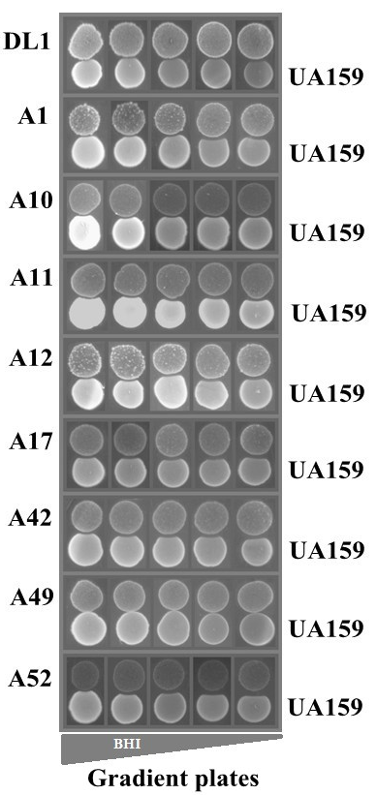

Figure S1. Growth inhibition of arginolytic strains on S. mutans UA159 using gradient BHI plates. Arginolytic strains were spotted first, and S. mutans was spotted 24 hr later.

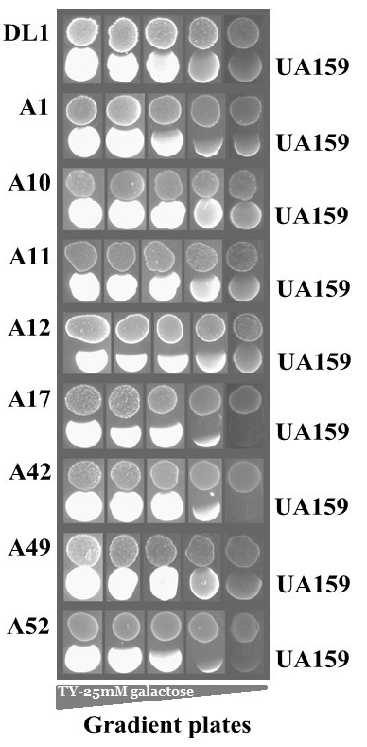

Figure S2. Growth inhibition of arginolytic strains on S. mutans UA159 using gradient TY-25mM galactose plates. Arginolytic strains were spotted first, and S. mutans was spotted 24 h later.

