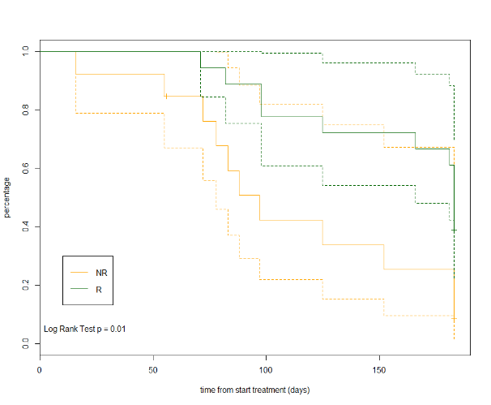
NR: non-responder; R: responder. Dotted curves represent confidence intervals

Figure 1 Suppl. Estimated Kaplan-Meier curve for overall survival comparing responders and non-responders for the 31 patients in the study.

