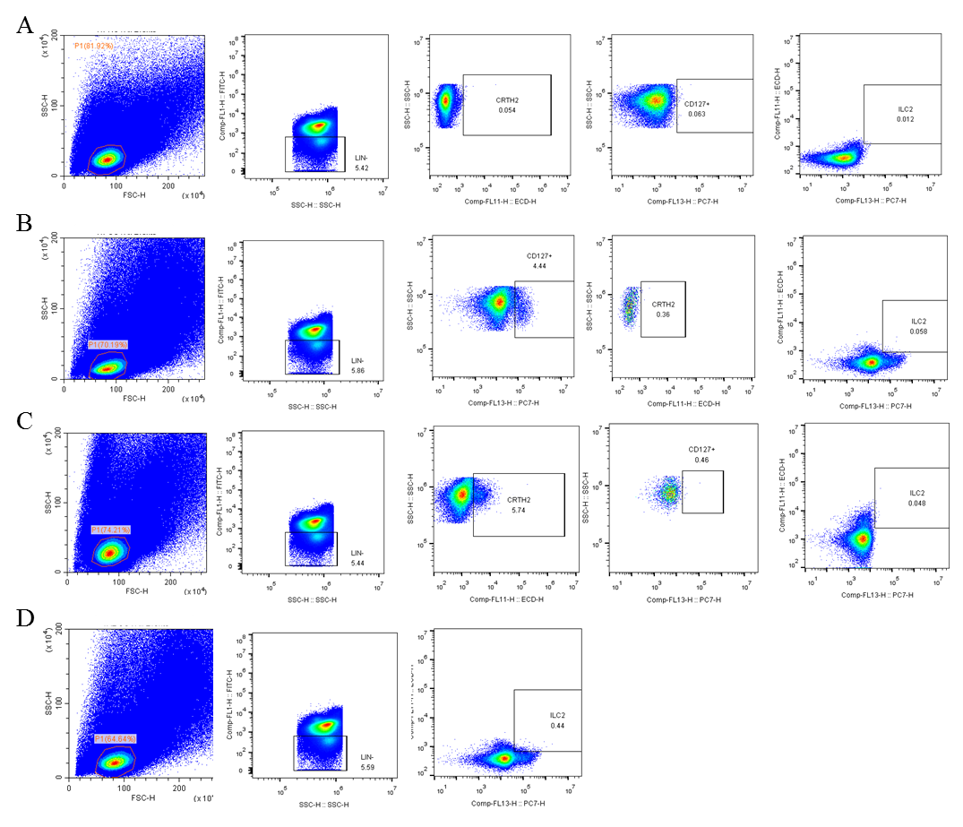
Fig S1. FMO flow cytometry diagrams showing the identifies of different sub-cellular groups. A, Lin⁻ stained only PBMCs showing the identity of Lin⁻ cells in PBMCs; B, Lin⁻ and CD127 stained PBMCs that taken as unstained control for CRTH2 staining; C, Lin⁻ and CRTH2 stained PBMCs that taken as unstained control for CD127 staining; D, Lin- CD127 and CRTH2 stained PBMCs that showing the ILC2s in PBMCs.

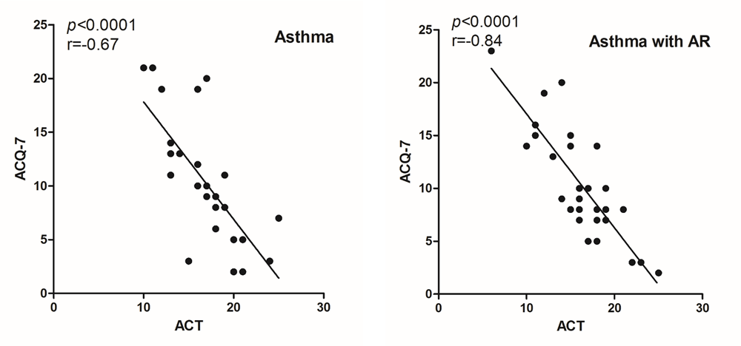
Fig S2. The correlation between ACT and ACQ-7 scores in both asthma and asthma with AR patients.

