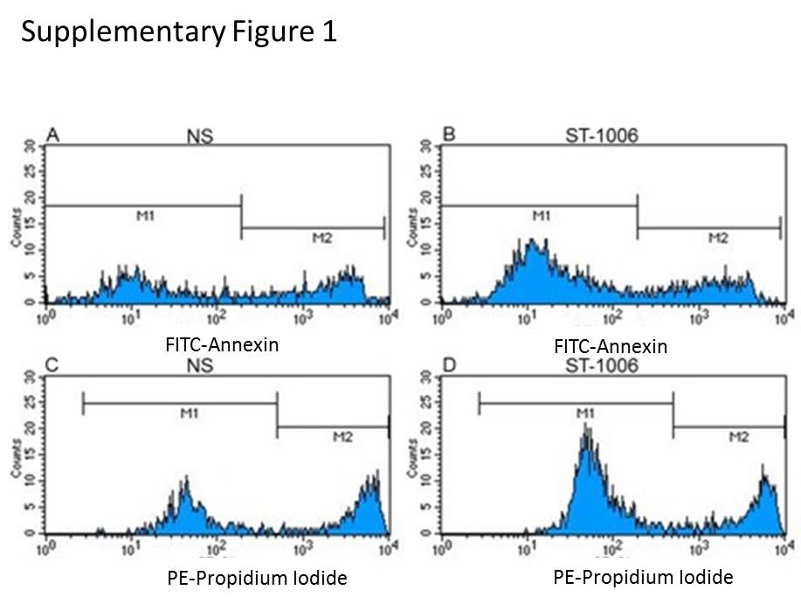

Suppl. Fig. 1. The cell viability of M2 macrophages shows no remarkable deviations between cells treated with ST-1006 during the period of differentiation as assessed by Propidium Iodide and Annexin V-FITC staining when compared to un-treated cells.
Primary monocytes were differentiated into M2 macrophages with M-CSF (10 ng/ml) in the presence or absence of ST-1006 (10 µM) for 10 days. (a), Forward Scatter and Sideward Scatter of monocyted derived macrophages. Cells were stained with Propidium Iodide and Annexin V-FITC for identification of late apoptotic and dead cells or early apoptotic cells respectively. (b) Propidium Iodide staining in non-stimulated or (d) in ST-1006 treated cells. (c) Annexin V-FITC staining in non-stimulated or (e) in ST-1006 treated cells. The left quadrants show Propidium Iodide or Annexin V-FITC negative cells which are considered as viable. The right quadrants show Propidium Iodide postitive or Annexin V-FITC positive cells which are considered as late apoptotic/dead cells or early apoptotic cells respectively.

