Supplementary Information

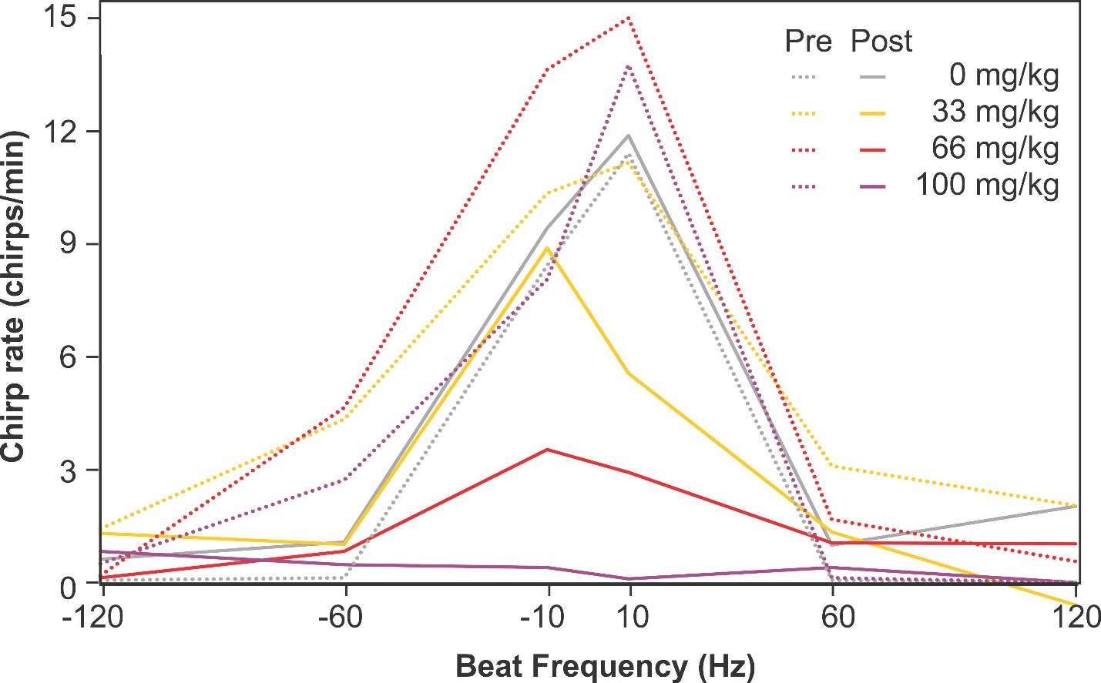

Figure S1: Effect of THC on responses to communication signals. Stimuli with chirps and different beat frequencies are presented to fish in chirp chambers and the number of chirps they produced in response is quantified here before and after injections with varying concentrations of THC. The difference between the pre and post data presented here is displayed in figure 3D.

Movie 1: Aggressive behavior in control fish. The video presents a 1-minute stimulation of a fish injected with vehicle only and tested 30 min after injection. This is the first stimulation of the series. We chose a fish where aggressive behaviors were marked for the purpose of clearly illustrating the patterns. The video also illustrates the analysis procedure used to track the fish. Lunges are most easily identified by eye but they also correlated with some of the fastest movement in the sequence (see the dark red portions of trace in the movement track presented at the end of the movie).

Movie 2: Aggressive behavior in THC-injected fish. The video presents a 1-minute stimulation of a fish injected with 66 mc/kg and tested 30 min after injection. This is the first stimulation of the series. Compared to control fish, THC-injected fish displayed less aggressive movements as illustrated in this movie

