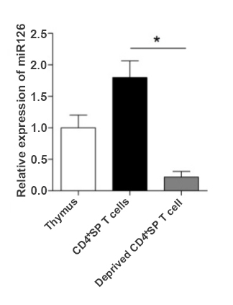
Suppl. Fig.1. The relative expression of miR-126.
FVB/N6 mice (4 weeks old, n=6) were sacrificed and thymus tissue was collected. Then, CD4⁺SP cells were purified by MACS and the relative expression of miR-126 was analyzed by Realtime PCR assay and calculated. * p<0.05.

