Supplementary Figure Legends:
Supplementary Figure 1
[Figure Name] Association between estimated salt intake and cardiovascular death and all-cause mortality without cancer death
[Legend] Supplementary Figure 1(a) shows cubic splines between estimated salt intake and cardiovascular death (defined as death from cardiovascular causes, myocardial infarction, stroke, or heart failure). Supplementary Figure 1(b) shows cubic splines between estimated salt intake and all-cause mortality without cancer death. Both were adjusted for age, gender, body mass index, hemodialysis vintage, dialysis time per one dialysis session, Kt/V, protein catabolic rate normalized to body weight, comorbidity conditions, cause of end stage renal disease, type of vascular access, serum potassium, phosphate, calcium, and CRP levels, and endotoxin level in dialysate. Solid blue line indicates point estimation. Grey zones indicate the 95% confidence interval. The reference was median estimated salt intake (6.4 g/day) indicated by the dashed line. To convert the values for estimated salt intake to sodium excretion in g per day, divide by 2.5. Histogram indicates distribution of patients at risk.
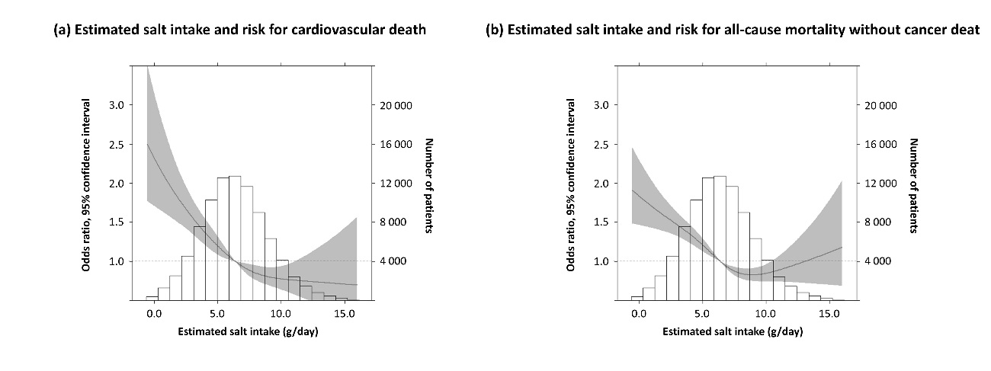
Supplementary Figure 2
[Figure Name] Association between estimated salt intake and cardiovascular death and all-cause mortality without cancer death (crude analysis)
[Legend] Supplementary Figure 2(a) shows cubic splines between estimated salt intake and cardiovascular death on crude analysis. Supplementary Figure 2(b) shows cubic splines between estimated salt intake and all-cause mortality without cancer on crude analysis. Solid line indicates point estimation. Grey zones indicate the 95% confidence interval. The reference was median estimated salt intake (6.4 g/day) indicated by the dashed line. To convert the values for estimated salt intake to sodium excretion in g per day, divide by 2.5. Histogram indicates distribution of patients at risk.

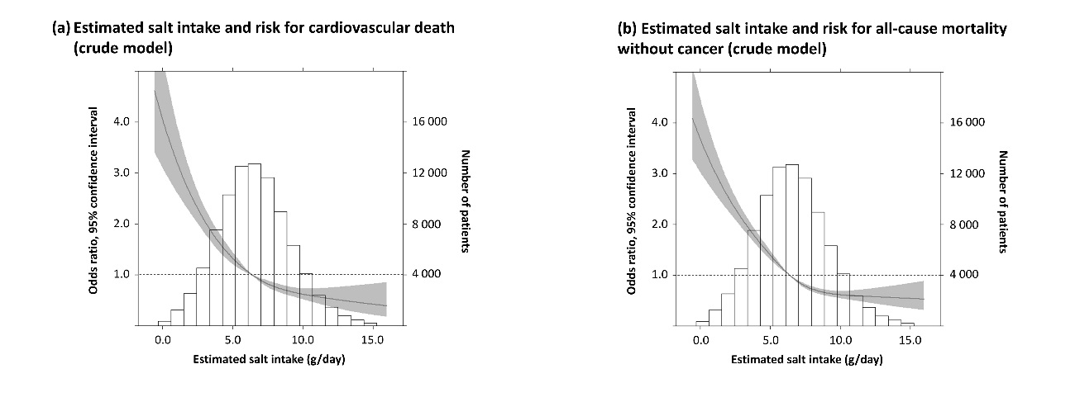
Supplementary Figure 3
[Figure Name] Association between estimated salt intake and all-cause mortality by inter-dialytic weight gain
[Legend] Supplementary Figure 3(a) shows cubic splines between estimated salt intake and all-cause mortality among patients with an inter-dialytic weight gain <1.9 kg. Supplementary Figure 3(b) shows cubic splines between estimated salt intake and all-cause mortality among patients with an inter-dialytic weight gain 1.9−2.5 kg. Supplementary Figure 3(c) shows cubic splines between estimated salt intake and all-cause mortality among patients with an inter-dialytic weight gain 2.5−3.1 kg. All groups were adjusted for age, gender, body mass index, hemodialysis vintage, dialysis time per one dialysis session, Kt/V, protein catabolic rate normalized to body weight, comorbidity conditions, cause of end stage renal disease, type of vascular access, serum potassium, phosphate, calcium, and C-reactive protein levels, and endotoxin level in dialysate. Solid blue line indicates point estimation. Grey zones indicate the 95% confidence interval. The reference was median estimated salt intake (6.4 g/day) among the total model indicated by the dashed line. To convert the values for estimated salt intake to sodium excretion in g per day, divide by 2.5. Histogram indicates distribution of patients at risk.

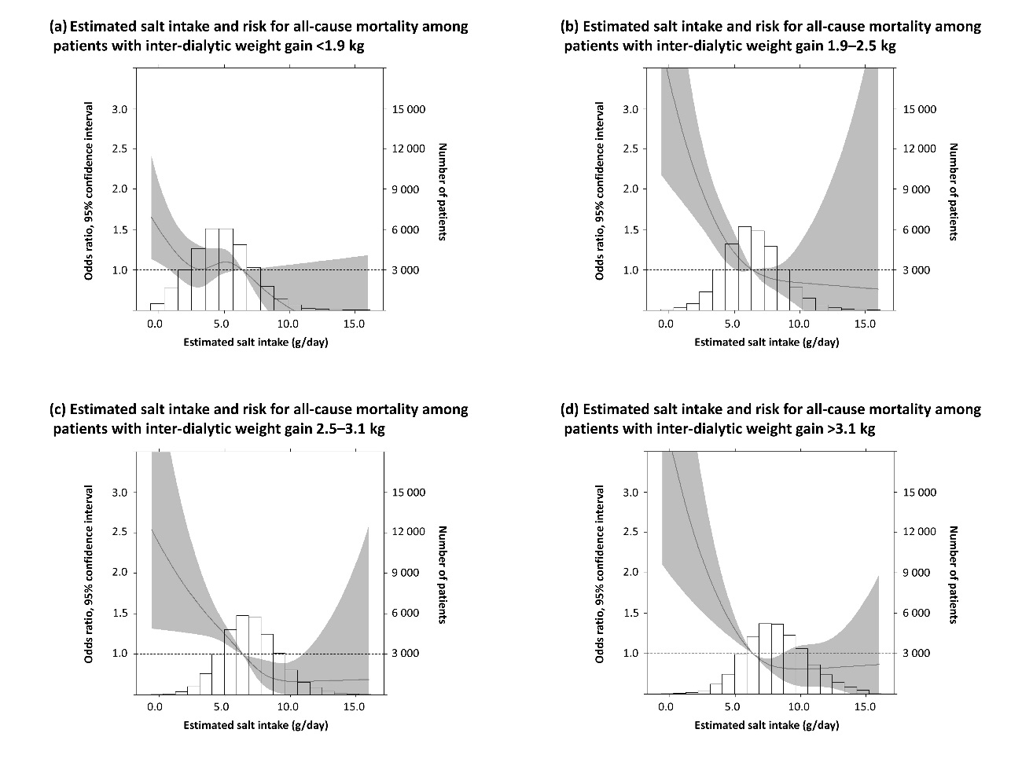
Supplementary Figure 4
[Figure Name] Association between estimated salt intake and mortality among patients with a hemodialysis vintage >5 years
[Legend] Supplementary Figure 4(a) shows cubic splines between estimated salt intake and all-cause mortality among patients with a hemodialysis vintage >5 years. Supplementary Figure 4(b) shows cubic splines between estimated salt intake and cardiovascular death among the patients with a hemodialysis vintage >5 years. Supplementary Figure 4(c) shows cubic splines between estimated salt intake and all-cause mortality without cancer death among patients with a hemodialysis vintage >5 years. All groups were adjusted for age, gender, body mass index, hemodialysis vintage, dialysis time per one dialysis session, Kt/V, protein catabolic rate normalized to body weight, comorbidity conditions, cause of end stage renal disease, type of vascular access, serum potassium, phosphate, calcium, and C-reactive protein levels, and endotoxin level in dialysate. Solid blue line indicates point estimation. Grey zones indicate the 95% confidence interval. The reference was median estimated salt intake (6.4 g/day). To convert the values for estimated salt intake to sodium excretion in g per day, divide by 2.5. Histogram indicates distribution of patients at risk.
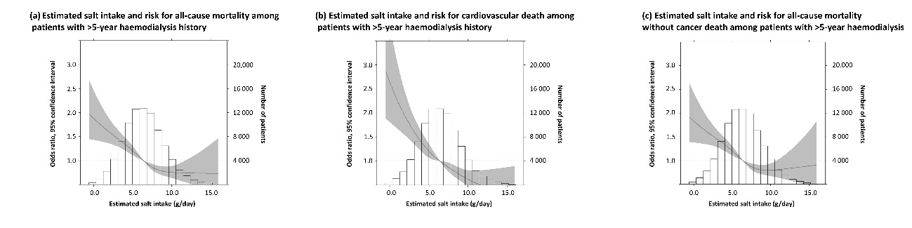
Supplementary Figure 5
[Figure Name] Association between estimated salt intake and death during 6- to 12-month period
[Legend] Supplementary Figure 5(a) shows cubic splines between estimated salt intake and all-cause mortality for 6−12 months. Supplementary Figure 5(b) shows cubic splines between estimated salt intake and cardiovascular death for 6−12 months. Supplementary Figure 5(c) shows cubic splines between estimated salt intake and all-cause mortality without cancer death for 6−12 months. All groups were adjusted for age, gender, body mass index, hemodialysis vintage, dialysis time per one dialysis session, Kt/V, protein catabolic rate normalized to body weight, comorbidity conditions, cause of end stage renal disease, type of vascular access, serum potassium, phosphate, calcium, and C-reactive protein levels, and endotoxin level in dialysate. Solid blue line indicates point estimation. Grey zones indicate the 95% confidence interval. The reference was median estimated salt intake (6.4 g/day). To convert the values for estimated salt intake to sodium excretion in g per day, divide by 2.5. Histogram indicates distribution of patients at risk.
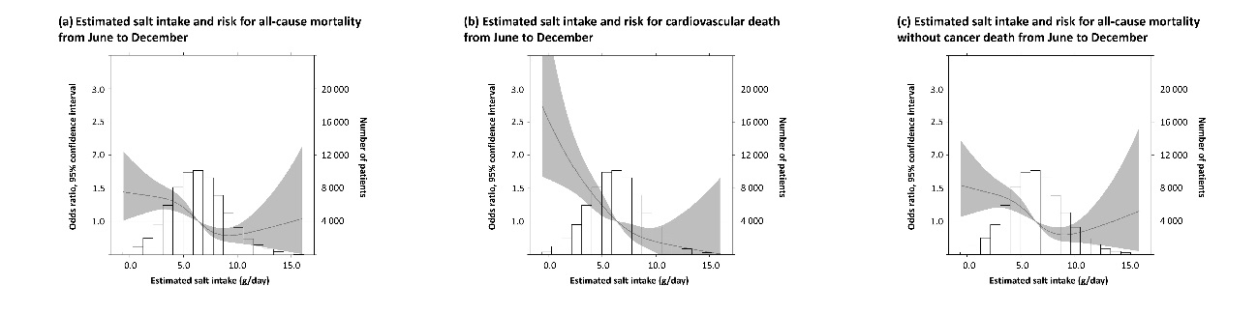

Supplementary Figure 6
[Figure Name] Association between estimated salt intake and death during 6- to 12-month period
[Legend] Supplementary Figure 6 shows cubic splines between estimated salt intake and all-cause mortality among patients with no missing data (n=58 095). This was adjusted for age, gender, body mass index, haemodialysis vintage, dialysis time per one dialysis session, Kt/V, protein catabolic rate normalised to body weight, comorbidity conditions, cause of end stage renal disease, type of vascular access, serum potassium, phosphate, calcium, and C-reactive protein levels, and endotoxin level in dialysate. Solid blue line indicates point estimation. Grey zones indicate the 95% confidence interval. The reference was median estimated salt intake (6.4 g/day) among the total model indicated by the dashed line. To convert the values for estimated salt intake to sodium excretion in g per day, divide by 2.5. Histogram indicates distribution of patients at risk.

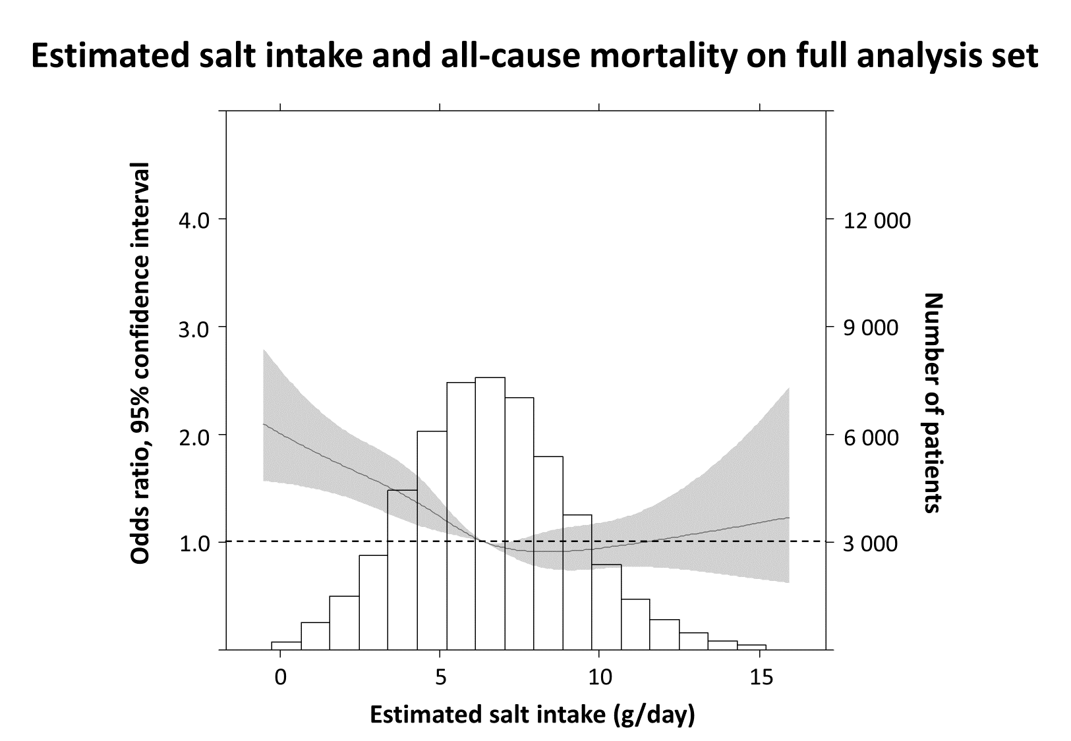

Supplementary Figure 7
[Figure Name] Association between estimated salt intake and all-cause mortality by cause of end stage renal disease
[Legend] Figure 7 (A) shows cubic splines between estimated salt intake and all-cause mortality among patients with chronic glomerulonephritis (n = 39 177). Figure 7 (B) shows cubic splines between estimated salt intake and all-cause mortality among patients with diabetic nephropathy (n = 27 642). Figure 7 (C) shows cubic splines between estimated salt intake and all-cause mortality among patients with nephrosclerosis (n = 5 215). This was adjusted for age, gender, body mass index, haemodialysis vintage, dialysis time per one dialysis session, Kt/V, protein catabolic rate normalised to body weight, comorbidity conditions, type of vascular access, serum potassium, phosphate, calcium, and C-reactive protein levels, and endotoxin level in dialysate. Solid blue line indicates point estimation. Grey zones indicate the 95% confidence interval. The reference was median estimated salt intake (6.4 g/day) among the total model indicated by the dashed line. To convert the values for estimated salt intake to sodium excretion in g per day, divide by 2.5. Histogram indicates distribution of patients at risk.
