Online-only Supplemental Material

Acquisition Parameters of Retinal Imaging and Microperimetry in the ProgStar-4 study

1.) Hardware devices and software versions
In the ProgStar-4 study, hardware devices for acquisition of fundus autofluorescence (FAF) and spectral-domain optical coherence-tomography (SD-OCT) images adhere to study requirements. Examples of eligible devices include, but are not limited to, the following Heidelberg Engineering® instruments: SpectralisTM OCT (with or without BluePeak), SpectralisTM OCT Plus (with or without BluePeak), SpectralisTM FA + OCT, Spectralis HRA + OCT.
Eligible software versions are: HRA2 / Spectralis Family Acquisition Module with Version ≥ 5.3.0.0; HRA / Spectralis Viewing Module with Version ≥ 5.3.0.0; Heidelberg Eye Explorer (Heyex) with Version ≥ 1.6.1.0).
The prospective ProgStar study requires FAF images to be captured with decreased FA laser power. For this purpose, a special software package has been developed by Heidelberg Engineering® and provided to the participating study sites for the exclusive use in the prospective ProgStar study.
Microperimetry is conducted with Nidek® MP-1 devices, software version ≥ 1.7.7.

2.) Spectral-domain optical coherence tomography
The following are the SD-OCT scan parameters required for each study eye in the prospective ProgStar study, all centered on the fovea:

All scans are acquired using IR + OCT imaging mode:
Scan Pattern: Volume
IR Field of View: 30°
Resolution: High Resolution

For the “Enhanced Depth Imaging (EDI) off” scan:
Acquisition Mode: Retina
Scan Pattern: Volume Scan (20° x 20°)
# B-Scan Sections: 49
Scan Angle: 0° (horizontal)
OCT ART Mean: ≥9 Frames

For the “Enhanced Depth Imaging (EDI) on” scan:
Acquisition Mode: Retina
Scan Pattern: Volume Scan (20° x 5°)
# B-Scan Sections: 7
Scan Angle: 0° (horizontal)
OCT ART Mean: ≥ 9 Frames

After acquisition, the baseline visit scans are set as reference scans. For follow-up visit scan acquisitions, the “follow-up” option is utilized referencing the corresponding baseline visit scans.

3.) Fundus Autofluorescence (FAF) and infrared confocal scanning laser ophthalmoscope (cSLO) images.
The following are the Heidelberg Engineering® cSLO imaging parameters required for the prospective ProgStar-2 study in each eye:
For both Infrared (IR) and Fundus Autofluorescence (FAF) images:
- 30° field of view
- High Speed
- Single image
- ART ≥15
- Not Normalized
- centered on the fovea

For infrared (reflectance) images:
Acquisition Mode: IR
For fundus (blue) autofluorescence images:
Acquisition Mode: FA

In each eye, the following image types are acquired:
- 1 x Infrared reflectance image, centered on fovea
- 1 x Fundus autofluorescence image, centered on fovea
- FA Laser Power = 25%
- Total sensitivity = 87
- 1 x Fundus autofluorescence image, centered on fovea
- FA Laser Power = 25%
- Total sensitivity = not fixed; adjust to optimize image exposure
- 1 x Fundus autofluorescence image, centered on fovea
- FA Laser Power = 100%
- Total sensitivity = not fixed; adjust to optimize image exposure

Additional images can be acquired at the discretion of the investigator, if image quality issues are present using the standard protocol:
- 1 x Infrared reflectance image, centered on fovea

4. Microperimetry
The microperimetry examination includes the following
- Possibly a training microperimetry exam
- Fixation exam
- Scotopic Microperimetry Exam
- Mesopic Microperimetry Exam
- Color retinograph imaging (for fixation and microperimetry exam registration)

1. Training exam
To minimize the confounding learning effect in microperimetry data collection, a training exam was performed for patients with no prior microperimetry exam experience. The training microperimetry exam was required only in one eye with the following parameters:

Stimulus
Size: Goldmann III
Color: White
Duration: 200 ms
Pattern
Thresh. Strategy: 4-2
Pattern Type: Automatic
Associated pattern: 8 loci within 4° of the foveal center with an initial attenuation of 8 dB
Activate Pre-Test: Unchecked
Eccentric patterns: Checked

Background
Color: White

Fixation
Shape: Single cross
Extension: Start with default 2°; increase minimally as needed
Thickness: Start with default 1; increase minimally as needed
Color: Red

2. Fixation exam
Each examination includes a 30 s fixation exam collected prior to the microperimetry exam.

3. Mesopic microperimetry Exam
The following exam parameters have been applied:
Stimulus
Size: Goldmann III
Color: White
Duration: 200 ms
Pattern
Thresh. Strategy: 4-2
Pattern Type: Automatic
Associated pattern: Humphrey 10-2 (68 loci; initial attenuation of 8 dB for points within 6° of the foveal center, and 12 dB for all other points)
Activate Pre-Test: Unchecked
Eccentric patterns: Yes (if no alignment software tools have been used)

Background
Color: White
Fixation
Shape: Single cross
Extension: Start with default 2°; increase minimally as needed
Thickness: Start with default 1; increase minimally as needed
Color: Red

At the baseline visit, the grid was centered on the patient’s anatomical fovea regardless of the patient’s fixation location. Examiners identify the anatomical fovea (including cases where the foveal contour was compromised due to central atrophic lesions) on a previously-obtained SD-OCT image, and use that positional information to guide the manual placement of the grid.
Effective May 18th 2015, an alignment (“Fovea on OCT“) tool provided by Nidek® has been applied for the import of a patient’s SD-OCT image (acquired with a Heidelberg Engineering® SD-OCT device) for the automatic centration of the microperimetry test pattern grid onto the anatomical fovea.

4. Color retinograph imaging
At the end of the exam, a color fundus photo was taken for registration of microperimetry data using the MP-1 instrument

5. Scotopic microperimetry Exam
A Light-filter was inserted in the stimulus optic pathway of the MP-1 device. Examinations were performed with 1.0 OD unit ND+ Blue Filter. No light was allowed in the testing room, except by the light from the operator’s monitor, which had been covered by a red filter. The room luminance was <0.1 lux.
Dark-adaptation of the study eye(s) lastet at least for 30 minutes - after the Standard MP and fundus photo in the study eyes, the eye was covered with an eye pad. It was assured that no light leaks through the pad borders.

The following exam parameters have been applied:
Stimulus
Size: Goldmann III
Color: White
Duration: 200 ms
Pattern
Thresh. Strategy: 4-2
Pattern Type: Automatic
Associated pattern: A customized grid has been provided to the sites prior to study begin; it consists
of 40 tested locations covering rings from 4° to 10° around the foveal center
(supplemental figure 2)
Activate Pre-Test: Unchecked
Eccentric patterns: Yes (if no alignment software tools have been used)

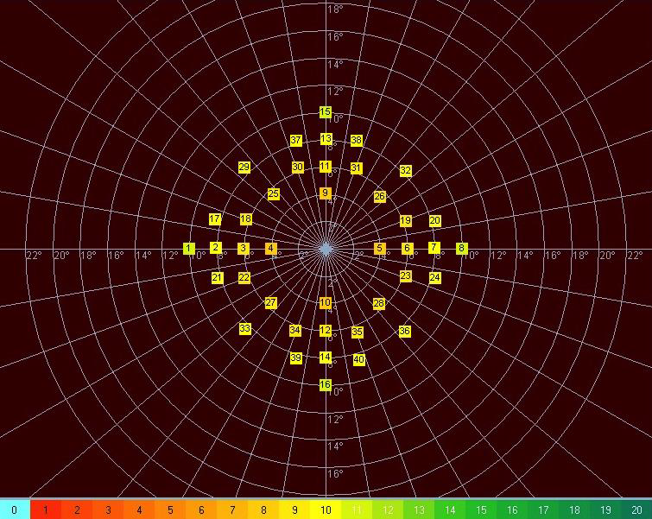
Supplemental figure 2: grid pattern for the scotopic examination. The pattern was provided to all participating sites prior to begin of the ProgStar-4 study.

Background
Color: Red
Fixation
Shape: Single circle
Extension: Radius 2
Thickness: 1
Color: White

6. Color retinograph imaging
At the end of the exam, a color fundus photo was taken for registration of microperimetry data using the MP-1S instrument.

