Appendix

A.1: Procedure Codes used in Germany

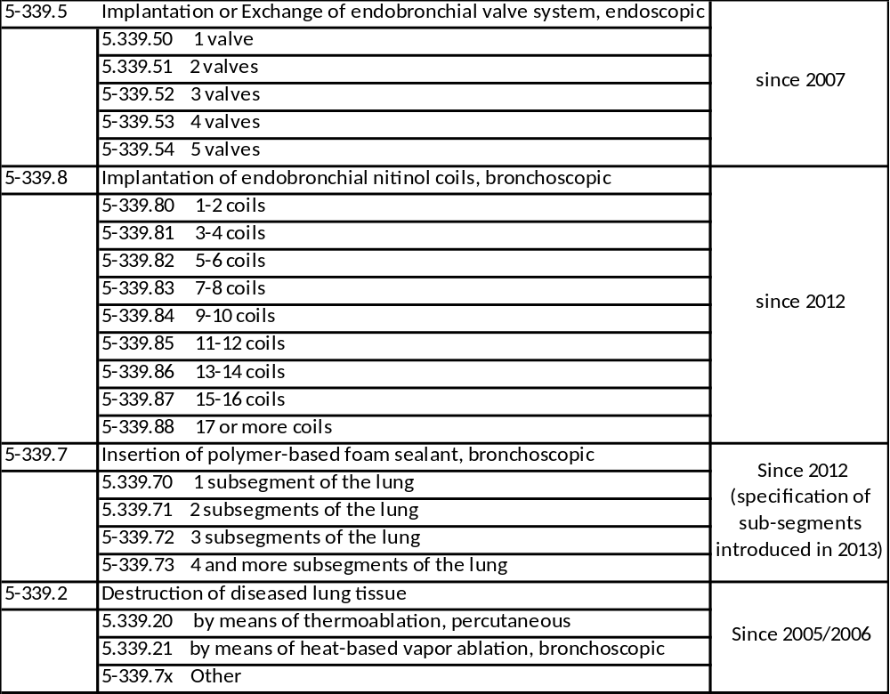 Table A.1: BLVR-related procedure codes in the German OPS procedure coding system, with information about the introduction of respective codes. Note: The current analysis reports on valves and coils only, as the other BLVR approaches have been abandoned or are not commonly used in current clinical practice.

A.2: Detailed data on procedure utilization in different age groups

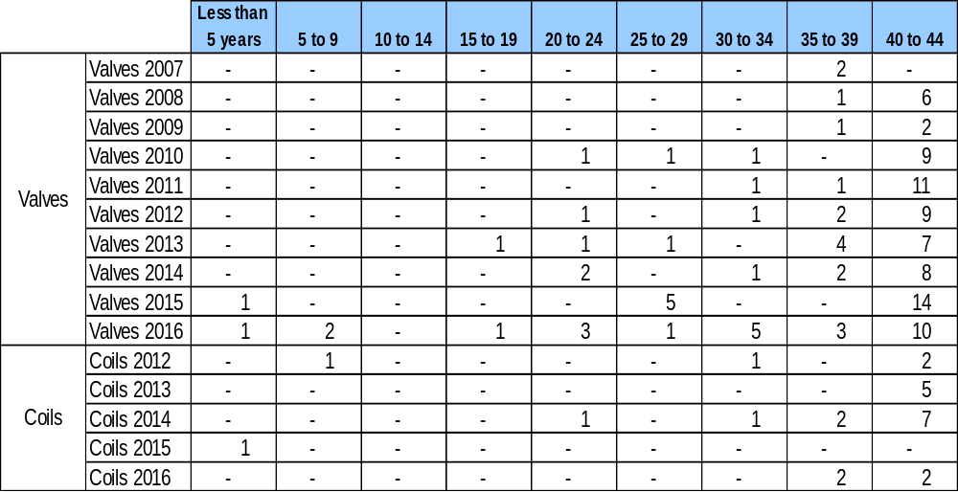

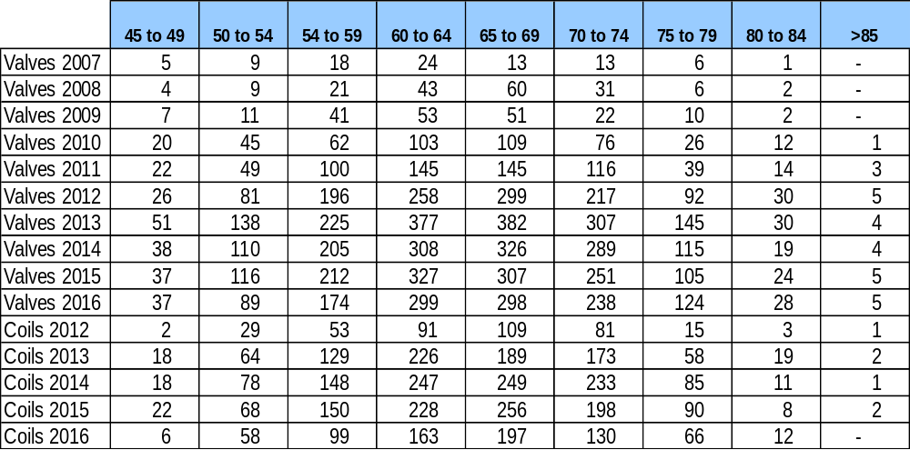

Table A.2: Number of valve and coil procedures, by age group, for each available data year. Percentages add up to 100% for each year. Note: Age groups <5 yrs. and up to 40 to 44 yrs. of age are shown in the upper part of the table, remaining age groups in the lower part of the table.

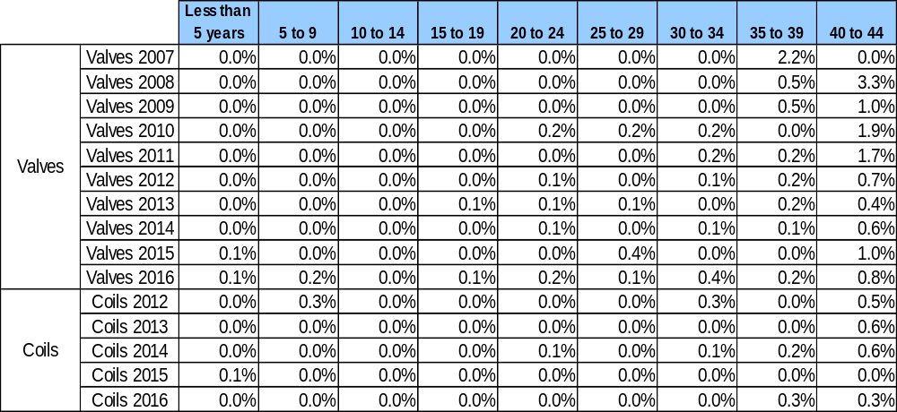

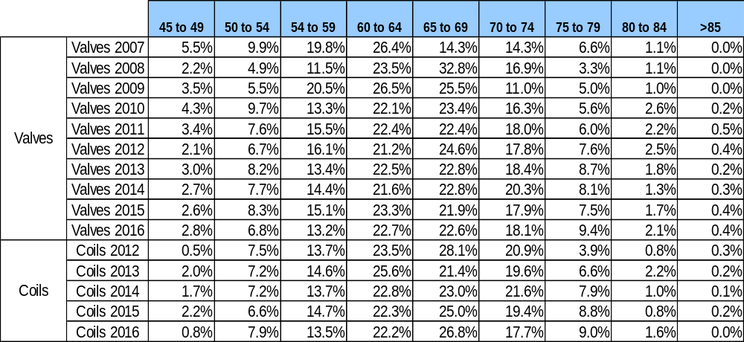
Table A.3: Relative proportion of valve and coil procedures, by age group, for each available data year. Percentages add up to 100% for each year. Note: Age groups <5 yrs. and up to 40 to 44 yrs. of age are shown in the upper part of the table, remaining age groups in the lower part of the table.

