Supplementary Table 1. Correlations between complete blood count and estimates
Cells | Correlation between CBC and estimates*
Lymphocytes | 0.87
Granulocytes | 0.88
Monocytes | 0.69
Natural Killer cells | 0.68
B cells | 0.61
CD4 T cells | 0.83
CD8 T cells | 0.85
* CBC = complete blood count; estimates = abundance measures of cell types estimated by Horvath’s
epigenetic clock software

Supplementary Figure 1. Scatterplot of epigenetic age by chronological age in total sample (N=160)
Epigenetic age
PTSD status

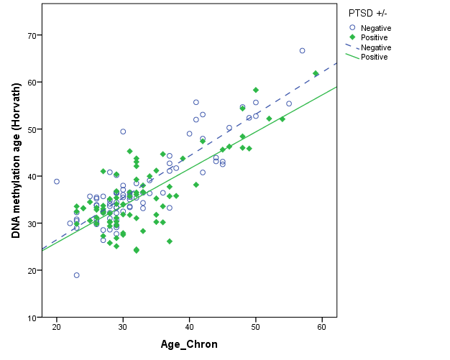
Chronological age

Supplementary Figure 2. Scatterplot of epigenetic age at baseline and at follow-up (N=44)

epigenetic age at follow-up
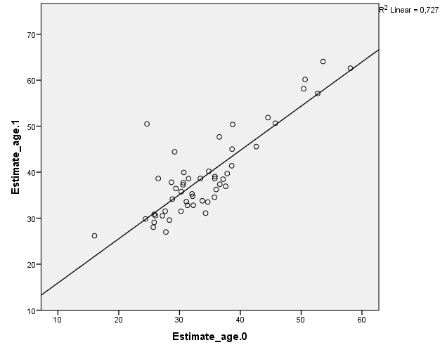
epigenetic age at baseline

Supplementary Figure 3. Scatterplot of ∆age at baseline and at follow-up (N=44)
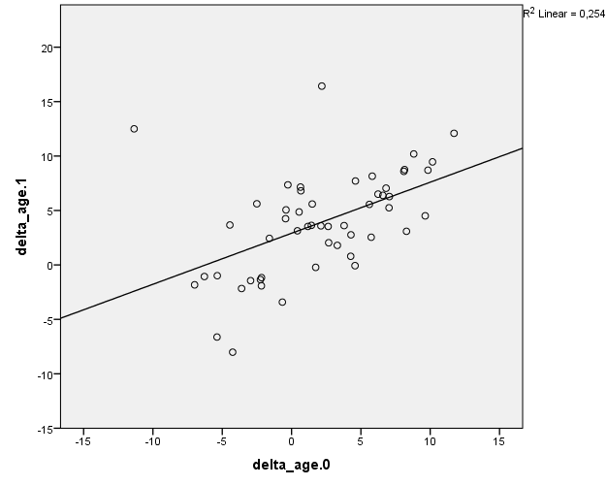

∆age at follow-up
∆age at baseline

