Non-antibiotic herbal therapy (BNO 1045) versus antibiotic therapy (fosfomycin trometamol) for the treatment of acute lower uncomplicated urinary tract infections in women: A double-blind, parallel-group, randomized, multicentre, non-inferiority Phase III trial
Supplementary Material

Florian M. Wagenlehnerª
Dimitri Abramov-Sommariva^{b}
Martina Höller^{b}
Hubert Steindl^{b}
Kurt G. Naber^{c}
ªClinic for Urology, Pediatric Urology and Andrology, Justus-Liebig University, Giessen, Rudolf-Buchheim-Straße 7, 35392 Giessen, Germany;
^{b}Bionorica SE, Kerschensteinerstr. 11–15, 92318 Neumarkt, Germany;
^{c}Technical University of Munich, PA: Karl-Bickleder Street 44c, 94315 Straubing, Germany.

Corresponding author:
Professor Florian M. Wagenlehner
Clinic for Urology, Pediatric Urology and Andrology, Justus-Liebig University, Giessen, Rudolf-Buchheim-Straße 7, 35392 Giessen (Germany)
E-Mail Florian.Wagenlehner@chiru.med.uni-giessen.de

Supplementary Figure 1: Study Design

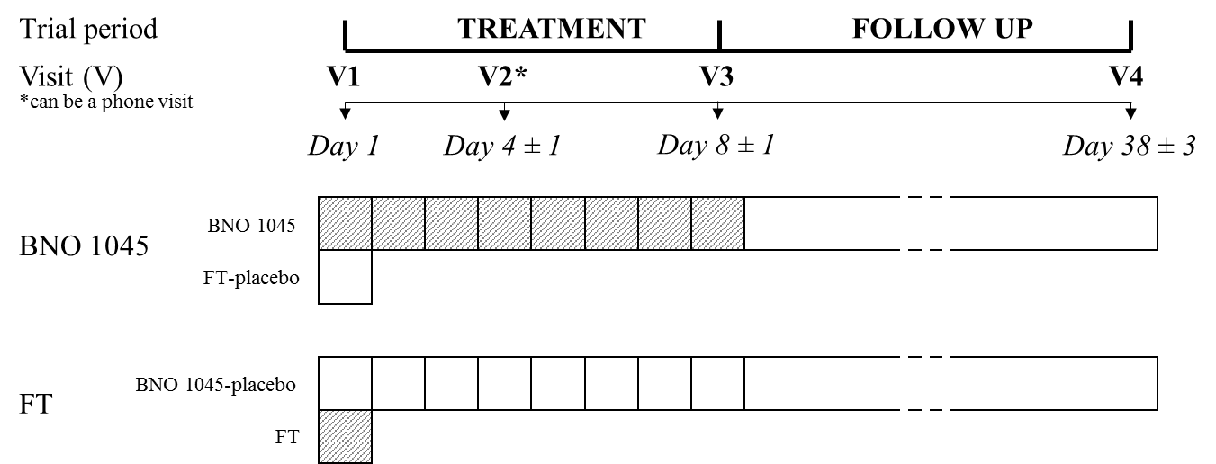
FT: fosfomycin trometamol; V: visit.

SCHEDULE OF STUDY ASSESSMENTS

Assessments | Treatment |  |  | Follow-up | UV²
 | Visit 1 | Visit 2¹ | Visit 3 | Visit 4
 | Day 1 | Day 4 ± 1 | Day 8 ± 1 | Day 38 ± 3
Informed consent | X
Inclusion/ exclusion criteria | X
Demographic data | X
Medical history | X
Prior/ concomitant medication | X | X | X | X | X
Physical examination³ | X | X⁴ | X | X | (X)
Vital signs | X | X⁴ | X | X | (X)
ACSS questionnaire | X | X⁵ | X | X | X
Pregnancy test (urine) | X |  |  | X | (X)
Sexual activity status | X
Urinalysis (dipstick and microbiological culture, including antibiogram) | X |  | X | X | X
Cytokines, prostaglandins and creatinine in urine (selected centres only) | X |  | X
Safety laboratory (blood) | X |  | X | X | (X)
Randomization | X
Dispense of IMPs* | X
Adverse events | X | X | X | X | X
Use of additional antibiotic(s) |  | X | X | X | X
Drug compliance |  | X⁴ | X | X⁷ | X⁶
Investigator’s and patient’s overall assessment of efficacy |  |  | X | X
Investigator’s and patient’s overall assessment of tolerability |  |  | X | X
Return of unused IMPs/ empty package |  |  | X | X⁷ | (X)
ACSS: Acute Cystitis Symptom Score; IMP: investigational medicinal product; UV: unscheduled visit.
*Record date and time of last meal (Fosfomycin trometamol 2 hours’ interval to meal)
¹The visit could be conducted at the site or on the phone. ²UV could be performed at any time between Visit 1 and Visit 4 if deemed necessary by the investigator. Assessments which were not mandatory but could be performed at the discretion of the investigator are indicated in brackets, (X). ³Standard physical examination was performed at Visit 1 and Visit 4; at other visits disease oriented physical examination could be performed. ⁴Applied only if Visit 2 took place on-site. ⁵In case of a telephone visit, ACSS questionnaire were to be filled in by the patient at home and sent promptly to the investigator by mail. ⁶Applied only if UV took place between Visit 1 and Visit 3. ⁷Applied only if not already done at Visit 3.
ADDITIONAL SECONDARY ENDPOINTS
Secondary efficacy variables analysed in the study were:

• AB (antibiotic)-rate, i.e. proportion of patients who received additional AB for the treatment of acute lower uncomplicated urinary tract infections (uUTIs) and/or for worsening of uUTI between Days 1 and 38, and did not receive any other AB during this period, by reason of persistent symptoms (assessed by the investigator)
• AB-rate by reason of recurrent symptoms (assessed by investigator)
• Efficacy endpoints based on Acute Cystitis Symptom Score (ACSS) questionnaire results at Visits 2, 3 and 4, including:
- Severity of each uUTI symptom reported on the ACSS-Typical domain at each visit
- Sum-score of the ACSS-Typical domain at each visit
- Sum-score of the main uUTI symptoms (dysuria, pollakisuria, and urgency) reported on the ACSS-Typical domain at each visit
- Clearance of the uUTI symptoms reported on the ACSS-Typical domain (defined as none of the uUTI symptoms score being >1) at each visit
- Clinical changes defined as clinical cure (sum-score of the main uUTI symptoms - reported on the ACSS-Typical domain ≤3 and none of the symptoms score >1), clinical failure (sum-score of the main uUTI symptoms reported on the ACSS-Typical domain ≥6), and improved (neither the criteria of clinical cure nor the criteria of clinical failure were met) on Days 4, 8 and 38
- Single-item ACSS-Dynamics domain scores on Days 4, 8 and 38
- Single-item ACSS-quality of life (QoL) domain scores at each visit
- Sum-score of the ACSS-QoL domain at each visit
• Amount of bacteriuria [colony forming units (CFU)/mL] on Days 8 and 38
• Significant bacteriuria (≥10³ CFU/mL), non-significant bacteriuria, and unknown bacteriuria (i.e. microbiological tests were not available for a certain reason, such as too small urine sample) on Days 1, 8 and 38
• Leukocyturia (positive dipstick) on Days 8 and 38
• Paracetamol intake for acute lower uUTI symptoms between Days 1 and 38
• Investigator’s and patient’s overall assessments of efficacy on Days 1 and 38
• IL-6, IL-8, PGE2, and creatinine levels (for normalization) in urine collected on Days 1 and 8 (for a subset of patients in selected investigational sites) (data reported elsewhere)

INCLUSION CRITERIA
The inclusion criteria were:
1. Signed informed consent and data protection declaration
2. Female outpatients aged 18–70 years
3. Sum-score of the three main uUTI symptoms (dysuria [‘feeling pain or burning when passing urine’ No.3], pollakisuria [‘frequent urination of small volumes of urine’, No. 1], and urgency [‘Urgent urination’, No. 2]) reported on the ACSS-Typical domain on Day 1 is ≥ 6
4. Symptoms of the acute episode of lower uUTI were developed within ≤6 days prior to Day 1
5. Leukocyturia on Day 1, confirmed by positive dipstick
6. Patients willing to refrain from consuming prohibited concomitant medications and products
7. Non-lactating female patients who were surgically sterile (had a documented sterilization, bilateral oophorectomy ≥3 months before the start of the trial and/or hysterectomy), or postmenopausal (cessation of menses for ≥12 months), or women of childbearing potential with a negative pregnancy test on Day 1 willing to use highly effective (failure rate less than 1% per year, i.e., Pearl Index <1) contraception methods, e.g. contraceptive patch, oral, injected or implanted hormonal methods of contraception, or one of the following double-barrier method methods:
- Condom* AND occlusive cap (diaphragm or Portio cap or Lea Contraceptivum) with spermicidal foam/gel/film/cream/suppository (*A female condom and a male condom were not to be used together as friction between the two can result in either product failing.), OR
- Hormone-free intra uterine device (IUD) AND condom, OR
- Hormone-free IUD AND sponge, OR
- Hormone-free IUD AND spermicidal foam/gel/film/cream/suppository OR
- Intrauterine System (hormonal coil, Mirena® or similar)
- Vasectomized partner (at least three months before the start of the trial) OR
- Sexual abstinence during the trial including the follow-up period

EXCLUSION CRITERIA
The exclusion criteria were:
1. Any signs of complicated UTIs, pyelonephritis (i.e., fever temperature ≥38·0°C [grade 2], flank and/or back pain, chills and shivers), and/or vulvo-vaginitis with vaginal and/or with urethral discharge (without urination) on Day 1
2. Any conditions that may lead to complicated infections (i.e. renal diseases, urinary tract abnormalities or past urinary surgery, urine catheterization, uncontrolled diabetes mellitus, spinal cord injury, etc.)
3. Recurrent infection of the urinary tract known from medical history
4. Persisting signs or symptoms of severe, progressive, or uncontrolled systemic disease (i.e. renal, hepatic, biliary, hematological, gastro-intestinal, endocrine, pulmonary, cardiac, neurological, or cerebral disease)
5. Uncontrolled hypertension (a diastolic blood pressure >95 mmHg on Day 1)
6. Known severe cardiac insufficiency, coronary heart disease, valvular heart disease, cardiac arrhythmia, QT interval prolongation or other severe cardiac disease at Day 1
7. Any AB therapy within 30 days prior to Day 1
8. Other acute infections (except uUTIs) requiring AB treatment on Day 1
9. Patients receiving treatment for suspected or confirmed UTI (AB or phytopharmaceutical) within 30 days prior to Day 1
10. Patients who took anti-inflammatory or analgesic drugs (e.g. ibuprofen, paracetamol, acetylsalicylic acid) or spasmolytics for any reason within 24 hours prior to Visit 1, and/or were not willing to stop the intake of any of the following medication not permitted for use during the trial: Rosmarini folium, Levistici radix, and Centaurii herba supplements other than the CLR [investigational medicinal product (IMP)], anti-inflammatory or analgesic drugs (e.g. ibuprofen, acetylsalicylic acid, with exception of paracetamol), spasmolytics, herbal drugs or supplements, cranberry juice, and kidney or bladder teas
11. Known severe impaired renal function (creatinine clearance <20 mL/min)
12. Known history of oncological disease which had not been cured or was not stable within 12 months prior to Day 1
13. Active peptic ulcers
14. Immunosuppressive or immunostimulant (including vaccines) therapy within 30 days prior to Day 1
15. Hypersensitivity to CLR (active substances or any of the excipients), to other plants of the Apiaceae (Umbelliferae) family (e.g. anise, fennel), and to anethole (i.e. a component of the essential oils of anise, fennel, etc.)
16. Hypersensitivity to FT or to any of the excipients
17. History of severe drug allergy or hypersensitivity
18. Hereditary fructose intolerance, glucose-galactose malabsorption, saccharase-isomaltase insufficiency, galactose intolerance, or lactase deficiency
19. Known human immunodeficiency virus-positive infection
20. History of or current alcohol or drug abuse
21. Pregnancy (as confirmed by urine pregnancy test on Day 1)
22. Breast-feeding
23. Legal incapacity and/or other circumstances rendering the patient unable to understand the nature, scope, and possible impact of the trial
24. Known to be, or suspected of being unable to comply with the trial protocol
25. Patients who were currently participating or had participated in another clinical trial within 30 days prior to Visit 1 or had previously participated in the current clinical trial
26. Patients dependent from the sponsor, contract research organization, or the investigator (e.g. employees, relatives, etc.)

