Online Supplementary Figures S1-S2

Figure S1. Funnel plots of prevalence estimates for various forms of AMD stratified by CKD. Blue circle represents CKD, whereas red triangle represents non-CKD. AMD = age-related macular degeneration; CKD = chronic kidney disease; CI = confidence interval.
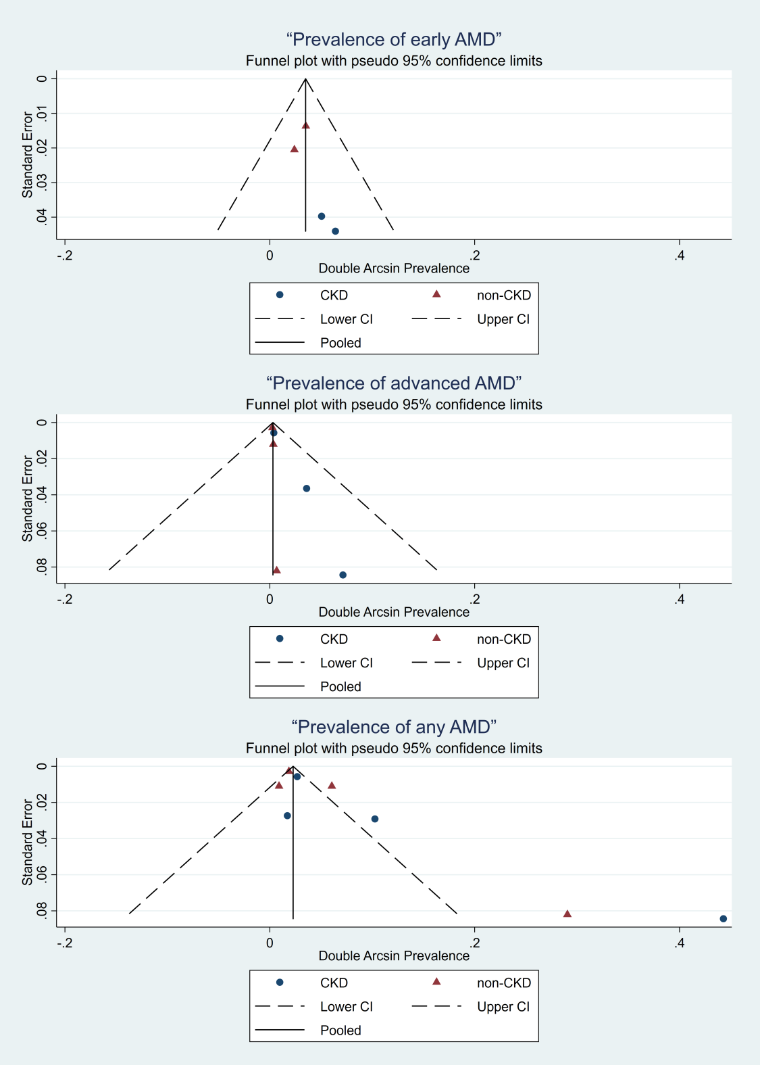

Figure S2. Funnel plots of odds ratios estimates in various forms of AMD. AMD = age-related macular degeneration; SE logOR = standard error of log odds ratio.
