SUPPLEMENTARY METHODS 1
Inclusion Criteria
Eligible subjects included males or females of non-childbearing potential aged 30–75 years, with a score of ≥ 24 on the Mini-Mental State Examination (MMSE); a clinical diagnosis of idiopathic Parkinson’s disease (PD) and presence of at least 2 out of 3 cardinal characteristics (tremor, rigidity, and/or bradykinesia); a Hoehn & Yahr Stage I–III (inclusive) if not experiencing motor fluctuations and Hoehn & Yahr Stage II–IV (inclusive) when “OFF”, if experiencing motor fluctuations; treatment with a daily levodopa (L-Dopa) dose between 300 mg and 1200 mg inclusive; average speed on the Modified Bradykinesia Rating Scale (MBRS) scores > 1; and average finger tapping speed measured by Kinesia technology > 1. Female subjects of non-childbearing potential must have met at least one of the following criteria: achieved postmenopausal status, defined as cessation of regular menses for at least 12 consecutive months with no alternative pathological/physiological cause, and had a serum follicle-stimulating hormone (FSH) level within the reference range for postmenopausal females; had undergone a documented hysterectomy and/or a bilateral oophorectomy; had medically confirmed ovarian failure. Subjects had a body mass index of 17.5–32 kg/m² and total body weight > 50 kg (110 lbs).

Exclusion criteria included history/clinical features consistent with atypical parkinsonian syndrome; history of surgical intervention for PD (pallidotomy, thalamotomy, deep brain stimulation); history of troublesome dyskinesias; history of painful, sudden, unpredictable, or severe “OFF” score of 4 in any tremor-related item on the Movement Disorder Society’s Unified Parkinson’s Disease Rating Scale (MDS-UPDRS) [1] to limit interference of severe tremor with measurements of kinesia.

Levodopa Equivalent Dose
Conversion factors have been calculated for antiparkinsonian drugs that yield a total daily levodopa equivalent dose (LED). The LED was derived using a standard formula: (Daily dose of levodopa + converted dose of the coadministered therapy) ÷ 3 = calculated levodopa equivalent dose (rounded up to nearest 50 mg) [38].

Pharmacokinetics
Measurement of PF-06412562 and Metabolite PF-06663872
The lower limits of quantification (LLOQ) for PF-06412562 and PF-06663872 were 0.500 ng/mL and 0.250 ng/mL, respectively. The between-day assay accuracy (% relative error [RE]) ranged from –5.2% to 6.0% (PF-06412562) and –5.6% to 1.0% (PF-06663872) for the low, medium low, medium, high, and diluted QC samples, which were 1.50, 20.0, 200, 400, 2500 ng/mL and 0.750, 10.0, 100, 1250 ng/mL for PF-06412562 and PF-06663872, respectively. Assay precision, expressed as the between-day percent coefficient of variation (%CV) of the mean estimated concentrations of QC samples was ≤ 5.7% (PF-06412562) and ≤ 5.4% (PF-06663872) for low, medium, high, and diluted concentrations.

Measurement of Levodopa
Levodopa samples were assayed using a validated, sensitive, and specific high-performance liquid chromatography-mass spectrometry (HPLC-MS)/MS. The LLOQ for levodopa was 10.0 ng/mL. Clinical specimens with plasma levodopa concentrations below the LLOQ were reported as below LLOQ. The between-day assay accuracy, expressed as %RE, for QC concentrations, ranged from –4.53% to 4.38% for the low, medium low, medium high, high, and diluted QC samples. Assay precision, expressed as the between-day %CV of the mean estimated concentrations of QC samples was ≤5.40% for low (24.0 ng/mL), medium low (60.0 ng/mL), medium high (240 ng/mL), high (800 ng/mL), and diluted (3800 ng/mL) concentrations.
PK parameters for PF-06412562 and its metabolite PF-06663872 and levodopa were determined with an internally developed and validated software system using standard electronic non-compartmental analysis of concentration–time data. Maximum plasma concentrations (C_{max}) was observed directly from data, with time of maximum change from baseline (T_{max}) defined as the time of the first occurrence of C_{max}. The terminal half-life (t_{1/2}) was estimated using linear regression of the log-linear concentration–time curve. The area under the plasma concentration-time profile from time 0 to the time of the last quantifiable concentration (AUC_{last}) was estimated using linear/log trapezoidal methods.

SUPPLEMENTARY METHODS 2
Statistical Analysis
Primary Endpoint
The treatment effect of PF-06412562 as measured by maximum percent improvement from
baseline in finger tapping speed was tested using a mixed model for repeated measures (MMRM) with a restricted maximum likelihood method for the estimation of the covariance parameters. The model included treatment and period as fixed categorical effect as well as random subject effect. The Kenward Roger approximation was used to estimate denominator degrees of freedom. An unstructured covariance matrix was used to model the within-subject errors. The difference between PF-06412562 and placebo was compared using appropriate contrasts of least-squares means.

Exploratory Endpoints
For MDS-UPDRS motor score and sub-scores, an MMRM model with a restricted maximum likelihood method for the estimation of the covariance parameters was used to test for treatment effect of PF-06412562 relative to placebo for each endpoint. The analyses were conducted on both per-protocol analysis set (PPAS) and full analysis set (FAS) with data obtained from Period 2 and Period 3. The model included treatment, period, nominal time, and treatment by nominal time interaction as fixed categorical effect as well as the baseline scores (2 baseline covariates, the mean of period baseline, base_mean within each subject in Period 2 and 3, and the difference between period baseline and base_mean, in Period 2 and 3 to separate out the effect of baseline between and within subject). The subject data were included in the model as a random effect. An unstructured covariance matrix was used to model the within-subject errors. If model-fitting issues occurred with the unstructured covariance matrix, other covariance structures including Toeplitz, compound symmetry, and first order autoregressive were considered. The covariance structure converging to the best fit, as determined by Akaike’s information criterion (AIC), was used in final analysis: the competing models were ranked according to their AIC, with the one having the lowest AIC being the best. The Kenward Roger approximation was used to estimate denominator degrees of freedom. The difference between PF-06412562 and placebo at each post baseline nominal time was compared using appropriate contrasts of LS means. Mean, one-sided 90% CI of model based contrast, and corresponding one-sided p-value was generated.
Supplementary Table 1. Demographic and baseline characteristics (Open-Label Analysis Set)

 | Male  N = 8 | Female  N = 11 | Total  N = 19
Age (years)  45–64  ≥65 | 5  3 | 7  4 | 12  7
Mean (SD) | 62.6 (5.9) | 64.6 (6.3) | 63.8 (6.1)
Range | 55–73 | 52–74 | 52–74
Race (n)
White | 8 | 11 | 19
Weight (kg)
Mean (SD) | 84.8 (13.3) | 69.2 (10.5) | 75.8 (13.9)
Range | 69.2–108.6 | 52.5–83.9 | 52.5–108.6
Body mass index (kg/m²)
Mean (SD) | 27.8 (2.9) | 26.9 (3.6) | 27.3 (3.3)
Range | 24.5–31.9 | 21.6–31.6 | 21.6–31.9
Height (cm)
Mean (SD) | 174.3 (9.3) | 160.3 (8.2) | 166.2 (11.0)
Range | 163.0–193.5 | 150.0–179.0 | 150.0–193.5
N = number of evaluable subjects; n = number of subjects with that characteristic; SD = standard deviation.

Supplementary Table 2. Summary of change from baseline of finger tapping speed by treatment: Periods 2 and 3 (Per-Protocol Analysis Set)
 | PF-06412562 30 + 20 mg  N = 11 |  | Placebo  N = 11
Baseline  Mean (SD)  Median | n = 11  192.8 (59.0)  204.0 |  | n = 11  198.5 (54.5)  193.0
Range | 79.3–269.4 |  | 117.0–254.8
Day 3/5
1 hour |  | n = 11 | n = 11
Mean (SD) |  | –4.8 (30.7) | 9.4 (28.9)
Median |  | 0.00 | 0.00
Range |  | –61.2–39.2 | –28.4–63.5
2 hours |  | n = 11 | n = 11
Mean (SD) |  | 1.1 (25.4) | –1.7 (48.3)
Median |  | 0.0 | 13.8
Range |  | –41.4–39.2 | 108.7–46.3
3 hours |  | n = 11 | n = 11
Mean (SD) |  | 1.1 (18.4) | –15.1 (72.0)
Median |  | 0.00 | 0.00
Range |  | –25.6–37.0 | –150.1–76.4
4 hours |  | n = 11 | n = 11
Mean (SD) |  | 8.2 (35.8) | –21.4 (59.1)
Median |  | 13.0 | -13. 8
Range |  | –69.5–53.7 | –131.1–48.1
5 hours |  | n = 11 | n = 11
Mean (SD) |  | 10.8 (34.7) | –16.0 (63.5)
Median |  | 6.3 | 0.0
Range |  | –28.5–69.1 | –166.2–41.4
8 hours |  | n = 11 | n = 11
Mean (SD) |  | –1.1 (36.6) | –7.2 (69.5)
Median |  | -11.0 | 10.4
Range |  | –44.3–80.8 | –175.6–61.9
12 hours |  | n = 11 | n = 11
Mean (SD) |  | –6.4 (38.4) | –21.5 (58.5)
Median |  | 0.00 | -26.9
Range |  | –58.9–50.8 | 144.2–76.4

N = number of evaluable subjects; n = number of subjects evaluated (at each nominal time point); SD = standard deviation.
Supplementary Table 3. MMRM inferential analysis of maximum percent improvement from baseline in finger tapping speed by treatment: Periods 2 and 3 (Per-Protocol Analysis Set)

 | PF-06412562 30 + 20 mg  N = 11 | Placebo  N = 11
Periods 2 and 3 | n = 11 | n = 11
Mean (SD) | 21.8 (13.2) | 14.8 (14.0)
Median | 24.9 | 11.8
Range | 5.7–39.6 | 0.0–39.6
Versus placebo
LS-Mean different (SE) | 6.8 (6.2)
90% 1-sided lower CI | (–1.7, inf)
MMRM 1-sided p-value | 0.15

MMRM = mixed model for repeated measures; N = number of evaluable subjects; n = number of subjects evaluated; SD = standard deviation; SE = standard error.

Supplementary Table 4a. Descriptive summary/MMRM inferential analysis of change from baseline for MDS-UPDRS motor score by treatment: Periods 2 and 3 (Per-Protocol Analysis Set)

 | Change from baseline
 | PF-06412562  30 + 20 mg  N = 11 | Placebo
Baseline | n = 11 | n = 11
Mean (SD) | 37.7 (11.6) | 38.4 (9.8)
Median | 39.0 | 41.0
Range | 15.0–62.0 | 18.0–53.0
Day 3/5 | n = 11 | n = 11
1.5–2.5 hours
Mean (SD) | −10.9 (7.2) | −1.2 (7.5)
Median | −11.0 | −1.0
Range | −21.0– −1.0 | −16.0–11.0
Versus placebo
LS-mean difference (SE) | −10.6 (2.4)
90% 1-sided upper CI | (-inf, −7.4)
MMRM 1-sided p-value | < 0.0001
3 hours | n = 11 | n = 11
Mean (SD) | −8.9 (6.2) | 0.9 (7.5)
Median | −10.0 | 3.0
Range | −19.0–2.0 | −18.0–8.0
Versus placebo
LS-mean difference (SE) | −10.7 (2.5)
90% 1-sided upper CI | (-inf, −7.4)
MMRM 1-sided p-value | < 0.0001
5 hours | n = 11 | n = 11
Mean (SD) | −5.9 (5.7) | 0.0 (6.7)
Median | −6.0 | 1.0
Range | −15.0–2.0 | −14.0–10.0
Versus placebo
LS-mean difference (SE) | −6.6 (2.5)
90% 1-sided upper CI | (-inf, −3.3)
MMRM 1-sided p-value | 0.0054
8 hours | n = 11 | n = 11
Mean (SD) | −5.5 (4.5) | 1.4 (7.3)
Median | −7.0 | 0.0
Range | −12.0–1.0 | −12.0–9.0
Versus placebo
LS-mean difference (SE) | −7.4 (2.5)
90% 1-sided upper CI | (-inf, −4.1)
MMRM 1-sided p-value | 0.0022
12 hours | n = 11 | n = 11
Mean (SD) | −3.4 (6.6) | 1.8 (7.8)
Median | −4.0 | 0.0
Range | −14.0–9.0 | −10.0–13.0
Versus placebo
LS-mean difference (SE) | −5.2 (2.4)
90% 1-sided upper CI | (-inf, −2.1)
MMRM 1-sided p-value | 0.0176
CI = confidence interval; inf = infinity; MDS-UPDRS = Movement Disorder Society-Unified Parkinson’s Disease Rating Scale; MMRM = mixed model for repeated measures; N = number of evaluable subjects; n = number of subjects evaluated (at each nominal time point); SD = standard deviation; SE = standard error.

Supplementary Table 4b. Descriptive summary/MMRM inferential analysis of change from baseline for MDS-UPDRS motor subscale scores by treatment: Periods 2 and 3 (Per-Protocol Analysis Set)

 | Tremor |  | Rigidity |  | Bradykinesia |  | PIGD
 | PF-06412562  30 + 20 mg N = 11 | Placebo  N = 11 | PF-06412562  30 + 20 mg N = 11 | Placebo  N = 11 | PF-06412562  30 + 20 mg N = 11 | Placebo  N = 11 | PF-06412562  30 + 20 mg N = 11 | Placebo  N = 11
Baseline  Mean (SD)  Median  Range | n = 11  5.3 (3.1)  4.0  1.0–10.0 | n = 11  5.5 (2.8)  5.0  1.0–10.0 | n = 11  6.5 (3.8)  5.0  2.0–13.0 | n = 11  7.3 (3.7)  5.0  2.0–15.0 | n = 11  16.3 (5.5)  17.0  5.0– 25.0 | n = 11  16.4 (5.1)  17.0  7.0–24.0 | n = 11  1.4 (0.8)  1.0  0.0–3.0 | n = 11  1.3 (0.7)  1.0  0.0–2.0
Day 3/5  1.5–2.5 hours  Mean (SD)  Median  Range | n = 11  −2.2 (1.7)  −2.0  −5.0–0.0 | n = 11  0.1 (2.1)  0.0  −2.0–6.0 | n = 11  −1.2 (2.1)  −1.0  −4.0–3.0 | n = 11  −0.6 (1.6)  −1.0  −3.0–3.0 | n = 11  −5.0 (4.2)  −4.0  −15.0–0.0 | n = 11  −1.0 (3.7)  0.0  −9.0–5.0 | n = 11  −0.4 (0.9)  0.0  −3.0–0.0 | n = 11  0.3 (0.9)  0.0  −1.0–2.0
Versus placebo  LS-mean difference (SE)  90% 1-sided upper CI  MMRM 1-sided p-value | −2. 8 (1.0)  −inf, −1.5  0.0048 |  | −0.6 (0.6)  −inf, 0.2  0.1684 |  | −4.4 (1.3)  −inf, −2. 8  0.0003 |  | −0. 6 (0.3)  inf, −0.2  0.0320
3 hours  Mean (SD)  Median  Range | n = 11  −1.3 (2.8)  −1.0  −6.0–4.0 | n = 11  0.4 (1.7)  0.0  −2.0–4.0 | n = 11  −0.8 (1.9)  −1.0  −4.0–3.0 | n = 11  −0.4 (1.1)  0.0  −2.0–2.0 | n = 11  −4.6 (4.3)  −4.0  −13.0–1.0 | n = 11  0.3 (4.6)  2.0  −12.0–4.0 | n = 11  −0.5 (0.7)  0.0  −2.0–0.0 | n = 11  0.0 (0.6)  0.0  −1.0–1.0
Versus placebo  LS-mean difference (SE)  90% 1-sided upper CI  MMRM 1-sided p-value | −2.0 (1.0)  −inf, −0.7  0.0299 |  | −0.6 (0.6)  −inf, 0.3  0.1926 |  | −5.2 (1.3)  −inf, −3.5  0.0001 |  | −0.3 (0.3)  −inf, 0.04  0.1250
5 hours  Mean (SD)  Median  Range | n = 11  −1.2 (2.1)  0.0  −5.0–1.0 | n = 11  0.0 (1.3)  0.0  −3.0–2.0 | n = 11  −0.4 (1.8)  0.0  −3.0–3.0 | n = 11  0.0 (0. 9)  0.0  −1.0–2.0 | n = 11  −2.8 (2.0)  −3.0  −6.0–1.0 | n = 11  0.0 (4.1)  1.0  −10.0–5.0 | n = 11  −0.4 (1.0)  0.0  −3.0–1.0 | n = 11  0.2 (0.8)  0.0  −1.0–2.0
Versus placebo  LS-mean difference (SE)  90% 1-sided upper CI  MMRM 1-sided p-value | −1.0 (1.0)  −inf, 0.3  0.1523 |  | −0.5 (0.6)  −inf, 0.4  0.2320 |  | −3.0 (1.3)  −inf, −1.3  0.0124 |  | −0.3 (0.3)  −inf, 0.1  0.1333
8 hours  Mean (SD)  Median  Range | n = 11  −1.5(1.6)  −1.0  −4.0–0.0 | n = 11  0.4 (1.6)  0.0  −3.0–3.0 | n = 11  0.2 (1.3)  0.0  −2.0–3.0 | n = 11  0.1 (1.1)  0.0  −2.0–2.0 | n = 11  −3.1 (3.4)  −3.0  −10.0–1.0 | n = 11  0.8 (4.3)  1.0  −9.0–6.0 | n = 11  −0.3 (0.5)  0.0  −1.0–0.0 | n = 11  0.0 (0.5)  0.0  −1.0–1.0
Versus placebo
LS-mean difference (SE)  90% 1-sided upper CI  MMRM 1-sided p-value | −2.3 (1.0)  −inf, −1.0  0.0147 |  | 0.0 (0.6)  −inf, 0.8  0.5119 |  | −3.9 (1.3)  −inf, -2.3  0.0016 |  | −0.1 (0.3)  (−inf, 0.25)  0.3562
12 hours  Mean (SD)  Median  Range | n = 11  −0.4 (2.3)  0.0  −5.0–4.0 | n = 11  1.2 (2.6)  0.0  −2.0–6.0 | n = 11  −0.2 (0.8)  0.0  −1.0–1.0 | n = 11  0.0 (0. 9)  0.0  −2.0–1.0 | n = 11  −1.8 (3.9)  0.0  −11.0–2.0 | n = 11  0.6 (3.4)  1.0  −6.0–5.0 | n = 11  −0.5 (1.0)  0.0  −3.0–1.0 | n = 11  0.0 (0.6)  0.0  −1.0–1.0
Versus placebo
LS-mean difference (SE)  90% 1-sided upper CI  MMRM 1-sided p-value | −2.0 (1.0)  −inf, −0.7  0.0299 |  | −0.2 (0.6)  −inf, 0.6  0.3907 |  | −2.2 (1.3)  −inf, −0.6  0.0378 |  | −0.3 (0.3)  −inf, 0.1  0.1608
CI = confidence interval; inf = infinity; LS = least square; MDS-UPDRS = Movement Disorder Society-Unified Parkinson's Disease Rating Scale; MMRM = mixed model for repeated measures; N = number of evaluable subjects; n = number of subjects evaluated (at each nominal time point); PIGD = postural instability/gait difficulty; PPAS = Per-Protocol Analysis Set; SD = standard deviation; SE = standard error.

Supplementary Table 5. Pharmacokinetic parameters of plasma PF-06412562, PF-06663872, and levodopa following oral doses

Parameter, Units | PF-06412562 | PF-06663872 | Levodopa
N, n | 12, 12 | 12, 11 | 19, 12
AUC_{last} (ng•hr/mL) | 6880 (36) | 1053 (23) | 4749 (42)
C_{max} (ng/mL) | 841.9 (30) | 83.0 (32) | 2458 (55)
T_{max} (hr) | 1.0 (1.0–5.1) | 5.1 (1.0–8.1) | 0.5 (0.5–1.1)
t_{1/2} (hr) | 6.4 ± 1.5 | 6.7 ± 1.3 | 1.2 ± 0.1
Data presented as geometric mean (geometric %CV) for all parameters except median (range) for T_{max}, and arithmetic mean (±SD) for t_{1/2}.
%CV = percent coefficient of variation;; N = number of subjects in the treatment group and contributing to the mean; n = number of subjects where t_{½} were reported; NR = not reported; SD = standard deviation.

Supplementary Table 6. Summary of treatment-emergent adverse events, all causalities (treatment-related)

Number of subjects | Levodopa | PF-06412562  30 + 20 mg | Placebo
Subjects evaluable for AEs | 19 | 13 | 13
Number of AEs (treatment-related AEs) | 1 (0) | 7 (6) | 9 (4)
Subjects with AEs (treatment-related AEs) | 1 (0) | 5 (4) | 5 (3)
Subjects with SAEs | 0 | 0 | 0
Subjects with severe AEs | 0 | 0 | 0
Subjects discontinued due to AEs | 0 | 0 | 0
Subjects with dose reduced or temporary discontinuation due to AEs | 0 | 0 | 0

AE = adverse event; SAE = serious adverse event.

Supplementary Table 7. Incidence of treatment-emergent adverse events, all causality (treatment-related)
Number of subjects with AEs by System Organ Class and MedDRA Preferred Termª | Levodopa  (n = 19) | PF-06412562  30 + 20 mg  (n = 13) | Placebo  (n = 13)
Gastrointestinal disorders | 1 (0) | 2 (1) | 3 (0)
Constipation | 1 (0) | 0 | 1 (0)
Nausea | 0 | 2 (1) | 2 (0)
Vomiting | 0 | 1 (1) | 1 (0)
General disorders and administration site conditions | 0 | 2 (2) | 2 (2)
Fatigue | 0 | 2 (2) | 2 (2)
Infections and infestations  Urinary tract infection  Nervous system disorders  Dizziness  Headache  Psychiatric disorders  Anxiety  Total preferred term events | 0  0  0  0  0  0  0  1 (0) | 0  0  1 (1)  0  1 (1)  1 (1)  1 (1)  7 (6) | 1 (0)  1(0)  1 (1)  1 (1)  0  1 (1)  1 (1)  9 (4)

Treatment-related AEs are in parentheses. Subjects were counted only once per treatment in each row. AE = adverse event; MedDRA = Medical Dictionary for Regulatory Activities; n = number of subjects. ªMedDRA (version 17.0) coding dictionary applied.
Supplementary Fig. 1. Maximum percent improvement from baseline in finger tapping speed against treatment: Periods 2 and 3 (Per-Protocol Analysis Set)
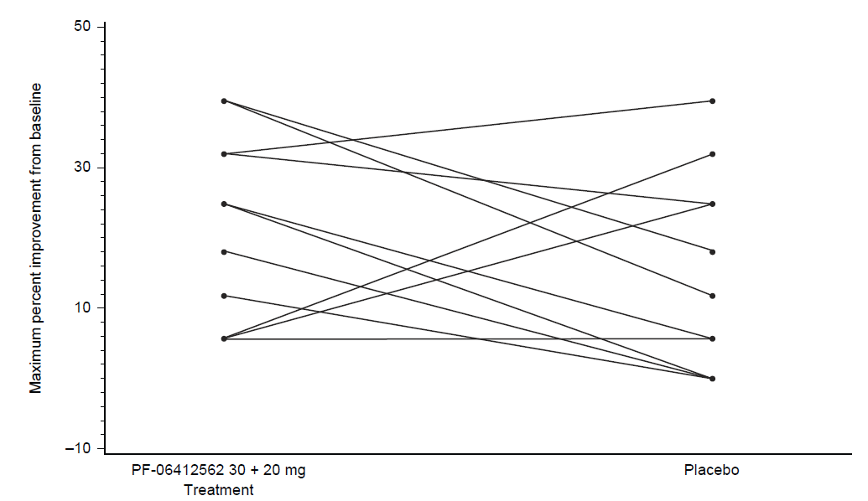

Supplementary Fig. 2. Median plasma PF-06412562 concentration–time profiles following split doses
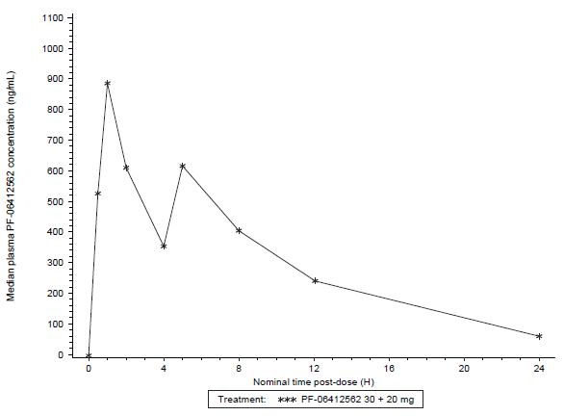

H = hour.

