Supplementary Information for:

Genome-scale single nucleotide resolution analysis of DNA methylation in human autosomal dominant polycystic kidney disease.

Sarah A Bowden^{1#}, Euan J Rodger^{1,2#}, Michael Bates^{1#}, Aniruddha Chatterjee^{1,2}, Michael R Eccles^{1,2}, Cherie Stayner¹*

¹Department of Pathology, Dunedin School of Medicine, University of Otago, 270 Great King Street, Dunedin 9054, New Zealand. ²Maurice Wilkins Centre for Molecular Biodiscovery, Level 2, 3A Symonds Street, Auckland 1010, New Zealand.
# These authors contributed equally to this work

Running title: DNA methylation in human ADPKD

*Correspondence: Dr. Cherie Stayner, Department of Pathology, Dunedin School of Medicine, University of Otago, P.O. Box 56, Dunedin 9054, New Zealand, Phone: +64 3 470 3453, Fax: +64 3 479 7136 email: cherie.stayner@otago.ac.nz.

Supplementary Figures S1-S3

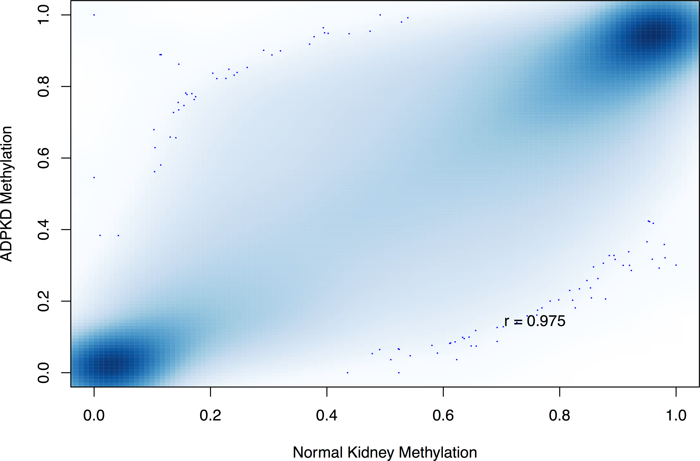
Figure S1. Correlation of DNA methylation in ADPKD compared to non-ADPKD kidney. A smoothed colour density scatterplot of the 345711 commonly analysed RRBS MspI fragments shows the correlation of methylation in ADPKD (y-axis) compared to non-ADPKD (x-axis).

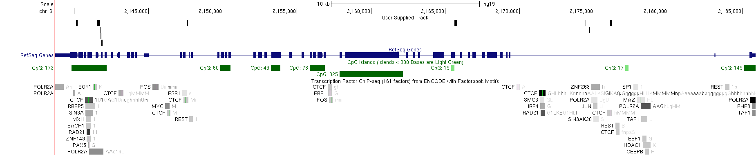
Figure S2. Gene map of PKD1 in ADPKD and non-ADPKD kidney. ANOVA analysis of RRBS MspI fragment-based methylomes from renal cortex of non-ADPKD (n=3) compared to ADPKD kidney (n=4) identified 10 fragments (shown in black on top track) with a nominal raw P-value threshold of <0.05 and methylation differences greater than 0.10. The bottom track shows predicted transcription factor binding sites from ENCODE.

Supplementary Tables S1-S7

Table S1. Summary of Bismark genome alignment for RRBS libraries
 | ADPKD 07 | ADPKD 08 | ADPKD 05 | ADPKD 16 | Non-ADPKD E1 | Non-ADPKD G2 | Non-ADPKD H3 | TOTAL | MEDIAN
Sequences analysed in total | 4.69.E+07 | 5.72.E+07 | 1.86E+07 | 1.42E+07 | 4.25.E+07 | 3.50.E+07 | 4.15.E+07 | 2.56E+08 | 4.15.E+07
No. of alignments with a unique best hit | 3.13.E+07 | 3.78.E+07 | 1.01E+07 | 7.70E+06 | 2.59.E+07 | 2.34.E+07 | 2.83.E+07 | 1.65E+08 | 2.83.E+07
Mapping efficiency | 66.70% | 66.20% | 54.20% | 54.20% | 61.00% | 67.00% | 68.30% |  | 66.20%
Sequences with no alignments under any condition | 6.90E+06 | 9.41E+06 | 5.09E+06 | 3.86E+06 | 8.81E+06 | 5.94E+06 | 5.38E+06 | 4.54E+07 | 5.94E+06
Sequences did not map uniquely | 8.71E+06 | 9.93E+06 | 3.41E+06 | 2.63E+06 | 7.75E+06 | 5.59E+06 | 7.76E+06 | 4.58E+07 | 7.75E+06
Total number of Cs analysed | 6.38E+08 | 8.06E+08 | 2.01E+08 | 1.37E+08 | 5.50E+08 | 4.92E+08 | 5.93E+08 | 3.42E+09 | 5.93E+08
C meth in CpG context | 35.80% | 31.90% | 39.00% | 35.90% | 40.90% | 40.00% | 39.00% |  | 39.00%
C meth in CHG context | 0.80% | 0.90% | 0.40% | 0.80% | 1.00% | 1.20% | 1.00% |  | 1.00%
C meth in CHH context | 0.50% | 0.40% | 0.40% | 0.70% | 0.50% | 0.70% | 0.60% |  | 0.50%

Table S2. Global methylation analysis of ADPKD and non-ADPKD kidney tissue
 | Genome-wide |  | Promoter |  | Intron |  | Exon |  | Intron/Exon Boundary |  | Intergenic
 | Non-ADPKD | ADPKD | Non-ADPKD | ADPKD | Non-ADPKD | ADPKD | Non-ADPKD | ADPKD | Non-ADPKD | ADPKD | Non-ADPKD | ADPKD
Median methylation | 0.7833 | 0.7619 | 0.0380 | 0.0278 | 0.8202 | 0.7985 | 0.2521 | 0.2204 | 0.5425 | 0.5396 | 0.8706 | 0.8507
Mean methylation | 0.5778 | 0.5633 | 0.1790 | 0.1655 | 0.6048 | 0.5892 | 0.4399 | 0.4250 | 0.4869 | 0.4737 | 0.6785 | 0.6648
Analysed fragments | 345711 |  | 72182 |  | 129949 |  | 33199 |  | 15764 |  | 131420
Wilcoxon rank sum test | W = 63754556349  P-value < 2.2e-16 |  | W = 2914702038  P-value < 2.2e-16 |  | W = 9036317200  P-value < 2.2e-16 |  | W = 590623184  P-value < 2.2e-16 |  | W = 132954508  P-value < 2.2e-16 |  | W = 9293002131  P-value < 2.2e-16

Table S3. Global CpG island methylation analysis of ADPKD and non-ADPKD kidney tissue
 | Genome-wide |  | CGI core |  | CGI shore |  | CGI shelf |  | Open sea
 | Non-ADPKD | ADPKD | Non-ADPKD | ADPKD | Non-ADPKD | ADPKD | Non-ADPKD | ADPKD | Non-ADPKD | ADPKD
Median methylation | 0.7833 | 0.7619 | 0.0293 | 0.0215 | 0.4423 | 0.4207 | 0.7985 | 0.7751 | 0.8818 | 0.8605
Mean methylation | 0.5778 | 0.5633 | 0.0819 | 0.0705 | 0.4802 | 0.4664 | 0.6153 | 0.5969 | 0.6933 | 0.6782
Analysed fragments | 345711 |  | 56922 |  | 12602 |  | 8291 |  | 263957
Wilcoxon rank sum test | W = 63754556349  P-value < 2.2e-16 |  | W = 1881819234  P-value < 2.2e-16 |  | W = 82547192  P-value < 2.2e-16 |  | W = 36694268  P-value < 2.2e-16 |  | W = 37679062783  P-value < 2.2e-16

Table S4. Genehancer analysis on differentially methylated fragments (DMFs) in ADPKD
ADPKD DMFs |  |  | Genehancer analysis
Chr | Start | End | Confidence  score | ID | Connected  gene 1  (assoc. score) | Connected  gene 2  (assoc. score) | Connected  gene 3  (assoc. score) | Connected  gene 4  (assoc. score) | Connected  gene 5  (assoc. score) | Connected  gene 6  (assoc. score)
4 | 793929 | 794143
7 | 922176 | 922249 | 0.38 | GH07F000881 | PRKAR1B (15.26) | DNAAF5 (11.4)
7 | 6511106 | 6511153
7 | 6495310 | 6495378
10 | 14979136 | 14979987
12 | 3862528 | 3862582 | 0.25 | GH12F003751 | CRACR2A (6.18) | TULP3 (5.31)
17 | 40683608 | 40683711 | 1.09 | GH17F042528 | TUBG2 (20.8) | NAGLU (15.87) | RAB5C (10.61) | HSD17B1 (8.99) | MLX (8.7) | BECN1 (5.8)
22 | 37499386 | 37499523
2 | 771624 | 771728
9 | 130768316 | 130768366 | 1.39 | GH09F128004 | LOC101929314 (11.5) | FAM102A (11.47) | PIP5KL1 (10.81)
18 | 10271529 | 10271568
19 | 789109 | 789181 | 0.87 | GH19F000788 | CFD (4.83)
20 | 2513933 | 2513980

Table S5. OregAnno analysis on differentially methylated fragments (DMFs) in ADPKD
ADPKD DMFs |  |  | OregAnno analysis
Chr | Start | End | ID | Target Gene | Transcription Factors
4 | 793929 | 794143
7 | 922176 | 922249 | OREG1180168, OREG1530622 | GET4 | TFAP2C, ESR1
7 | 6511106 | 6511153
7 | 6495310 | 6495378
10 | 14979136 | 14979987 | OREG1772349 | DCLRE1C | MITF
12 | 3862528 | 3862582 | OREG1511145 | CRACR2A | EGR1
17 | 40683608 | 40683711 | OREG1267929 | ATP6V0A1 | SMARCA4
22 | 37499386 | 37499523
2 | 771624 | 771728
9 | 130768316 | 130768366 | OREG1885090, OREG1174681, OREG1639121, OREG1675784, OREG0298345 | FAM102A | STAT1, TFAP2C, FOXA1, GATA2, STAT1
18 | 10271529 | 10271568
19 | 789109 | 789181 | OREG1487706, OREG1365666 | PTBP1 | EGR1, CTCF
20 | 2513933 | 2513980

Table S6. All RRBS MspI fragments spanning the PKD1 gene
Chr | Start | End | Fragment  Length | No. of CpGs | Raw P-value  (ANOVA) | Mean non-ADPKD  methylation  (n=3) | Mean ADPKD  methylation  (n=4) | Methdiff ¹ | Overlap | Genehancer ID
16 | 2189554 | 2189620 | 67 | 9 | 0.597 | 0.96 | 0.95 | -0.01 | Promoter
16 | 2185561 | 2185611 | 51 | 7 | 0.271 | 0.07 | 0.05 | -0.02 | E1
16 | 2185297 | 2185356 | 60 | 9 | 0.292 | 0.00 | 0.00 | 0.00 | I1
16 | 2185140 | 2185253 | 114 | 11 | 0.183 | 0.00 | 0.01 | 0.01 | I1
16 | 2183963 | 2184050 | 88 | 1 | 0.064 | 0.82 | 0.55 | -0.27 | I1
16 | 2180046 | 2180194 | 149 | 14 | 0.343 | 0.57 | 0.42 | -0.15 | I1 | GH16H002129
16 | 2176100 | 2176196 | 97 | 5 | 0.010 | 0.75 | 0.50 | -0.25 | I1 | GH16H002121
16 | 2175156 | 2175228 | 73 | 3 | 0.145 | 0.30 | 0.11 | -0.19 | I1 | GH16H002121
16 | 2174754 | 2174804 | 51 | 5 | 0.068 | 0.61 | 0.17 | -0.44 | I1 | GH16H002121
16 | 2174683 | 2174753 | 71 | 5 | 0.004 | 0.55 | 0.11 | -0.44 | I1 | GH16H002121
16 | 2174553 | 2174682 | 130 | 2 | 0.051 | 0.62 | 0.25 | -0.36 | I1 | GH16H002121
16 | 2174493 | 2174552 | 60 | 2 | 0.165 | 0.33 | 0.20 | -0.13 | I1 | GH16H002121
16 | 2174437 | 2174483 | 47 | 2 | 0.042 | 0.60 | 0.39 | -0.21 | I1 | GH16H002121
16 | 2174236 | 2174288 | 53 | 5 | 0.507 | 0.23 | 0.14 | -0.09 | I1 | GH16H002121
16 | 2173064 | 2173148 | 85 | 3 | 0.322 | 0.94 | 0.84 | -0.10 | I1 | GH16H002121
16 | 2171927 | 2171991 | 65 | 3 | 0.102 | 0.91 | 0.69 | -0.22 | I1 | GH16H002121
16 | 2170942 | 2171087 | 146 | 4 | 0.683 | 0.94 | 0.91 | -0.03 | I1
16 | 2170874 | 2170941 | 68 | 4 | 0.268 | 0.92 | 0.83 | -0.09 | I1
16 | 2170696 | 2170740 | 45 | 2 | 0.503 | 0.85 | 0.80 | -0.05 | I1
16 | 2168570 | 2168666 | 97 | 1 | 0.470 | 0.30 | 0.27 | -0.04 | I4
16 | 2168488 | 2168569 | 82 | 5 | 0.277 | 0.57 | 0.67 | 0.10 | I4
16 | 2167293 | 2167354 | 62 | 2 | 0.215 | 0.97 | 0.93 | -0.05 | I6
16 | 2167179 | 2167240 | 62 | 2 | 0.046 | 0.96 | 0.88 | -0.08 | I6
16 | 2166837 | 2166896 | 60 | 6 | 0.054 | 0.63 | 0.76 | 0.13 | E7
16 | 2165619 | 2165775 | 157 | 4 | 0.045 | 0.94 | 0.81 | -0.14 | E10/I9
16 | 2165447 | 2165585 | 139 | 8 | 0.004 | 0.96 | 0.87 | -0.09 | E10
16 | 2164268 | 2164373 | 106 | 6 | 0.491 | 0.93 | 0.91 | -0.02 | E11
16 | 2162624 | 2162769 | 146 | 5 | 0.698 | 0.96 | 0.98 | 0.02 | I13
16 | 2162506 | 2162579 | 74 | 5 | 0.762 | 0.92 | 0.90 | -0.02 | I13
16 | 2161327 | 2161399 | 73 | 5 | 0.959 | 0.95 | 0.94 | -0.01 | E15
16 | 2161213 | 2161313 | 101 | 13 | 0.822 | 0.97 | 0.97 | 0.00 | E15
16 | 2159464 | 2159573 | 110 | 7 | 0.062 | 0.96 | 0.89 | -0.07 | E15
16 | 2159371 | 2159427 | 57 | 5 | 0.025 | 0.98 | 0.95 | -0.03 | E15
16 | 2158574 | 2158720 | 147 | 13 | 0.016 | 0.98 | 0.96 | -0.02 | E15
16 | 2156939 | 2157066 | 128 | 2 | 0.759 | 0.92 | 0.90 | -0.01 | E17/I16 | GH16H002106
16 | 2155697 | 2155768 | 72 | 3 | 0.273 | 0.94 | 0.90 | -0.04 | I20
16 | 2155553 | 2155685 | 133 | 6 | 0.062 | 0.97 | 0.91 | -0.06 | I20
16 | 2153303 | 2153403 | 101 | 8 | 0.201 | 0.96 | 0.93 | -0.03 | E23
16 | 2152911 | 2153002 | 92 | 5 | 0.025 | 0.97 | 0.93 | -0.04 | E24/I23
16 | 2152842 | 2152910 | 69 | 3 | 0.961 | 0.94 | 0.92 | -0.02 | E24
16 | 2152709 | 2152816 | 108 | 4 | 0.579 | 0.97 | 0.94 | -0.03 | I24/E24
16 | 2152070 | 2152144 | 75 | 7 | 0.406 | 0.97 | 0.95 | -0.02 | E26
16 | 2151079 | 2151145 | 67 | 4 | 0.126 | 0.95 | 0.97 | 0.02 | I26
16 | 2150522 | 2150683 | 162 | 6 | 0.920 | 0.93 | 0.94 | 0.01 | E27/I26
16 | 2150459 | 2150509 | 51 | 4 | 0.567 | 0.96 | 0.97 | 0.01 | E27
16 | 2147955 | 2148077 | 123 | 5 | 0.625 | 0.91 | 0.88 | -0.03 | E31/I30
16 | 2147611 | 2147671 | 61 | 3 | 0.001 | 0.16 | 0.78 | 0.62 | I32
16 | 2146813 | 2146886 | 74 | 3 | 0.968 | 0.78 | 0.81 | 0.03 | I34
16 | 2146379 | 2146422 | 44 | 8 | 0.670 | 0.93 | 0.96 | 0.04 | I34
16 | 2146263 | 2146378 | 116 | 4 | 0.174 | 0.58 | 0.81 | 0.23 | I34
16 | 2145756 | 2145856 | 101 | 7 | 0.643 | 0.85 | 0.85 | 0.00 | I34
16 | 2144777 | 2144863 | 87 | 7 | 0.043 | 0.97 | 0.93 | -0.04 | I34
16 | 2144074 | 2144242 | 169 | 5 | 0.598 | 0.72 | 0.77 | 0.05 | I35/E35/I34 | GH16H002086
16 | 2143980 | 2144073 | 94 | 3 | 0.223 | 0.93 | 0.86 | -0.06 | E36/I35 | GH16H002086
16 | 2143265 | 2143404 | 140 | 2 | 0.746 | 0.96 | 0.97 | 0.00 | I37 | GH16H002086
16 | 2142169 | 2142212 | 44 | 1 | 0.289 | 0.92 | 0.82 | -0.10 | E40/I39 | GH16H002086
16 | 2142059 | 2142168 | 110 | 10 | 0.938 | 0.88 | 0.86 | -0.02 | E40 | GH16H002086
16 | 2141958 | 2142026 | 69 | 5 | 0.476 | 0.91 | 0.92 | 0.01 | I40 | GH16H002086
16 | 2141821 | 2141911 | 91 | 6 | 0.006 | 0.73 | 0.86 | 0.14 | E41/I40 | GH16H002086
16 | 2141754 | 2141820 | 67 | 2 | 0.034 | 0.61 | 0.76 | 0.15 | I41/E41 | GH16H002086
16 | 2141710 | 2141753 | 44 | 2 | 0.012 | 0.38 | 0.66 | 0.28 | I41 | GH16H002086
16 | 2141559 | 2141709 | 151 | 15 | 0.049 | 0.14 | 0.51 | 0.37 | E42/I41 | GH16H002086
16 | 2141514 | 2141558 | 45 | 8 | 0.093 | 0.21 | 0.45 | 0.24 | E42 | GH16H002086
16 | 2141409 | 2141506 | 98 | 15 | 0.121 | 0.20 | 0.53 | 0.34 | I42/E42 | GH16H002086
16 | 2141283 | 2141351 | 69 | 10 | 0.067 | 0.06 | 0.20 | 0.14 | I42 | GH16H002086
16 | 2140121 | 2140224 | 104 | 6 | 0.008 | 0.69 | 0.87 | 0.18 | E46/I45 | GH16H002086
16 | 2140032 | 2140120 | 89 | 5 | 0.365 | 0.59 | 0.76 | 0.17 | E46 | GH16H002086
16 | 2139882 | 2140031 | 150 | 7 | 0.196 | 0.45 | 0.56 | 0.11 | E46 | GH16H002086
¹ Methdiff = average methylation difference between ADPKD and non-ADPKD tissue (a negative value indicates hypomethylation in ADPKD compared to non-ADPKD). Fragments with Methdiff >0.10 and a nominal raw P-value <0.05 are highlighted in yellow.

Table S7. Correlation of RRBS fragment methylation with PKD1 expression
RRBS  Fragment | Spearman r | P value | P value summary  (alpha = 0.05) | Number of XY Pairs
1 | 0.9286 | 0.0067 | ** | 7
2 | 1 | 0.0028 | ** | 6
3 | 0.8214 | 0.0341 | * | 7
4 | 0.5714 | 0.2000 | ns | 7
5 | 0.9 | 0.0833 | ns | 5
6 | 0.8857 | 0.0333 | * | 6
7 | -0.6 | 0.4167 | ns | 4
8 | -0.9643 | 0.0028 | ** | 7
9 | -0.7714 | 0.1028 | ns | 6
10 | -0.8286 | 0.0583 | ns | 6

Target |  | Primer Sequence (5’ to 3’)
GET4 | F | GAGCCCTGAAGTGGTCCAG
 | R | GTGCAGAAAATGATACCTCGACT
NAGLU | F | TGGCACATCAAGCAGCTTTA
 | R | GTGACAGCCTCGGGAACAT
PKD1 | F | CTGCAGGAAGCACTCTACCC
 | R | CTCCCAGCCAACGTCGTAAT
B2M | F | GAGTGCTGTCTCCATGTTTGATGT
 | R | AAGTTGCCAGCCCTCCTAGAG
EEFA1A | F | CTGCCACCCCACTCTTAATCA
 | R | GGCCAATTGAAACAAACAGTTCT
Table S8: RT-PCR primer sequences

