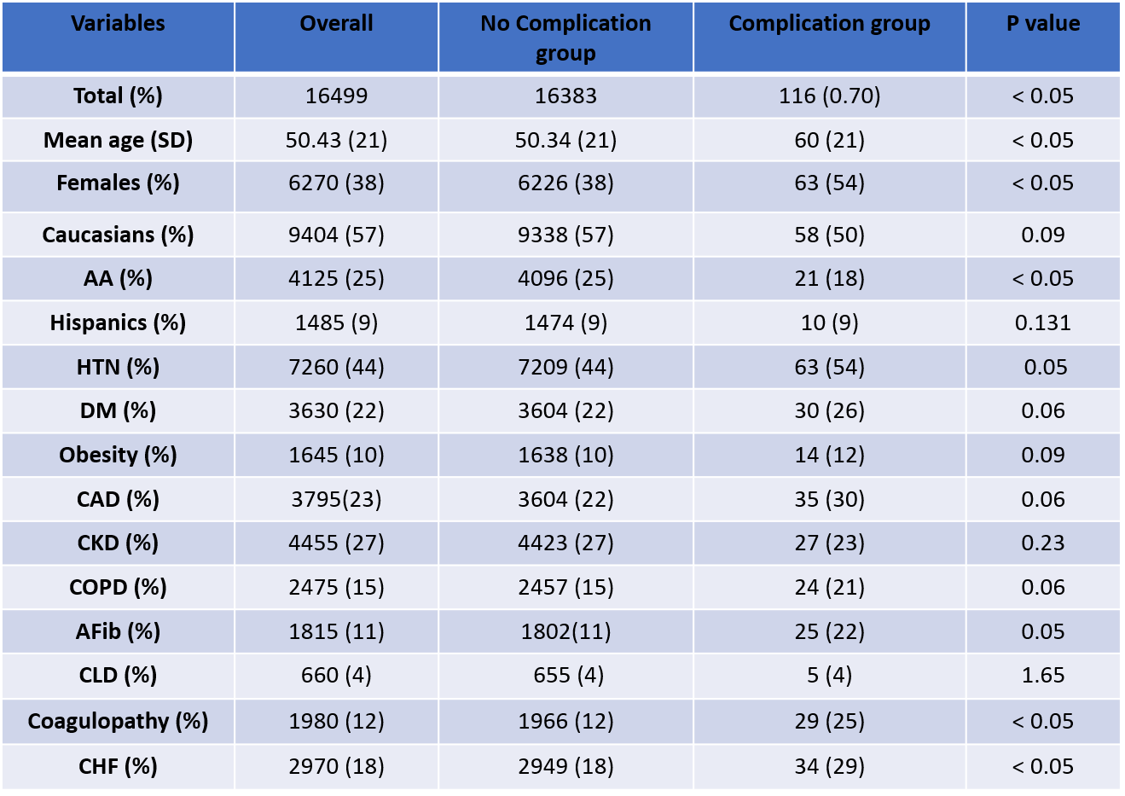

**Supplemental table-2: Baseline characters and comorbidities of cohort 1**