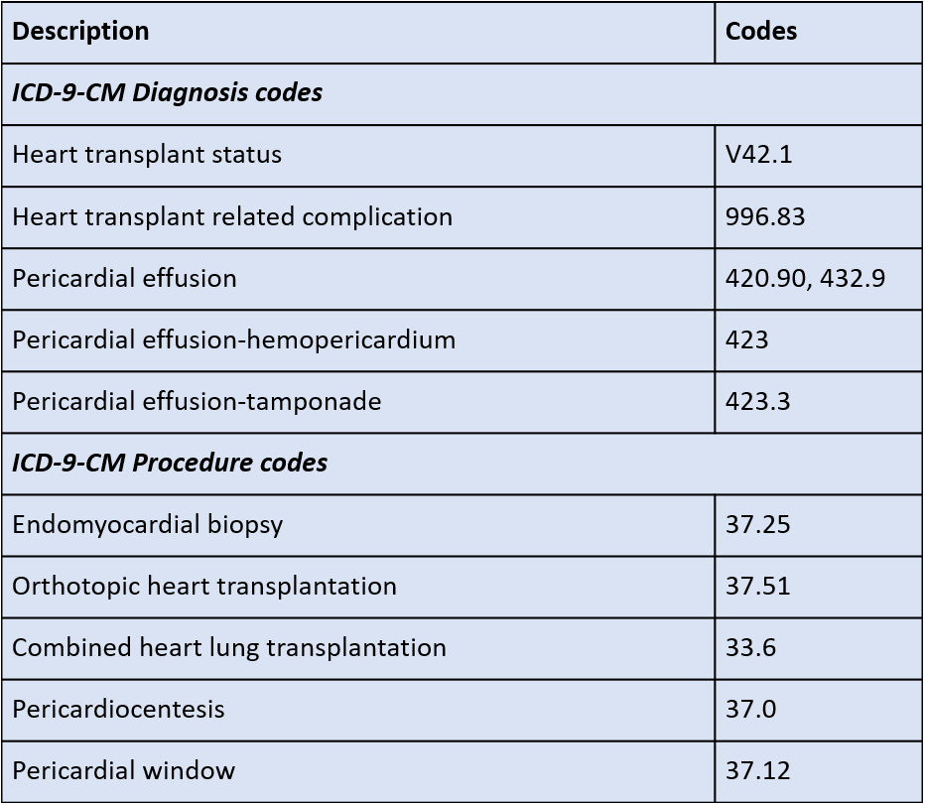

**Supplemental table 1: International Classification of Diseases, Ninth Revision,**

**Clinical Modification [ICD-9-CM] codes**