SUPPLEMENT
Platelet dense granules worsen pre-infection thrombocytopenia during gram negative pneumonia derived sepsis

Running head: Platelet dense granules in pneumonia and sepsis

Theodora A.M. Claushuis, M.D.¹, Alex F. de Vos, PhD*, Joris J.T.H. Roelofs, M.D., PhD², Onno J. de Boer, PhD², Cornelis van ’t Veer, PhD¹ and Tom van der Poll, M.D., PhD^{1,3}
¹Center for Experimental and Molecular Medicine, Academic Medical Center, University of Amsterdam, Amsterdam, the Netherlands; ²Department of Pathology, Academic Medical Center, Amsterdam, The Netherlands; ³Division of Infectious Diseases, Academic Medical Center, University of Amsterdam, Amsterdam, the Netherlands.

Supplemental Figures
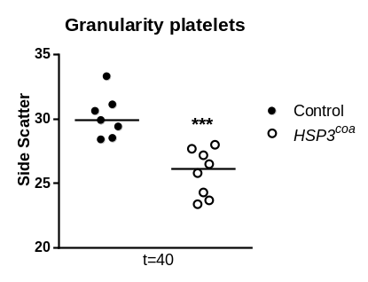

Figure S1: Platelets of Hps3^{coa} mice show reduced granularity during pneumosepsis
Control or Hps3^{coa} mice were infected with K. pneumoniae via the airways and sacrificed 40 hours after infection. Platelet side scatter. Data are represented as scatter dot plots, lines show median. N=8 mice per group. ***P<0.0005, vs. controls.

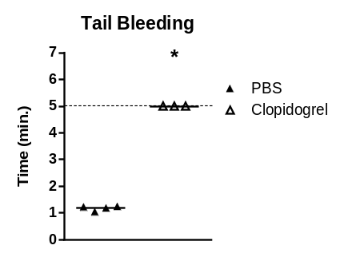

Figure S2 Clopidogrel prolongs bleeding time.
C57BL6/J were treated with clopidrogel or PBS control once daily for 3 days. Data are represented scatter dot plots of 4 mice per group. Lines show median. *P<0.05 vs. controls

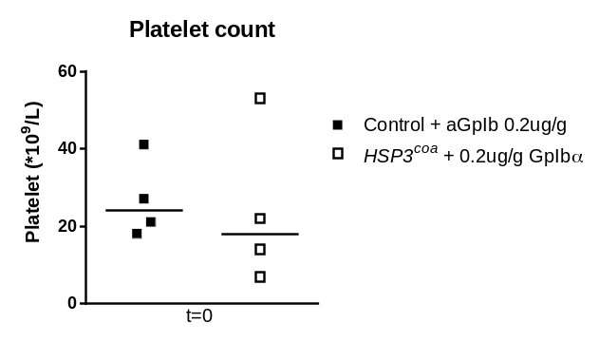

Figure S3: Anti-GPIbα injection induces similar thrombocytopenia in control or Hps3^{coa} mice directly prior to infection
Control or Hps3^{coa} mice were injected with anti-GPIbα antibody to deplete platelet counts to ~10% and sacrificed 2 hours later (i.e., at the time point mice were infected in other experiments). Data are represented scatter dot plots of 4 mice per group. Lines show median.

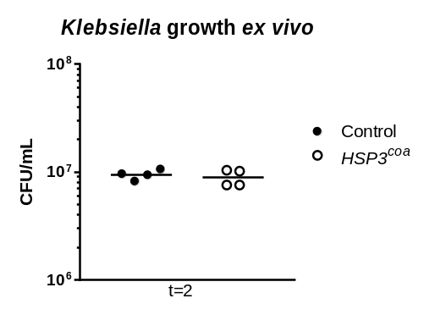

Figure S4: Platelet δ granules do not influence Klebsiella growth in blood ex vivo
Control or Hps3^{coa} mice were sacrificed uninfected and whole blood was incubated with viable Klebsiella (10⁴ CFU). Bacterial growth was assessed after 2 hours. Data are represented scatter dot plots of 4 mice per group. Lines show median.

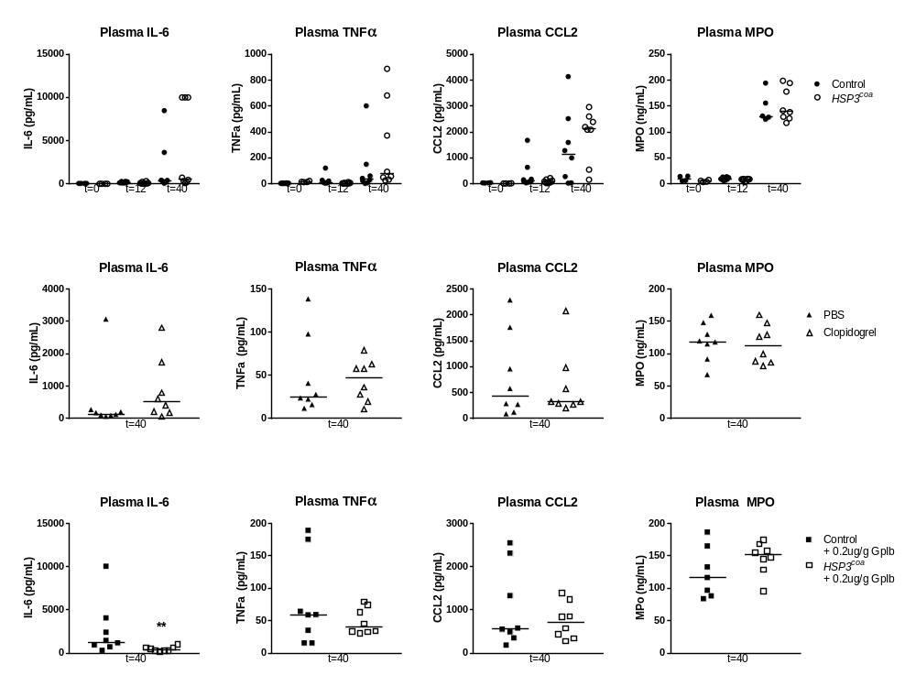
A
C
D
B
E
G
F
I
K
J

H

L

Figure S5: Plasma cytokine levels
(A-D) Control or Hps3^{coa} mice were infected with K. pneumoniae via the airways and sacrificed 12 or 40 hours after infection. Plasma (A) IL-6 (B) TNF-α, (C) CCL2, (D) MPO levels. (E-H) Mice treated with PBS or clopidrogel were infected with K. pneumoniae via the airways and sacrificed 40 hours after infection. Plasma (E) IL-6 (F) TNF-α, (G) CCL2, (H) MPO levels. (I-L) Control or Hps3^{coa} mice were injected with a-GPIBα antibody to deplete platelet counts to ~10%, infected with K. pneumoniae via the airways and sacrificed 40 hours after infection. Plasma (I) IL-6 (J) TNF-α, (K) CCL2, (L) MPO levels. Data are represented as scatter dot plots of 8 mice per group, lines show median. **P<0.005, vs. controls.

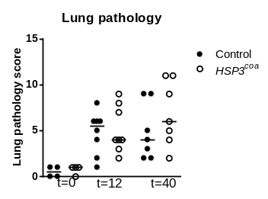
A
B
D
F
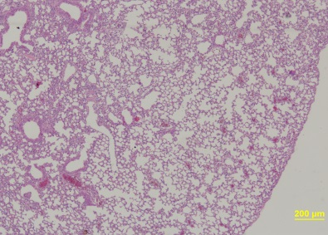
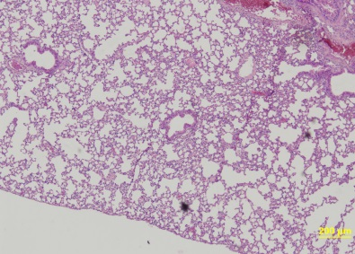
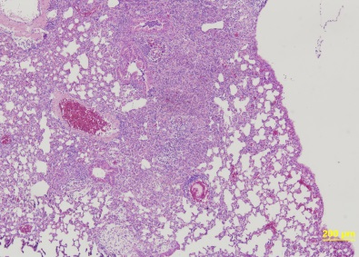
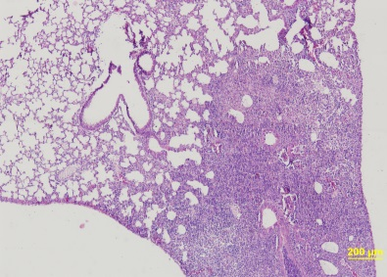
Control, uninfected
HSP3^{coa}, uninfected
Control, t=40 Klebsiella
HSP3^{coa}, t=40 Klebsiella

C
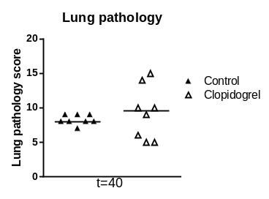
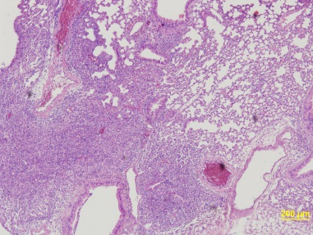
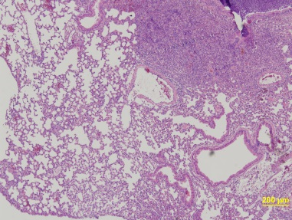
Control, t=40 Klebsiella
Clopidrogel, t=40 Klebsiella

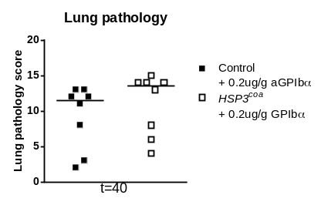
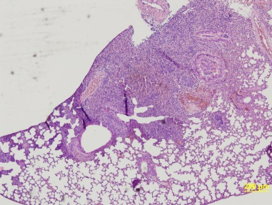
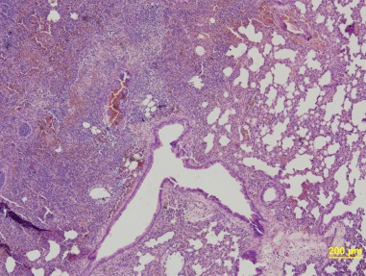
Control +aGpIb, t=40 Klebsiella
HSP3^{coa} +aGpIb, t=40 Klebsiella
E

Figure S6: Lung pathology
(A-B) Control or Hps3^{coa} mice were infected with K. pneumoniae via the airways and sacrificed 12 or 40 hours after infection. (A) Lung pathology score. (B) Representative pictures (original magnification 40x). (C-D) Mice treated with PBS or clopidrogel were infected with K. pneumoniae via the airways and sacrificed 40 hours after infection. (C) Lung pathology score. (D) Representative pictures (original magnification 40x). (E-F) Control or Hps3^{coa} mice were injected with a-GPIBα antibody to deplete platelet counts to ~10% and infected with K. pneumoniae via the airways and sacrificed 40 hours after infection. (E) Lung pathology score. (F) Representative pictures (original magnification 40x). Data are represented scatter dot plots of 8 mice per group. Line shows median.

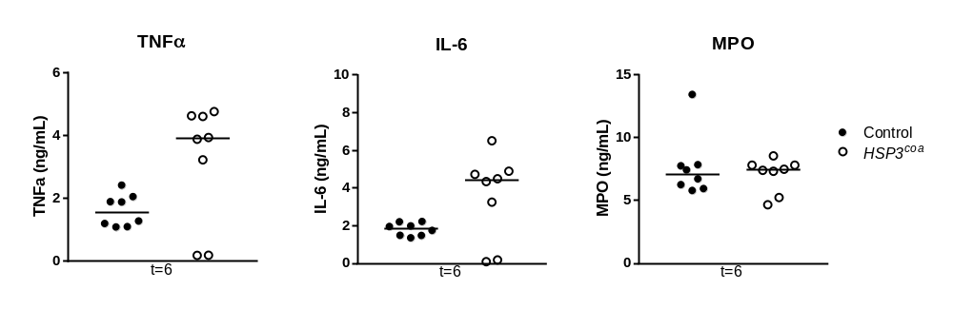
A B C

Figure S7: Plasma IL-6, TNFα and MPO levels after stimulation of whole blood with Klebsiella
(A-C) Control or Hps3^{coa} mice were sacrificed uninfected and whole blood was stimulated with UV-radiated K. pneumoniae, for 6 hours at 37 degrees. Plasma (A) IL-6 (B) TNF-α, (C) MPO. Data are represented as scatter dot plots of 4 mice per group. Lines show median.

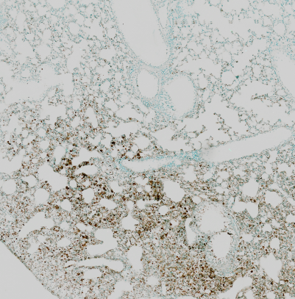
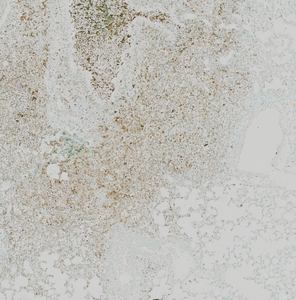
A
B
C
D
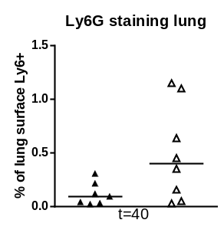

T=40 Control
T=40 Clopidrogel
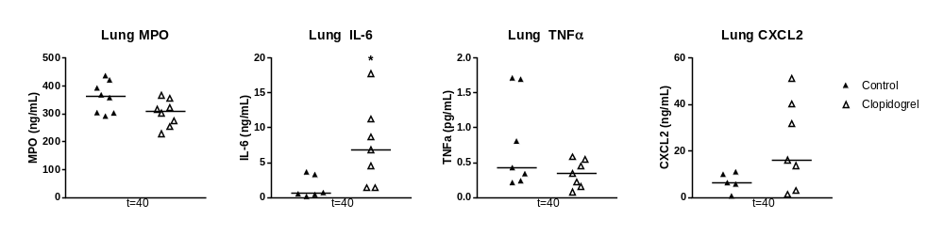
E
F

Figure S8: Neutrophil recruitment and lung cytokine levels in control or clopidrogel treated mice.
Mice treated with PBS or clopidrogel were infected with K. pneumoniae via the airways and sacrificed 40 hours after infection. (A) Ly6G staining lung sections. (B) Representative photos (original magnification 10x). Lung MPO (C) IL-6 (D), TNFα (E) and CXCL2 (F) levels. Data are represented as scatter dot plots of 8 mice per group, lines show median. *P<0.05, vs. controls.

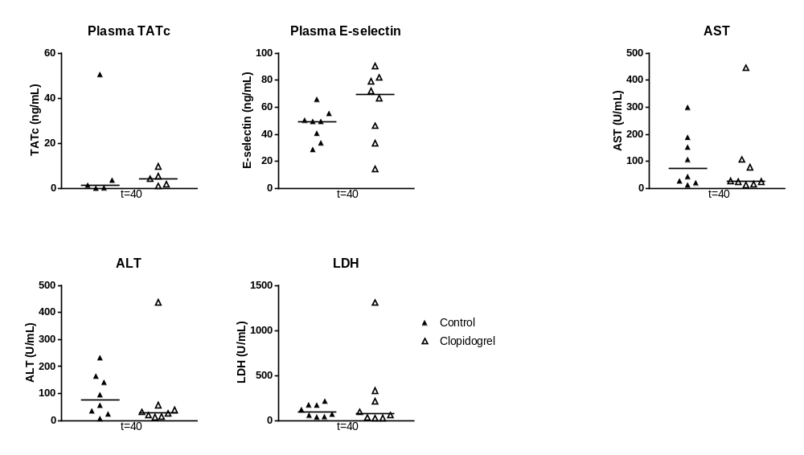
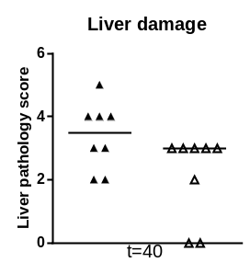
A
C
D
B

E

F

Figure S9: Coagulation, endothelial cell activation and distant organ damage in clopidogrel treated mice.
Mice treated with PBS or clopidrogel were infected with K. pneumoniae via the airways and sacrificed 40 hours after infection. Plasma TATc (A) and E-selectin (B) levels. (C) Pathology score liver. Plasma (D) AST (E) ALT and (F) LDH levels. Data are represented as scatter dot plots of 8 mice per group. Lines show median. Differences between groups were not significant.

