Supplementary Table 1. The Frailty Phenotype Assessment.
Frailty Criteria | Measure
Unintentional Weight Loss | ≥10 pounds or ≥5% body weight over the preceding 12 months.
Weakness | Hand grip strength frailty criterion cut offs:  Men  BMI ≤24: ≤29 kg  BMI 24.1-26: ≤30 kg  BMI 26.1-28: ≤30 kg  BMI >28: ≤32 kg | Women  BMI ≤23: ≤17 kg  BMI 23.1-26: ≤17.3 kg  BMI 26.1-29: ≤18 kg  BMI >29: ≤21 kg
Self-perceived Exhaustion | Participants asked two statements from the Center for Epidemiological Studies Depression Scale:  - I felt that everything I did was an effort.  - I could not get going.  Participants then asked:  ‘How often did you feel this?’ and provided the following scale:  0 = rarely or none of the time  1 = some of the time  2 = moderate amount of the time  3 = most of the time  Frailty criterion: answers ≥2
Slowness | Walking speed frailty criterion cut offs:  Men  Height ≤173 cm: ≥7 seconds (≤0.65 m/s)  Height >173 cm: ≥6 seconds (≤0.76 m/s) | Women  Height ≤159 cm: ≥7 seconds (≤0.65 m/s)  Height >159cm: ≥6 seconds (≤0.76 m/s)
Low Physical Activity | Modified version of the Minnesota Leisure Time Questionnaire used to assess energy expenditure per week. Frailty criterion: Men <383 Kcals/week, Women <270 Kcals/week.
Frailty diagnosed if 3 or more frailty criteria present. Pre-frailty, or intermediate frailty, defined as the presence of 1 or 2 frailty criteria.

Supplementary Table 2. The PRISMA-7 Questionnaire Frailty Screening Tool.
Question | Answer
1. Are you more than 85 years old? | Yes/No
2. Male? | Yes/No
3. In general, do you have any health problems that require you to limit your activities? | Yes/No
4. Do you need someone to help you on a regular basis? | Yes/No
5. In general, do you have any health problems that require you to stay at home? | Yes/No
6. In case of need, can you count on someone close to you? | Yes/No
7. Do you regularly use a cane, a walker or a wheelchair to move about? | Yes/No
Total Number of ‘Yes’ Answers:
Frail: ≥3 ‘Yes’ Answers

Supplementary Table 3. CKD Frailty Index.
CKD Frailty Index Variables and Corresponding Scoring
Depression (clinical diagnosis):  Yes= 1, No=0 | Gastrointestinal problems:  Yes= 1, No=0 | Problems bathing or dressing:  Yes= 1, No=0
Ischaemic heart disease:  Yes= 1, No=0 | Skin problems:  Yes= 1, No=0 | Self-rating of health:  Poor=1, Fair= 0.75, Good = 0.5, Very Good = 0.25, Excellent = 0
Arrhythmia:  Yes= 1, No=0 | Peripheral vascular disease:  Yes= 1, No=0 | Change in health in the last year:  Worse = 1, Better/Same = 0
Heart Failure:  Yes= 1, No=0 | History of seizures:  Yes= 1, No=0 | Health problems that require you to limit your activities:  Yes= 1, No=0
Hypertension:  Yes=1, No=0 | History of malignancy:  Yes= 1, No=0 | Health problems that require you to stay at home:  Yes= 1, No=0
Cerebrovascular disease:  Yes= 1, No=0 | Other medical problems:  Yes= 1, No=0 | Need someone to help you on a regular basis:  Yes= 1, No=0
Diabetes mellitus:  Yes= 1, No=0 | Falls last 6 months:  Yes=1, No= 0 | Require a walking aid:  Yes= 1, No=0
Chronic lung disease:  Yes=1, No=0 | Problems shopping:  Yes= 1, No=0 | Felt everything was an effort:  Moderate/most of time = 1, some of the time = 0.5, rarely = 0
Chronic Liver disease:  Yes=1, No=0 | Problems with stairs:  Yes=1, No=0 | Had trouble getting going:  Moderate/most of time = 1, some of the time = 0.5, rarely = 0
Thyroid disease:  Yes= 1, No=0 | Problems cooking:  Yes= 1, No=0 | Self-reported low mood (“down in the dumps”, “downhearted or blue”):  Good bit/most/all of time = 1, some/little of the time = 0.5, rarely = 0
Musculoskeletal problems:  Yes= 1, No=0 | Problems swallowing:  Yes= 1, No=0 | Weight loss in last 12 months (more than 4.5Kg or >5% of body weight):  Yes= 1 No= 0
CKD Frailty Index = Total Number of Deficits
33

Supplementary Table 4. CKD FI-LAB.
Variable | Lower Cut Off | Upper Cut Off
Systolic BP, mmHg | 90 | 140
Diastolic BP, mmHg | 60 | 90
Haemoglobin, g/L | 100 | 120*
MCV, fl | 82 | 98
White cell count, x 10⁹/L | 4.0 | 11.0
Platelet count, x 10⁹/L | 140 | 440
Ferritin, μg/L | 100** | 800
Transferrin saturation, % | 20 | 50
Sodium, mmol/L | 133 | 146
Potassium, mmol/L | 3.5 | 5.3
Bicarbonate, mmol/L | 22 | 29
CRP, mg/L | 0 | 5
Corrected calcium, mmol/L | 2.20 | 2.60
Phosphate, mmol/L | 0.80 | 1.50
Alkaline phosphatase, U/L | 30 | 130
Albumin, g/L | 35 | 50
Total Protein, g/L | 60 | 80
ALT, U/L | 0 | 41
Bilirubin, μmol/L | 0 | 21
Prothrombin Time, seconds | 9 | 12
Fibrinogen, g/L | 1.8 | 4.5
Folate, μg/L | 3.9 | 19.8
TSH, mU/L | 0.35 | 5.00
T4, pmol/L | 11.0 | 23.0
B12, ng/L | 200 | 900 ng/L
HbA1C, mmol/mol | 20 | 41
Vitamin D, nmol/L | 50 | 150
CKD FI-LAB = Total Number of Deficits
Total Number of Variables
Measured

BP, Blood Pressure; MCV, Mean Corpuscular Volume; CRP, C-Reactive Protein; ALT, Alanine Transaminase; TSH, Thyroid-Stimulating Hormone. *If on Erythropoietin Stimulating Agent. Otherwise, haemoglobin upper cut off 165 g/L for women and 180 g/L for men. **If haemoglobin less than 110 g/L and/or receiving Erythropoietin Stimulating Agent. Otherwise, ferritin lower cut off 20μg/L for men and 15μg/L for women.
Supplementary Table 5. Cross-tabulation of Frailty Screening Methods by Frailty Phenotype Frailty Diagnosis.
 | Frailty Phenotype |  | Total
 | Frail | Non-Frail
CFS ≥5  CFS ≥4  PRISMA-7 ≥3  CKD FI >0.21  CKD FI >0.32  WS: Frailty Phenotype Frail  WS: ≤0.8 m/s, or unable  HGS: Frailty Phenotype Frail  HGS: Men <30kg; Women <20kg  SPPB <10  SPPB <9 | 15  19  17  19  18  16  18  19  18  19  19 | 9  32  28  45  23  3  10  24  28  34  16 | 24  51  45  64  41  19  28  43  46  53  35
CFS <5  CFS <4  PRISMA-7 <3  CKD FI ≤0.21  CKD FI ≤0.32  WS: Frailty Phenotype Non-Frail  WS: >0.8 m/s  HGS: Frailty Phenotype Non-Frail  HGS: Men ≥30kg; Women ≥20kg  SPPB ≥10  SPPB ≥9 | 4  0  2  0  1  3  1  0  1  0  0 | 62  39  43  26  48  68  61  47  43  37  55 | 66  39  45  26  49  71  62  47  44  37  55
Total for Individual Frailty Screening Methods | 19 | 71 | 90

CFS, Clinical Frailty Scale; FI, Frailty Index; WS, Walking Speed; HGS, Hand Grip Strength; SPPB, Short Physical Performance Battery; m/s, metres/second; kg, kilograms.

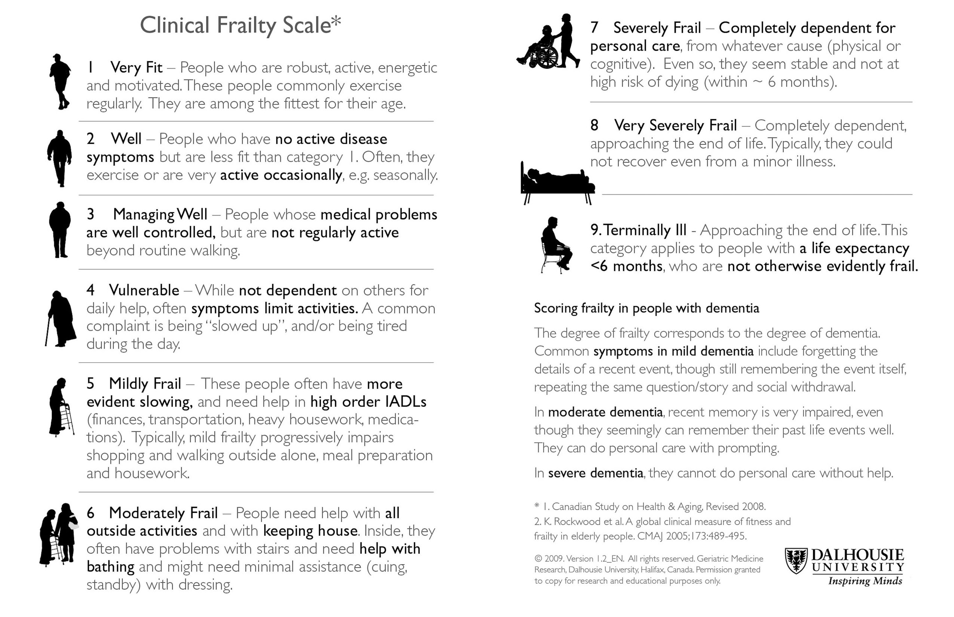
Supplementary Figure 1. The Clinical Frailty Scale.
The 9-point Clinical Frailty Scale was adapted from the 7-point scale used in the Canadian Study of Health and Aging and has been reprinted with permission of Geriatric Medicine Research, Dalhousie University, Halifax, Nova Scotia, Canada.
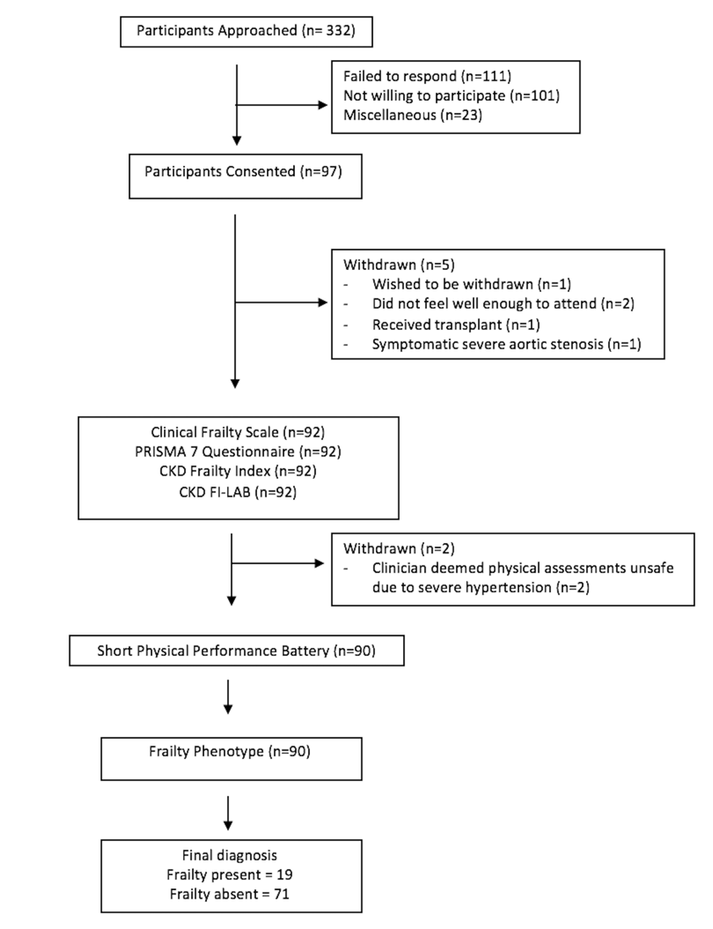
Supplementary Figure 2. Participant Flow Diagram.

