**Supplemental Files**

**Supplemental Table 1. Characteristics of the Study Patients According to Atherosclerotic Category.**

|  |  |  |  |  |
| --- | --- | --- | --- | --- |
|  | Atherosclerotic category | | |  |
|  | 1 | 2 | 3 | p valuec |
| n | 16 | 49 | 32 |  |
| Age *, years | 74.63±5.045 | 73.14±7.312 | 72.63±7.033 | 0.637 |
| Male sex, n(%) | 12(75) | 43(87.8) | 27(84.3) | 0.45 |
| Neurological symptoms within 120 days, n(%) | 2(12.5) | 29(59.2) | 9(28.1) | 0.001 |
| Diabetes mellitus, n(%) | 6(37.5) | 22(44.9) | 12(37.5) | 0.872 |
| Hypertension, n(%) | 12(75) | 36(73.5) | 23(71.9) | 0.972 |
| Dyslipidemia, n(%) | 10(62.5) | 39(79.6) | 17(53.1) | 0.039 |
| Prescription of statins, n(%) | 6(37.5) | 18(36.7) | 20(62.5) | 0.067 |
| Peripheral Artery Disease, n(%) | 1(6.3) | 4(8.2) | 3(9.4) | 1 |
| Ischemic Heart Disease, n(%) | 3(18.8) | 15(30.6) | 5(15.6) | 0.264 |
| Smoking, n(%) | 8(50) | 28(57.1) | 25(78.1) | 0.081 |
| Antiplatelet Agents, n(%) | 11(68.8) | 45(91.8) | 28(87.5) | 0.062 |
| NASCET†, % | 75 (62-87) | 68 (55-83) | 82 (70-95) | 0.006 |

*Mean±standard deviation (SD). †Median (interquartile range). NASCET: North American symptomatic carotid endarterectomy trial.

**Supplemental Table 2a. Characteristics of the Study Patients According to Neovascularization positive (NV)**

|  |  |  |  |
| --- | --- | --- | --- |
|  | NV positive | NV negative | p valuec |
| n | 53 | 44 |  |
| Age *, years | 72.1±7.0 | 74.6±6.5 | 0.077 |
| Male sex, n(%) | 48 (90.6%) | 34 (77.2%) | 0.093 |
| Neurological symptoms within 120 days, n(%) | 21 (39.6%) | 19 (43.1%) | 0.441 |
| Diabetes mellitus, n(%) | 25 (47.1%) | 17 (38.6%) | 0.42 |
| Hypertension, n(%) | 39 (73.6%) | 32 (72.7%) | 0.99 |
| Dyslipidemia, n(%) | 31 (58.5%) | 35 (79.5%) | 0.031 |
| Prescription of statins, n(%) | 22 (41.5%) | 31 (70.5%) | 0.007 |
| Peripheral Artery Disease, n(%) | 4 (7.5%) | 4 (9.1%) | 0.99 |
| Ischemic Heart Disease, n(%) | 11 (20.8%) | 12 (27.3%) | 0.48 |
| Smoking, n(%) | 37 (69.8%) | 24 (54.5%) | 0.14 |
| Antiplatelet Agents, n(%) | 47 (88.7%) | 37 (84.1%) | 0.56 |
| NASCET†, % | 73 (67-78) | 78 (60-85) | 0.21 |

**Supplemental Table 2b. Characteristics of the Study Patients According to Vascular scale at 1 minute.**

|  |  |  |  |  |
| --- | --- | --- | --- | --- |
|  | Vascular scale at 1 minute | | |  |
|  | 1 | 2 | 3 | p valuec |
| n | 44 | 15 | 38 |  |
| Age *, years | 74.6±6.5 | 72.8±8.0 | 71.8±6.7 | 0.19 |
| Male sex, n(%) | 34 (77.3%) | 12 (80.0%) | 36 (94.7%) | 0.055 |
| Neurological symptoms within 120 days, n(%) | 19 (43.2%) | 7 (46.7%) | 14 (36.8%) | 0.76 |
| Diabetes mellitus, n(%) | 17 (38.6%) | 7 (46.7%) | 18 (47.4%) | 0.76 |
| Hypertension, n(%) | 32 (72.7%) | 11 (73.3%) | 28 (73.7%) | 0.99 |
| Dyslipidemia, n(%) | 35 (79.5%) | 11 (73.3%) | 20 (52.6%) | 0.031 |
| Prescription of statins, n(%) | 31 (70.5%) | 9 (60.0%) | 13 (34.2%) | 0.004 |
| Peripheral Artery Disease, n(%) | 4 (9.1%) | 2 (13.3%) | 2 (5.3%) | 0.62 |
| Ischemic Heart Disease, n(%) | 12 (27.3%) | 2 (13.3%) | 9 (23.7%) | 0.59 |
| Smoking, n(%) | 24 (54.5%) | 9 (60.0%) | 28 (73.7%) | 0.19 |
| Antiplatelet Agents, n(%) | 37 (84.1%) | 14 (93.3%) | 33 (86.8%) | 0.73 |
| NASCET†, % | 78 (60-85) | 72 (70-88) | 83 (62-95) | 0.26 |

**Supplemental Table 2c. Characteristics of the Study Patients According to Vascular grade at 10 minutes.**

|  |  |  |  |  |
| --- | --- | --- | --- | --- |
|  | Vascular grade at 10 minutes | | |  |
|  | 1 | 2 | 3 | p valuec |
| n | 52 | 30 | 15 |  |
| Age *, years | 74.7±6.7 | 71.8±5.9 | 71.1±8.5 | 0.08 |
| Male sex, n(%) | 42 (80.8%) | 27 (90.0%) | 13 (86.7%) | 0.59 |
| Neurological symptoms within 120 days, n(%) | 23(44.2%) | 10 (33.3%) | 7 (46.7%) | 0.59 |
| Diabetes mellitus, n(%) | 22 (42.3%) | 12 (40.0%) | 8 (53.3%) | 0.73 |
| Hypertension, n(%) | 41 (78.8%) | 22 (73.3%) | 8 (53.3%) | 0.16 |
| Dyslipidemia, n(%) | 41 (78.8%) | 16 (53.3%) | 9 (60.0%) | 0.04 |
| Prescription of statins, n(%) | 34 (65.4%) | 13 (43.3%) | 6 (40.0%) | 0.078 |
| Peripheral Artery Disease, n(%) | 5 (9.6%) | 1 (3.3%) | 2 (13.3%) | 0.36 |
| Ischemic Heart Disease, n(%) | 13 (25.0%) | 8 (26.7%) | 2 (13.3%) | 0.68 |
| Smoking, n(%) | 29 (55.8%) | 22 (73.3%) | 10 (66.7%) | 0.26 |
| Antiplatelet Agents, n(%) | 43 (82.7%) | 28 (93.3%) | 13 (86.7%) | 0.43 |
| NASCET†, % | 77 (60-82) | 79 (60-91) | 92 (66-95) | 0.1 |

**Supplemental Figure 1.** Flow chart of patient selection

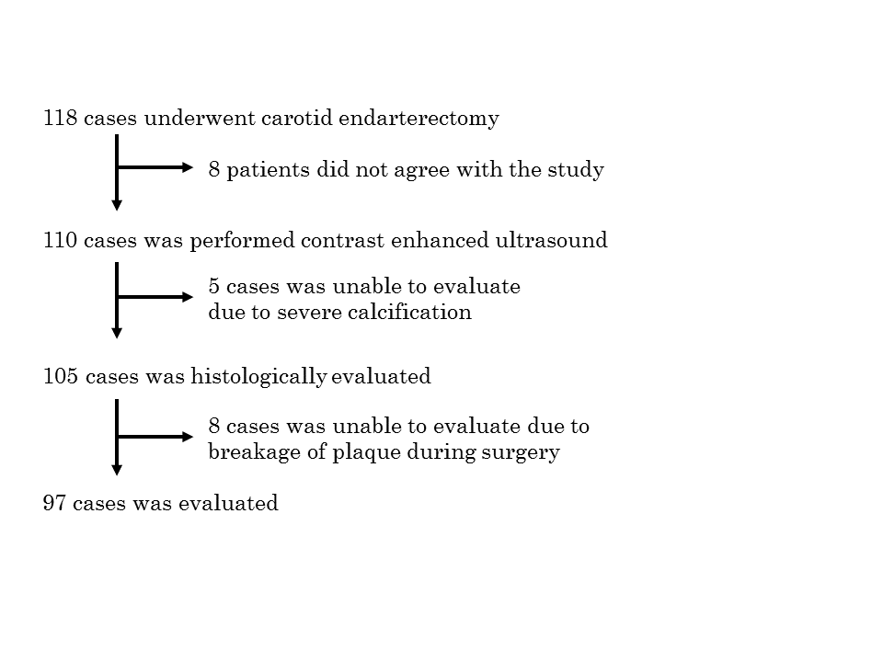

**Supplemental Figure 2.** Scattergram of atherosclerotic category (Ath-cat) and vascular scale (Vas-S) at 0 min (**A**), 1 min (**B**), 3 min (**C**), and 5 min (**D**).



**Supplemental Figure 2.** Scattergram of Ath-cat and vascular grade (Vas-G) at 0 min (**A**) and 10 min (**B**).

