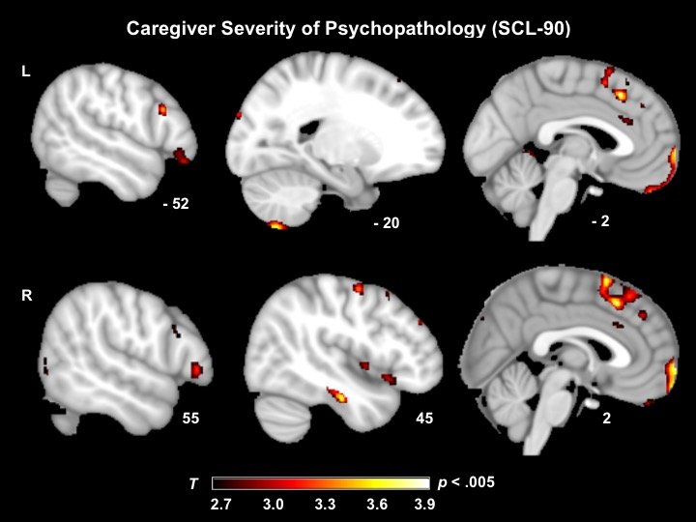

Figure S1. Neural correlates of caregiver severity of psychopathology.
T-score maps of brain areas for which smaller volumes in patient and healthy control brains was associated with greater severity of psychopathology symptoms in caregivers when controlling for caregiver/partner age, caregiver/partner sex, patient diagnosis, MMSE, CDR-Box, field strength, and total intracranial volume. Smaller volume in the medial prefrontal cortex, inferior frontal gyri, supplementary motor area, cerebellum, and right insula was associated with greater severity of caregiver psychopathology symptoms (Max T = 3.81; p < .005, uncorrected). Results for all analyses are overlaid on an MNI template brain.

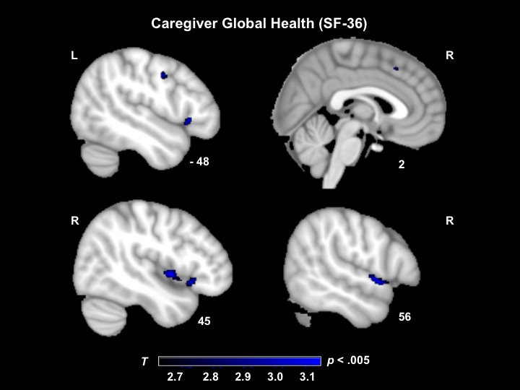

Figure S2. Neural correlates of caregiver global health.
T-score maps of brain areas for which volume loss in patient and healthy control brains was associated with poorer caregiver global health (physical and mental health outcomes) when controlling for caregiver/partner age, caregiver/partner sex, MMSE, CDR-Box, field strength, and total intracranial volume. Smaller volume in the right superior temporal gyrus, right superior temporal pole, right insula, superior medial frontal gyrus, and other regions was associated with poorer caregiver physical and mental health outcomes (Max T = 3.38; p < .005, uncorrected). Results for all analyses are overlaid on an MNI template brain.

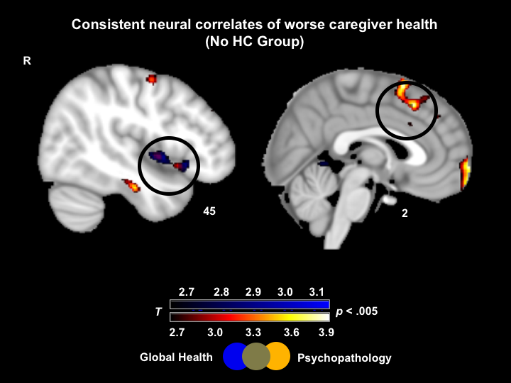

Figure S3. Consistent neural correlates of worse caregiver health (without HC group).
To ensure our results were not driven by differences between patients and healthy controls, we re-ran our VBM analyses with the same covariates and excluded the HC group. Here we show T-score maps of brain areas for which smaller volume in patient brains is associated with greater severity of caregiver psychopathology symptoms and worse caregiver global health (p < .005, uncorrected). T-score maps still overlap on the right ventral anterior insula and superior medial frontal gyrus. Results are overlaid on a MNI template brain.

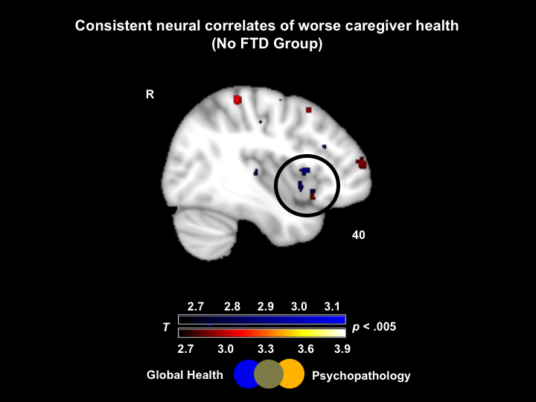
Figure S4. Consistent neural correlates of worse caregiver health (without FTD group).
To ensure our results were not driven by individuals with FTD, a group known to heavy fronto-insular damage, we re-ran our VBM analyses with the same covariates and excluded patients with FTD. Here we show T-score maps of brain areas for which smaller volume in patient and healthy control brains is associated with greater severity of caregiver psychopathology symptoms and worse caregiver global health (p < .005, uncorrected). T-score maps still overlap on the right ventral anterior insula. Results are overlaid on a MNI template brain.

