**Supplementary**

**Novel benzodiazepine-like ligands with various anxiolytic, antidepressant or pro-cognitive profiles**

Thomas D. Prevot1,2, Guanguan Li3, Aleksandra Vidojevic4, Keith A. Misquitta1,5, Corey Fee1,5 Anja Santrac4, Daniel E. Knutson3, Michael R. Stephen3, Revathi Kodali3, Nicolas M. Zahn3, Leggy A. Arnold3, Petra Scholze6, Janet L. Fisher7, Bojan D. Marković8, Mounira Banasr1,2,5, James M. Cook3, Miroslav Savic4* and Etienne Sibille1, 2,5*.

1Campbell FamilyMental Health Research Institute of CAMH, Toronto, Canada

2Department of Psychiatry, University of Toronto, Toronto, Canada

3Department of Chemistry and Biochemistry, University of Wisconsin–Milwaukee, Milwaukee, USA

4Department of Pharmacology, Faculty of Pharmacy, University of Belgrade, Belgrade, Serbia

5Department of Pharmacology and Toxicology, University of Toronto, Toronto, Canada

6Department of Pathobiology of the Nervous System, Center for Brain Research, Medical University of Vienna, Vienna, Austria

7Department of Pharmacology, Physiology and Neuroscience, University of South Carolina School of Medicine, Columbia South Carolina, USA

8Department of Pharmaceutical Pharmacy, Faculty of Pharmacy, University of Belgrade, Belgrade, Serbia

*Corresponding authors

Etienne Sibille, Ph.D., CAMH, 250 College street, room 134, Toronto, ON M5T 1R8, Canada

Tel: 416-535-8501, ext 36571; E-mail: [Etienne.sibille@camh.ca](mailto:Etienne.sibille@camh.ca)

Miroslav Savic, Ph.D. Faculty of Pharmacy, University of Belgrade, Vojvode Stepe 450, 11221 Belgrade. Tel: +3816427551447; E-mail: miroslav@pharmacy.bg.ac.rs

Contents

Supplementary Methods 4

Chemistry 4

Electrophysiological recordings 7

Binding studies 8

Animals 10

Pharmacokinetic characterization 11

Behavioral Assessment 13

Supplementary Tables 15

**Supplementary Table S1**: Statistical analysis for potentiation at α1/2/3/4/5/6, β1/3,γ/δ GABAA-receptors 15

**Supplementary Table S2:** Preferential potentiation at α5-GABAA-R 16

**Supplementary Table S3:** Statistical comparison between α1β**1**γ2 and α1β**3**γ2potentiation at 100nM and 1µM 17

**Supplementary Table S4:** Half-life and percentage of compound remaining after incubation with human or mouse liver microsomes 18

**Supplementary Table S5:** Electrophysiological records of the GL series for α1β3γ2 and α5β3γ2 GABAA receptor subtypes 19

**Supplementary Table S6:** Ki values for all three compounds at α1/2/3/5β3γ2 receptor 20

**Supplementary Table S7:** The approximated % of GABA potentiation and the values of electrophysiological potentiation obtained at α2β3γ2 and α3β3γ2 receptors (presented in **Figure 1**), for the estimated brain free concentrations of GL-II-73, GL-II-74 and GL-II-75, administered at the doses of 1 mg/kg and 10 mg/kg, 30 minutes after administration. 21

**Supplementary Table S8:** Statistical analysis for each behavioral test assessing emotionality in mice 22

**Supplementary Table S9:** Statistical analysis for the Y-maze alternation rate after acute administration in young mice (stressed and non-stressed) 23

**Supplementary Table S10:** Statistical analysis for the Y-maze alternation rate after acute administration in old mice 24

**Supplementary Table S11:** Statistical analysis for the Y-maze alternation rate after sub-chronic administration in young and old mice 25

Supplementary Figures 26

**Supplementary Figure S1.** General synthetic route to amides 26

**Supplementary Figure S2.** Concentration of GL-II-73, GL-II-74 and GL-II-75 in the brain of male C57BL/6 mice after administration of a compound at doses of 1, 5 or 10mg/kg 27

**Supplementary Figure S3.** Locomotor activity changes induced by DZP injection 28

**Supplementary Figure S4.** Locomotor activity changes induced by αPAM injection 29

**Supplementary Figure S5.** Effect of GL-II-73, GL-II-74, GL-II-75 and DZP on alternation rate in a Y-maze alternation task assessing working memory in non-stressed adult mice 30

**Supplementary Figure S6.** Scheme of repeated assessment of cognitive performances in the Y-Maze in function of stress exposure and α5-PAM administration 31

# Supplementary Methods

## Chemistry

Based on previous compounds (1) synthetized and screened which proved their potency at the α5-subtype of the Bz/GABAAA-ergic receptors, a new series of metabolically more stable compounds were prepared following the steps described below (2).

**(R)-8-Ethynyl-6-(2-fluorophenyl)-4-methyl-4*H*-benzo[*f*]imidazo[1,5-*a*][1,4]diazepine-3-carboxylic acid** SH-053-2'F-R-CH3-acid (**2**)

The ethyl ester SH-053-2'F-R-CH3 **1** (20.0 g, 51.6 mmol) was dissolved in DCM (200 mL) and EtOH (500 mL), after which solid NaOH (16.6 g, 413 mmol) was added to the solution. This reaction mixture was heated to 55 ˚C for 0.5 h and the EtOH was removed under reduced pressure. The remaining aq solution which remained was stirred at 0 ˚C for 10 min and then aq HCl (1M) was added dropwise to the solution until the pH was 5 (pH paper). A pale white precipitate which formed was left in the solution for 10 min and was then collected by filtration, and washed with cold water after which the aq layer was also allowed to stand at rt for 10 h to yield additional acid. The combined solids were dried in a vacuum oven at 80 ˚C for 7 h to get pure acid **2** as a white powder (18.4 g, 51.2 mmol, 99.2%): mp 196-198 °C; **[α]D25** = +4.00 (*c* 0.80, CHCl3); **1H NMR** (300 MHz, DMSO-*d6*): δ 8.42 (s, 1H), 7.94 (d, *J* = 8.2 Hz, 1H), 7.81 (d, *J* = 7.8 Hz, 1H), 7.65 – 7.49 (m, 2H), 7.32 (t, *J* = 7.3 Hz, 1H), 7.22 (t*, J* = 8.8 Hz, 2H), 6.51 (q, *J* = 6.7 Hz, 1H), 4.37 (s, 1H), 1.14 (d, *J* = 6.8 Hz, 3H); **13C NMR** (75 MHz, DMSO-*d6*): δ 165.03 (s), 162.63 (s), 159.82 (d, *J* = 248.4 Hz), 140.49 (s), 136.40 (s), 135.52 (s), 134.78 (d, *J* = 1.0 Hz), 133.18 (s), 133.14 (s), 132.59 (d, *J* = 5.8 Hz), 131.88 (s), 129.35 (s), 128.95 (d, *J* = 12.6 Hz), 125.15 (d, *J* = 1.8 Hz), 123.97 (s), 121.05 (s), 116.37 (d, *J* = 20.9 Hz), 83.37 (s), 82.01 (s), 49.74 (s), 15.10 (s); **HRMS** (ESI/IT-TOF) *m/z*: [M + H]+ Calcd for C21H15FN3O2 360.1143; found 360.1140.

**General procedure for amides**

A mixture of the acid SH-053-2'F-R-CH3-acid **2** (2 g, 5.56 mmol), thionyl chloride (55.6 mmol) and dry DCM (50 mL) was placed in an oven dried round bottom flask under argon. This suspension was allowed to reflux at 60 ˚C for 2 h under argon. The absence of the starting material was confirmed by TLC (silica gel). The organic solvent and excess thionyl chloride were evaporated under reduced pressure, which was repeated 5 times with dry DCM (20 mL). The yellow residue, which was obtained, was dissolved in dry DCM (50 mL) and cooled to 0 ˚C for 10 min under argon. Then the appropriate amine was added (11.12 mmol), followed by administration of Et3N (5.56 mmol) to the reaction mixture at 0˚C and the mixture was then allowed to warm to rt and stirred for 2-7 h depending on the amine. After the completion of the reaction the solvent was removed under reduced pressure. The residue was treated with ice cold water and extracted with DCM (3 X 50 mL). The combined organic layer was washed with brine (20 mL). The solvent was removed under reduced pressure and the residue was purified by column chromatography on silica gel to yield the corresponding pure amides.

**(R)-8-Ethynyl-6-(2-fluorophenyl)-N,N,4-trimethyl-4*H*-benzo[*f*]imidazo[1,5-*a*][1,4]diazepine-3-carboxam** GL-II-73 (**3a**)

The amide **3a** was prepared from **2** following the general procedure with dry dimethylamine as the nucleophile. The crude residue was purified by column chromatography (silica gel, EtOAc and 1% MeOH) to yield pure dimethyl amide **3a** as a light yellow powder (1.5 g, 3.9 mmol, 70%): mp 189-190 °C; **[α]D25** = +40.98 (*c* 0.61, CHCl3); **1H NMR** (300 MHz, CDCl3): δ 7.92 (s, 1H), 7.68 (d, *J* = 8.0 Hz, 1H), 7.59 (t, *J* = 7.3 Hz, 1H), 7.49 (d, *J* = 8.2 Hz, 1H), 7.45 – 7.35 (m, 2H), 7.21 (t, *J* = 7.5 Hz, 1H), 6.99 (t, *J* = 9.3 Hz, 1H), 4.28 (q, *J* = 6.0 Hz, 1H), 3.14 (s, 1H), 3.09 (s, 3H), 2.96 (s, 3H), 1.89 (d, *J* = 6.6 Hz, 3H); **13C NMR** (75 MHz, CDCl3) δ 166.10 (s), 162.69 (s), 160.19 (d, *J* = 250.4 Hz), 135.34 (s), 134.62 (d, *J* = 9.0 Hz), 133.90 (s), 133.71 (s), 132.94 (d, *J* = 8.4 Hz), 132.47 (s), 132.12 (d, *J* = 9.1 Hz), 131.29 (s), 129.18 (s), 127.57 (d, *J* = 11.6 Hz), 124.51 (d, *J* = 2.2 Hz), 122.87 (s), 121.52 (s), 116.17 (d, *J* = 21.3 Hz), 81.52 (s), 79.63 (s), 52.13 (s), 39.09 (s), 35.04 (s), 18.37 (s); **HRMS** (ESI/IT-TOF) *m/z*: [M + H]+ Calcd for C23H20FN4O 387.1616; found 387.1626.

**(R)-N-Ethyl-8-ethynyl-6-(2-fluorophenyl)-4-methyl-4*H*-benzo[*f*]imidazo[1,5-*a*][1,4]diazepine-3-carboxamide** GL-II-74 (**3b**)

The amide **3b** was prepared from **2** following the general procedure with dry ethylamine as the nucleophile. The crude residue was purified by column chromatography (silica gel, 3:2 EtOAc and hexane) to yield pure ethyl amide **3b** as a white powder (1.6 g, 4.3 mmol, 78%): mp 215-216 °C; **[α]D25** = +44.07 (*c* 0.59, CHCl3); **1H NMR** (300 MHz, CDCl3): δ 7.83 (s, 1H), 7.65 (dd, *J* = 16.8, 7.8 Hz, 2H), 7.53 (d, *J* = 8.3 Hz, 1H), 7.47 – 7.39 (m, 2H), 7.24 (t, *J* = 7.5 Hz, 1H), 7.17 (s, 1H), 7.01 (t, *J* = 9.3 Hz, 1H), 6.90 (q, *J* = 6.3 Hz, 1H), 3.61 – 3.34 (m, 2H), 3.15 (s, 1H), 1.26 (d, *J* = 9.0 Hz, 3H), 1.22 (t, *J* = 7.3 Hz, 3H); **13C NMR** (75 MHz, CDCl3) δ 162.81 (s), 162.51 (s), 160.13 (d, *J* = 250.7 Hz), 138.81 (s), 134.96 (s), 134.71 (s), 133.90 (s), 133.37 (s), 131.84 (s), 131.76 (s), 131.37 (s), 129.78 (s), 128.86 (d, *J* = 10.6 Hz), 124.44 (d, *J* = 3.4 Hz), 122.04 (s), 121.38 (s), 116.06 (d, *J* = 21.5 Hz), 81.55 (s), 79.52 (s), 49.89 (s), 33.70 (s), 15.02 (s), 15.01(s); **HRMS** (ESI/IT-TOF) *m/z*: [M + H]+ Calcd for C23H20FN4O 387.1616; found 387.1618.

**(R)-N-Cyclopropyl-8-ethynyl-6-(2-fluorophenyl)-4-methyl-4*H*-benzo[*f*]imidazo[1,5-*a*][1,4]diazepine-3-carboxamide** GL-II-75 (**3c**)

The amide **3c** was prepared from **2** following the general procedure with dry cyclopropylamine as the nucleophile. The crude residue was purified by a column chromatography (silica gel, 1:1 EtOAc and hexane) to yield pure cyclopropyl amide **3c** as a white powder (1.8 g, 4.5 mmol, 82%): mp 231-232 °C; **[α]D25** = +3.81 (*c* 0.46, CHCl3); **1H NMR** (300 MHz, CDCl3): δ 7.80 (s, 1H), 7.64 (dd, *J* = 15.9, 7.6 Hz, 2H), 7.52 (d, *J* = 8.3 Hz, 1H), 7.47 – 7.37 (m, 2H), 7.30 – 7.19 (m, 2H), 7.01 (t, *J* = 9.3 Hz, 1H), 6.89 (q, J = 7.0 Hz, 1H), 3.15 (s, 1H), 2.93 – 2.67 (m, 1H), 1.26 (d, *J* = 6.8 Hz, 3H), 0.87 – 0.76 (m, 2H), 0.65 – 0.51 (m, 2H); **13C NMR** (75 MHz, CDCl3) δ 164.02 (s), 162.82 (s), 160.13 (d, *J* = 249.9 Hz), 138.91 (s), 134.97 (s), 134.65 (s), 133.89 (s), 133.37 (s), 131.80 (d, *J* = 9.0 Hz), 131.58 (s), 131.36 (s), 129.78 (s), 128.81 (d, *J* = 14.6 Hz), 124.45 (d, *J* = 3.4 Hz), 122.04 (s), 121.42 (s), 116.06 (d, *J* = 21.5 Hz), 81.53 (s), 79.55 (s), 49.88 (s), 22.10 (s), 14.99 (s), 6.54 (s), 6.50 (s); **HRMS** (ESI/IT-TOF) *m/z*: [M + H]+ Calcd for C24H20FN4O 399.1616; found 399.1621.

**(R)-(8-Ethynyl-6-(2-fluorophenyl)-4-methyl-4*H*-benzo[*f*]imidazo[1,5-*a*][1,4]diazepin-3-yl)(pyrrolidin-1-yl)methanone** GL-II-76 (**3d**)

The amide **3d** was prepared from **2** following the general procedure with dry pyrrolidine as the nucleophile. The crude residue was purified by column chromatography (silica gel, 6:4 EtOAc and hexane) to yield a mixture of rotamers **3d** as a white powder (3:2 ratio by 1H NMR, 1.8 g, 4.4 mmol, 80%): mp 173-174 °C; **[α]D25** = -23.91 (*c* 0.70, CHCl3); **1H NMR** **Major rotamer** (300 MHz, CDCl3): δ 7.90 (s, 1H), 7.73 – 7.58 (m, 2H), 7.51 (t, *J* = 9.0 Hz, 1H), 7.47 – 7.35 (m, 2H), 7.23 (t, *J* = 7.5 Hz, 1H), 7.01 (t, *J* = 9.3 Hz, 1H), 4.31 (q, *J* = 6.1 Hz, 1H), 3.66 – 3.56 (m, 4H), 3.14 (s, 1H), 1.95 (d, *J* = 6.4 Hz, 3H), 1.93 – 1.69 (m, 4H); **1H NMR** **Minor rotamer** (300 MHz, CDCl3): δ 7.85 (s, 1H), 7.74 – 7.57 (m, 2H), 7.51 (t, *J* = 9.0 Hz, 1H), 7.47 – 7.35 (m, 2H), 7.23 (t, *J* = 7.5 Hz, 1H), 7.01 (t, *J* = 9.3 Hz, 1H), 6.49 (q, *J* = 6.6 Hz, 1H), 3.82 (dd, *J* = 58.0, 32.3 Hz, 4H), 3.46 (d, *J* = 26.4 Hz, 4H), 3.14 (s, 1H), 1.28 (d, *J* = 6.4 Hz, 3H); **HRMS** (ESI/IT-TOF) *m/z*: [M + H]+ Calcd for C25H22FN4O 413.1772; found 413.1772.

## Electrophysiological recordings

Electrophysiological recordings were performed following the methods described in Alexeev et al (3)(2)(2)(2). Full-length cDNAs for GABAA receptor subtypes (generously provided by Dr. Robert Macdonald, Vanderbilt University and Dr. David Weiss, University of Texas Health Science Center, San Antonio, TX) in mammalian expression vectors were transiently transfected into the HEK-293T cell line (GenHunter, Nashville, TN). All subtypes were rat clones except for α2, which was a human clone. Cells were transiently transfected using calcium phosphate precipitation. Plasmids encoding GABAA receptor subtype cDNAs were added to the cells in 1:1:1 ratios (α:β:γ) of 2 μg each (4)(3)(3)(3). Cells were patch-clamped at −50 mV in the whole-cell recording configuration. GABA was diluted into the bath solution from freshly made or frozen stocks in water. Compounds were dissolved in DMSO and diluted into the bath solution with the highest DMSO level applied to cells of 0.01%. Solutions containing GABA or GABA + compounds were applied to cells for 5s using a 3-barrelled solution delivery device controlled by a computer-driven stepper motor (SF-77B, Harvard Apparatus, Holliston, MA, open tip exchange time of <50ms). There was a continuous flow of external solution through the chamber. Currents were recorded with an Axon 200B (Foster City, CA) patch clamp amplifier. Whole-cell currents were analyzed using the programs Clampfit (pClamp9 suite, Axon Instruments, Foster City, CA) and Prism (Graphpad, San Diego, CA). Concentration−response data was fit with a four-parameter logistic equation $current=\frac{minimum current+(maximum current-minimum current)}{1+(10\left(logEC50-\log\left(modulator\right)\right)n)}$ where n represents the Hill number. All fits were made to normalized data with current expressed as a percentage of the response to GABA alone for each cell.

## Binding studies

Binding studies were performed on HEK-293 cells following the methods described in (5)Human embryonic kidney (HEK) 293 cells (AmericanType Culture Collection ATCCs CRL-1574™) were maintained in Dulbecco's modified Eagle medium (DMEM, high glucose, GlutaMAX™ supplement, Gibco61965-059, ThermoFisher, Waltham, Massachusetts, USA) supplemented with 10% fetal calf serum (Sigma-AldrichF7524, St. Louis, Missouri, USA), 100U/ml Penicillin-Streptomycin (Gibco 15140-122, ThermoFisher, Waltham, Massachusetts, USA) and MEM (Non-Essential Amino Acids Gibco 11140-035, ThermoFisher, Waltham, Massachusetts, USA) on 10cm Cell culture dishes (Cell+, Sarstedt, Nürnbrecht, Germany) at 37 °C and 5% CO2. HEK293 cells were transfected with cDNAs encoding rat GABAA-receptor subunits subcloned into pCI expression vectors. The ratio of plasmids used for transfection with the calcium phosphate precipitation method (Chen and Okayama,1987) were 3 mg α(1,2,3or5): 3 mg β3 and 15 mg γ2 per 10cm dish. Medium was changed 4–6 h after transfection. Cells were harvested 72 days after transfection by scraping into phosphate buffered saline. After centrifugation (10 min,12000 g, 4°C) cells were resuspended in TC50 (50 mM Tris-CitratepH¼7.1), homogenized with an Ultra-Turraxs (IKA, Staufen, Germany) and centrifuged (20 min,50000 g). Membranes were washed three times in TC50 as described above and frozen at -20°C until use. Frozen membranes were thawed, re-suspended in TC50 and incubated for 90 min at 4°C in a total of 500 ml of a solution containing 50 mM Tris/citrate buffer, pH=7.1, 150 mM NaCl and 2 nM [3H]-Flunitrazepam (Perkin Elmer New England Nuclear, Waltham, Massachusetts, USA) in the absence or presence of either 5 mM diazepam (Nycomed, Opfikon, Switzerland) (to determine unspecific binding) or various concentrations of receptor ligands (dissolved in DMSO, final DMSO- concentration 0.5%). Membranes were filtered through Whatman GF/B filters and the filters were rinsed twice with 4ml of ice-cold 50 mM Tris/citrate buffer. Filters were transferred to scintillation vials and subjected to scintillation counting after the addition of 3 ml Rotiszint Eco plus liquid scintillation cocktail. Non-specific binding determined in the presence of 5mM Diazepam was subtracted from total [3H]-Flunitrazepam binding to result in specific binding. In order to determine the equilibrium binding constant KD of 3H-Flunitrazepam for the various receptor-subtypes, membranes were incubated with various concentrations of 3H-Flunitrazepam in the absence or presence of 5 mM Diazepam. Saturation binding experiments were analyzed using the equation Y=Bmax*X/(KD+X). Non-linear regression analysis of the displacement curves used the equation: log(inhibitor) vs. response-variable slope with Top=100% and Bottom=0% Y=100/(1+10^((logIC50-x)*Hill-slope)). Both analyses were performed using GraphPad Prism (LaJolla California USA). Drug concentrations resulting in half maximal inhibition of specific 3H-Flunitrazepam binding (IC50) were converted to Ki values by using the Cheng-Prusoff relationship (Cheng andPrusoff, 1973) Ki=IC50/(1+(S/KD)) with S being the concentration of the radioligand (2 nM) and the KD values listed in **Supplementary Table 6**.

## Animals

Young (2-3 months) or old (21-22 months) C57BL/6 mice were were obtained from Jackson Laboratories (US), or the Military Medical Academy (Serbia) and kept in normal housing conditions (21±2°C, relative humidity 40-45%) with a 12hr light-dark cycle (7am ON), water and food *ad libitum*. Prior to behavioral assessment, animals were handled daily for 5 min, over 5 consecutive days, to reduce acute anxiety-like responses (6). Testing took place during the light phase, and was conducted in accordance with the Canadian or U.S. institutional animal care committee and the Ethical Commission on Animal Experimentation of the Faculty of Pharmacy in Belgrade (carried out in accordance with the EEC Directive 86/609).

#### Compound preparation and administration

For pharmacokinetic assays and behavioral testing, compounds were diluted in a vehicle solution containing 85% distilled H2O, 14% propylene glycol (Sigma Aldrich) and 1% Tween 80 (Sigma Aldrich) to be administered intraperitoneally (i.p.) at a volume of 10 ml/kg. Working solutions were prepared at 1, 5 or 10 mg/kg and adjusted to body weight before injection. DZP was used as a non-selective GABAA-R PAM with known anxiolytic and no cognitive efficacies. DZP was administered i.p. at 1.5 mg/kg in a 10ml/kg volume, based on previous studies.

For sub-chronic administration in the drinking water for 10 consecutive days, compounds were diluted in tap-water at 30mg/kg, stirred over night at room temperature and given to the animals in glass bottles. Bottles were changed every other day to provide freshly prepared solutions.

## Pharmacokinetic characterization

#### Metabolic stability assessment

The method used was previously described in (7). The test compounds were incubated at 10µM with active or heat-inactivated human liver microsomes and cofactors. Aliquots were removed at 0, 10, 20, 30, 40, 50, 60 and 120 min and mixed with acetonitrile containing internal standard for analysis. Samples were extracted and assayed using a liquid chromatography/tandem mass spectrometry (LC-MS/MS) analytical method. On the day of the experiment, the test compounds, prepared in DMSO, were diluted in the 100mM phosphate buffer (pH=7.4) to achieve appropriate final concentrations. The test compounds were incubated with human or mouse liver microsomes (0.5mg protein/mL; BD Gentest and Life Technologies) and appropriate cofactors (2.5mM NADPH and 3.3 nM magnesium chloride) in 100mM phosphate buffer, pH 7.4 (0.1% final DMSO), in a 37°C water bath. At selected time points, a single 100µL aliquot was removed from each sample and mixed with 200µL of chilled acetonitrile containing internal standard. Following brief vortexing and centrifugation, the samples were further diluted for subsequent LC-MS/MS analysis, in triplicate. Experimental controls consisted of: (a) incubation of all components except test compound for 0 and 60 min, (b) incubation of Verapamil (positive control) at 10 lM for 0, 10, 20, 30, 40, 50, 60 and 120 min, and (c) incubation of 1 and 10 µM test compound and 10 µM Verapamil with heat-inactivated microsomes (0.5 mg protein/mL) for 0 and 60 min. Samples were analyzed by LC–MS/MS in multiple reaction monitoring mode using positive-ion electrospray ionization. The details of the LC–MS/MS method can be provided upon request. To determine metabolic stability, the percent remaining at each time point was calculated:

$\%remaining at time T= \frac{{(Peak area of test compound}/{Peak area of Verapamil)T}}{{(Peak area of test compound}/{Peak area of Verapamil)0}} x 100$.

Pharmacokinetic profiles

Aiming to obtain the respective pharmacokinetic profiles, young mice (n = 15 per compound) were divided into five groups of animals; each group contained three animals and corresponded to predetermined time intervals (5, 20, 60, 180, and 720 min). The mice were treated intraperitoneally (i.p.) at the 10 mg/kg dose and in a volume of 10 ml/kg. Also, brain concentrations were measured 20 min after i.p. administration of the 1 mg/kg dose.

In order to parallel the design of behavioral studies, additional experiments were performed with compounds dosed at 1, 5 and 10 mg/kg, where brain concentrations were determined 30 min after single i.p. injection, as well as after three i.p. injections, administered 24 h, 20 h and 1 h prior to the concentration measurement.

At the appropriate time intervals, the blood samples were collected via cardiac puncture of mice anesthetized with ketamine solution (10% Ketamidor, Richter Pharma Ag, Wels, Austria, dosed i.p. at 100 mg/kg) in heparinized syringes and centrifuged at 800 rcf for 10 min to obtain plasma samples. Mice were decapitated and brains were weighed, homogenized in 1.25 ml of methanol and centrifuged at 3400 rcf for 20 min. Compounds were extracted from plasma and supernatants of brain tissue homogenates by solid phase extraction, using Oasis HLB cartridges (Waters Corporation, Milford, Massachusetts). The procedure of sample preparation and determination of concentration by ultraperformance liquid chromatography–tandem mass spectrometry (UPLC–MS/MS) with Thermo Scientific Accela 600 UPLC system connected to a Thermo Scientific TSQ Quantum Access MAX triple quadrupole mass spectrometer (Thermo Fisher Scientific, San Jose, California), equipped with electrospray ionization (ESI) source, has been already described in detail. Non-compartmental pharmacokinetic analysis was performed using PK Functions for Microsoft Excel software (by Joel Usansky, Atul Desai, and Diane Tang-Liuwere), while graphs were constructed in commercial statistical software Sigma Plot 12 (Systat Software Inc., USA).

#### In vitro hydrolytic stability study in plasma

The compounds were tested for their hydrolytic stability *in vitro* at 37 °C, utilizing blank mouse plasma spiked with the respective compound and internal standard (SH-I-048A; synthesized at the Department of Chemistry and Biochemistry, University of Wisconsin–Milwaukee, USA), as detailed in (5).

#### Plasma protein and brain tissue binding studies

The rapid equilibrium dialysis assay used to determine free fraction of GL-II-73, GL-II-74 and GL-II-75 in mouse plasma and brain tissue was the same as in (8). Free concentrations in the brain were calculated by multiplying the obtained total brain concentrations with the appropriate free fractions determined by rapid equilibrium dialysis (12.14%, 4.49% and 1.34% for GL-II-73, GL-II-74 and GL-II-75, respectively).

## Behavioral Assessment

Elevated plus Maze

The elevated plus maze (EPM) is designed to assess anxiety-like behaviors in rodents. The maze is made of four white Plexiglas arms, two open arms (29x7 cm), and two enclosed arms (29x7x17 cm) that formed a cross shape with the two open arms opposite each other. The maze is 90 cm above the floor and illuminated at 100 lux. Young male and female (50%) mice (Jackson Laboratories) were injected i.p. with vehicle, 5 or 10mg/kg dose of test compound or 1.5mg/kg of DZP, 30 minutes prior to testing. They were placed individually on the central platform, facing an open arm, and allowed to explore the apparatus for 10 min. Behavior was recorded with a digital camera and analyzed using ANY-maze Video Tracking System software (Stoelting Co, Wood Dale, IL, USA). The time in the open arm was used to calculate the percentage of time in the open arm presented in the results section using the following formula: $Percentage Time in open arm=\frac{Time in the open arm}{Total Time} x 100$.

#### Forced Swim Test

Young male mice were tested in the forced swim test (FST), assessing for antidepressant efficacy. Mice (Jackson Laboratories) were sub-chronically injected via i.p. with vehicle or 1, 5 or 10 mg/kg of test compounds 24 h, 20 h and 1 h before testing, as per standard methods in the field for testing potential antidepressant compounds. Following standard protocol for DZP, animals were injected only once at the dose of 1.5 mg/kg, 1 h prior testing. The protocol used was initially described by Porsolt (9), where mice were placed in an inescapable transparent tank filled with water (25 cm, 26±1oC). Animals were recorded for a period of 6min and a manual count of the immobile time in the tank was measured. Immobility is defined as the minimum amount of movement to stay afloat, between the second and the sixth minute of testing. Compounds that reduced immobility in the FST are considered to have potential antidepressant actions.

#### Spontaneous alternation in the Y-Maze

Young male and female (50%) mice (Jackson Laboratories, Bar Harbor, USA) and old males (22 months-old) were single-housed. Young animals were subjected to a chronic stress protocol (CS) to induce a working memory deficit. They were placed in a 50 ml Falcon® tube, twice a day, for 1 hr during their diurnal cycle. CS was not applied on testing days. The apparatus was a black plastic Y-maze with 3 arms, 26cm long, 8cm wide with sidewalls 13cm high and all separated by 120°; each arm having a sliding door. The protocol used was a modified version of the one described in Vandesquille et al (10). Briefly, mice were first habituated to the apparatus and to distal cues during 2 consecutive days over a 10 min free exploration session. The following day, animals performed a training session consisting of seven successive trials where they have to alternate between the 2 goal arms with an inter trial interval (ITI) of 30 sec. The same general procedure used in the training session was implemented 24h later, except that the ITI was lengthened to 90s or 60s, for young or old animals respectively. Animals were acutely injected i.p. with vehicle, 1, 5 or 10 mg/kg dose of the test compounds or 1.5mg/kg DZP, 30 min before the beginning of the test. To dissociate memory deficits from an eventual progressive loss of motivation, an 8th trial was added to the series which was separated from the 7th trial by a shorter ITI (5s). All animals failing to alternate at the 8th trial were excluded from the analysis. The alternation rate was calculated and was expressed in percentage: $Alternation rate= \frac{Alternation}{Maximum alternation possible} x 100$. The percentage of alternation during the entire task was considered as an index of working memory performance (50% of alternation corresponding to a random alternation rate). This test can be repeated weekly, with no requirement for habituating the animals again. This allows us to reduce the number of animals and test multiple doses or compounds in the same animals, with a week of wash-out between experiments. We confirmed that the compounds were washed out of the organism of the mouse by conducting a pilot experiment that validated our design (for more details, see **Supplementary Figure 6**).

#### Spontaneous locomotor activity

Based on previous studies from our team, we analyzed the influence of each compound on spontaneous locomotor activity (SLA) of young mice (n=27). The apparatus was a white and opaque Plexiglas chamber (40×25×35 cm) under dim red light (20 lux). A digital camera mounted above the apparatus recorded the animal activity, which was tracked and analyzed using ANY-maze Video Tracking System software (Stoelting Co, Wood Dale, IL, USA). Compounds or vehicle was applied i.p. and a single mouse was immediately placed in the center of the chamber. The activity was tracked for a total of 60min. Chambers were cleaned with 70% ethanol after every trial.

# Supplementary Tables

### **Supplementary Table S1**: Statistical analysis for potentiation at α1/2/3/4/5/6, β1/3,γ/δ GABAA-receptors



t-test comparison to 100%.

### **Supplementary Table S2:** Preferential potentiation at α5-GABAA-R



* refers to the group used as reference for *post-hoc* statistical analysis.

### **Supplementary Table S3:** Statistical comparison between α1β**1**γ2 and α1β**3**γ2potentiation at 100nM and 1µM



* refers to the group used as reference for *post-hoc* statistical analysis.

### **Supplementary Table S4:** Half-life and percentage of compound remaining after incubation with human or mouse liver microsomes

|  |  |  |  |  |
| --- | --- | --- | --- | --- |
| **Compound Name** | **Half-life (min) (HLM)** | **% left after 2 hr. (HLM)** | **Half-life (min)**  **(MLM)** | **% left after 2 hr. (MLM)** |
| **GL-II-73** | 280 ± 31 | 73.34 ± 0.6 | 472.7 ± 56 | 81.6 ± 0.27 |
| **GL-II-74** | 403 ± 40 | 82 ± 0.52 | 72 ± 6.7 | 32.1 ± 0.54 |
| **GL-II-75** | 163 ± 12 | 61.9 ± 0.9 | 106 ± 8 | 50 ± 0.55 |
| **GL-II-76** | 154 ± 5 | 75 ± 0.1 | 23 ± 1 | 18.6 ± 0.3 |

### **Supplementary Table S5:** Electrophysiological records of the GL series for α1β3γ2 and α5β3γ2 GABAA receptor subtypes

|  |  |  |  |  |  |  |
| --- | --- | --- | --- | --- | --- | --- |
|  | **α1β3γ2** | | | **α5β3γ2** | | |
| **Compound** | **# cells** | **Average EC50 (±SEM)** | **Average max potentiation (±SEM)** | **# cells** | **Average EC50 (±SEM)** | **Average max potentiation (±SEM)** |
| **GL-II-73** | 3 | 892.3 ± 287.0 nM | 219.9 ± 42.7% | 3 | 890.8 ± 287.0 nM | 382.8 ± 36.2% |
| **GL-II-74** | 4 | 1136.2 ± 170.7 nM | 367.3 ± 17.3% | 3 | 206.9 ± 58.5 nM | 371.2 ± 26.6% |
| **GL-II-75** | 3 | 215.3 ± 46.2 nM | 409.5 ± 16.8% | 3 | 190.8 ± 58.8 nM | 326.4 ± 19.3% |
| **Diazepam** | 3 | 48.5 ± 6.3 nM | 335.7 ± 13.0% | 4 | 78.2 ± 8.5 nM | 266.0 ± 10.8% |

### **Supplementary Table S6:** Ki values for all three compounds at α1/2/3/5β3γ2 receptor

|  |  |  |  |  |
| --- | --- | --- | --- | --- |
|  | **α1β3γ2** | **α2β3γ2** | **α3β3γ2** | **α5β3γ2** |
| **GL-II-73** | 55 ± 4µM | 30 ± 5 µM | 63 ± 7µM | 5 ± 2 µM*** |
| **GL-II-74** | 1060 ± 100 nM | 809 ± 130nM | 1250 ± 51nM | 83 ± 12nM*** |
| **GL-II-75** | 542 ± 88 nM | 789 ± 130 nM | 480 ± 62 nM | 79 ± 2 nM** |
| **;DZP** | 22.4 ± 5.4 nM | 13.4 ±1.1 nM | 20.4 ± 2.8 nM | 12.1 ± 1.2 nM |

Significance towards α1β3γ2 ; *:p<0.05,**:p<0.01,***:p<0.001

### **Supplementary Table S7:** The approximated % of GABA potentiation and the values of electrophysiological potentiation obtained at α2β3γ2 and α3β3γ2 receptors (presented in **Figure 1**), for the estimated brain free concentrations of GL-II-73, GL-II-74 and GL-II-75, administered at the doses of 1 mg/kg and 10 mg/kg, 30 minutes after administration.

|  |  |  |  |  |  |  |  |
| --- | --- | --- | --- | --- | --- | --- | --- |
| **Dose** | **Compound** | **Estimated**  **brain free concentrations (ng/g)** | **Estimated**  **brain free concentrations (nmol/kg)** | **Approximated % of GABA potentiation** | | | |
| **α1β3γ2** | **α2β3γ2** | **α3β3γ2** | **α5β3γ2** |
| 1 mg/kg | GL-II-73 | 5.67 | 14.67 | 100.96 | <120% | <120% | **103.93** |
| GL-II-74 | 4.07 | 10.53 | 100.71 | <120% | <120% | **118.68** |
| GL-II-75 | 2.29 | 5.76 | 100.34 | <120% | <120% | **99.97** |
| 10 mg/kg | GL-II-73 | 117.29 | 303.53 | 131.68 | 124.25 | 129.08 | **179.62** |
| GL-II-74 | 94.93 | 245.67 | 146.18 | 150.02 | 154.85 | **256.67** |
| GL-II-75 | 18.85 | 47.32 | 162.90 | 153.24 | 139.49 | **136.76** |

### **Supplementary Table S8:** Statistical analysis for each behavioral test assessing emotionality in mice



* refers to the group used as reference for *post-hoc* statistical analysis.

### **Supplementary Table S9:** Statistical analysis for the Y-maze alternation rate after acute administration in young mice (stressed and non-stressed)



* refers to the group used as reference for *post-hoc* statistical analysis.

### **Supplementary Table S10:** Statistical analysis for the Y-maze alternation rate after acute administration in old mice



* refers to the group used as reference for *post-hoc* statistical analysis.

### **Supplementary Table S11:** Statistical analysis for the Y-maze alternation rate after sub-chronic administration in young and old mice



* refers to the group used as reference for *post-hoc* statistical analysis.

# Supplementary Figures

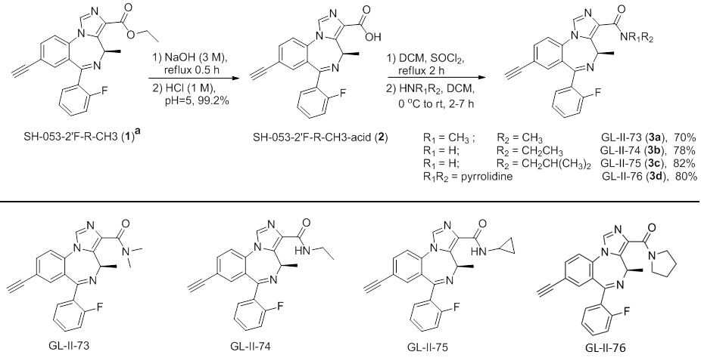

### **Supplementary Figure S1.** General synthetic route to amides

Summarized in these schemes are the principal steps for the synthesis of the GL-II series compounds from the parent compound SH-053-2'F-R-CH3 (**1**). A detailed synthesis of SH-053-2'F-R-CH3 (**1**) is summarized in the US Patent 7,618,958.

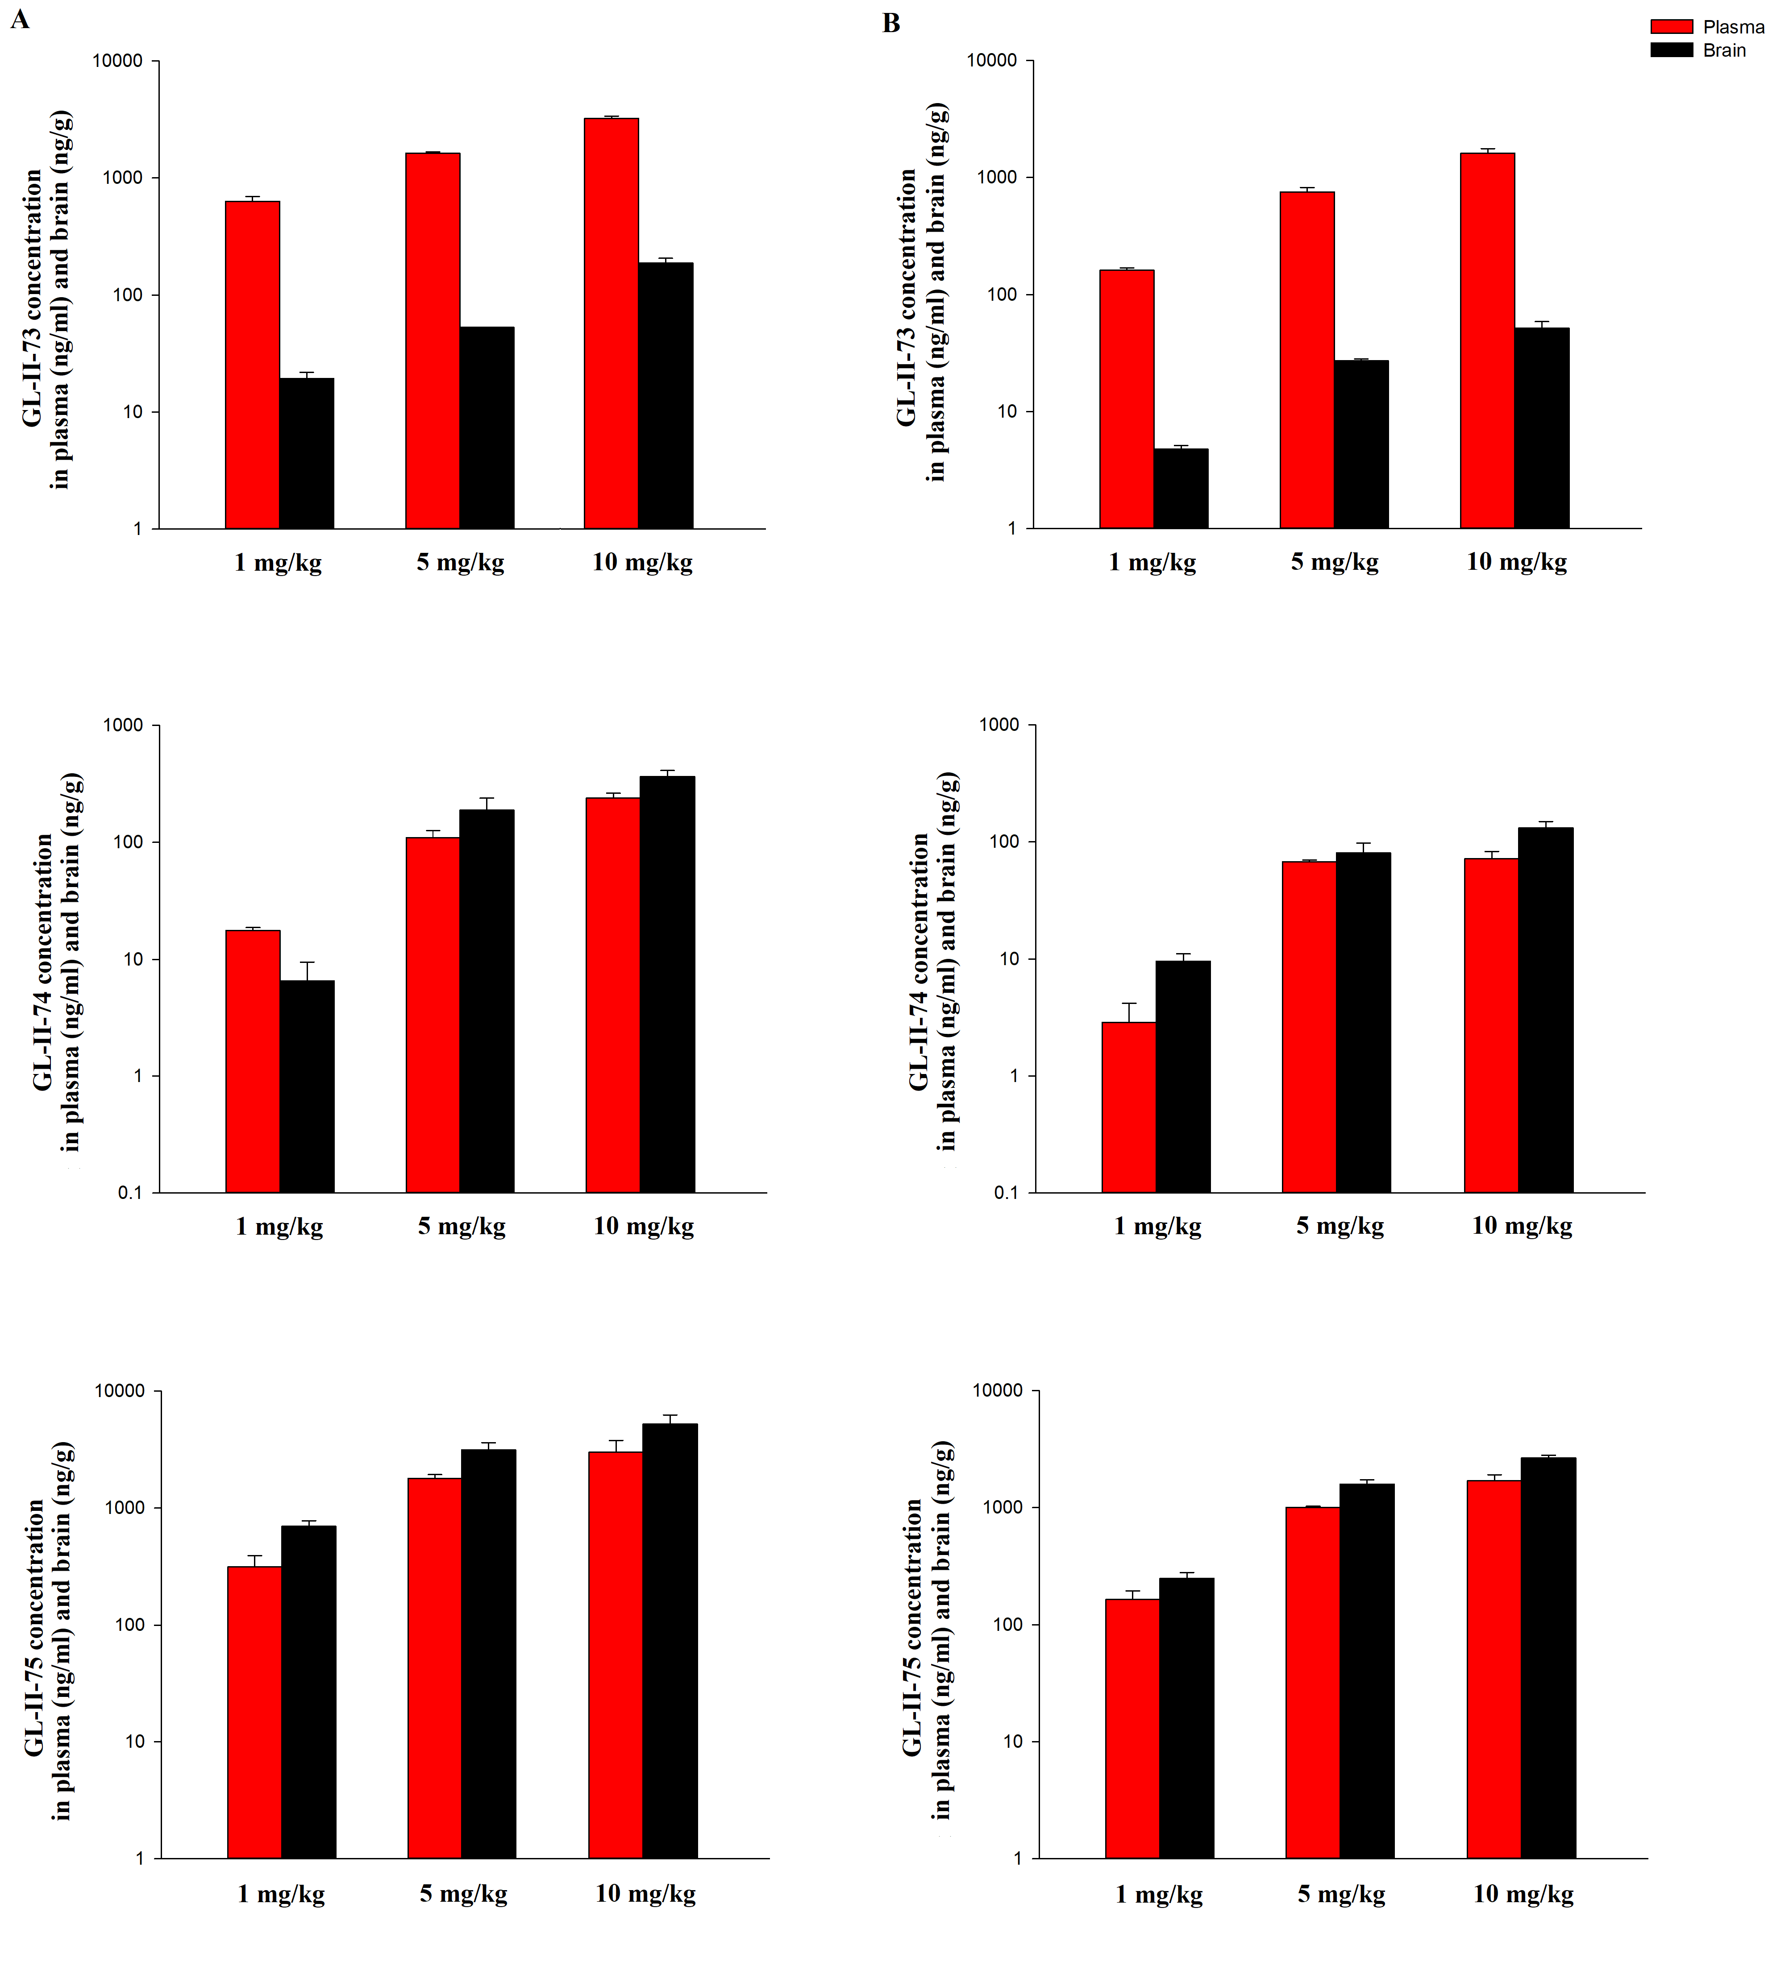

### **Supplementary Figure S2.** Concentration of GL-II-73, GL-II-74 and GL-II-75 in plasma and brain of male C57BL/6 mice after administration of a compound at doses of 1, 5 or 10 mg/kg, 30 min after single i.p. injection (A), as well as after three i.p. injections, administered 24 h, 20 h and 1 h (B) prior to concentration measurement.

In order to parallel the design of behavioral studies (elevated plus maze, Y maze and forced swim test), plasma and brain concentrations were determined 30 min after single i.p. injection (A), as well as after three i.p. injections, administered 24 h, 20 h and 1 h (B) prior to concentration measurement with compounds dosed at 1, 5 and 10 mg/kg. In the appropriate time intervals, the samples were collected from mice anesthetized with ketamine solution (10% Ketamidor, dosed i.p. at 100 mg/kg). Compounds were extracted from plasma and supernatants of brain tissue homogenates by solid phase extraction. The procedure of sample preparation and determination of concentration by ultraperformance liquid chromatography–tandem mass spectrometry (UPLC–MS/MS) has been already described in Obradovitch et al.



**Supplementary Figure S3.** Locomotor activity changes induced by DZP injection

The effect of the referent non-selective PAM DZP dosed i.p. at 10 mg/kg was assessed on distance traveled in 5-min bins during recording in the locomotor activity test in male mice. Animals were injected and immediately placed in an opaque Plexiglas chamber under dim red light (20 lux) for 1hr. Chambers were cleaned with 70% ethanol after every trial. Distance travelled per 5-min bin was quantified *a posteriori* using ANYmaze Video Tracking System. A two-way repeated measures ANOVA showed a significant effect of factor Treatment (Treatment: F(1,132)=17.376, p=0.001; Time: F(11,132)=1.822, p=0.056; Interaction: F(11,253)=0.809, p=0.631). Post-hoc comparisons demonstrated that DZP induced a hypolocomotor response in time intervals 10-35 min and 40-55 min suggesting a sedative effect in the spontaneous locomotor activity test in mice, in accordance with the approximated substantial potentiation of α1-containing GABAA receptors.

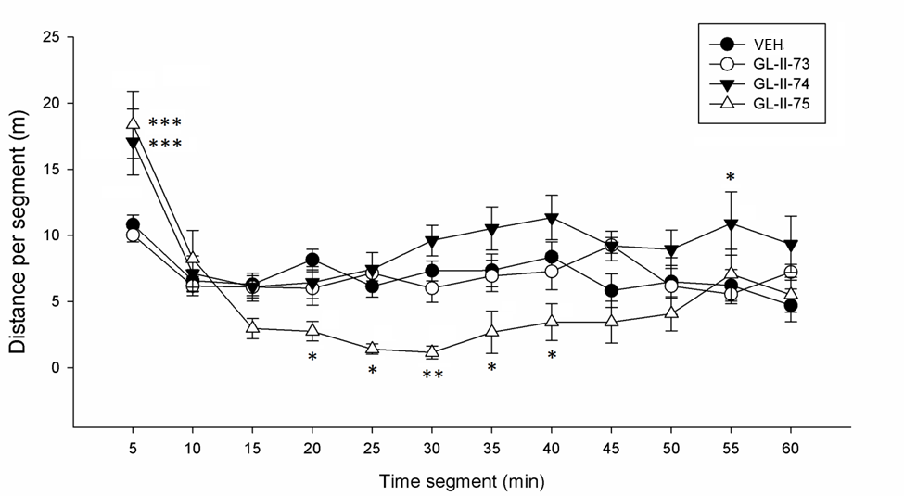

### **Supplementary Figure S4.** Locomotor activity changes induced by αPAM injection

The effect of GL-II-73, GL-II-74 and GL-II-75 all dosed i.p. at 10 mg/kg were assessed on distance traveled in 5-min bins during recording in the locomotor activity test in male mice. Animals were injected with vehicle (VEH) or the test compounds and immediately placed in an opaque Plexiglas chamber under dim red light (20 lux) for 1 hr. Chambers were cleaned with 70% ethanol after every trial. Distance travelled per 5-min bin was quantified *a posteriori* using ANYmaze Video Tracking System. A two-way repeated measures ANOVA revealed a significant effect of all factors (Treatment: F(3,253)=6.52, P=0.002; Time: F(11,253)=14.59, P<0.001; Interaction: F(33,253)=3.25, P<0.001). Post-hoc comparisons of 5-min bins demonstrated that GL-II-74 induced a hyperlocomotor response in time intervals 0-5 min and 50-55 min, while GL-II-75 elicited a similar stimulant-like effect in the first 5 min, but a consistent hypolocomotion in the whole period 15-40 min.

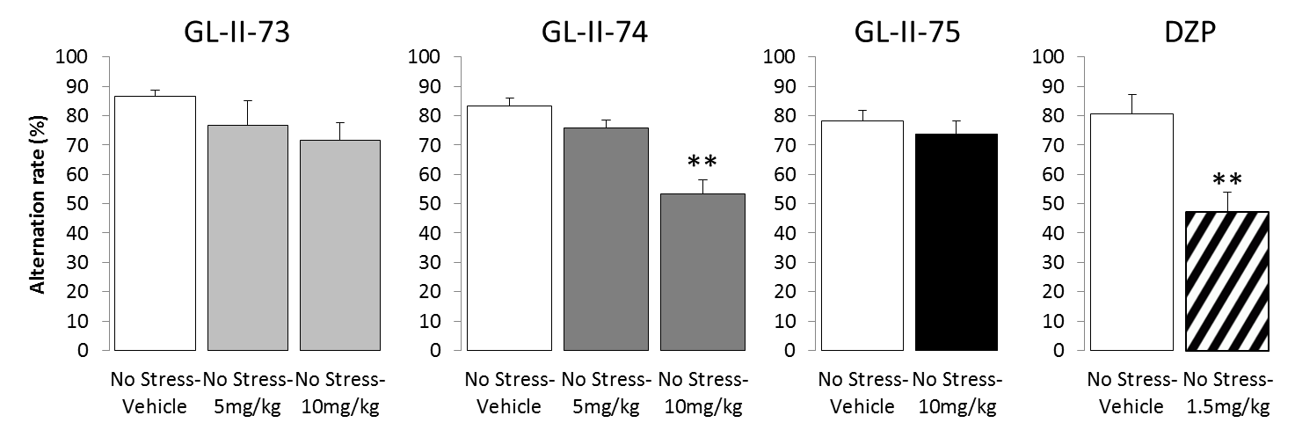

### **Supplementary Figure S5.** Effect of GL-II-73, GL-II-74, GL-II-75 and DZP on alternation rate in a Y-maze alternation task assessing working memory in non-stressed adult mice

The effect of each compound and the non-selective PAM DZP was assessed on alternation performance in the Y-maze to evaluate potential cognitive deficit induced by the compound under baseline conditions. Animals received 5 or 10mg/kg of the compounds, or 1.5mg/kg of DZP, 30 min prior to testing. GL-II-74 was the only compound to show decreased alternation rate after 10 mg/kg administration, similarly comparable to DZP. **p<0.001 compared to “No Stress-Vehicle” group.

### **Supplementary Figure S6.** Scheme of repeated assessment of cognitive performances in the Y-Maze in function of stress exposure and α5-PAM administration

The same animals (N=10 per condition: Control or Stress) were evaluated weekly in the Y-Maze task, assessing working memory abilities. The first week, after habituation to the maze, the animals were tested without receiving the compound and without being exposed to chronic stress yet. After that first assessment, animals belonging to the Stress group were exposed to 1 week of chronic stress (CS), and re-evaluated. Results showed that 1 week of CS induced alternation deficit in that task. The following week, while the stress group was still exposed to CS, animals were injected with GL-II-73, 10 mg/kg. Results showed that the compound administration restored the alternation rate that was altered the week before due to CS exposure. However, if we keep exposing the animal to CS, without injecting them, the alternation rate drops down again, suggesting that the single drug administration does not have long term effect, and that the compound is washed out from the organism.

References

1. Cook JM, Zhou H, S. H, Sarma PVVS, Zhang C (2009): Stereospecific anxiolytic and anticonvulsant agents with reduced muscle-relaxant, sedative hypnotic and ataxic effects. *PCT WO2006/004945A1*.

2. Li G, Stephen MR, Kodali R, Zahn NM, Poe MM, Tiruveedhula VVNPB, et al. (2018): Synthesis of chiral GABAA receptor subtype selective ligands as potential agents to treat schizophrenia as well as depression. *ARKIVOC*.158-183.

3. Alexeev M, Grosenbaugh DK, Mott DD, Fisher JL (2012): The natural products magnolol and honokiol are positive allosteric modulators of both synaptic and extra-synaptic GABA(A) receptors. *Neuropharmacology*. 62:2507-2514.

4. Fisher JL, Zhang J, Macdonald RL (1997): The role of alpha1 and alpha6 subtype amino-terminal domains in allosteric regulation of gamma-aminobutyric acida receptors. *Molecular pharmacology*. 52:714-724.

5. Stamenic TT, Poe MM, Rehman S, Santrac A, Divovic B, Scholze P, et al. (2016): Ester to amide substitution improves selectivity, efficacy and kinetic behavior of a benzodiazepine positive modulator of GABAA receptors containing the alpha5 subunit. *European journal of pharmacology*. 791:433-443.

6. Ghosal S, Nunley A, Mahbod P, Lewis AG, Smith EP, Tong J, et al. (2015): Mouse handling limits the impact of stress on metabolic endpoints. *Physiology & behavior*. 150:31-37.

7. Namjoshi OA, Wang ZJ, Rallapalli SK, Johnson EM, Jr., Johnson YT, Ng H, et al. (2013): Search for alpha3beta(2)/(3)gamma2 subtype selective ligands that are stable on human liver microsomes. *Bioorganic & medicinal chemistry*. 21:93-101.

8. Obradovic A, Joksimovic S, Poe MM, Ramerstorfer J, Varagic Z, Namjoshi O, et al. (2014): Sh-I-048A, an in vitro non-selective super-agonist at the benzodiazepine site of GABAA receptors: the approximated activation of receptor subtypes may explain behavioral effects. *Brain research*. 1554:36-48.

9. Porsolt RD (1979): Animal model of depression. *Biomedicine / [publiee pour l'AAICIG]*. 30:139-140.

10. Vandesquille M, Krazem A, Louis C, Lestage P, Beracochea D (2011): S 18986 reverses spatial working memory impairments in aged mice: comparison with memantine. *Psychopharmacology*. 215:709-720.