SUPPLEMENTARY MATERIALS FOR:

Manuscript Title
Differential Molecular Modeling Predictions of Mid and Conventional Dialysate Flows

Authors
John K. Leypoldt, PhD³, Sarah Prichard, MD⁴, Glenn M. Chertow, MD¹ , Luis Alvarez, MD, PhD²
¹Stanford University School of Medicine, ²Palo Alto Medical Foundation, ³Unaffiliated, San Clemente, CA ⁴Unaffiliated, Montreal, Canada

Supplementary Methods – Kinetic Model
The kinetic models for urea, phosphate and beta₂-microglobulin used in our study are all based on a two-compartment model framework that can be described generically with the details for each solute identified subsequently. The general two-compartment model framework used here is very similar to that described by Daugirdas et al for urea kinetics [1], Ward et al for beta₂-microglobulin kinetics [2], and Agar et al for phosphate kinetics [3]. The supplementary figure (below) shows the two-compartment model framework schematically. The model assumes that the solute can be considered to be distributed into two separate, well-mixed compartments; 1) a perfused compartment with volume V_{P} from which solute is removed by the dialyzer with a clearance of K_{D} and 2) a non-perfused compartment with volume V_{NP}. The solute concentration in the perfused compartment is denoted as C_{P} and that in the non-perfused compartment as C_{NP}. There is resistance to solute movement between the two compartments; the intercompartment solute mass transfer rate is equal to the product of the intercompartmental clearance (K_{IC}) multiplied by the difference in solute concentration between the two compartments. Solute generation with a rate of G and non-kidney clearance (K_{NK}) was assumed to be confined to the perfused compartment. Fluid is assumed to be removed by the dialyzer at a constant rate Q_{UF} from one or both compartments at a constant rate during the dialysis treatment and to be gained by one or both compartments at a constant rate α (a negative value of G) during the interdialytic interval. Residual kidney clearance of all solutes was neglected in this study.
The perfused and non-perfused compartment volumes are different for each solute and are assumed to be approximated by physiological body compartments. For urea, the perfused and non-perfused compartment volumes are assumed to be the extracellular and intracellular fluid volumes, respectively; thus, the sum of the perfused and non-perfused compartments for urea is approximately total body water volume. For beta₂-microglobulin, the perfused and non-perfused compartment volumes are assumed to be plasma and interstitial fluid volumes, respectively; thus, the sum of the perfused and non-perfused compartments for beta₂-microglobulin is approximately extracellular fluid volume. For phosphate, the perfused compartment volume is assumed to be the extracellular fluid volume and the non-perfused compartment volume is assumed to be infinitely large [3]. For all solutes, fluid is assumed to be removed from the extracellular compartment; thus, fluid is assumed to be removed from the perfused compartment only when considering urea and phosphate, but it is assumed to be removed proportionately from the perfused and non-perfused compartments when considering beta₂-microglobulin.
The change in solute mass in the perfused compartment is given by
$$\frac{d(C_{P}V_{P})}{dt}=∅_{\text{P}}G+K_{IC}\left(C_{NP}-C_{P}\right)+ϑK_{D}C_{P}-K_{NK}C_{P}$$ | (1)

And in the non-perfused compartment by
$$\frac{d\left(C_{NP}V_{NP}\right)}{dt}={∅_{\text{NP}}G+K}_{IC}\left(C_{P}-C_{NP}\right)$$ | (2)

In equations (1) and (2), the values of φ_{P} and φ_{P} denote the fraction of the compartment volumes in the perfused and non-perfused compartments, respectively. The symbol θ is an indicator variable such that θ=1 during an intradialytic interval and θ=0 during an interdialytic interval.
Comparable equations describe the change in volume of the perfused compartment as given by
$$\frac{dV_{P}}{dt}=-ϑ{∅_{P}Q}_{UF}+\left(1-ϑ\right)∅_{P}∝$$ | (3)
and in the non-perfused compartment by
$$\frac{dV_{NP}}{dt}=-ϑ{∅_{NP}Q}_{UF}+\left(1-ϑ\right)∅_{NP}∝$$ | (4)
Note that these equations are those described by Ward et al [2] but neglect the effect of solute transport by convection between the perfused and non-perfused compartments.
To account for solute convection in determining the total dialyzer clearance (K_{D}), we used the following equation for all solutes

$$K_{D}=K_{diff}+Tr×Q_{UF}$$ | (5)

where K_{diff} denotes diffusive solute clearance from the dialyzer as estimated using Michaels’ equation, where the “blood” flow rate term in the equation is the blood water flow rate for urea and plasma flow rate for beta₂-microglobulin and phosphate, and Tr denotes the transmittance coefficient [4, 5] defined as

$$Tr=S×(1-\frac{K_{D}}{Q_{b}})$$ | (6)

where the sieving coefficient denoted by S was assumed as 1, 0.8, and 1 for urea, beta₂-microglobulin and phosphate, respectively, in this study. When the sieving coefficient is assumed to be unity, the equation for K_{D} reduces to the conventional expression for urea [1].

The values of the various parameters assumed for urea, beta₂-microglobulin and phosphate are described in the supplementary table (see below).

SUPPLEMENTARY TABLE
Parameter | For Urea | For beta₂-microglobulin | For Phosphate
V_{P} | Extracellular Volume (ECV) or TBW/3 | Plasma Volume or ECV/4 | Extracellular Volume or TBW/3
V_{NP} | Intracellular Volume or 2×TBW/3 | Interstitial Tissue Volume or 3 × ECV/4 | Infinitely Large
G (mg/min) | Arbitrary | Arbitrary | Neglected
K_{NK} (mL/min) | 0 | 3 | 0
φ_{P} | 0.33 | 0.25 | 0.33
φ_{NP} | 0.67 | 0.75 | 0.67
“Blood Flow Rate” | 0.894 × Q_{b} | 0.67 × Q_{b} | 0.67 × Q_{b}
Dialyzer S | 1 | 0.8 | 1
Dialyzer K_{o}A (mL/min) | As reported in main text | 80 [2] | 60% of that for urea

TBW = Total Body Water Volume and the hematocrit was assumed to be 33%.
SUPPLEMENTARY FIGURE
The two-compartment model framework used in this study.
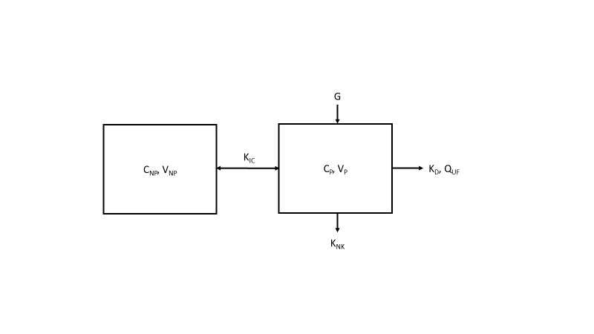

REFERENCES
1. Daugirdas JT, Depner TA, Greene T, Silisteanu P. Solute-solver: a web-based tool for modeling urea kinetics for a broad range of hemodialysis schedules in multiple patients. Am J Kidney Dis 2009; 54: 798-809
2. Ward RA, Greene T, Hartmann B, Samtleben W. Resistance to intercompartmental mass transfer limits beta2-microglobulin removal by post-dilution hemodiafiltration. Kidney Int 2006; 69: 1431-7
3. Agar BU, Akonur A, Lo YC, Cheung AK, Leypoldt JK. Kinetic model of phosphorus mobilization during and after short and conventional hemodialysis. Clin J Am Soc Nephrol 2011; 6: 2854-60
4. Granger A, Vantard G, Vantelon J, Perrone B. A mathematical approach of simulataneous dialysis and filtration (SDF). Proc Eur Soc Artif Organs 1978: 174-7
5. Leypoldt JK. Solute fluxes in different treatment modalities. Nephrol Dial Transplant 2000; 15 Suppl 1: 3-9

