miR-192 is Overexpressed and Promotes Cell Proliferation in Prostate Cancer
Zhong-Jun Chenª, You-Ji Yanª, Hao Shen^{b}, Jia-Jie Zhouª, Guang-Hua Yangª, Yi-Xiang Liaoª, Jin-Min Zengª, Tao Yangª
ª Department of Urology, Jingzhou Central Hospital, The Second Clinical Medical College, Yangtze University, Jingzhou, Hubei; ^{b}Department of Urology, Renmin Hospital of Wuhan University, Wuhan, Hubei, China

Address all Correspondence to:
Shen Hao
Department of Urology
Renmin Hospital of Wuhan University
Wuhan, Hubei 430060
China
Email: 2009203020115@whu.edu.cn

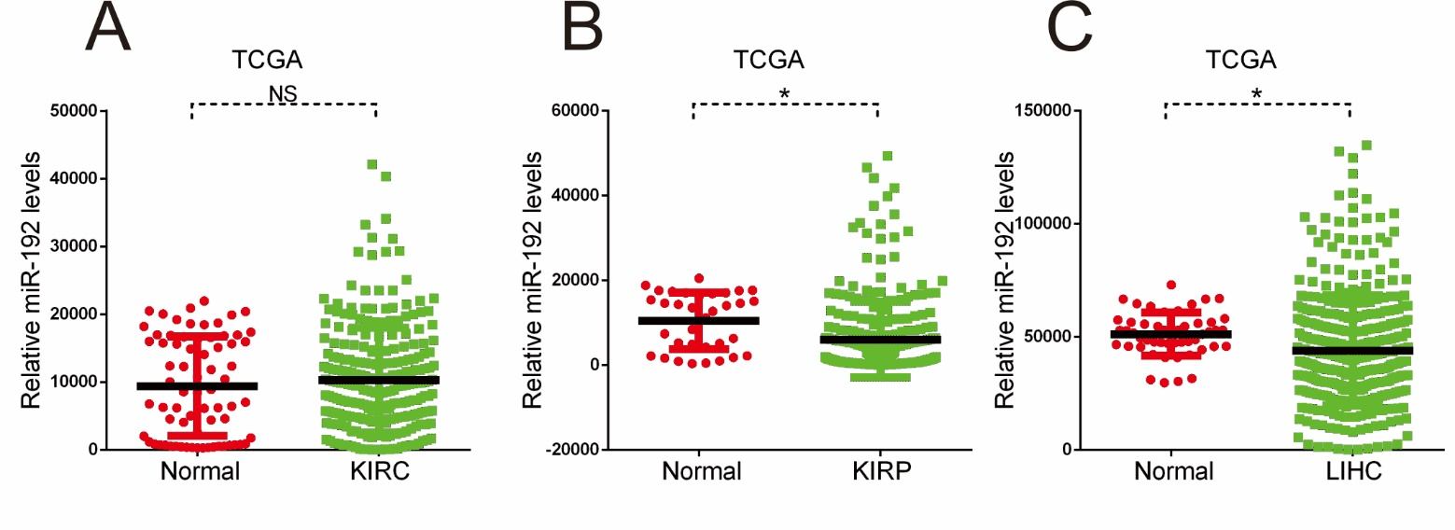

Supplementary Figure 1. Analysis of TCGA datasets, for the expression of miR-192-5p in KIRC(A), in KIRP(B), in LIHC(C). (*, p < 0.05).

