SUPPLEMENTARY MATERIALS
Feasibility and acceptability of an intervention providing computer-generated tailored feedback to target alcohol consumption and depressive symptoms in proactively recruited health care patients and reactively recruited media volunteers – results of a pilot study
Kristian Krause, Diana Guertler, Anne Moehring, Anil Batra, Sandra Eck, Hans-Jürgen Rumpf, Gallus Bischof, Michael Lucht, Jennis Freyer-Adam, Sabina Ulbricht, Ulrich John, Christian Meyer

Table of contents
Supplementary Tables……………………………………………………………………………………………….. | 3
Supplementary Table 1: Reasons for dropping out from screening to baseline for health care patients by setting…………………………………………………………………………………………………………. | 3
Supplementary Table 2: Basic intervention characteristics………………………………………………….. | 4
Supplementary Table 3: Contents of the written feedback letters and what they were tailored by…………………………………………………………………………………………………………………………….. | 5
Supplementary Table 4: Assessment of alcohol consumption with the original AUDIT consumption items and its adaptations………………………………………………………………………………… | 8
Supplementary Table 5: Frequencies of the different motivational stages of change concerning alcohol consumption in the overall sample and the two subsamples……………….. | 10
Supplementary Table 6: Percentage of participants in each motivational stage at baseline and 6-month follow-up for each depression preventive behavior……………………………………….. | 11
Supplementary Figures………………………………………………………………………………………………. | 12
Supplementary Figure 1: Graphical representation of the course of the intervention………… | 12
Supplementary Figure 2: Graphical representation of the staging algorithms used…………….. | 13
Written intervention description……………………………………………………………………………….. | 14
Example feedback letters…………………………………………………………………………………………… | 17
Participant A: Letter 1…………………………………………………………………………………………………………… | 17
Participant A: Letter 2…………………………………………………………………………………………………………… | 21
Participant A: Letter 3…………………………………………………………………………………………………………… | 24
Participant A: Letter 4…………………………………………………………………………………………………………… | 28
Participant A: Letter 5…………………………………………………………………………………………………………… | 32
Participant A: Letter 6…………………………………………………………………………………………………………… | 36
Participant B: Letter 1…………………………………………………………………………………………………………… | 40
Participant B: Letter 2…………………………………………………………………………………………………………… | 44
Participant B: Letter 3…………………………………………………………………………………………………………… | 47
Participant B: Letter 4…………………………………………………………………………………………………………… | 51
Participant B: Letter 5…………………………………………………………………………………………………………… | 55
Participant B: Letter 6…………………………………………………………………………………………………………… | 59
References……………………………………………………………………………………………………………………………….. | 63

Supplementary Table 1: Reasons for dropping out from screening to baseline for health care patients by setting
 | General hospitals | General practitioners offices
Screening completed | 1250 (100) | 1523 (100)
Thereof:  Neither hazardous drinking nor depressive symptoms | 847 (67.8) | 964 (63.3)
Hazardous drinking without depressive symptoms | 216 (17.3) | 258 (16.9)
Depressive symptoms without hazardous drinking | 156 (12.5) | 242 (15.9)
Inclusion criteria met (hazardous drinking +  depressive symptoms) | 31 (2.5) | 59 (3.9)
Thereof:  ≥1 exclusion criteria met | 15 (48.4) | 20 (33.9)
Suspected severe depression | 3 (9.7) | 3 (5.1)
Moderate or severe alcohol use disorder | 9 (29.0) | 8 (13.6)
Seeing a psychotherapist | 10 (32.3) | 13 (22.0)
No weekly internet and smartphone use | 0 (0.0) | 0 (0.0)
Theoretical amount of eligible patients¹ | 16 (51.6) | 39 (66.1)
Thereof:  “Lost” due to:  Initial inclusion criteria | 5 (31.3) | 3 (7.7)
Assignment to Project 2 | 0 (0.0) | 6 (15.4)
Participation offered | 11 (68.8) | 30 (76.9)
Thereof:  Did not consent | 4 (36.4) | 10 (33.3)
Consented to participate | 7 (63.3) | 20 (66.7)
Thereof:  Unwilling to participate | 1 (14.3) | 2 (10.0)
Unreachable | 0 (0.0) | 5 (25.0)
Baseline completed | 6 (31.6) | 13 (68.4)
Note. Data are presented as n (%).
¹: considering the final inclusion criteria.
Supplementary Table 2: Basic intervention characteristics
Behavioral target | Hazardous drinking,  Depression¹
Target population | Adults aged 18-64
Intended setting | Primary care
Access | facilitated by proactively approaching individuals in the intended setting
Language | German
Type of technology | Computer-based expert system [1]
Software platform | Microsoft Access 2010
Change technique | Motivational feedback
Theoretical basis | Transtheroretical model of behavior change (TTM) [2]
Tailoring | Yes²
Mode of assessment | Proactive CATIs at 3 time points (baseline, month 2, month 4)
Method of intervention delivery | Written postal feedback letters³,  SMS or e-mail ^{4, 5}
Counselor involvement | None
Cost to user | None
Intervention duration | 6 months
Note. CATI: computer-assisted telephone interview.
¹: Depressive symptoms were targeted by motivating participants to implement evidence-based depression preventive or ameliorating behaviors into their daily routine [3]; ²: Supplementary Table 3 provides an overview over the sections of the letters and what they were tailored by, ³: six letters in total, two after baseline, 2 months, and 4 months, respectively, ⁴: depending on availability; e-mail was chosen if participants did not use a mobile phone at least once a week, ⁵: one massage per week over a period of 6 months.
Supplementary Table 3: Contents of the written feedback letters and what they were tailored by
Section | Tailored by
Letter 1, 3, 5
Introduction | - Recruitment setting (Letter 1 only)
Depression module
Feedback on depressive symptoms# | - Recruitment setting  - Currency of depressive symptoms  - Number (one or more) and severity of depressive symptoms
Introduction of depression preventive behaviors | - generic
Feedback on the motivational stage of change to practice depression preventive behaviors# | - Overall motivational stage of change to practice depression prevention¹  - Number of depression preventive behaviors in the stage that represents the current overall motivational stage of change to practice depression prevention  - Motivational stage of change of each of the five depression preventive behaviors
Information on prevalence², course, and additional health risks of depressive symptoms | - Age  - Sex  - Currency of depressive symptoms  - Number (one or more) and severity of depressive symptoms  - Overall motivational stage of change to practice depression prevention
Information on the interaction of alcohol und depression (Letter 1 only) | - generic
Connecting passage (Letters 3 and 5 only) | - generic
Alcohol module
Feedback on the motivational stage of change to reduce alcohol intake# | - Motivational stage of change to reduce alcohol intake
Introduction of the boundaries of low-risk drinking | - Sex  - Age  - Weekly consumption days
Normative feedback on alcohol intake ^{3,#} | - Sex  - Number of drinks per week
Feedback on personal risk of experiencing negative consequences of consuming alcohol# | - Sex  - Number of drinks per week  - Frequency of binge drinking
Feedback on experienced pros and cons of consuming alcohol (alcohol decisional balance)# | - Experienced pros and cons of consuming alcohol

Supplementary Table 3 (continued): Contents of the written feedback letters and what they were tailored by
Section | Tailored by
Farewell passage# | - Motivational stages of change to reduce alcohol intake and to practice depression prevention
Brief 2,4,6
Introduction | - generic
Depression module
Feedback on the motivational stage of change to practice depression prevention | - Overall motivational stage of change to practice depression prevention¹  - Number of depression preventive behaviors in the stage that represents the current overall motivational stage of change to practice depression prevention  - Motivational stage of change of each of the five depression preventive behaviors
Feedback on outcome expectations of practicing depression prevention# | - Overall motivational stage of change to practice depression prevention¹  - Number of depression preventive behaviors in the stage that represents the current overall motivational stage of change to practice depression prevention  - Overall outcome expectation of practicing depression prevention and outcome expectations for each of the five depression preventive behaviors
Feedback on processes of change^{4,#} | - Overall motivational stage of change to practice depression prevention¹  - Reported use of the processes of change
Feedback on self-efficacy to use depression preventive behaviors# | - Overall motivational stage of change to practice depression prevention¹  - Number of depression preventive behaviors in the stage that represents the current overall motivational stage of change to practice depression prevention  - Overall self-efficacy to use depression preventive behaviors and self-efficacy to use each of the five behaviors
Making a plan  (only for preparators) | - Sex  - Number of behaviors in the preparation stage  - The behavior in preparation
Connecting passage | - generic
Alkoholmodul
Feedback on processes of change^{4,#} | - Motivational stage of change to reduce alcohol intake  - Reported use of the processes of change
Feedback on self-efficacy to not drink alcohol in critical situations# | - Motivational stage of change to reduce alcohol intake  - Self-efficacy to not drink alcohol in tempting situations
Making a plan  (only for preparators) | - Sex

Supplementary Table 3 (continued): Contents of the written feedback letters and what they were tailored by.
Farewell passage | - Communication channel for the weekly short-messages
Note. ¹: resembles the motivational stage of change of the depression preventive behavior(s) for which the participant presents the highest motivational stage of change, ²: participants received feedback on the percentage of men and women in their age range that also suffer from depressive symptoms (based on point prevalences from Busch et al. [4]), ³: Comparison of the alcohol intake with a normative database of individuals in the same motivational stage of change, ⁴: Feedback on processes of change was partly given via SMS/e-mail, a random algorithm decided which processes of change were thematised in the letter and which in the SMS/e-mail, #: at T1 and T2 feedback also included feedback on individual changes.
Supplementary Table 4: Assessment of alcohol consumption with the original AUDIT consumption items and its adaptations
AUDIT 1 original¹
How often do you have a drink containing alcohol? | Never  Monthly or less  Two to four times a month  Two to three times a week  Four or more times a week
AUDIT 1 continuous²
And how often exactly do you have a drink containing alcohol? | [if AUDIT 1 Two to four times a month]  Two times am month  Three times am month  Four times am month  [if AUDIT 1 Two to three times a week]  Two times a week  Three times a week  [if AUDIT 1 Four or more times a week]  Four times a week  Five times a week  Six times a week  Seven times a week
AUDIT 2 original
How many drinks containing alcohol do you have on a typical day when you are drinking? | 1 or 2  3 or 4  5 or 6  7 to 9  10 or more
AUDIT 2 continuous
And how many drinks containing alcohol do you have exactly on a typical day when you are drinking? | [if AUDIT 2 1 or 2]  1 drink per day  2 drinks per day  [if AUDIT 2 3 or 4]  3 drinks per day  4 drinks per day  [if AUDIT 2 5 or 6]  5 drinks per day  6 drinks per day  [if AUDIT 2 7 to 9]  7 drinks per day  8 drinks per day  9 drinks per day  [if AUDIT 2 10 or more]  10 drinks per day  11 drinks per day
Supplementary Table 4 (continued): Assessment of alcohol consumption with the original AUDIT consumption items and its adaptations
12 drinks per day
….
65 drinks per day
AUDIT 3 gendered
Women:  How often do you have four or more drinks on one occasion?  Men:  How often do you have five or more drinks on one occasion? | Never  Less than monthly  Monthly  Two to four times a month  Two to three times a week  Four or more times a week
AUDIT 3 gendered continuous³
Women:  And how often exactly do you have four or more drinks on one occasion?  Men:  And how often exactly do you have five or more drinks on one occasion? | [if AUDIT 3 gendered Two to four times a month]  Two times a month  Three times a month  Four times a month  [if AUDIT 3 gendered Two to three times a week]  Two times a week  Three times a week  [if AUDIT 3 gendered Four or more times a week]  Four times a week  Five times a week  Six times a week  Seven times a week
AUDIT 3 original
How often do you have six or more drinks on one occasion? | Never  Less than monthly  Monthly  Weekly  Daily or almost daily
Note. AUDIT: Alcohol Use Disorder Identification Test. Questions were asked in the presented order. ¹: if AUDIT 1 original was “Never” the remaining AUDIT questions were not asked; ²: only asked if AUDIT 1 original was at least “Two to four times a month”; ³: only asked if AUDIT 3 gendered was at least “Two to four times a month”.

Supplementary Table 5: Frequencies of the different motivational stages of change concerning alcohol consumption in the overall sample and the two subsamples
 | All (n = 30) |  | HCPs (n = 15) |  | MVs (n = 15)
Motivational Stage | BL | 6MFU | BL | 6MFU | BL | 6MFU
Precontemplation | 6 (20.0) | 6 (20.0) | 6 (40.0) | 5 (33.3) | 0 (0.0) | 1 (6.7)
Contemplation | 15 (50.0) | 8 (26.7) | 7 (46.7) | 5 (33.3) | 8 (53.3) | 3 (20.0)
Preparation | 6 (20.0) | 2 (6.7) | 0 (0.0) | 1 (6.7) | 6 (40.0) | 1 (6.7)
Action | 3 (10.0) | 14 (46.7) | 2 (13.3) | 4 (26.7) | 1 (6.7) | 10 (66.7)
Note. Data are presented as n (%).
HCPs: health care patients; MVs: media recruited volunteers; BL: baseline; 6MFU: 6-month follow-up.

Supplementary Table 6: Percentage of participants in each motivational stage at baseline and 6-month follow-up for each depression preventive behavior
DPB | All (n = 30) | HCPs (n = 15) | MVs (n = 15) |  | All (n = 30) | HCPs (n = 15) | MVs (n = 15)
 | Baseline |  |  |  | 6-month follow-up
Help-seeking
Precontemplation, n (%) | 4 (13.3) | 3 (20.0) | 1 (6.7) |  | 4 (13.3) | 3 (20.0) | 1 (6.7)
Contemplation, n (%) | 0 (0.0) | 0 (0.0) | 0 (0.0) |  | 0 (0.0) | 0 (0.0) | 0 (0.0)
Preparation, n (%) | 2 (6.7) | 0 (0.0) | 2 (13.3) |  | 1 (3.3) | 1 (6.7) | 0 (0.0)
Action, n (%) | 24 (80.0) | 12 (80.0) | 12 (80.0) |  | 25 (83.3) | 11 (73.3) | 14 (93.3)
Exercising
Precontemplation, n (%) | 10 (33.3) | 5 (33.3) | 5 (33.3) |  | 7 (23.3) | 2 (13.3) | 5 (33.3)
Contemplation, n (%) | 2 (6.7) | 1 (6.7) | 1 (6.7) |  | 1 (3.3) | 1 (6.7) | 0 (0.0)
Preparation, n (%) | 11 (36.7) | 6 (40.0) | 5 (33.3) |  | 10 (33.3) | 4 (26.7) | 6 (40.0)
Action, n (%) | 7 (23.3) | 3 (20.0) | 4 (26.7) |  | 12 (40.0) | 8 (53.3) | 4 (26.7)
Stress management
Precontemplation, n (%) | 5 (16.7) | 5 (33.3) | 0 (0.0) |  | 6 (20.0) | 5 (33.3) | 1 (6.7)
Contemplation, n (%) | 1 (3.3) | 0 (0.0) | 1 (6.7) |  | 2 (6.7) | 0 (0.0) | 2 (13.3)
Preparation, n (%) | 8 (26.7) | 3 (20.0) | 5 (33.3) |  | 6 (20.0) | 3 (20.0) | 3 (20.0)
Action, n (%) | 16 (53.3) | 7 (46.7) | 9 (60.0) |  | 16 (53.3) | 7 (46.7) | 9 (60.0)
Behavioral activation
Precontemplation, n (%) | 4 (13.3) | 3 (20.0) | 1 (6.7) |  | 2 (6.7) | 2 (13.3) | 0 (0.0)
Contemplation, n (%) | 1 (3.3) | 1 (6.7) | 0 (0.0) |  | 0 (0.0) | 0 (0.0) | 0 (0.0)
Preparation, n (%) | 9 (30.0) | 3 (20.0) | 6 (40.0) |  | 4 (13.3) | 2 (13.3) | 2 (13.3)
Action, n (%) | 16 (53.3) | 8 (53.3) | 8 (53.3) |  | 24 (80.0) | 11 (73.3) | 13 (86.7)
Obviate negative thoughts
Precontemplation, n (%) | 4 (13.3) | 4 (26.7) | 0 (0.0) |  | 3 (10.0) | 2 (13.3) | 1 (6.7)
Contemplation, n (%) | 0 (0.0) | 0 (0.0) | 0 (0.0) |  | 0 (0.0) | 0 (0.0) | 0 (0.0)
Preparation, n (%) | 8 (26.7) | 2 (13.3) | 6 (40.0) |  | 0 (0.0) | 0 (0.0) | 0 (0.0)
Action, n (%) | 18 (60.0) | 9 (60.0) | 9 (60.0) |  | 27 (90.0) | 13 (86.7) | 14 (93.3)
Note. DPB: depression preventive behavior; HCPs: health care patients; MVs: media recruited volunteers.

WEEK | 0 | 1 | 2 | 3 | 4 | 5 | 6 | 7 | 8 | 9 | 10 | 11 | 12 | 13 | 14 | 15 | 16 | 17 | 18 | 19 | 29 | 21 | 22 | 23 | 24 | 25 | 26 | 27 | X
ASSESSMENT | BL |  |  |  |  |  |  |  |  | T1 |  |  |  |  |  |  |  | T2 |  |  |  |  |  |  |  |  |  | FU | PI
LETTER |  | L1 | L2 |  |  |  |  |  |  |  | L3 | L4 |  |  |  |  |  |  | L5 | L6
SMS/E-MAIL |  | W |  |  |  |  |  |  |  |  |  |  |  |  |  |  |  |  |  |  |  |  |  |  |  |  | F
Supplementary Figure 1: Graphical representation of the course of the intervention. BL: baseline assessment; FU: 6-month follow-up assessment; PI: post-intervention interview; L: letter; W: welcoming message; F: farewell message.
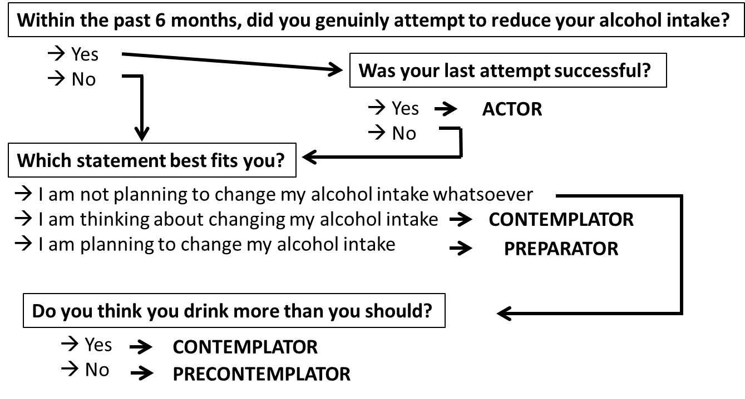
Supplementary Figure 2: Graphical representation of the staging algorithms used to assess participants motivational stage to change their drinking behavior (left) and to use each of the depression preventive behaviors (right).

Description of the intervention
The intervention was a computer-based, fully automatized expert system [1] that generated individually tailored motivational feedback letters for participants based on data gathered in computer-assisted telephone interviews. The software platform of our intervention was Microsoft Access (Microsoft Office 2010). Supplementary Table 2 provides an overview on the basic intervention characteristics.
The intervention consisted of an alcohol and a depression module, both based on the transtheoretical model of behavior change [2]. For the alcohol module we relied on an already existing system that has been found to reduce alcohol use among HCPs [5]. Minor modifications have been done to the system for our combined intervention. The depression module was newly developed. It was based on the work of Levesque et al. [3] who addressed depressive symptoms by motivating individuals to implement evidence-based depression preventive or ameliorating behaviors (DPBs) into their daily routine. We adopted this approach but made adjustments concerning the scope of the intervention. Instead of creating a lengthy workbook, we used external links to websites to provide additional information. The primary aim of the intervention was to trigger self-help behavior with a minimal intervention format. Thus, comprehensibility and simplicity were leading principles in choosing and defining DPBs. The five target behaviors chosen were largely congruent to Levesque et al.: 1) obviate negative thoughts [6,7], 2) engage in healthy, pleasant activities on most days [8,9], 3) practice stress management on most days [10-12], 4) exercise on most days [13-15], and 5) getting help (professional or non-professional) when needed. The main differences to Levesque et al. concerned behaviors 1 and 5. Cognitive restructuring was not made a topic of our intervention. We deemed it too complex for an unguided intervention not providing extensive auxiliary material, e.g., a workbook in which this strategy could be thoroughly explained. Instead, we aimed at motivating individuals to apply positive psychology exercises (e.g., the three good things exercise [16]) and to engage in individually meaningful activities (e.g., hobbies or rewarding social behaviors) despite the presence of negative thoughts. We further used a broader definition of help-seeking. In our intervention, help-seeking also included seeking help from non-professional sources (e.g., friends and family). Moreover, we wanted to motivate participants to seek help not only for mental health problems but also for other hassles of daily living (e.g., financial) that unresolved might facilitate the development of mental health problems.
The alcohol module contained feedback on 1) motivation to change drinking behavior, 2) current drinking behavior, 3) personal risk of experiencing (health related, psychological, social) negative consequences of consuming alcohol, 4) experienced pros and cons of consuming alcohol (alcohol related decisional balance), 5) processes of change, and 6) self-efficacy to resist drinking alcohol in highly tempting situations. The depression module contained feedback on 1) experienced depressive symptoms, 2) participants’ motivation to use each DPB, 3) outcome expectations concerning DPBs, 4) processes of change, and 5) participants’ self-efficacy to use DPBs. Outcome expectations were chosen over perceived pros and cons of using DPBs because it allows giving strategy specific feedback with less time consuming assessments. Participants preparing to reduce their alcohol intake or to adopt a DPB further received tips on how to plan the behavior change.
The final intervention system used in the pre-post pilot study contained 2902 text modules (baseline: n=727, T1: n=1095; T2: n=1080) which were combined by applying predefined rules, thus allowing for the creation of highly individualized feedback letters. After baseline, T1, and T2, participants received two letters, respectively (Supplementary Figure 1). The interval between letters was 7 days. Feedback was split to avoid that participants had to read and process too much information at once. Letters were divided into two parts. Part 1 focused on depression and DPBs, part 2 on alcohol consumption. Both modules were linked by information about the interrelation of depression and alcohol consumption. Supplementary Table 3 provides an overview on the different sections of the letters and the variables they were tailored by. Letters contained written and visual feedback elements (cf. attached example letters). Their length ranged from three to five pages. Beside the letters, participants received weekly individually tailored short messages via mobile phone or e-mail. These included one welcoming and one farewell message, 15 messages on DPBs (three for each DPB), and nine messages on processes of change (six alcohol-related, three depression-related). The pool of short messages contained 872 messages. Letters and short messages contained several normative feedback elements. At T1 and T2, they also provided feedback on whether and what individual changes have occurred.

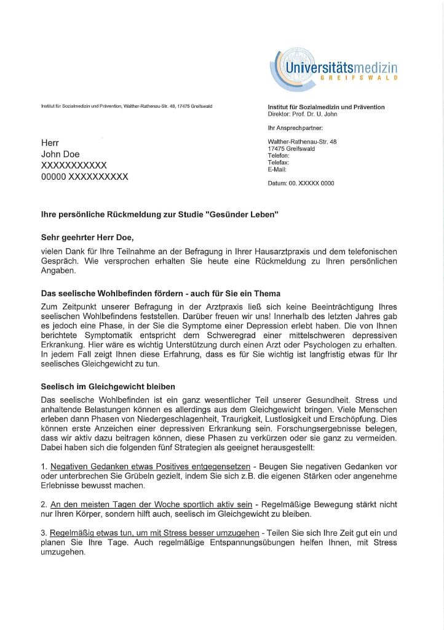
Participant A: Letter 1
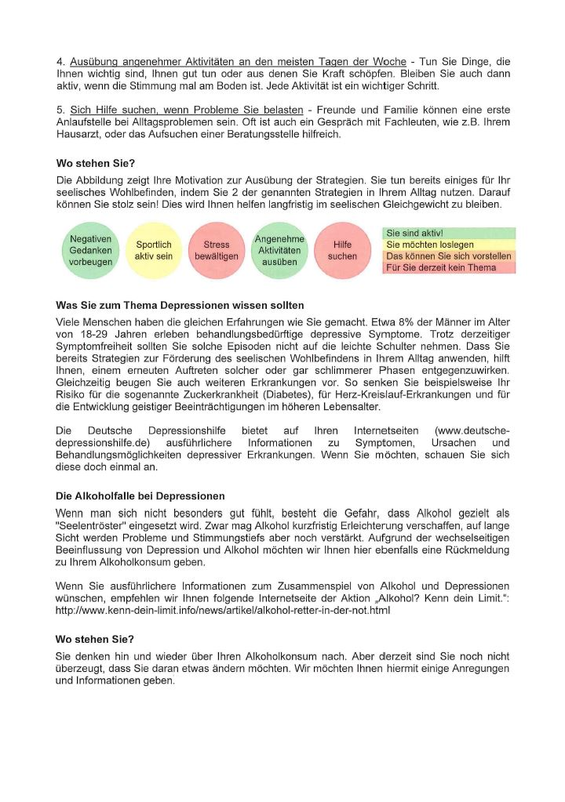
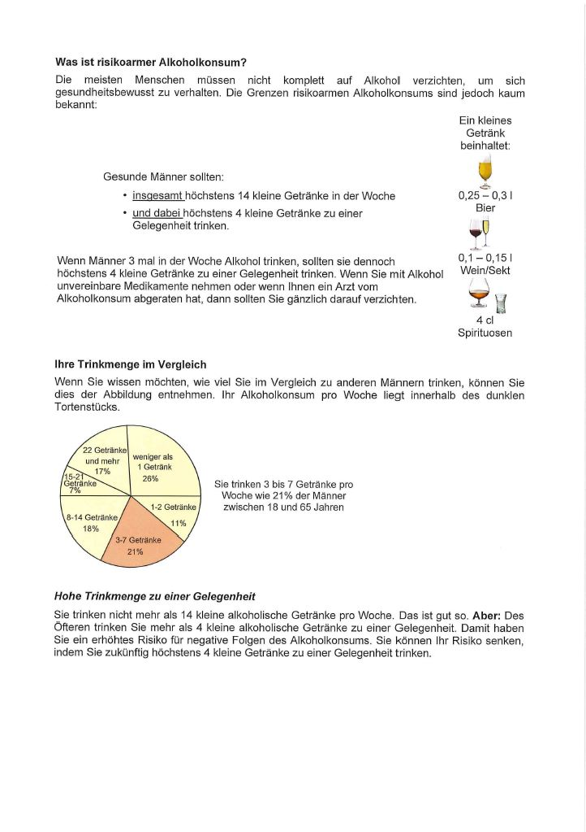
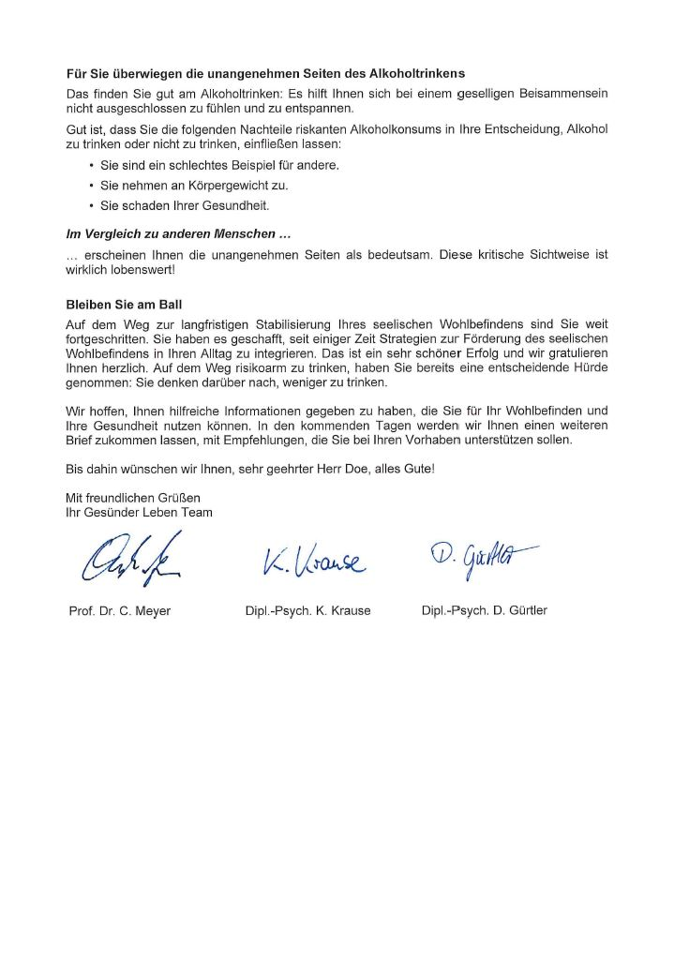
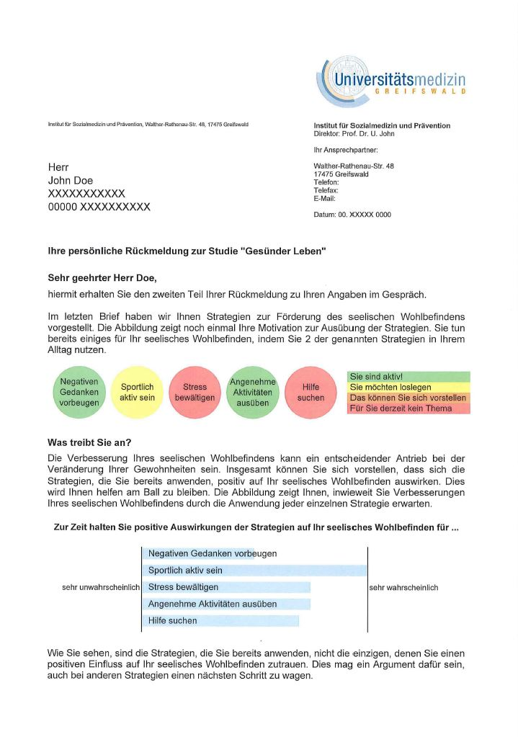
Participant A: Letter 2
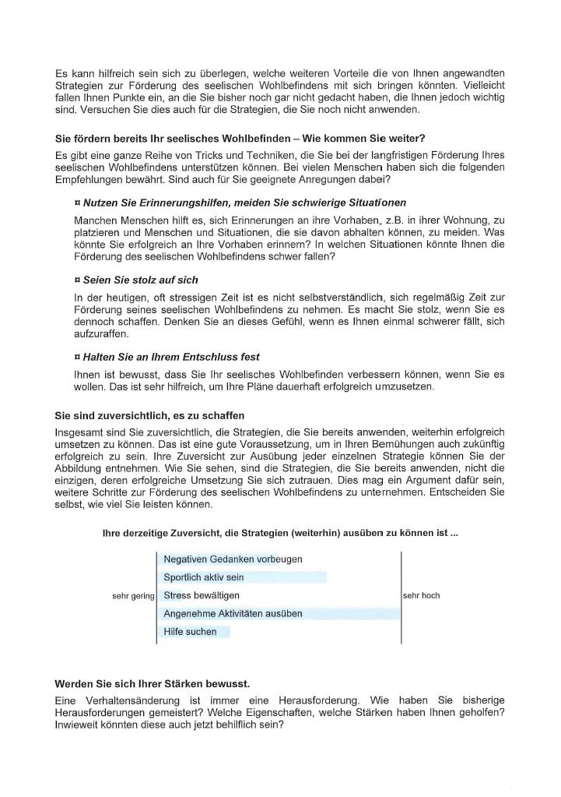
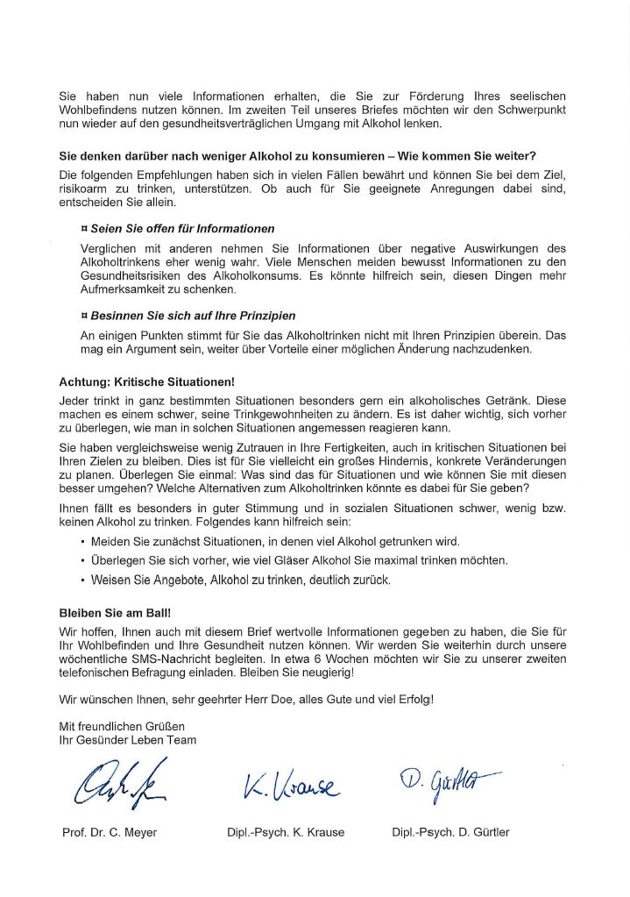
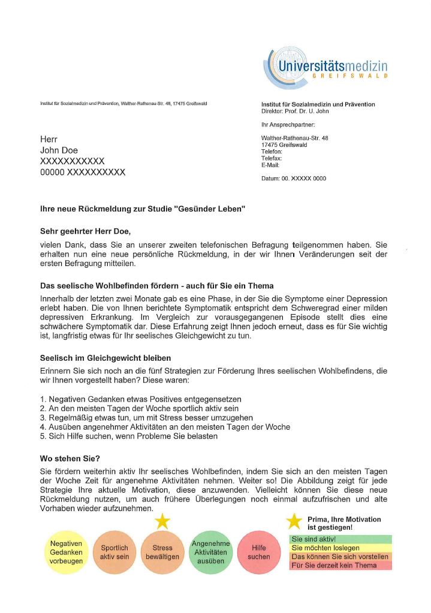
Participant A: Letter 3
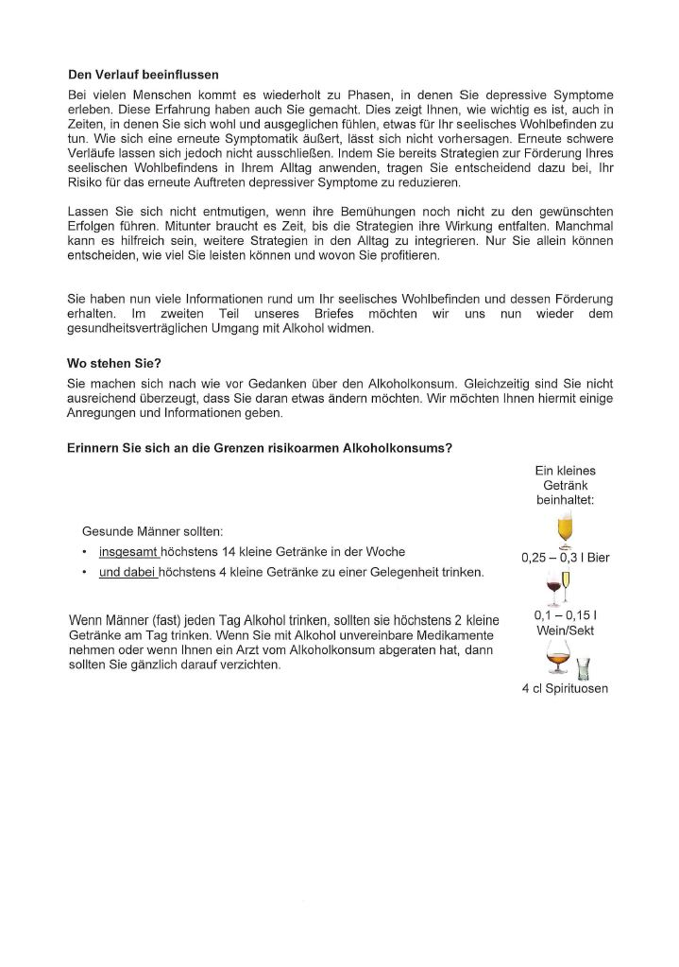
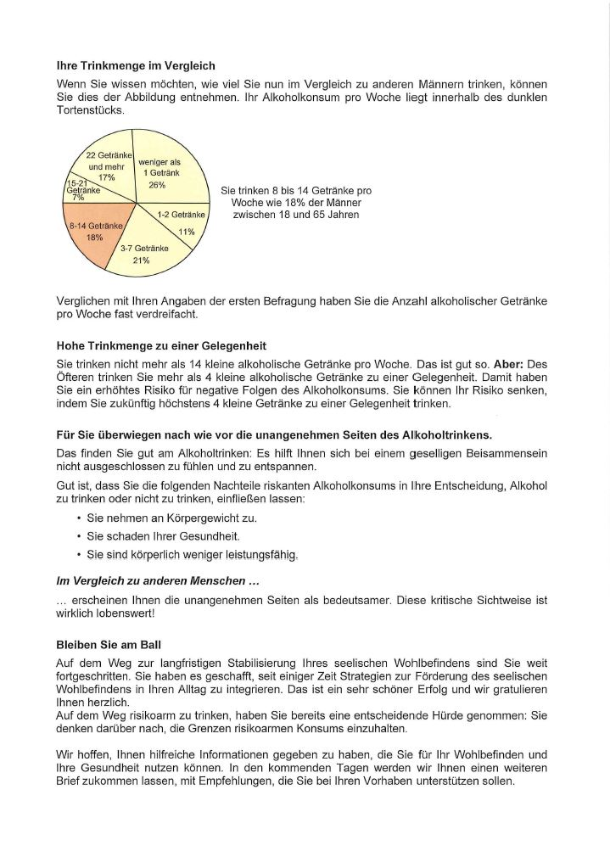
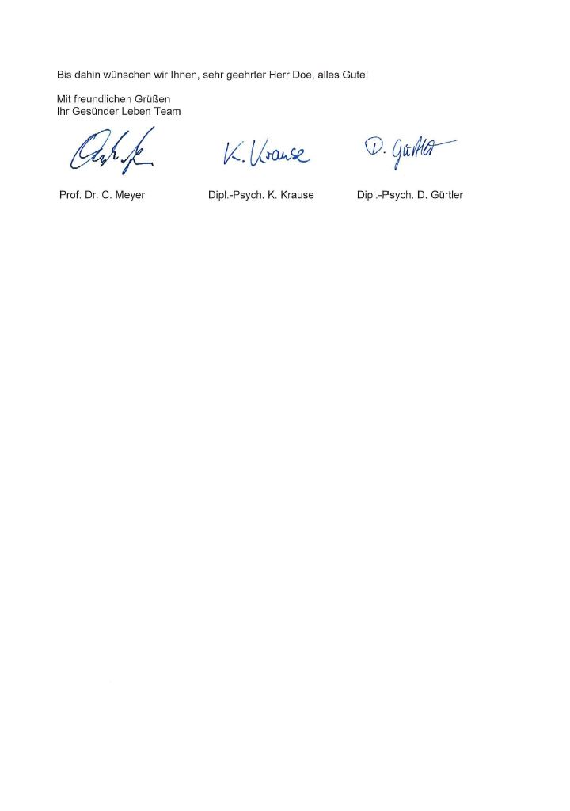
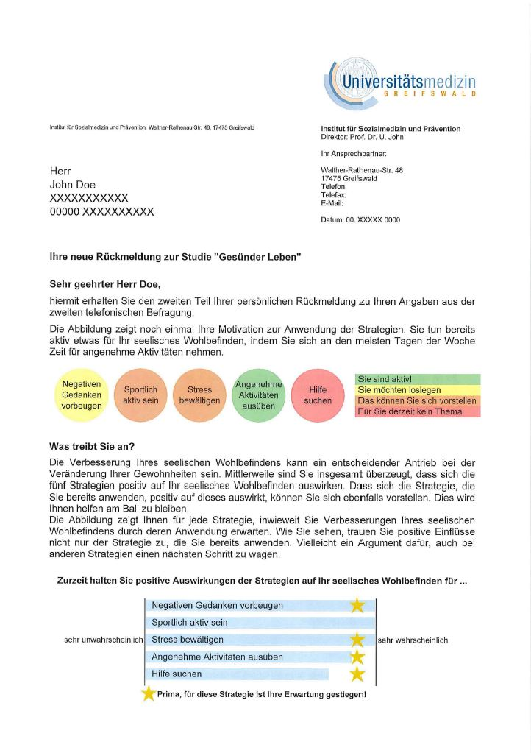
Participant A: Letter 4
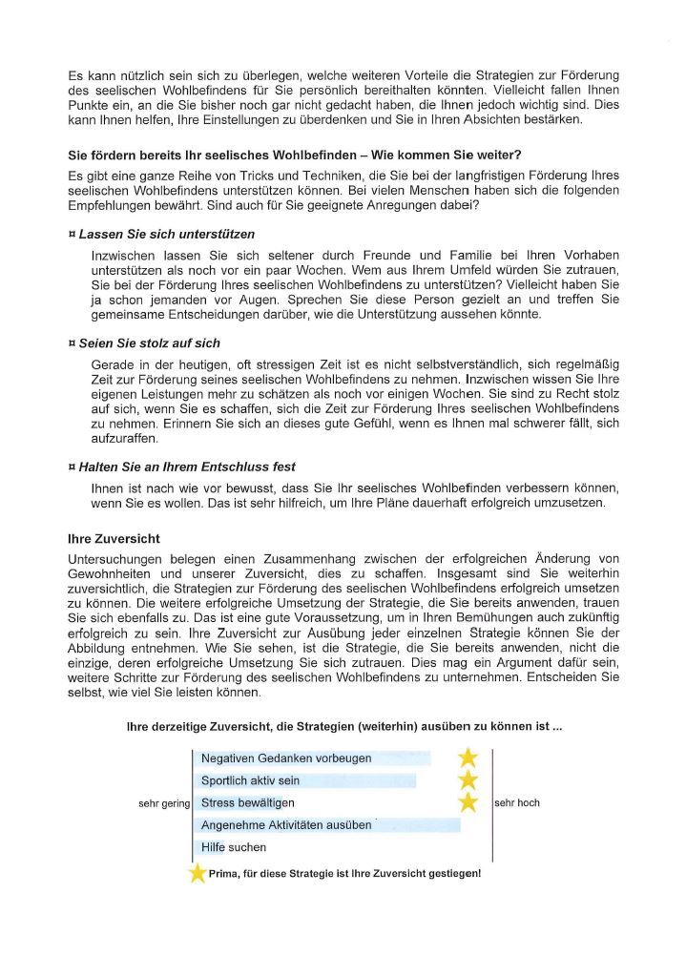
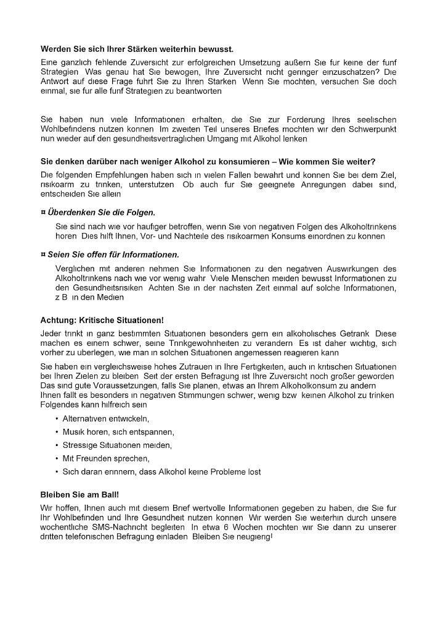
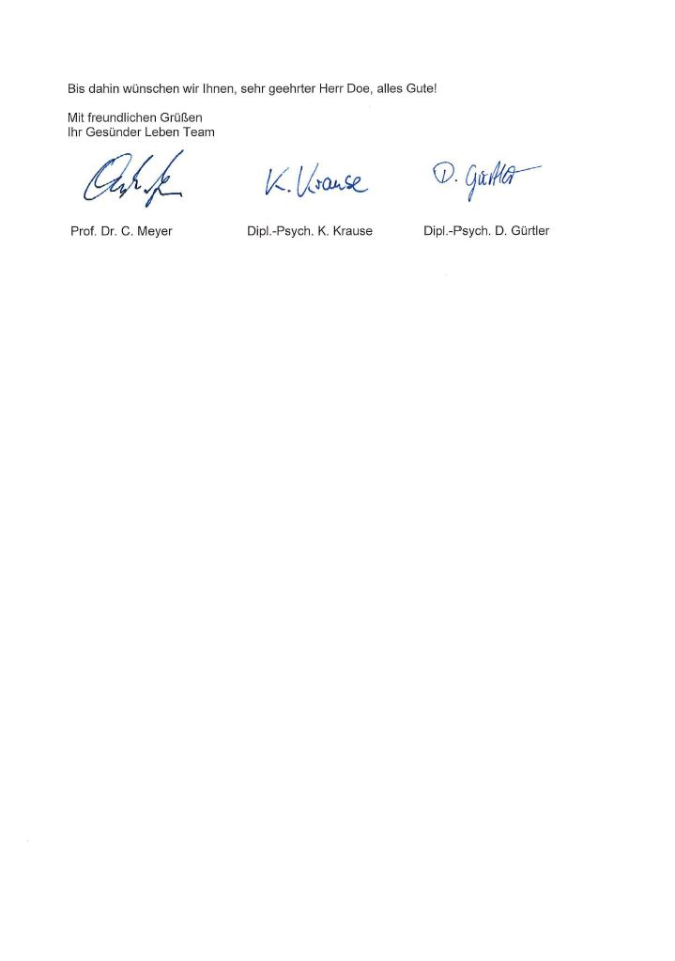
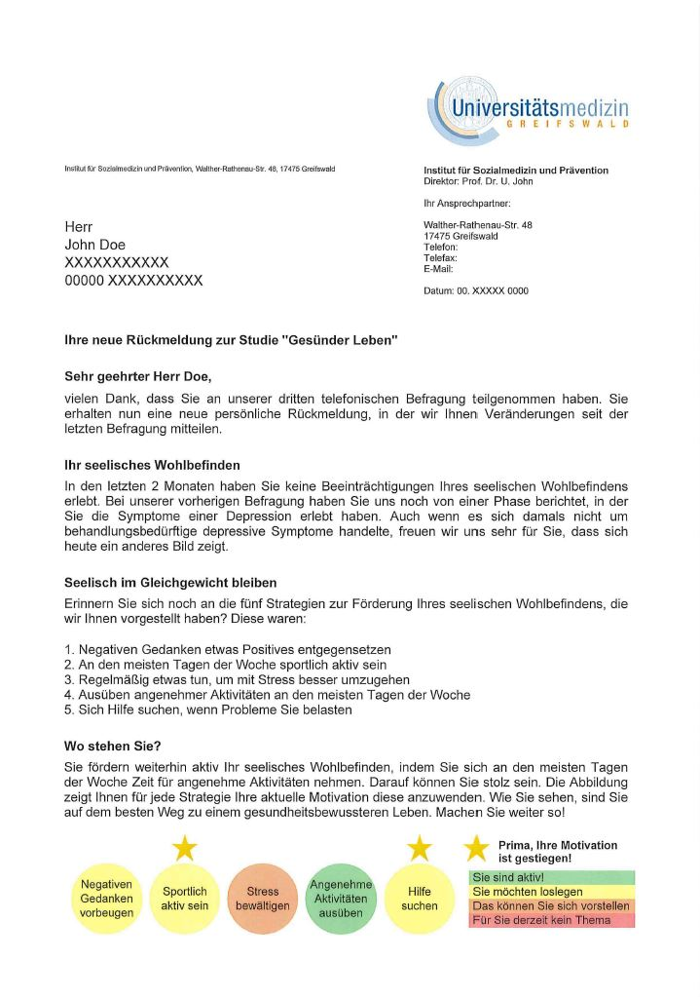
Participant A: Letter 5
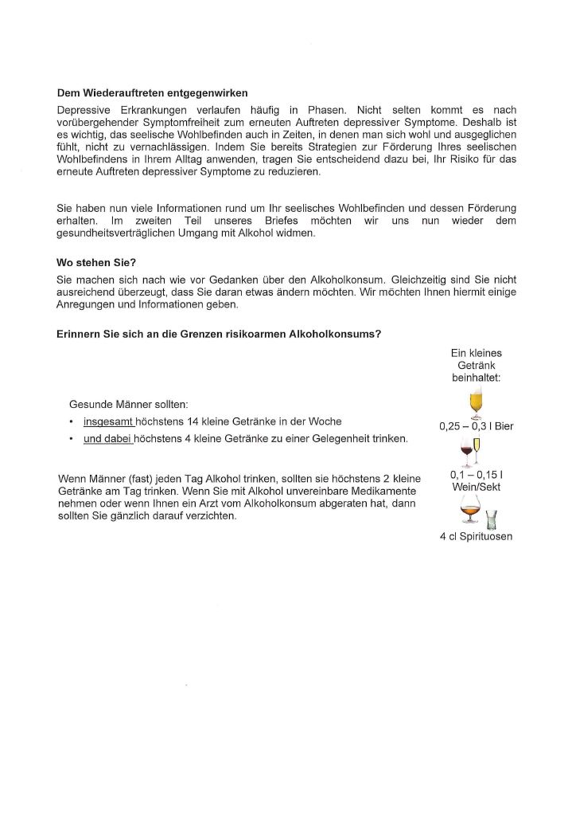
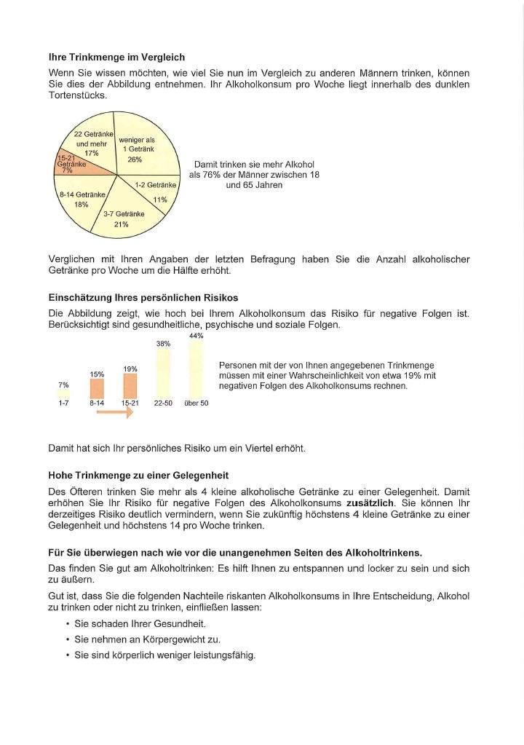
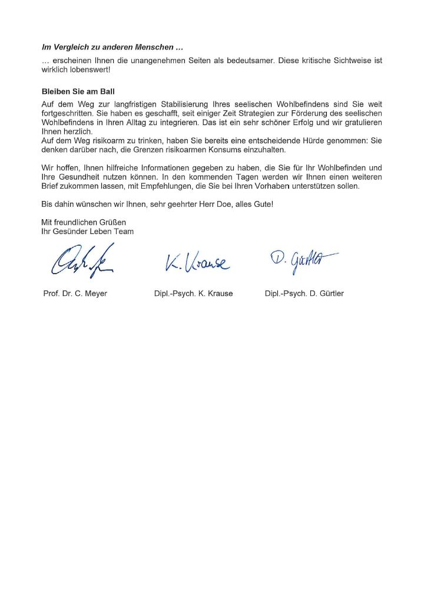
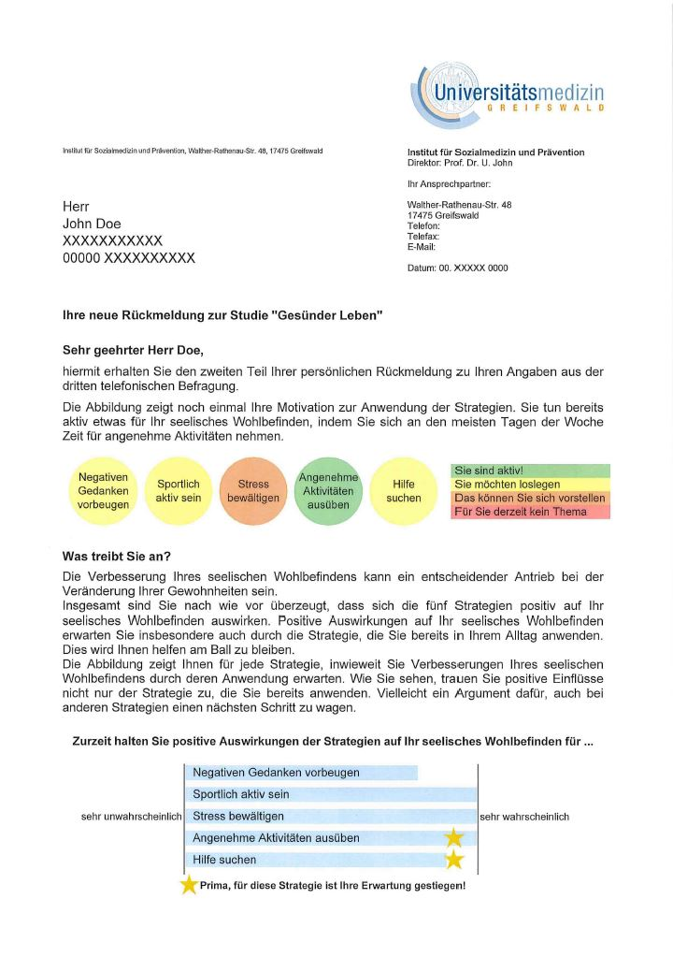
Participant A: Letter 6
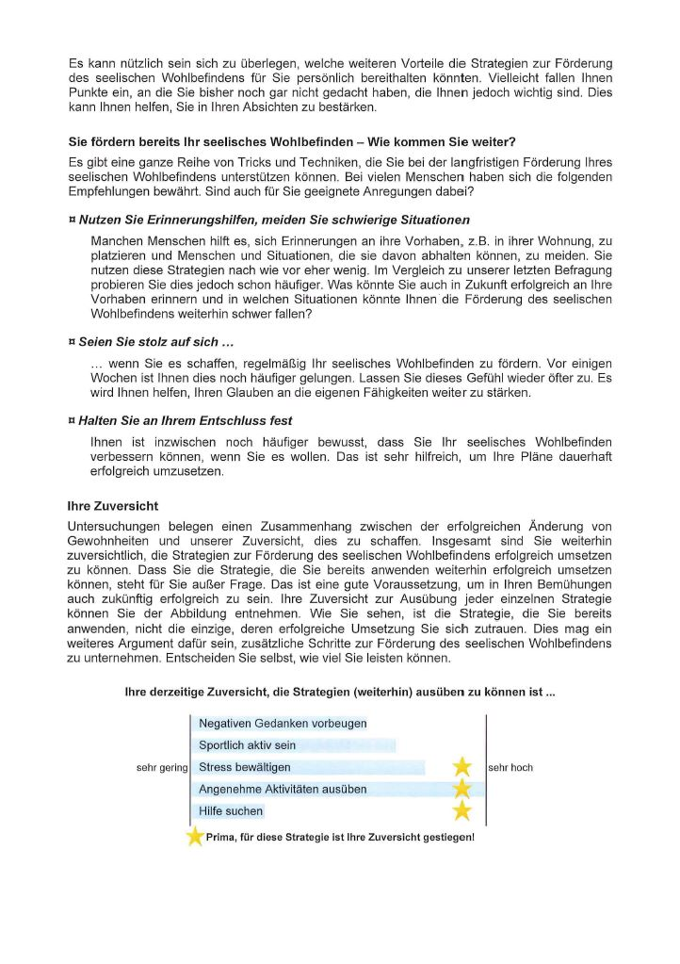
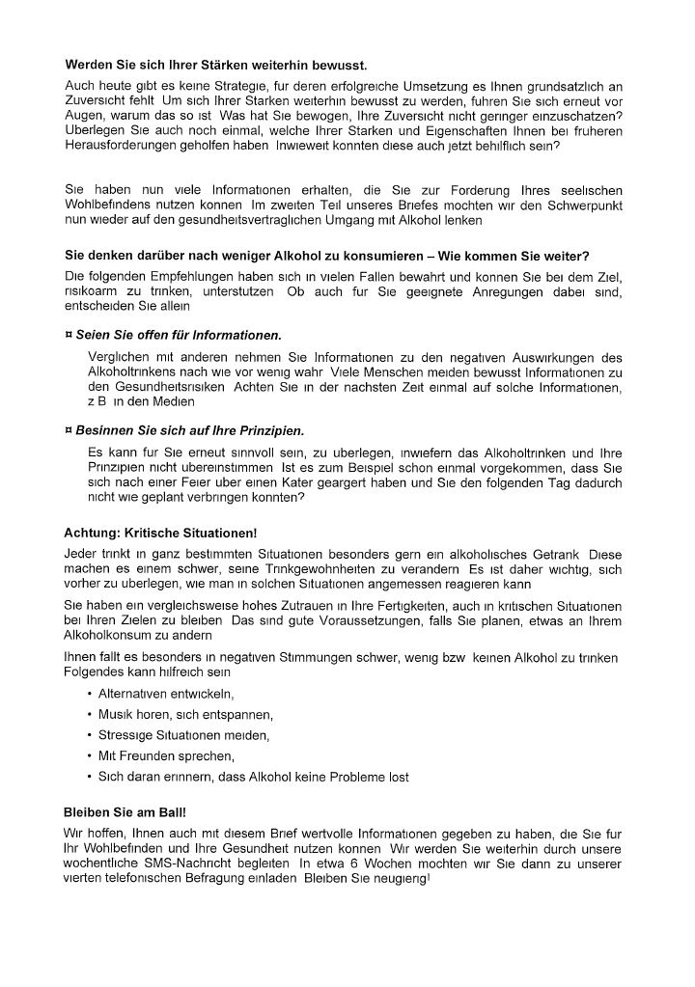
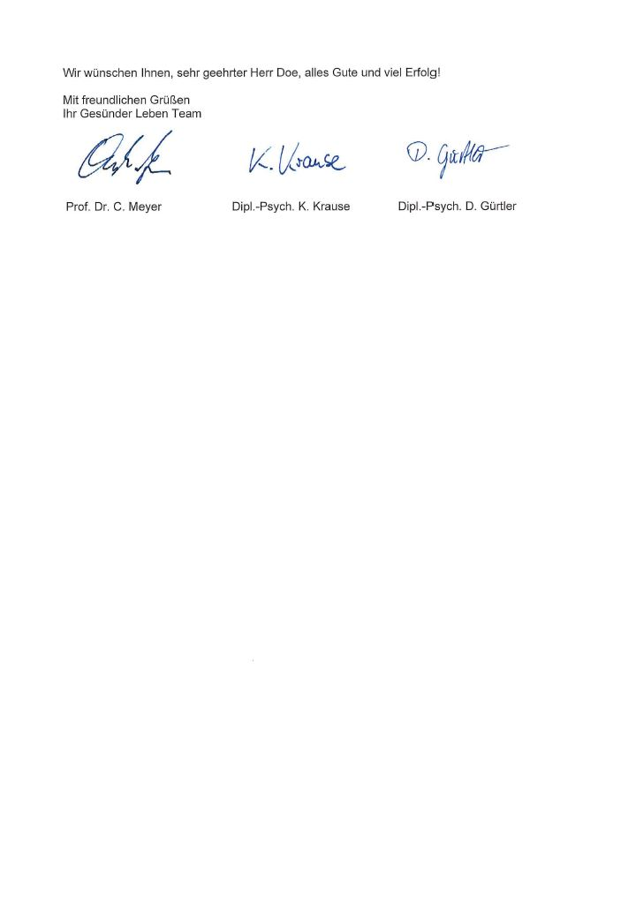
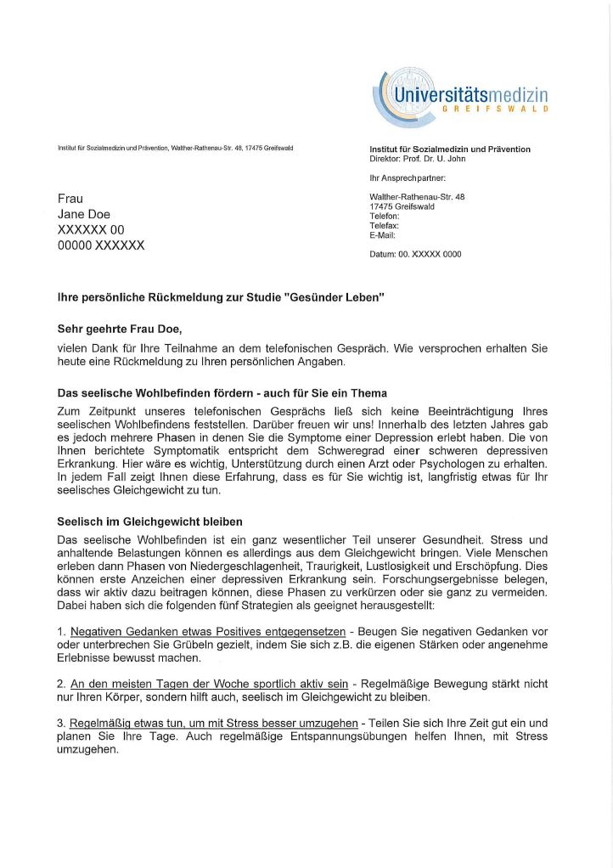
Participant B: Letter 1
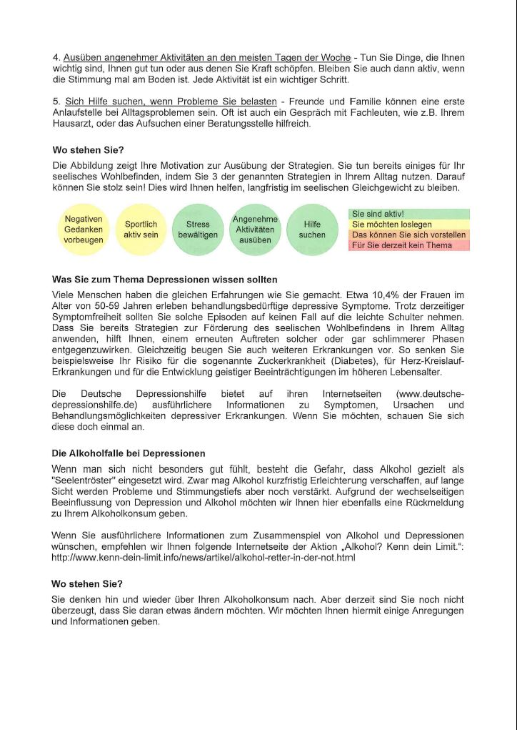
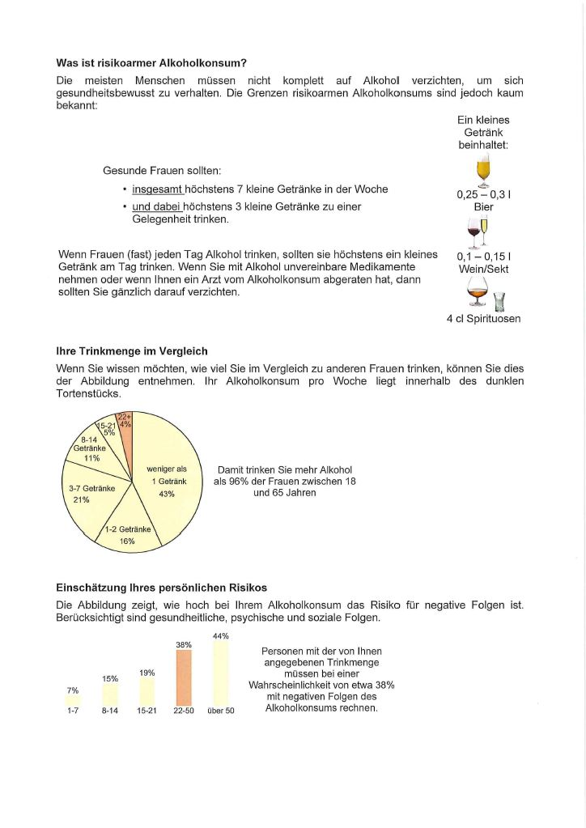
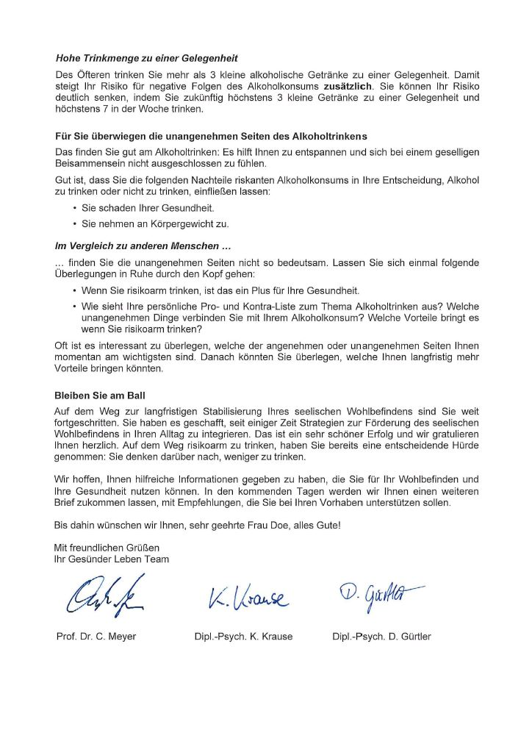
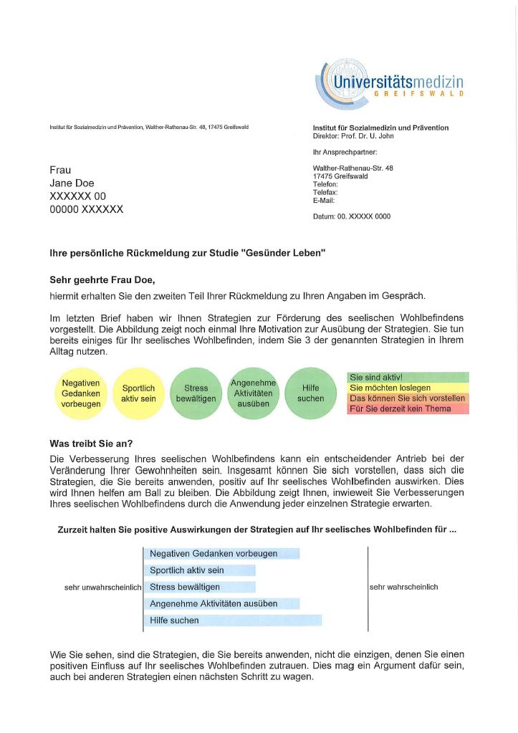
Participant B: Letter 2
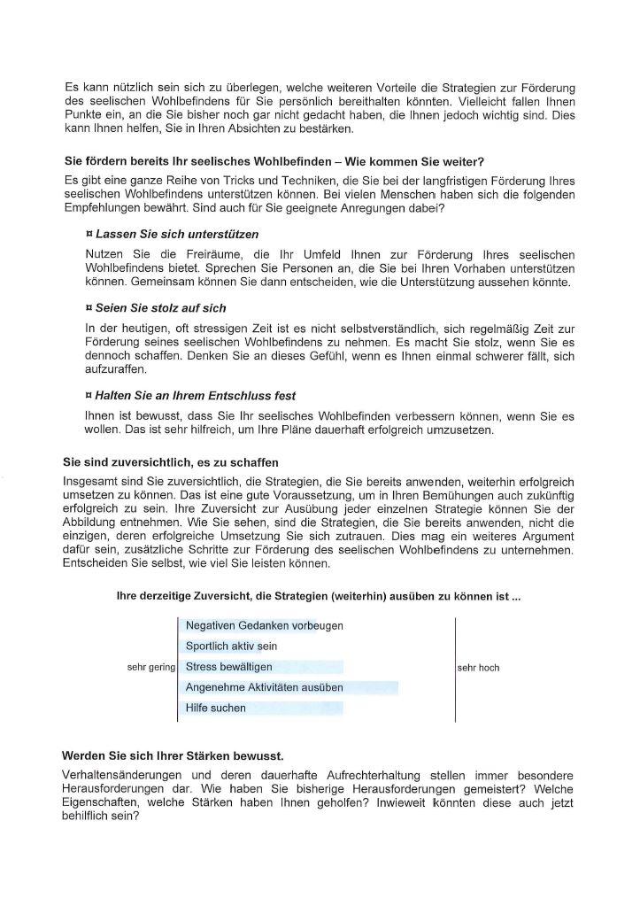
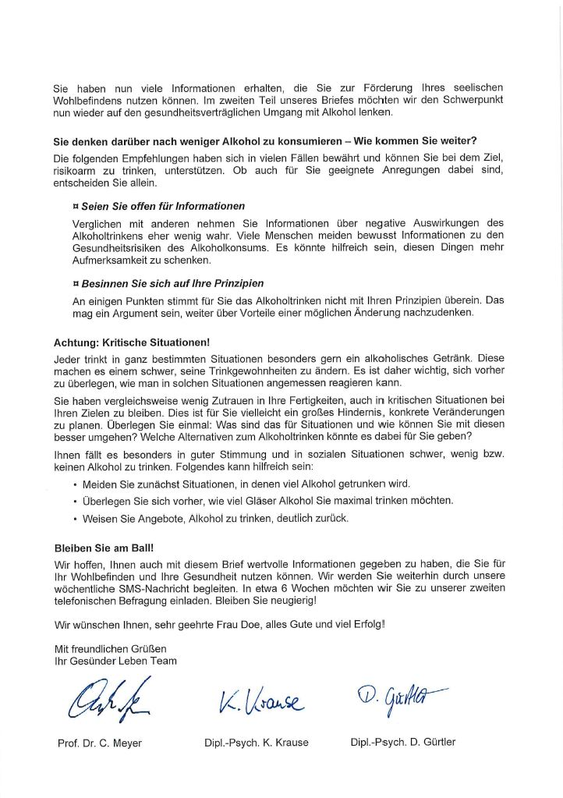
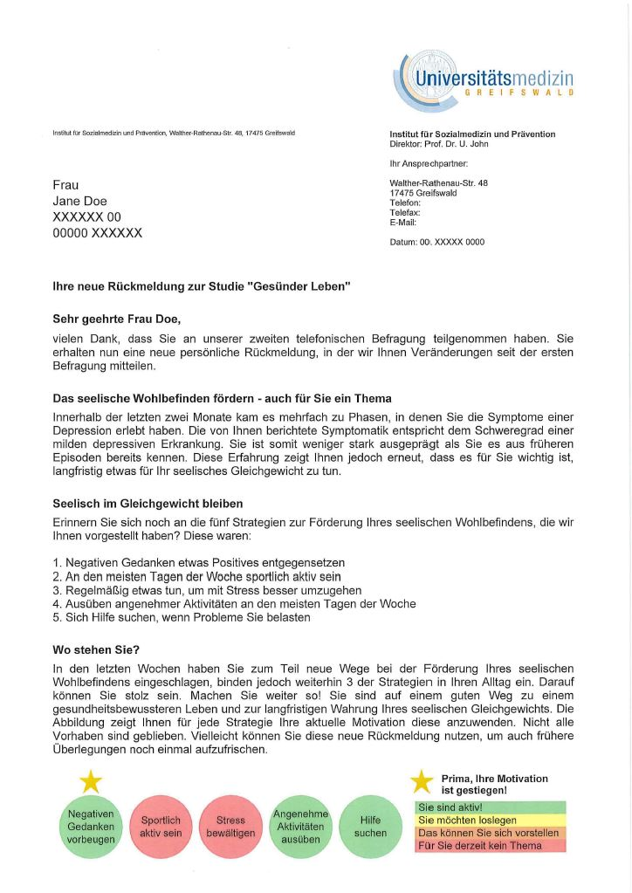
Participant B: Letter 3
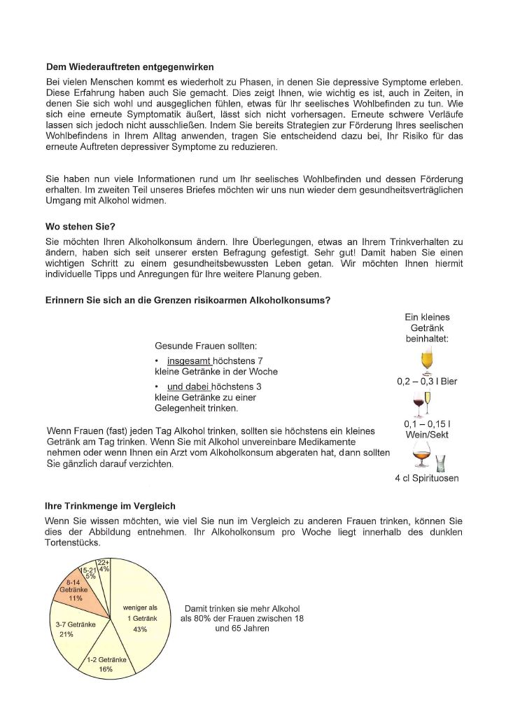
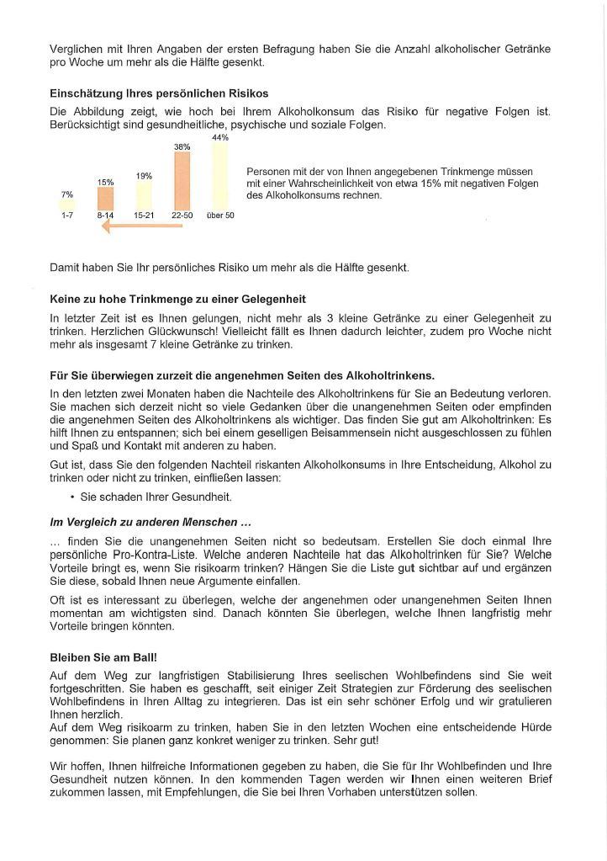
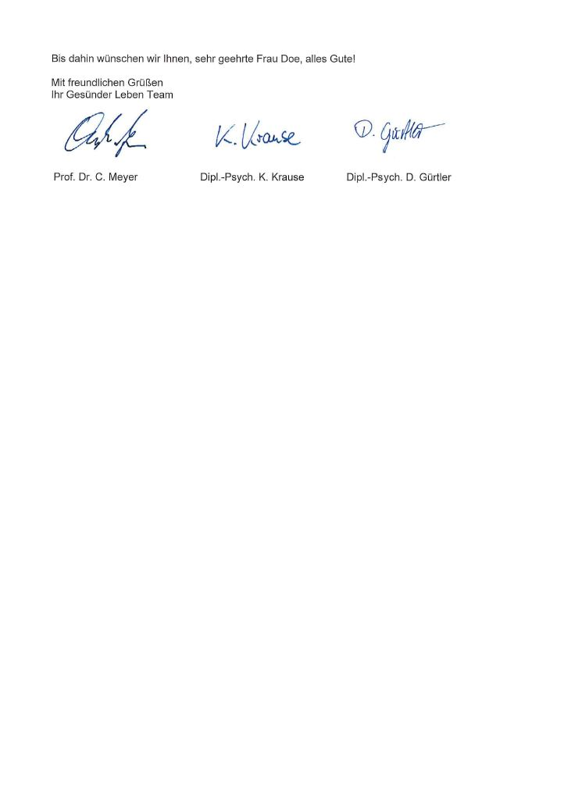
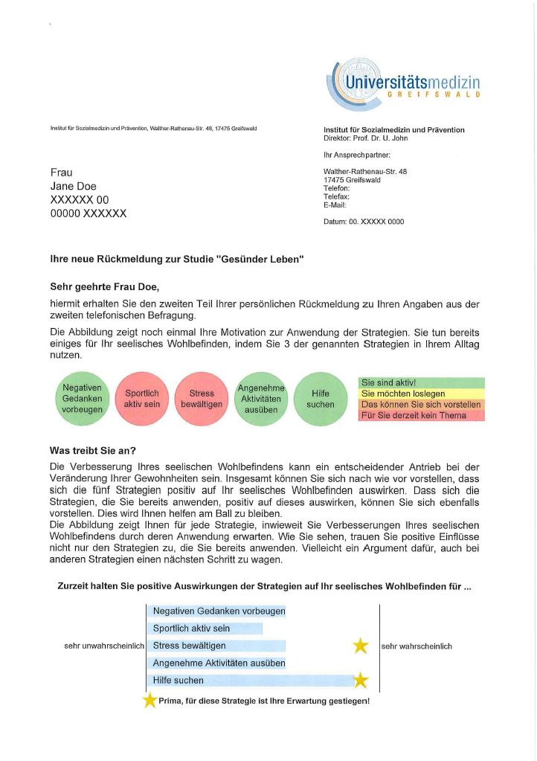
Participant B: Letter 4
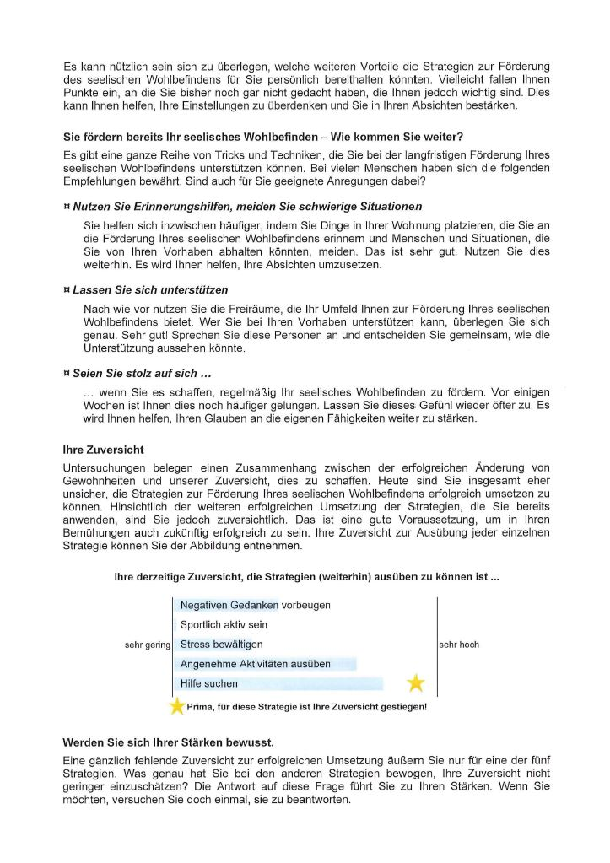
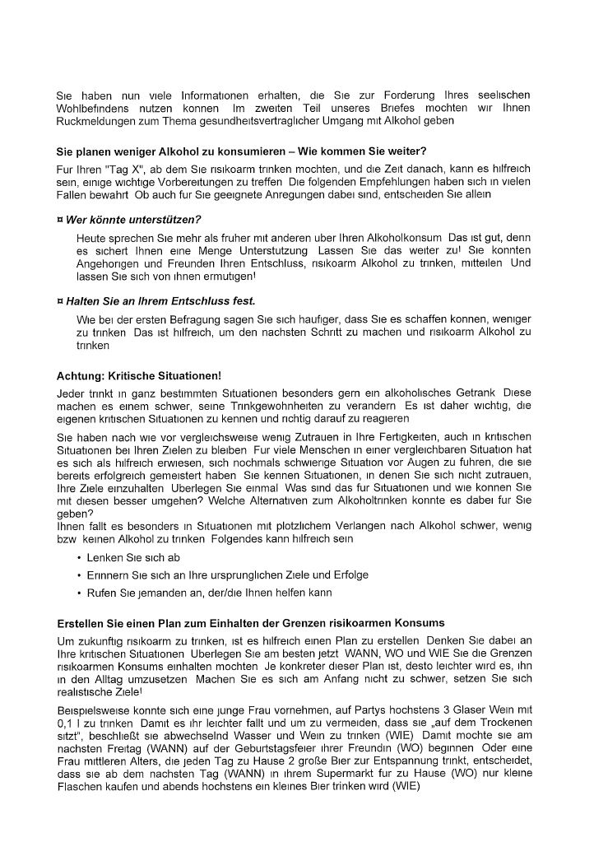
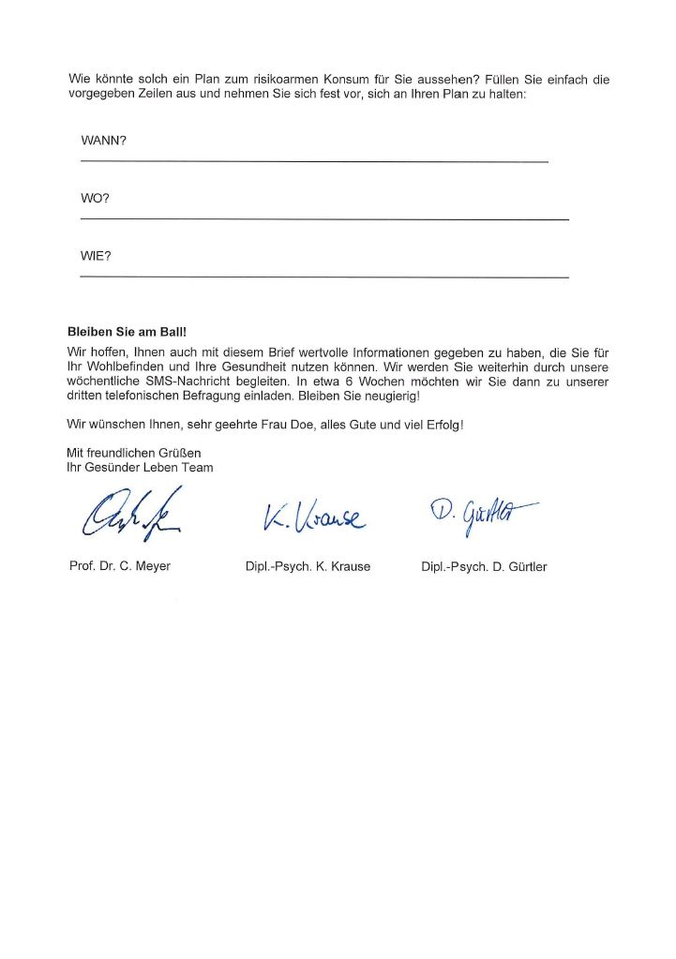
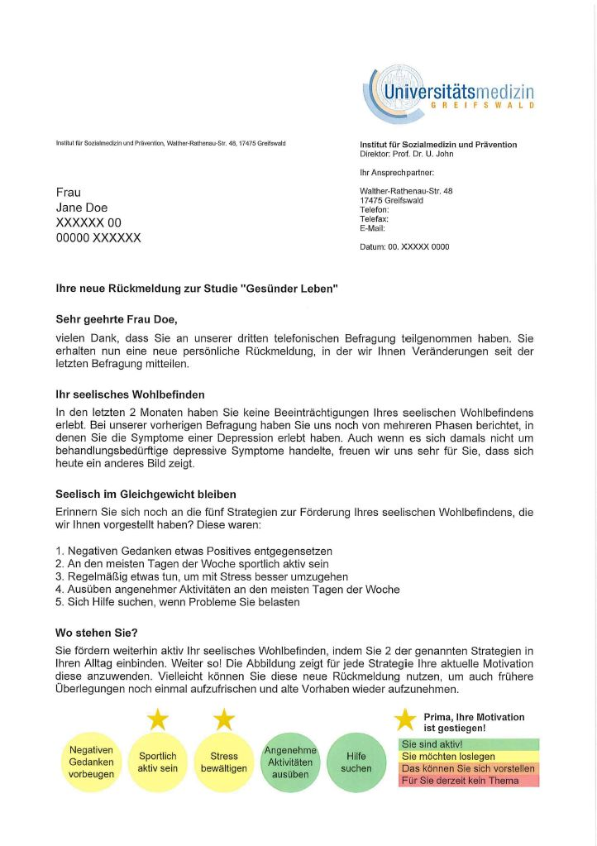
Participant B: Letter 5
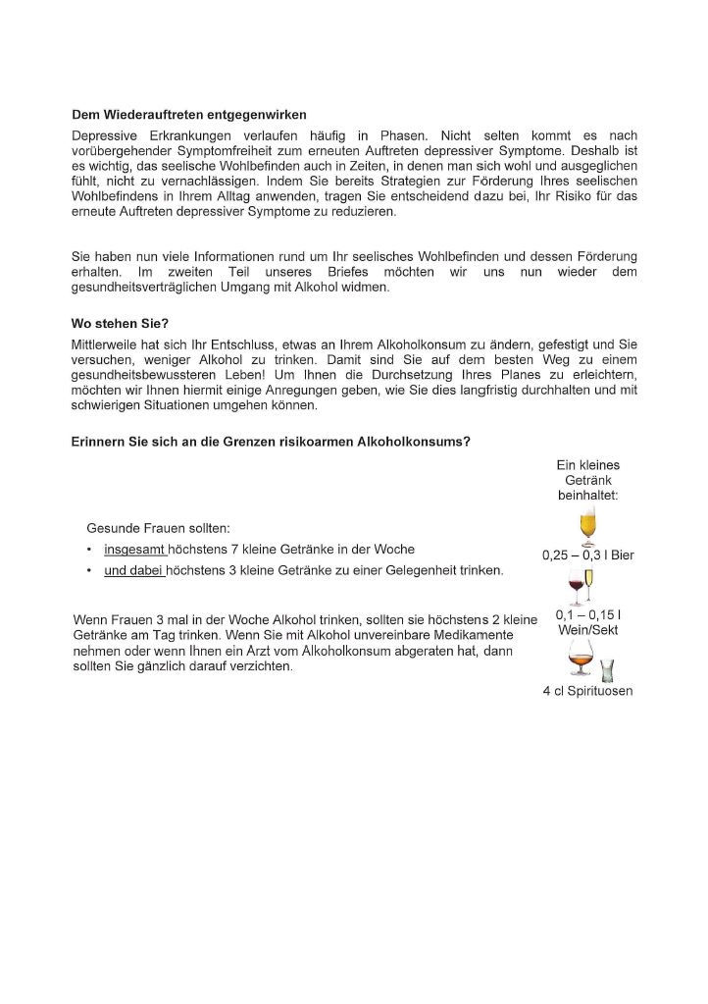
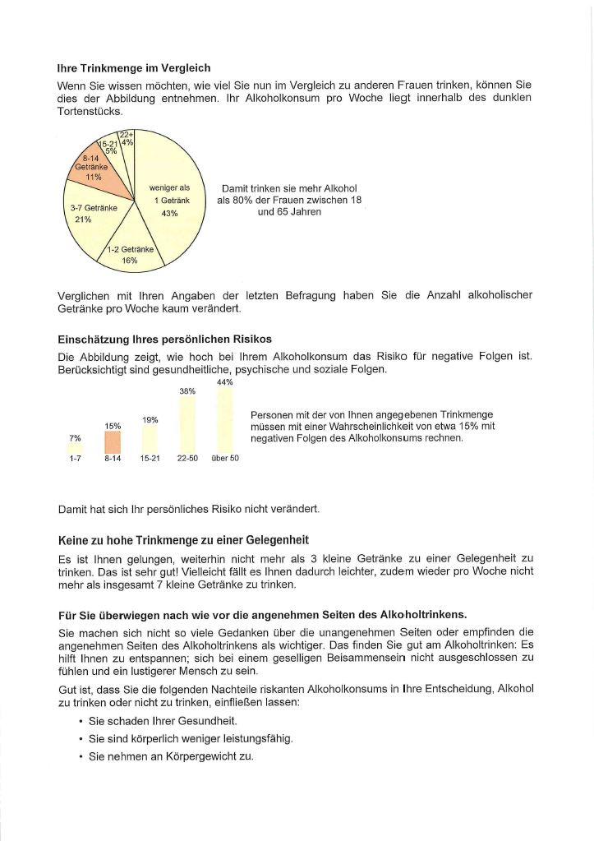
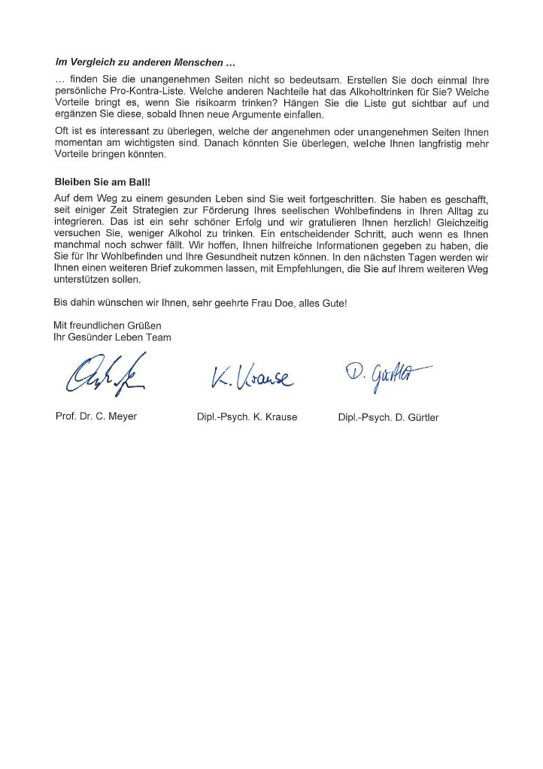
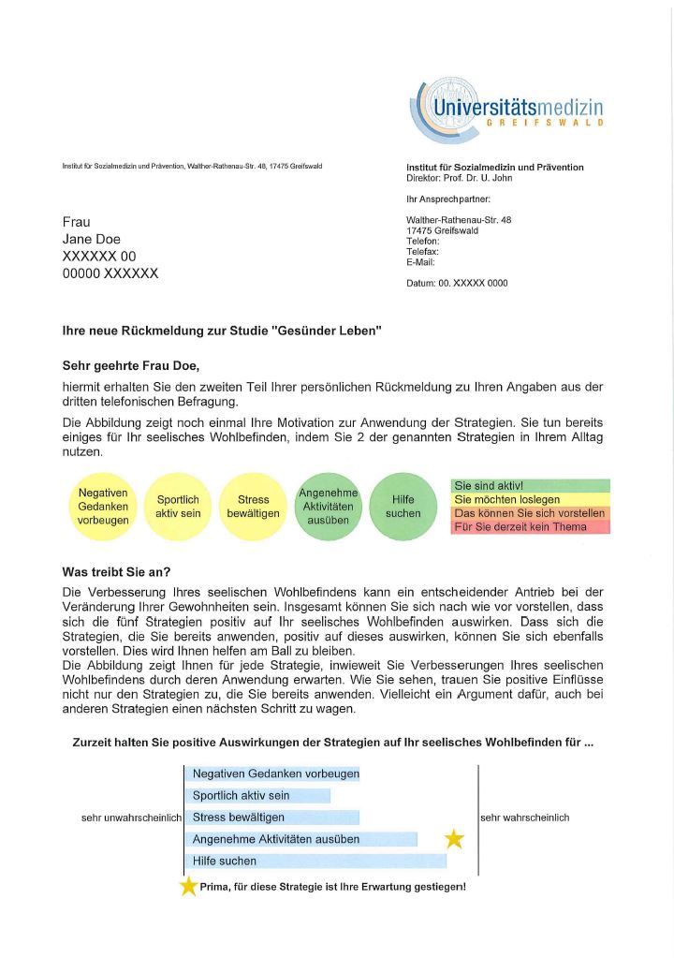
Participant B: Letter 6
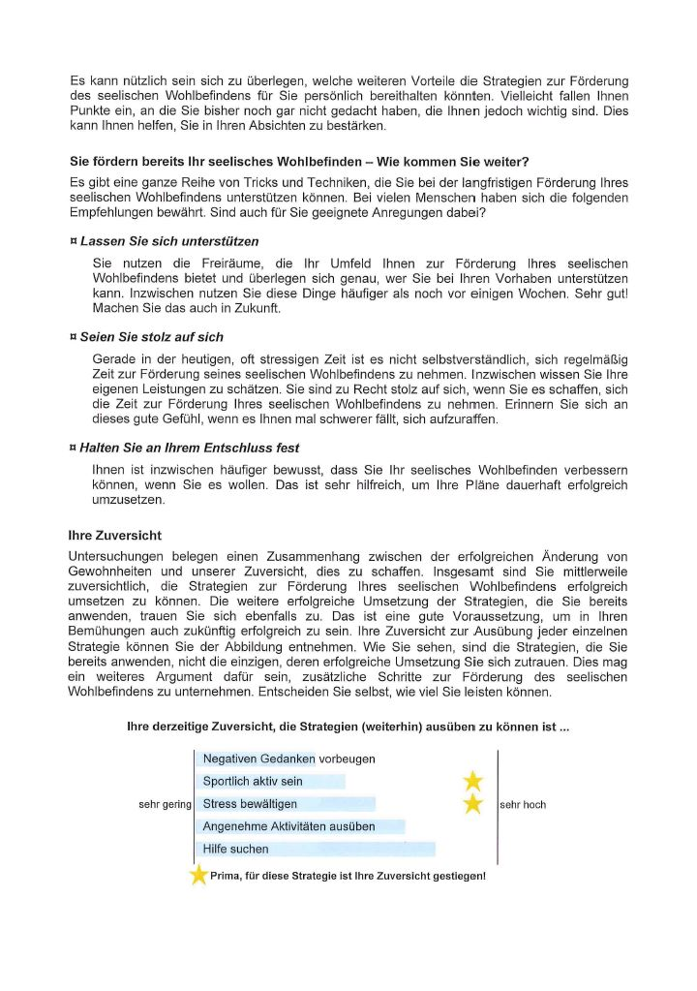
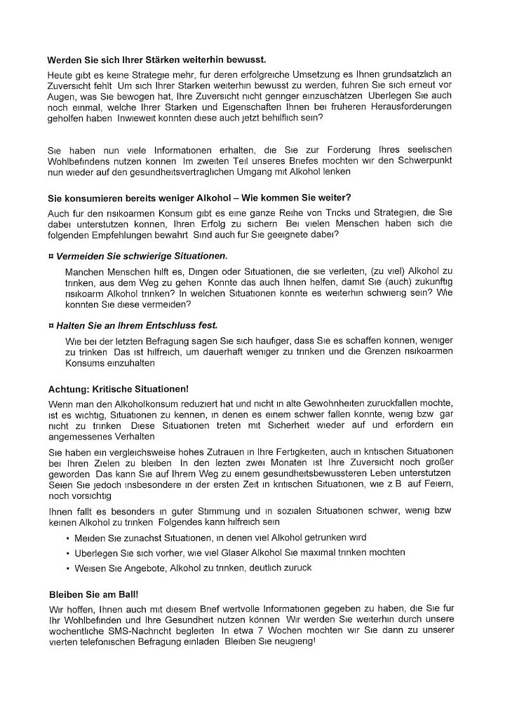
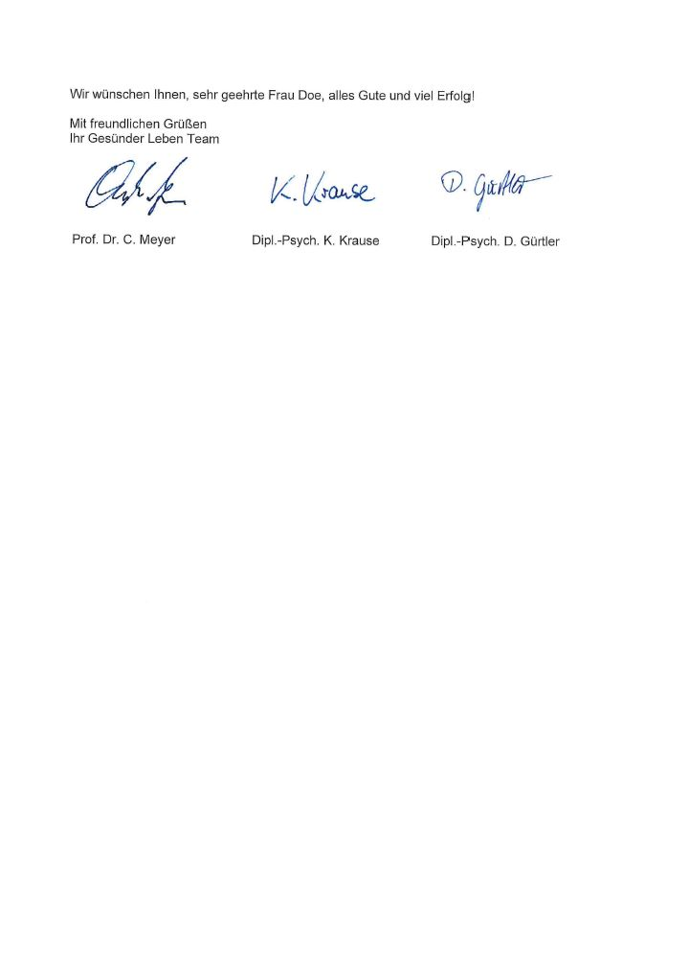

References

1 Velicer WF, Prochaska JO, Bellis JM, DiClemente CC, Rossi JS, Fava JL, Steiger JH: An expert system intervention for smoking cessation. Addict Behav 1993;18:269-290.
2 Prochaska JO, Velicer WF: The transtheoretical model of health behavior change. Am J Health Promot 1997;12:38-48.
3 Levesque DA, Van Marter DF, Schneider RJ, Bauer MR, Goldberg DN, Prochaska JO, Prochaska JM: Randomized trial of a computer-tailored intervention for patients with depression. Am J Health Promot 2011;26:77-89.
4 Busch MA, Maske UE, Ryl L, Schlack R, Hapke U: Prevalence of depressive symptoms and diagnosed depression among adults in Germany. Results of the German Health Interview and Examination Survey for Adults (DEGS1). Bundesgesundheitsblatt Gesundheitsforschung Gesundheitsschutz 2013;56:733-739.
5 Freyer-Adam J, Baumann S, Haberecht K, Tobschall S, Bischof G, John U, Gaertner B: In-Person Alcohol Counseling Versus Computer-Generated Feedback: Results From a Randomized Controlled Trial. Health Psychol 2018;37:70-80.
6 Gander F, Proyer RT, Ruch W, Wyss T: Strength-Based Positive Interventions: Further Evidence for Their Potential in Enhancing Well-Being and Alleviating Depression. J Happiness Stud 2013;14:1241-1259.
7 Nolen-Hoeksema S: Responses to depression and their effects on the duration of depressive episodes. J Abnorm Psychol 1991;100:569-582.
8 Cuijpers P, van Straten A, Warmerdam L: Behavioral activation treatments of depression: A meta-analysis. Clin Psychol Rev 2007;27:318-326.
9 Mazzucchelli T, Kane R, Rees C: Behavioral activation treatments for depression in adults: a meta‐analysis and review. Clin Psychol-Sci Pr 2009;16:383-411.
10 Stetter F, Kupper S: Autogenic Training: A Meta-Analysis of Clinical Outcome Studies. Appl Psychophysiol Biofeedback 2002;27:45-98.
11 Li Y, Wang R, Tang J, Chen C, Tan L, Wu Z, Yu F, Wang X: Progressive muscle relaxation improves anxiety and depression of pulmonary arterial hypertension patients. Evid Based Complement Alternat Med 2015;2015:792895.
12 Mino Y, Babazono A, Tsuda T, Yasuda N: Can stress management at the workplace prevent depression? A randomized controlled trial. Psychother Psychosom 2006;75:177-182.
13 Josefsson T, Lindwall M, Archer T: Physical exercise intervention in depressive disorders: Meta‐analysis and systematic review. Scand J Med Sci Sports 2014;24:259-272.
14 Stathopoulou G, Powers MB, Berry AC, Smits JAJ, Otto MW: Exercise Interventions for Mental Health: A Quantitative and Qualitative Review. Clin Psychol-Sci Pr 2006;13:179-193.
15 Schuch FB, Vancampfort D, Firth J, Rosenbaum S, Ward PB, Silva ES, Hallgren M, De Leon AP, Dunn AL, Deslandes AC, Fleck MP, Carvalho AF, Stubbs B: Physical Activity and Incident Depression: A Meta-Analysis of Prospective Cohort Studies. Am J Psychiatry 2018;175:631-648.
16 Seligman ME, Steen TA, Park N, Peterson C: Positive psychology progress: empirical validation of interventions. Am Psychol 2005;60:410.

