Comparison of 24-hour and office pulse wave velocity for prediction of mortality in hemodialysis patients
Supplementary Material

Julia Matschkal^{1*}, Christopher C. Mayer^{2,3*}, Pantelis A. Sarafidis⁴, Georg Lorenz¹, Matthias C. Braunisch¹, Roman Günthner¹, Susanne Angermann¹, Dominik Steubl¹, Stephan Kemmner¹, Quirin Bachmann¹, Christine Hauser¹, Louisa Nerl¹, Marcus Baumann⁵, Johannes F. Mann⁶, Philipp Moog¹, Claudius Küchle¹, Lutz Renders¹, Uwe Heemann^{1,} Siegfried Wassertheurer^{2,3} and Christoph Schmaderer¹

¹ Department of Nephrology, Klinikum rechts der Isar, Technical University Munich, Munich, Germany
² Center for Health & Bioresources, Biomedical Systems, AIT Austrian Institute of Technology, Vienna, Austria
³ Institute for Analysis and Scientific Computing, Vienna University of Technology, Vienna, Austria
⁴ Department of Nephrology, Hippokration Hospital, Aristotle University of Thessaloniki, Thessaloniki, Greece
⁵ Department of Nephrology, Internistische Fachklinik Dr. Steger, Nuremberg, Germany
⁶ KfH Dialysis Center Schwabing, Munich, Germany
* authors contributed equally to the work

Summary of Supplementary Material

Supplementary Figure 1: Unadjusted Kaplan-Meier estimates for cardiovascular-mortality: (A) tertiles of 24h-PWV and (B) tertiles of Office-PWV. Log-rank-test was used to compare tertiles. T = tertile
Supplementary Table 1: Cox regression analysis for cardiovascular mortality (total cohort)
Supplementary Table 2: Cox regression analysis for cardiovascular mortality in patients without heart failure and atrial fibrillation.
Supplementary Table 3: Comparison of the study population with excluded patients
Supplementary Table 4: Analysis of ROC-curves and calculation of threshold-values for 24h-PWV

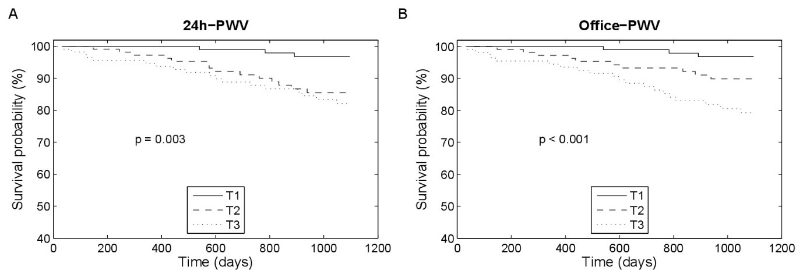
Supplementary Figure 1: Unadjusted Kaplan-Meier estimates for cardiovascular-mortality: (A) tertiles of 24h-PWV and (B) tertiles of Office-PWV. Log-rank-test was used to compare tertiles. T = tertile

Supplementary Table 1: Cox regression analysis for cardiovascular mortality (total cohort)
 | 24-hour values  n = 344 |  |  | Office-values  n = 344
PWV | HR [95%-CI] | P-value |  | HR [95%-CI] | P-value
Unadjusted PWV | 1.35 [1.13-1.61] | 0.001 |  | 1.35 [1.13-1.61] | 0.001
Adjusted PWV
Model 1 │ | 1.38 [0.46-4.18] | 0.6 |  | 0.95 [0.37-2.43] | 0.9
Model 2 ┼ | 1.73 [0.59-5.11] | 0.3 |  | 1.09 [0.44-2.69] | 0.9
Supplementary Table 1: Cox regression analysis for cardiovascular mortality (total cohort).
│ Adjusted for mean blood pressure and age*
┼ Adjusted for Model 1 + CCI
*quadratic-transformation for age

Supplementary Table 2: Cox regression analysis for cardiovascular mortality in patients without heart failure and atrial fibrillation
 | 24-hour values  n = 239 |  |  | Office values  n = 239
PWV | HR [95%-CI] | P-value |  | HR [95%-CI] | P-value
Unadjusted PWV | 1.42 [1.11-1.83] | 0.006 |  | 1.37 [1.06-1.77] | 0.02
Adjusted PWV
Model 1 │ | 6.11 [1.35-27.64] | 0.02 |  | 1.79 [0.41-7.71] | 0.4
Model 2 ┼ | 6.36 [1.23-32.16] | 0.03 |  | 1.74 [0.40-7.59] | 0.5
Supplementary Table 2: Cox regression analysis for cardiovascular mortality in patients without heart failure and atrial fibrillation.
│ Adjusted for mean blood pressure and age*
┼ Adjusted for Model 1 + CCI
* quadratic-transformation for age

Supplementary Table 3: Comparison of the study population with excluded patients
 | Study population  N = 344 | Excluded patients  N = 175 | p-value
Clinical characteristics
Age – yr | 69.3 [55.7-77.2] | 65.5 [52.6-77.0] | 0.34
Male sex – no. (%) | 234 (68) | 124 (71) | 0.80
BMI – kg/m² | 25.2 [22.8-28.7] | 25.3 [22.4-28.7] | 0.81
Ultrafiltration rate – ml/h | 501 ± 248 | 510 ± 265 | 0.71
Vintage of dialysis – m | 41.1 [22.7-76.6] | 44.8 [21.6-83.8] | 0.29
Dialysis catheter – no. (%) | 21 (6) | 17 (10) | 0.33
Comorbidities
aCCI | 3.0 [1.0-6.0] | 3.0 [1.0-7.0] | 0.73
Vascular disease* – no. (%) | 198 (58) | 104 (59) | 0.92
Diabetes – no. (%) | 135 (39) | 74 (42) | 0.80
History of hypertension – no. (%) | 326 (95) | 163 (93) | 0.75
History of myocardial infarction – no. (%) | 72 (21) | 31 (18) | 0.69
Atrial fibrillation/pacemaker – no. (%) | 69 (20) | 36 (21) | 0.99
Heart failure – no. (%) | 62 (18) | 37 (21) | 0.69
Laboratory parameters
hs-CRP – mg/dl | 0.5 [0.2-1.0] | 0.4 [0.2-1.0] | 0.46
Calcium-phosphorus product – mg²/dl² | 3.85 ± 1.15 | 4.14 ± 1.35 | 0.01
Albumin – g/dl | 4.0 ± 0.4 | 3.9 ± 0.4 | 0.18
Hemoglobin – g/dl | 11.7 ± 1.2 | 11.8 ± 1.2 | 0.41
Kt/V | 1.48 ± 0.39 | 1.49 ± 0.34 | 0.48
Medication
Use of BP medication – no. (%) | 314 (91) | 158 (90) | 0.93
Use of phenprocoumon – no. (%) | 52 (15) | 31 (18) | 0.75
Use of statins - no. (%) | 136 (40) | 60 (34) | 0.51
Supplementary Table 3: Comparison of the study population with excluded patients. Continuous variables with normal distributed data are described as mean and standard deviation, skewed data as median and interquartile range. Categorical variables are expressed as number and percentage. *Vascular disease included coronary artery disease, cerebrovascular disease, peripheral vascular disease and arteriosclerosis. Abbreviations: BMI = body-mass-index, aCCI = adapted Charlson-Comorbidity-Index, hs-CRP = high-sensitive C-reactive protein, Kt/V = clearance of urea x time / volume.

Supplementary Table 4: Analysis of ROC-curves and calculation of threshold-values for 24h-PWV
 | threshold-value [m/s] | AUC [95%-CI]
all-cause mortality  - Study population  - Patients without HF/AF | 9.1  9.5 | 0.681 [0.629-0.730]  0.686 [0.623-0.744]
cardiovascular mortality  - Study population  - Patients without HF/AF | 9.3  9.5 | 0.670 [0.617-0.719]  0.706 [0.644-0.763]
Supplementary Table 4: Analysis of ROC-curves and calculation of threshold-values for 24h-PWV. AUC with 95%-CI. Abbreviations: ROC = receiver operating characteristic; AUC= area under the curve; CI = confidence-interval; PWV = pulse wave velocity; HF = heart failure; AF = atrial fibrillation

