SUPPLEMENTAL MATERIALS

Modeled daily ingested and absorbed plus bound phosphorus: New measures of mineral balance in hemodialysis patients

by T. Kapoian et al. Am J Nephrol, 2019.
14 Mar 2019

Supplemental Materials Table S1. Association of diet and compliance questionnaire results with laboratory and modeled values (all patients, with and without residual kidney function).
 | Phosphorus additives in diet |  |  |  | Dietary protein content |  |  |  | Protein Source
 | Low | Medium | High | P* | Low | Medium | High | P | Mostly V | Mixed | Mostly A | P
Predialysis serum P (mg/dL) | 4.73 (0.83) | 5.17 (1.00) | 5.92 (1.53) | <0.001 | 5.10 (0.71) | 5.17 (1.18) | 5.63 (1.38) | 0.043 | 5.27 (0.72) | 5.14 (1.07) | 5.45 (1.35) | 0.268
Predialysis serum P (mmol/L) | 1.53  (0.27) | 1.67  (0.32) | 1.91  (0.49) | <0.001 | 1.65  (0.23) | 1.67  (0.38) | 1.82  (0.44) | 0.043 | 1.70  (0.23) | 1.66  (0.35) | 1.76  (0.44) | 0.268
EBD (g/day) | 2.87 (1.99) | 4.61 (3.18) | 6.33 (3.88) | < 0.001 | 4.04 (3.07) | 4.26 (3.06) | 5.86 (3.71) | 0.0065 | 4.93 (3.04) | 4.37 (3.31) | 5.06 (3.45) | 0.426
DABP (mg/day) | 554 (127) | 732 (205) | 921 (321) | <0.001 | 645 (210) | 699 (220) | 877 (297) | <0.001 | 711 (236) | 700 (231) | 796 (282) | 0.059
PCR (g/day) | 44.7 (11.6) | 58.9 (17.3) | 63.5 (21.4) | <0.001 | 44.0 (12.8) | 54.0 (16.5) | 67.9 (19.1) | <0.001 | 43.3 (12.2) | 55.1 (18.4) | 60.8 (18.8) | 0.0083
DABP / PCR ratio | 13.0 (3.88) | 13.0 (3.94) | 15.0 (5.12) | 0.020 | 15.2 (4.59) | 13.5 (4.59) | 13.3 (3.94) | 0.021 | 17.0 (4.67) | 13.3 (4.24) | 13.6 (4.38) | 0.060
DIP (mg/day) | 767 (156) | 994 (252) | 1235 (409) | <0.001 | 876 (258) | 953 (273) | 1184 (381) | <0.001 | 956 (295) | 952 (280) | 1079 (361) | 0.040
DIP / PCR ratio | 18.0 (4.81) | 17.6 (4.76) | 20.2 (6.38) | 0.023 | 20.7 (5.61) | 18.4 (5.63) | 17.9 (4.80) | 0.124 | 22.8 (5.71) | 18.1 (5.10) | 18.3 (5.43) | 0.046
Postweight (kg) | 65.4 (13.1) | 83.6 (21.9) | 91.2 (27.3) | <0.001 | 66.2 (22.2) | 80.2 (21.3) | 91.6 (25.1) | <0.001 | 76.6 (29.0) | 77.7 (23.0) | 86.4 (23.8) | 0.046
DIP/KG | 12.1 (3.13) | 12.4 (3.38) | 13.6 (3.53) | 0.054 | 13.5 (2.48) | 12.2 (3.32) | 13.2 (3.73) | 0.098 | 12.9 (2.42) | 12.6 (3.37) | 12.7 (3.55) | 0.967

Supplemental Materials Table S1 (continued):
 | Dairy content of diet |  |  |  | Compliance with P-binders
 | Low | Medium | High | P | Low | Medium | High | P
Predialysis serum P (mg/dL) | 4.64 (0.81) | 5.21 (1.09) | 6.29 (1.40) | <0.001 | 7.17 (1.32) | 5.59 (1.03) | 4.56 (0.76) | <0.001
Predialysis serum P (mmol/L) | 1.50 (0.26) | 1.70 (0.35) | 2.03 (0.45) | <0.001 | 2.31 (0.43) | 1.80 (0.33) | 1.47 (0.24) | <0.001
EBD (g/day) | 3.93 (3.22) | 4.69 (3.35) | 5.92 (3.41) | 0.040 | 7.35(4.87) | 5.38 (3.08) | 4.22 (2.50) | <0.001
DABP (mg/day) | 632 (198) | 744 (249) | 905 (296) | <0.001 | 1085 (351) | 810 (227) | 638 (182) | <0.001
PCR (g/day) | 52.4 (15.7) | 57.5 (18.7) | 63.5 (20.7) | 0.045 | 62.2 (18.7) | 60.4 (20.2) | 52.6 (15.2) | 0.026
DABP / PCR ratio | 12.5 (4.16) | 13.5 (4.43) | 15.0 (4.23) | 0.072 | 17.8(5.05) | 14.2 (4.29) | 12.5 (3.38) | <0.001
DIP (mg/day) | 859 (235) | 1011 (310) | 1224 (388) | <0.001 | 1462 (437) | 1091 (288) | 861 (226) | <0.001
DIP / PCR ratio | 17.1 (4.96) | 18.4 (5.44) | 20.1 (5.31) | 0.056 | 24.1 (5.97) | 19.2 (5.24) | 16.9 (4.24) | <0.001
POSTWEIGHT (kg) | 73.5 (15.9) | 84.2 (25.6) | 86.6 (23.9) | 0.041 | 93.8 (26.7) | 84.5 (25.2) | 76.9 (20.8) | 0.057
DIP / KG | 12.0 (3.59) | 12.4 (3.33) | 14.3 (3.14) | 0.0059 | 15.8 (3.32) | 13.4 (3.32) | 11.51 (2.67) | 0.0034

*P values by single-factor analysis of variance.

Multivariable analysis of DIP-related variables and dietary / compliance questionnaires:
-------------------------------------------------------------------------------------------------------------------------------------------------------
To assess the relation between each of the questionnaire variables with each of the significant variables, multiple generalized linear models were built. The full additive models were built using one of the questionnaires variables as the independent variable and controlled by age, weight, UOP (urinary output) and sex. In DIP/kg models, weight was not used. For each model we build the full range of models, from the null to the full additive model and the best ones were selected based on their AIC values. The data was subdivided by the presence of residual kidney function (urine output, UOP) into 2 groups, UOP = 1 (more than 100 ml/day) and UOP = 0 (anuric) and then the same models were built for each group. The best models were also selected by their AIC values again.
 |  | Dietary Protein | Protein Source | Dietary Dairy | Dietary Additives | Binder Compliance
UOP=0 or 1 | DIP | < 0.001 | 0.003 | < 0.001 | < 0.001 | < 0.001
 | PCR | < 0.001 | < 0.001 | 0.002 | < 0.001 | 0.002
 | DIP/PCR | 0.097 | 0.030 | 0.039 | 0.013 | < 0.001
 | DIP/kg | 0.085 | 0.965 | 0.004 | 0.046 | < 0.001
UOP = 0 | DIP | < 0.001 | 0.043 | < 0.001 | < 0.001 | < 0.001
 | PCR | < 0.001 | 0.002 | 0.010 | < 0.001 | 0.005
 | DIP/PCR | 0.838 | 0.802 | 0.246 | 0.009 | < 0.001
 | DIP/kg | 0.075 | 0.447 | 0.082 | 0.028 | < 0.001
UOP = 1 | DIP | 0.001 | 0.032 | < 0.001 | < 0.001 | < 0.001
 | PCR | < 0.001 | 0.026 | 0.105 | < 0.001 | 0.183
 | DIP/PCR | 0.007 | < 0.001 | 0.057 | 0.260 | 0.023
 | DIP/kg | 0.572 | 0.105 | 0.009 | 0.294 | 0.274
P-values inform how significant each independent variable is to the model, e. g., dietary protein explains a significant amount of the total variation of the model with DIP as a response variable. And the model fits better if this variable is included rather than it is not. For the relation between the response variable and levels of each questionnaire variable we have to see the linear models results. There are some models where we have a significant relevance of the variable but no significant relation between levels. That could be because the effect or change between levels could be too close to a slope = 0 and with the normal variation of the model, the estimate becomes non-significant.
Supplemental Materials Table S2. Results in patients by active vitamin D prescription.
 | Men |  |  | Women
 | Active D | No active D | P | Active D | No Active D | P
 | Mean (SD) |  |  | Mean (SD)
Predialysis serum  phosphorus (mg/dL) | 5.54 (1.33) | 4.92 (1.28) | 0.014 | 5.38 (1.09) | 5.24 (1.30) | 0.60
PCR | 65.7 (17.4) | 62.2 (19.0) | 0.26 | 48.9 (15.8) | 47.1 (15.7) | 0.62
DIP (mg/day) | 1135 (348) | 1005 (347) | 0.064 | 970 (292) | 882 (288) | 0.21
DIP/PCR | 17.7 (4.75) | 16.7 (5.34) | 0.32 | 20.4 (5.14) | 19.7 (6.61) | 0.61
DABP (mg/day) | 837 (276) | 733 (274) | 0.061 | 721 (238) | 647 (227) | 0.17
EBD (g/day) | 5.38 (3.76) | 4.23 (3.50) | 0.12 | 4.97 (3.2) | 3.93 (2.78) | 0.13
DABP/PCR ratio | 13.1 (4.01) | 12.2 (4.34) | 0.26 | 15.2 (4.30) | 14.4 (5.26) | 0.50
Anuric n of cases | 41 | 17 |  | 26 | 16
Nonanuric /n of cases | 29 | 21 |  | 17 | 15
ANURICS ONLY
Predialysis serum phosphorus (mg/dL) | 5.71 (1.42) | 5.12 (1.26) | 0.14 | 5.52 (1.23) | 5.44 (1.27) | 0.83
DIP (mg/day) | 1188 (345) | 1070 (434) | 0.27 | 1010 (314) | 927 (335) | 0.42
DABP (mg/day) | 880 (275) | 784 (349) | 0.27 | 757 (256) | 685 (272) | 0.36

Calculation Of Modeled Daily Ingested Phosphorus Dose (DIP):
Assuming 0.667 absorption fraction, and a reciprocal of 1.50, an estimate of DIP could be estimated as B + 1.50 × (DABP – B), where B is the among of phosphorus bound to binding drugs (45mg per gram EBD). Assuming an average level of EBD of 5-6g/day, say 5.5, and so a bound phosphorus (B) of 5.5 × 0.045 = 0.25 g/day, and a mean DABP value of 0.8 g/day :
DIP = B + 1.5 (DABP – B)
DIP = B + 1.5 DABP – 1.5 B = 1.5 DABP – 0.5B
= 1.5 × 0.800 – 0.5 × 0.25
= 1.2 – 0.125 = 1.075 g/day.
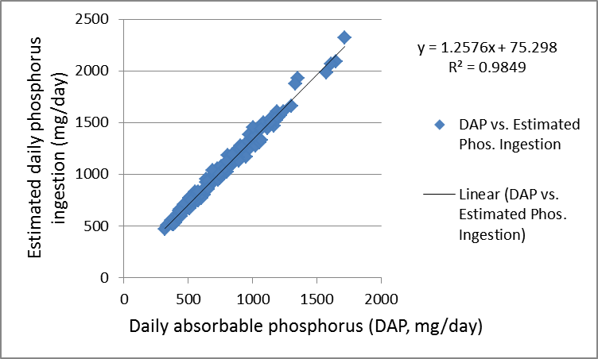
Supplemental Materials Figure S1: DABP vs. DIP (modeled ingested phosphorus) in the 183 patients.
Daily Absorb. Phosphorus: = 756 ±264 Modeled ingested phosphorus: 1026 ± 334 mg/day
The reason the slope of the slope is 1.26 rather than 1.50 is, that the bound fraction is subtracted before applying the fractional absorption multiplier.

Supplemental Materials Figure S2: Relation of predialysis serum albumin with PCR, predialysis serum phosphorus, and DIP or DABP.
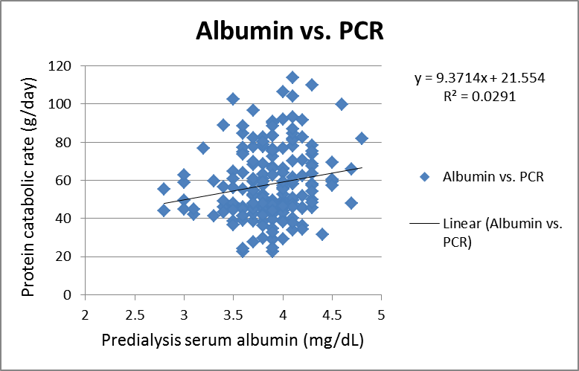

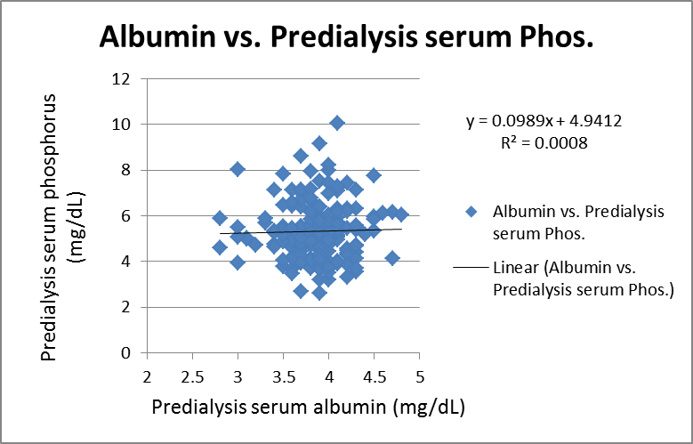

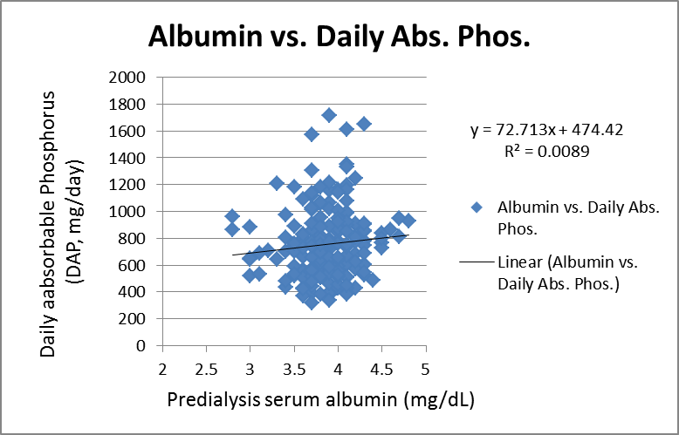
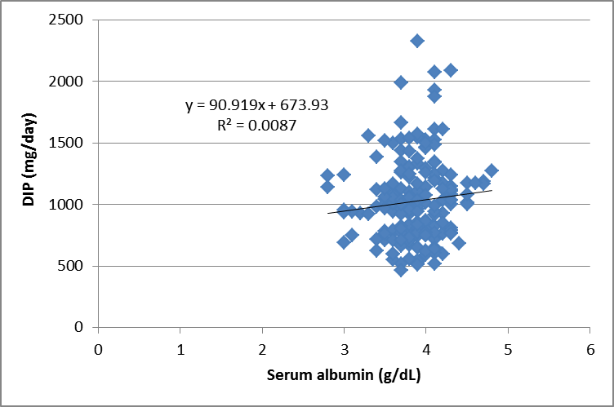

Worksheet for estimating EBD multiplier for sucroferric oxyhydroxide:
On the basis of the articles mentioned below, a new multiplier of 2.7 was chosen to compute EBD for Sucroferric oxyhydroxide. This is a work in progress, and this multiplier may need to be adjusted slightly as more data become available.
***********************************************************************************
Kidney Int. 2014 Sep;86(3):638-47. doi: 10.1038/ki.2014.58. Epub 2014 Mar 19.
A phase III study of the efficacy and safety of a novel iron-based phosphate binder in dialysis patients.
Floege J, Covic AC, Ketteler M, Rastogi A, Chong EM, Gaillard S, Lisk LJ, Sprague SM; for the PA21 Study Group.
3.1 velphoro 500 mg. 1.55 g/day 4.86/1.55 = 3.13 multiplier
8.1 sevelamer 800 mg 6.48 g/day x 0.75 = 4.86 EBD
(P control trend not quite as good with Velphoro as with sevelamer, so multiplier may be overestimated)
*************************************************************************************
Nephrol Dial Transplant. 2017 Nov 1;32(11):1918-1926. doi: 10.1093/ndt/gfw460.
One-year efficacy and safety of the iron-based phosphate binder sucroferric oxyhydroxide in patients on peritoneal dialysis.
Floege J, Covic AC, Ketteler M, Mann J, Rastogi A, Spinowitz B, Rakov V, Lisk LJ, Sprague SM.
3.4 velphoro 500 = 1.7 g/day 4.86 / 1.7 = 2.86 multiplier
8.1 sevelamer 800 = 6.48 g/day x 0.75 = 4.86
****************************************************************************************
Hemodial Int. 2018 Oct;22(4):480-491. doi: 10.1111/hdi.12663. Epub 2018 Apr 15.
Long-term efficacy and safety of sucroferric oxyhydroxide in African American dialysis patients.
Sprague SM, Ketteler M, Covic AC, Floege J, Rakov V, Walpen S, Rastogi A.
3.4 velphoro x 500 = 1.7 4.56 / 1.7 = 2.68 multiplier
7.6 sevelamer x 800 = 6.080 x 0.75 = 4.56
****************************************************************************************
Nephrology (Carlton). 2017 Apr;22(4):293-300. doi: 10.1111/nep.12891.
Efficacy and safety of sucroferric oxyhydroxide compared with sevelamer hydrochloride in Japanese haemodialysis patients with hyperphosphataemia: A randomized, open-label, multicentre, 12-week phase III study.
Koiwa F, Yokoyama K, Fukagawa M, Terao A, Akizawa T.
1403 velphoro 3.73 / 1.403 = 2.66 multiplier using 0.80 for sevelamer
4671 sevelamer = 4.671 x 0.80 = 3.73
4671 x 0.75 = 3.50 3.50/1.40 = 2.50 multiplier using 0.75 for sevelamer
(Note sevelamer multiplier increased from 0.75 to 0.80 due to the lower mean dose of sevelamer)
****************************************************************************************
Nephrol Dial Transplant. 2015 Jun;30(6):1037-46. doi: 10.1093/ndt/gfv006. Epub 2015 Feb 16.
Long-term effects of the iron-based phosphate binder, sucroferric oxyhydroxide, in dialysis patients.
Floege J, Covic AC, Ketteler M, Mann JF, Rastogi A, Spinowitz B, Chong EM, Gaillard S, Lisk LJ, Sprague SM; Sucroferric Oxyhydroxide Study Group.
4.0 x 0.5 = 2.0 5.656/2 = 2.83 multiplier
10.1 x 800 x 0.70 = 5.656
(Note: sevelamer multiplier reduced from 0.75 to 0.70 due to high mean dose of sevelamer.)
*******************************************************************************

WORKSHEET TO EXAMINE EFFECTS OF FAILURE TO INCLUDE KRU ON PCR, DIP, and DIP/PCR.
Consider patient with V=35 L, g=6 mg/min, dialyzed for 4 hours with a dialyzer urea clearance of 220 ml/min.
Residual kidney function (urea clearance = phosphorus clearance) is 4 ml/min.
Step 1: Compute the level of DABP with the correct input RKF of 4 ml/min:

Input this string into phosphate solver version 2.0 (which now focuses on DIP rather than DABP, but still calculates both quantities). Here we are assuming and EBD of 0, prephos = 5.5, and DIP is the unknown.

http://www.ureakinetics.org/calculators/batch/phos/phosphatesolver_200.html

------------------------------------------------------------------------------------------------------------
mg,Sally,33,f,3,135,4,35,6,300,500,240,9,60,kd,220,0.4,DZERNAME,0,999,5.5

Input g = 6 mg/min. This corresponds to a PCR of 66.2 g/day (this is a direct conversion from the input values of g and V).

The calculated value for estimated ingested P (DIP) is 1157 mg/day

Step 2: Compute the level of DIP with an incorrect input RKF of zero:

Input string :
mg,Sally,33,f,3,135,0,35,6,300,500,240,9,60,kd,220,0.4,DZERNAME,0,999,5.5

Calculated ingested P (DIP) is now 691 mg/day.

However, failure to input RKF will also lower g and PCR. This will potentially partially or completely correct this error.

To determine by how much the PCR would be underestimated, we do the following:

Step 3: Assume that the urea nitrogen generation value (G) of 6.0 mg/min is correct. We now use the “what-if-urea” module of Solute Solver to compute the expected pre- and postdialysis BUN values:

What if module, version 1.18;
http://ureakinetics.org/calculators/batch/whatif/whatif-urea-118.html
Input string:
Sally,3,135,4,35,6,300,500,240,11.0,70,kd,220
Results:
LabDay_PREBUN_plasma (mg/dL) = 47.245
LabDay_POSTBUN_plasma (mg/dL) = 14.095
spKt/V = 1.49; eKt/V = 1.32
Step 4: Now, we determine to what extent g and therefore PCR will be underestimated if we fail to input the RKF. To answer this question, we use Solute Solver version 2.11, 999 mode (input dialyzer clearance of 220 ml/min), setting Kru to 4 and then to 0.
http://ureakinetics.org/calculators/batch/solutesolver-211.html

Input string:
y,n,0,0,in,kg,mg/dL,Fred,na,na,m,na,3,135,4,47.25,14.09,430,500,240,73,70,a,na,dzername, na,na,na,na,0,0,999,220,extra1,0
y,n,0,0,in,kg,mg/dL,Fred,na,na,m,na,3,135,0,47.25,14.09,430,500,240,73,70,a,na,dzername, na,na,na,na,0,0,999,220,extra1,0

In the first row, Kru is set to 4, and in the 2nd row, to 0. The preBUN and postBUN values are set to 47.25 and 14.09.

In the first row, when set Kru to 4.0, we get back a value of G (2-pool) of 6.01 mg/min, which was our original input value.

In the second row, with Kru mistakenly input as zero, the value for G is now calculated to be 4.529.

To convert G to PCR:
PCRN2P = 5.423 * IG2P/IV2PL + 0.168;
PCR2P=PCRN2P * IV2PL/0.58;

The two modeled values for V are trivially different (35.11 and 35.64).

When we do the calculations, we get PCR = 66.36 with Kru=4, and 52.67 with Kru=0.

So, the failure to include the Kru of 4 ml/min causes a marked underestimation of PCR, 52.67 vs. 66.36.

ANALYSIS:
The failure to include RKF will underestimate daily ingested P, DIP by 691/1157 = 0.60.
Failure to include RKF will underestimate daily ingested protein, PCR by 52.67/66.36 = 0.79

Step 5: Recompute DIP/PCR ratios via phosphate solver using artefactually lower value for G.

Input string:
mg,Sally,33,f,3,135,4,35,6.0,300,500,240,9,60,kd,220,0.4,DZERNAME,0,999,5.5
mg,Sally,33,f,3,135,0,35,4.59,300,500,240,9,60,kd,220,0.4,DZERNAME,0,999,5.5

Here we are now combining the RKF of zero with a lower value for G (4.59 instead of 6.0)

Now we get back our PCR inputs as 66.2 (row 1) and 53.1 (row 2)
DIP values are: 1157 and 691 mg/day, respectively
DABP values are 771 and 461 mg/day, respectively

DIP / PCR values are now 17.47 (correct value) and 13.03 (falsely low value due to failure to include RKF).
DABP / PCR values are now: 11.64 (correct value) and 8.69 (falsely low value due to failure to include RKF)

CONCLUSION:
Failure to include RKF will underestimate BOTH DIP and DABP, as well as the PCR, but the underestimation of DIP and DABP is almost twice as great, and for this reason, incorrectly low values for DIP/PCR and for DABP/PCR will result.

Note: In the present models, 1 ml/min residual phosphorus clearance is set equal to 1 ml/min residual urea clearance. This is based on results presented by Matsuda et al. at the 2011 EDTA meeting in Prague (Matsuda A, Katou H, Tayama Y, et al. Contribution of residual renal function to phosphate elimination during peritoneal dialysis. European Renal Association / European Dialysis Transplant Association abstract, Prague, Czech Republic. 2011) , where they found an r value of 0.966 between residual Kr urea and residual Kr phosphorus with an apparent slope very close to 1.0 with an intercept of zero; however, this was measured in ESKD patients undergoing peritoneal dialysis, and needs to be confirmed in a hemodialysis setting.

Supplemental Materials Table S3: DABP (daily absorbed+bound phosphorus) vs. DIP (modeled ingested phosphorus) as affected by fractional dietary phosphorus absorption and value for equivalent binder dose (EBD).

 |  | DABP |  |  |  |  | DABP ratio EBDx / EBD0
 |  | fractional absorption of ingested P |  |  |  |  | fractional absorption
DIP | EBD | 0.5 | 0.667 | 0.8 | 1 |  | 0.5 | 0.667 | 0.8 | 1
1000 | 0 | 500 | 667 | 800 | 1000 |  | 1 | 1 | 1 | 1
1000 | 1 | 523 | 681.985 | 809 | 1000 |  | 1.046 | 1.022466 | 1.01125 | 1
1000 | 2 | 546 | 696.97 | 818 | 1000 |  | 1.092 | 1.044933 | 1.0225 | 1
1000 | 3 | 569 | 711.955 | 827 | 1000 |  | 1.138 | 1.067399 | 1.03375 | 1
1000 | 4 | 592 | 726.94 | 836 | 1000 |  | 1.184 | 1.089865 | 1.045 | 1
1000 | 6 | 638 | 756.91 | 854 | 1000 |  | 1.276 | 1.134798 | 1.0675 | 1
1000 | 8 | 684 | 786.88 | 872 | 1000 |  | 1.368 | 1.17973 | 1.09 | 1
1000 | 10 | 730 | 816.85 | 890 | 1000 |  | 1.46 | 1.224663 | 1.1125 | 1

This table shows why we chose to analyze DIP as a P ingestion variable of interest rather than DABP, even though we are using a population fractional absorption value of 0.667 based on data from the literature that may vary from patient to patient.

One of the eventual uses of phosphate solver may be to predict changes in predialysis serum P after a change in EBD dose. This requires knowledge of DABP. One reasonable assumption in such calculations is, that P intake will remain constant. As shown from the table, however, at a constant DIP (P intake) of 1 g/day, the value for DABP will depend on the value for EBD. When EBD is zero, DABP is simply fractional absorption rate x DIP, or 667 mg/day. However, as EBD is increased up to 10 g/day, the value for DABP progressively increases. This increase will be magnified at lower values for fractional absorption rate.

The four rightmost columns show that, if a population value for fractional absorption of 0.667 is used, the calculated value for DABP at a given level of EBD may be somewhat incorrect if the actual value for f-Abs is lower (e.g. 0.50) or higher (e.g. 0.80) than the population value of 0.667 used. In practice, after inputting values for serum P and EBD, the value for DABP will be correct but the value for DIP will be the value that will be slightly off.

Because we believe that DIP will tend to be more constant than DABP in a given patient, we chose DIP for the primary P intake variable. Of course, fractional absorption rate may well be higher in patients eating a high-additive diet, and lower in patients who have vitamin D insufficiency or who are eating mostly a vegetarian diet. It remains to be determined whether using a patient-specific value for fractional absorption of dietary P would increase the utility of the model in terms of providing practically actionable information. At this point, there is no easy method available to compute fractional absorption rate of ingested phosphorus on an individual subject basis.

Supplemental Material Figure S3.

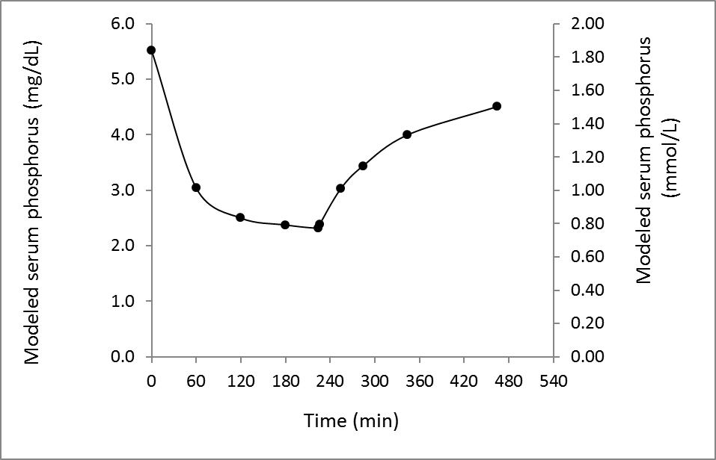

Supplemental Material Figure S3. Measured average value for predialysis serum phosphorus in the 183 patients, and the modeled mean intradialysis and early postdialysis values as predicted by the phosphate kinetic model (calculations done using Phosphate Solver version 2.0).

