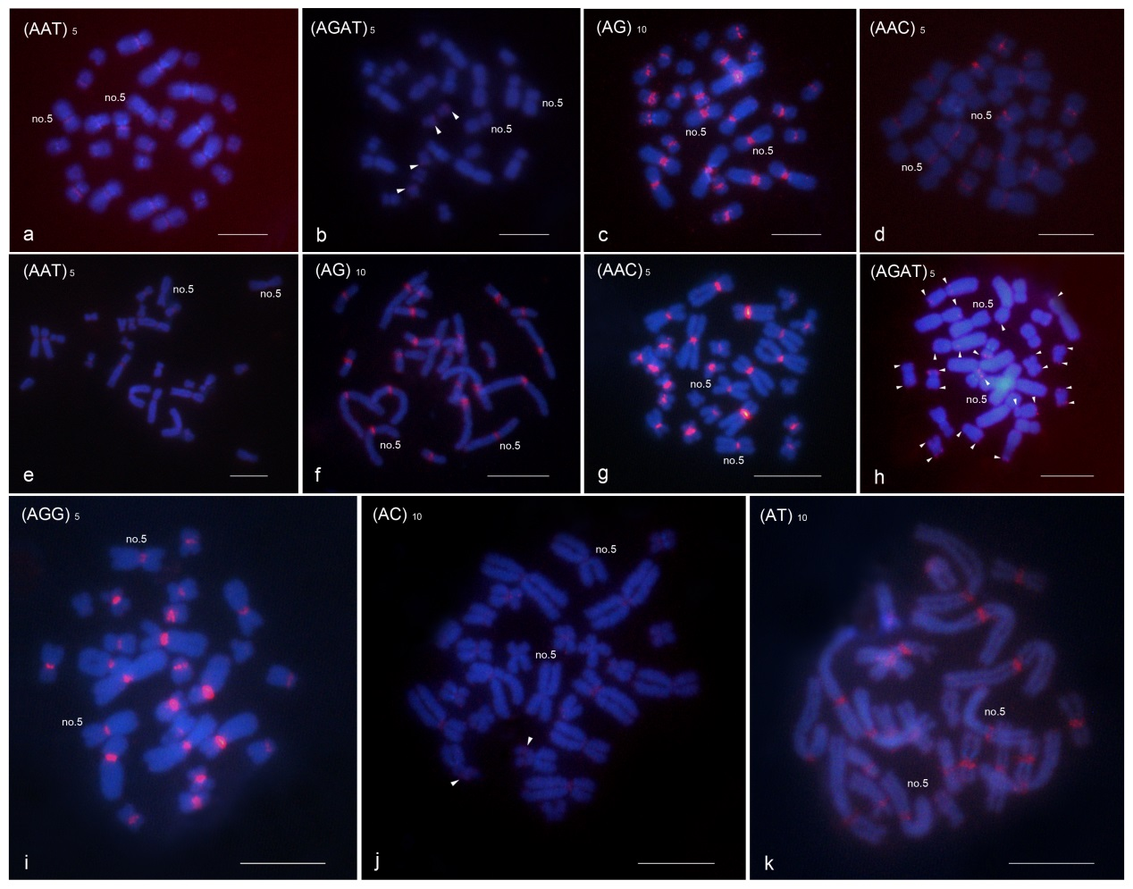
Figure S1. FISH mapping of microsatellite repeat motifs in A. kangtingensis and A. jinjiangensis. Four motifs, (AAT)₅ (a), (AGAT)₅ (b), (AG)₁₀ (c), and (AAC)₅ (d), were hybridized in A. kangtingensis. Seven motifs, (AAT)₅ (e), (AG)₁₀ (f), (AAC)₅ (g), (AGAT)₅ (h), (AGG)₅ (i), (AC)₁₀ (j), and (AT)₁₀ (k), were hybridized in A. jinjiangensis. Arrowheads indicate hybridization signals at the terminal or insertion positions of the chromosomes. Chromosomes were counterstained with DAPI (blue). Fluorescent signals of the motifs are shown in red. Bar = 10 μm.

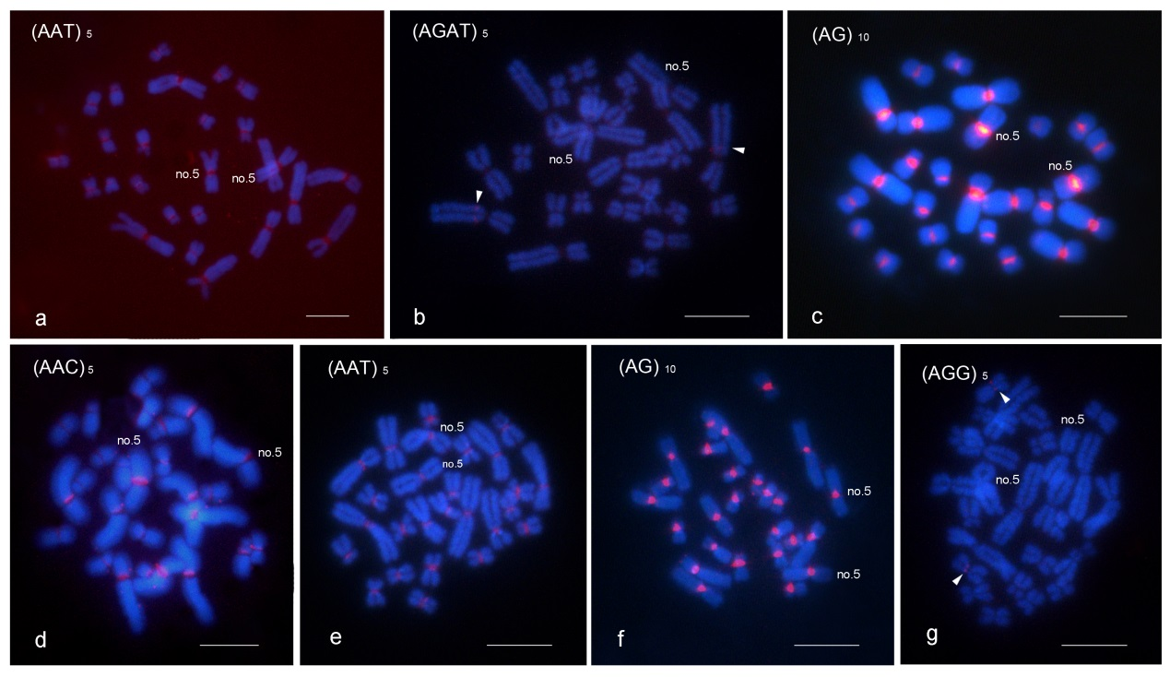
Figure S2. FISH mapping of microsatellite repeat motifs in A. lifanensis and A. loloensis. Four motifs, (AAT)₅ (a), (AGAT)₅ (b), (AG)₁₀ (c), and (AAC)₅ (d), were hybridized in A. lifanensis. Three motifs, (AAT)₅ (e), (AG)₁₀ (f), and (AGG)₅ (g), were hybridized in A. loloensis. Arrowheads indicate hybridization signals at the insertion positions of the chromosomes. Chromosomes were counterstained with DAPI (blue). Fluorescent signals of the motifs are shown in red. Bar = 10 μm.

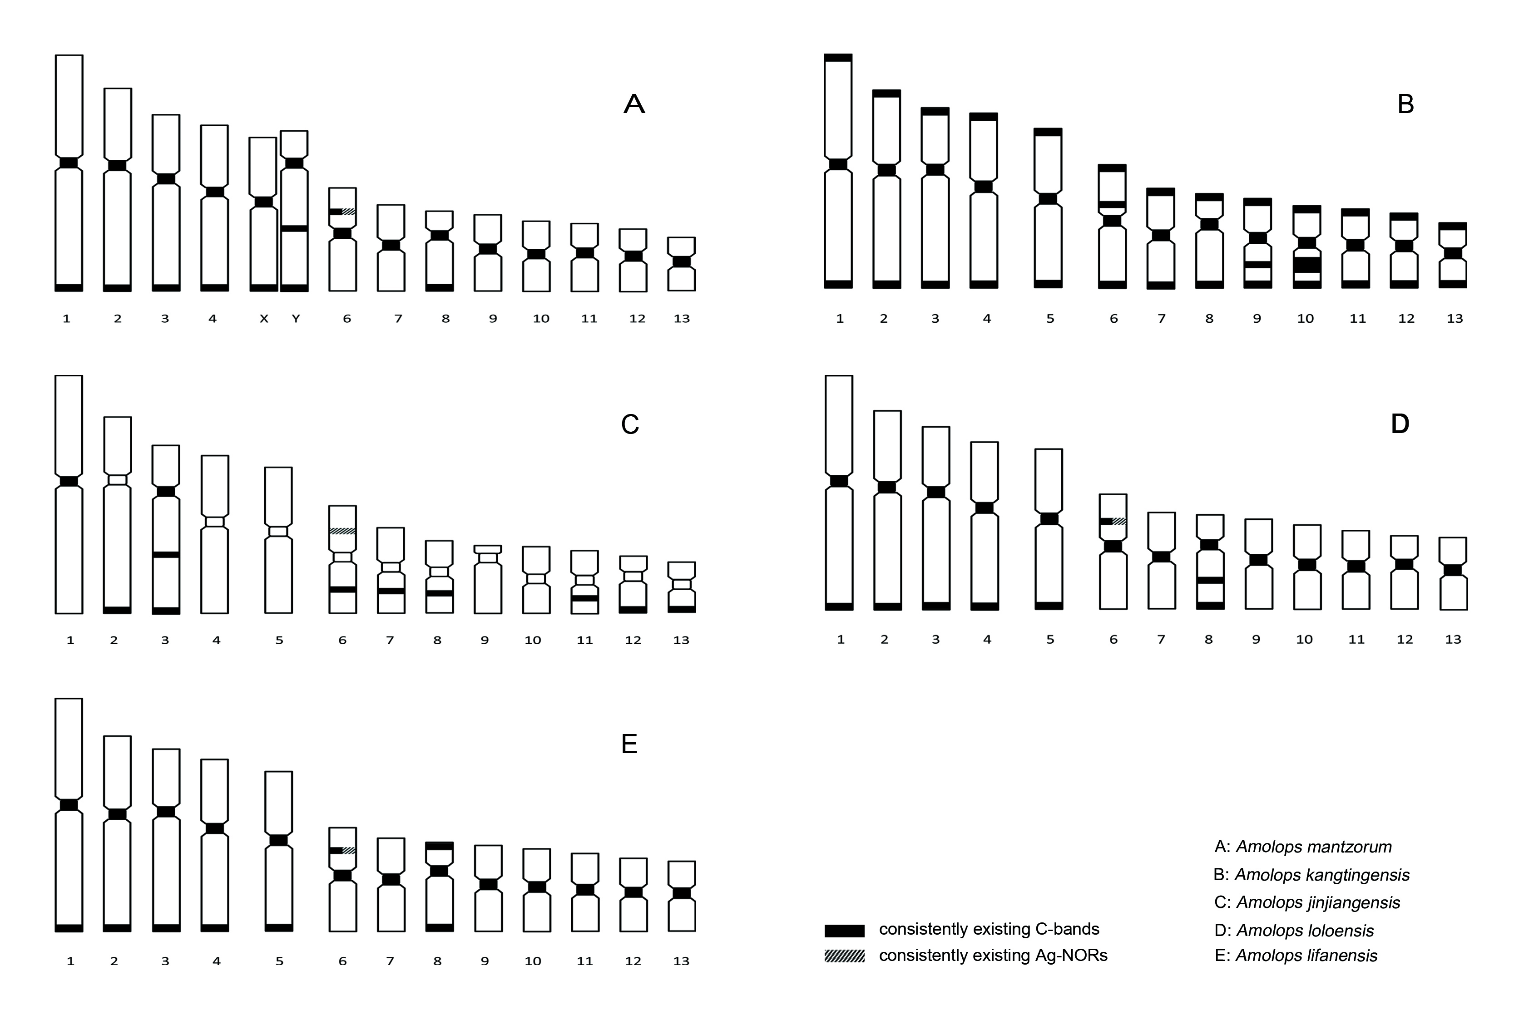
Figure S3. Summary of C-bands and Ag-NORs in five Amolops species. The idiogram of C-bands and Ag-NORs in these species is based on Wu et al. (1987a), Wu et al. (1987b), Liu and Yang (1994).The regions where the C-bands and Ag-NORs stained are shown on the chromosomes by different marks: black bar represents consistently present C-bands, grid graph represents consistently present Ag-NORs. A, B, C, D, and E represent A. mantzorum, A. kangtingensis, A. jinjiangensis, A. loloensis, and A. lifanensis respectively.

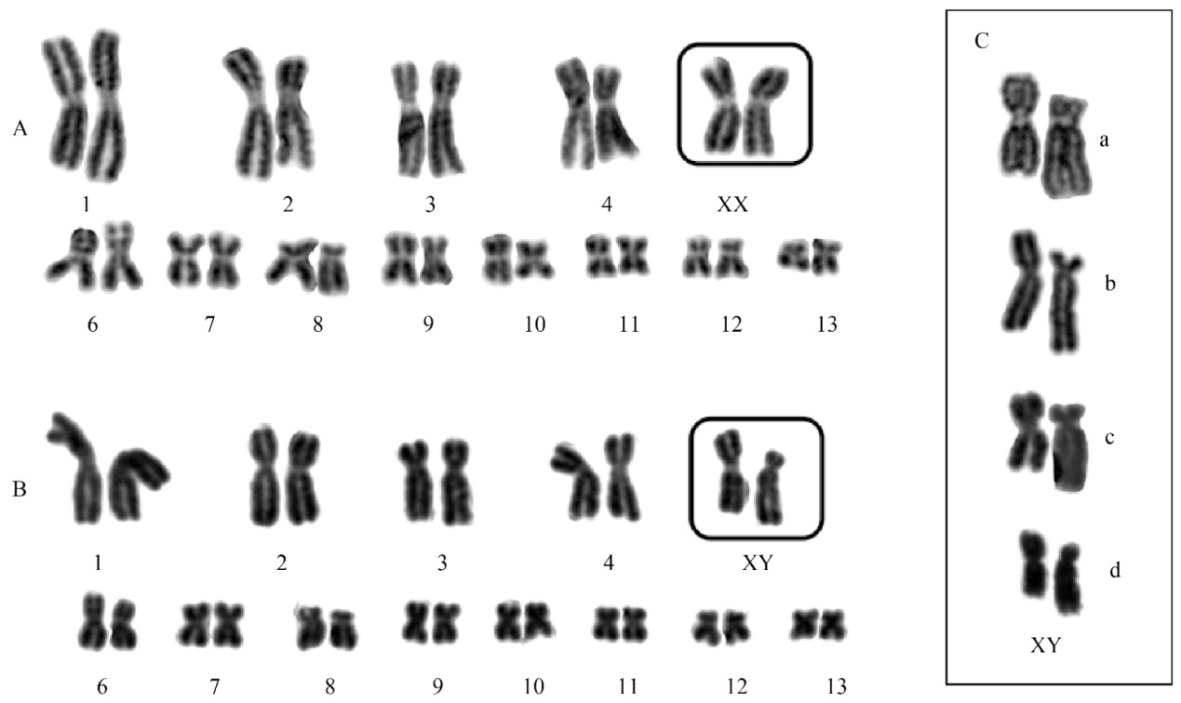Figure S4. The karyotype of Amolops mantzorum. A represents a female from Liangluxiang of Tianquan, B represents a male from Tianba of Luding, C represents chromosome 5 of four males from Xilingxueshan of Dayi(C-a), Dewei of Luding (C-b), Liangluxiang of Tianquan (C-c) and Liuyangcun of Kangding (C-d) (Zhang et al. 2015).

Table S1 Collection sites with the respective sample sizes of Amolops species
Species | Collection sites | Number of samples
A. mantzorum | Liangluxiang, Tianquan, Sichuan (N 29°59′28.88″ E 102°22′13.67″) | 1 female, 15 males
A. kangtingensis | Jiagenbaxiang, Kangding, Sichuan (N 29°47′20.61″ E 101°40′38.78″) | 2 females, 1 male
A. jinjiangensis | Benzilanzhen, Deqing, Yunnan (N 28°14′31.07″ E 99°17′58.49″)  Nixixiang, Shangri-la, Yunnan (N 28°08′20.67″ E 99°26′5.71″) | 5 females, 1 male  2 males
A. loloensis | Lajixiang, Yuexi, Sichuan (N 28°25′40.23″ E 102°32′5.86″) | 2 females, 1 male
A. lifanensis | Shangmengxiang, Lixian, Sichuan (N 31°37′45.72″ E 103°11′15.50″) | 5 males

Table S2 Chromosome charateristics of Amolops mantzorum (Zhang et al. 2015).
Number | Amolops mantzorum
 | Relative length | Arm ratio | Type
1 | 13.86±0.99 | 1.16±0.11 | M
2 | 11.85±0.85 | 1.44±0.12 | M
3 | 10.57±0.76 | 1.91±0.13 | SM
4 | 10.09±0.77 | 1.38±0.12 | M
5x | 9.30±0.59 | 1.25±0.13 | M
5y | 9.05±0.47 | 3.29±0.62 | ST
6 | 6.64±0.59 | 1.12±0.12 | M
7 | 5.69±0.59 | 1.12±0.07 | M
8 | 5.37±0.39 | 2.02±0.58 | SM
9 | 5.06±0.30 | 1.15±0.09 | M
10 | 4.71±0.25 | 1.15±0.11 | M
11 | 4.51±0.29 | 1.11±0.11 | M
12 | 4.25±0.31 | 1.22±0.22 | M

