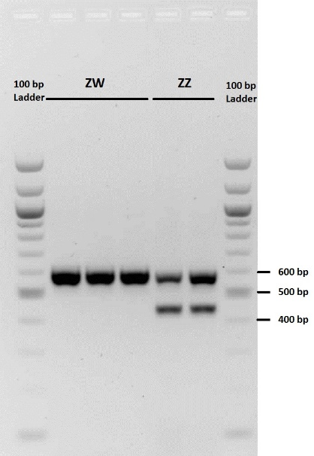
Figure S1. Electrophoresis of PCR products for determination of the genetic sex in chicken embryos. A common fragment with different size was amplified from Z and W chromosomes and visualized on a 1.5 % agarose gel. Based on the GenBank access number of NC_006126.5 and NC_006127.5 corresponding to CHD-W and CHD-Z, respectively, use of 2550F and 2718R primers yield a 447 and 591 bp band, respectively [Fridolfsson and Ellegren, 1999].

Fridolfsson, A.-K., H. Ellegren (1999) A simple and universal method for molecular sexing of non-ratite birds. Journal of avian biology: 116-121.

