Supplemental Material
Detailed description of material and methods, supplementary Tables and supplementary Figures.
Material and methods
Rate of motility assays
Motility assays were performed in NGM plates at 20 °C in presence of FUdR as described below. The age-synchronized adults N2 worms that had grown to the indicated time points (4, 7, 10 days) in the presence or absence of rBTI were collected and washed with M9 buffer. Next, 30-40 animals were placed onto the center of NGM dish in a drop of M9 buffer. Motility rate was measured as number of body bends performed in 30 seconds using an Olympus stereomicroscope. In this work, all ages refer to the age of adult life and do not include developmental time in order to minimize lifespan differences due to developmental phenotypes. The first day of C. elegans adult lifespan (adult day 0) occurs after the 4th and final larval molt.
Paralysis assay in AM140 C. elegans
The worm paralysis assay was performed as previously described [1], with slight modifications. Briefly, the age-synchronized AM140 worms were grown at 16 °C for 48 h (L3), and then separated them into two groups. One group still was cultured at 16 °C for 6 days, other group was cultured at 25 °C for 6 days. Next, the worms at 25 °C were exposed to 0 μM (control) or 10 μM rBTI in presence of FudR. Worms were scored as paralyzed if they failed to move during observation, and exhibited ‘halos’ of cleared bacteria around their heads (indicative of insufficient body movement to access food), eggs accumulated close to the body or if they failed to undergo a full body wave propagation upon prodding with a platinum wire.
Soluble protein extraction
The soluble protein extraction was performed as described previously, with some modifications [2]. Synchronized day 10 N2 worms were grown at 20 °C, and day 6 AM140 worms were grown at 25°C. Then, the worms were treated with 0 μM (control) or 10 μM rBTI for 1 day. Each sample was tested in triplicate, and approximately 200mg of worms (wet weight) were collected. Total protein extracts were produced in phosphate-buffered saline by sonication on ice, followed by a brief centrifugation at 3000×g to remove remaining carcasses. All samples were normalized for total protein concentration as assessed by the BCA assay. Samples were centrifuged at 16,000×g and 4°C, and were then washed in lysis buffer to remove the insoluble fraction. Equal volumes of supernatants (soluble fraction) were loaded and analyzed by SDS-PAGE. Mean intensities of protein bands were analyzed using the Image-J software (National Institutes of Health, Bethesda, MD, USA).
RNA isolation and qRT-PCR
Total RNA was isolated from worms were treated as described in text, using Trizol reagent (TaKaRa Biotechnology Co., Ltd, Dalian, China). The purity of RNA samples was assessed by UV absorbance (260/280 ratio). cDNA was synthesized using primer Oligo(dT)20 and a SuperScript III First-Strand Kit (TaKaRa Biotechnology Ltd, Dalian, China) according to the manufacturer's protocol. RT-PCR was performed in 20 μL of Power SYBR PCR Master Mix, in triplicate for each sample. PCR reactions were carried out in a Real Time PCR Machine 7500 Fast (Applied Biosystems, America) under the following conditions: PCR initial heat activation at 95 °C for 5 min, denaturation at 95 °C for 10 s for 40 cycles, and combined annealing/extension at 60 °C for 30 s. The amplified products were analyzed using the onboard software of the Real Time PCR machine. The target genes' transcriptional expression levels were normalized using the internal control actin-1 (act-1). The primers used for qRT-PCR are listed in Table S1. All experiments were repeated three times, and consistent results were obtained from these independent experiments.
Quantification of mtDNA and Sequence-specific mtDNA damage
mtDNA content measurement was performed as previously described [3]. Briefly, worms were treated as described in text and total DNA was isolated using the Tissue DNA Kit (Omega Bio-tek Inc, Norcross USA). Copy numbers of mtDNA were analyzed by qPCR. An amount of 0.4 ng of total DNA was used as a template for the amplification. C. elegans mtDNA transcripts were normalized to nuclear 18S rRNA. And these primers were listed in Table S1.
The sequence-specific burden of oxidative DNA lesions was determined according to the previously published method of Melov [4], with slight modifications. Briefly, populations of synchronized worms were treated as described in the text. Next, mtDNA was extracted as described earlier, and digested using formamidopyrimidine-DNA glycolase (fpg), followed by PCR amplification using the previously published primers (Forward primer: 5′-TCGCTTTTATTACTCTATATGAGCG-3′, Reverse primer: 5′-TCAGTTACCAAAACCACCGATT-3′) [4]. Sequence-specific mtDNA damage was assessed in a 6.3 kb region of the mitochondrial genome. The results were examined by PCR and agarose gel electrophoresis. Fpg recognizes and excises a range of modified DNA bases, including 8-oxoguanine, thereby rendering any templates, containing at least one such lesion, resistant to PCR amplification. The more serious the mtDNA damage, the less complete the DNA template is.
Quantification of ATP content and proteasomal activity
The ATP assay kit (Promega Corporation, New York, America) was used to measure ATP concentrations, according to the manufacturer's protocol. The kit works on the principle that light is produced by ATP and luciferin in the presence of luciferase. Worms were treated as described in the text, day 10 N2 worms grown at 20°C and day 6 AM140 worms grown at 25°C were treated with either 0 μM (control) or 10 μM rBTI for 1 day. And then, populations of ~1000 worms in each group were collected and washed with M9 buffer, and immediately ground with a homogenizer on ice in a final volume of 500 μL PBS plus PMSF. The ATP levels in each biological sample were then measured 3 times with a luminometer, in a fluorescence cuvette containing 1.5 mL of sample extract.
In vitro proteasome activity was assessed using a proteasome activity assays kit (Promega Corporation, New York, America). Worms were treated, harvested and lysed as described in Quantification of ATP content. The lysates were centrifuged at 120,000 ×g for 10 min at 4°C. Protein extracts were quantified using the BCA Assay Kit. The proteasome activity measurements were carried out using a luminometric assay, according to the manufacturer’s instructions.
Staining of lysosomes
The formation of lysosomes was assessed by fluorescent microscopy after labeling with the fluorescent dye. Lyso-Tracker Red. This dye specifically accumulates within acidic organelles, and can be detected after excitation with a 575 nm laser by measuring emission at 600 nm. In brief, synchronous nematodes were incubated at the young-adult stage with Lyso-Tracker Red (final concentration 2 μM) for 48 h. Next, worms were washed and anaesthetized by the addition of 2 mM levamisole. The dye was visualized using a fluorescence microscope, using an excitation wavelength of 531 ± 40 nm and an emission wavelength of 593 ± 40 nm. Images were collected at 10 × magnification.
RNA Interference
RNA interference (RNAi) technique to generate loss-of function RNAi phenotypes was performed in C. elegans by feeding worms with E. coli expressing double-stranded RNA that is homologous to a target gene. Briefly, E. coli strain HT115(DE3) harboring the appropriate vectors were grown in LB broth containing ampicillin (100 μg/ml) and tetracycline (10 μg/ml) at 37 °C overnight. Bacteria were plated onto NGM plates containing 100 μg/ml ampicillin and 5 mM isopropyl β-D thiogalactoside and were allowed to grow overnight at 37 °C. Gravid adults were allowed to lay eggs on RNAi expressing lawns of bacteria for 5 h. The eggs were allowed to develop into L4 young larvae on RNAi or vector control plates at required temperature. The L4 larvae were transferred to another plate containing dsRNA, and were allowed to lay eggs. The resultant adult worms were used for the paralysis assays as described earlier. The RNAi constructs targeting daf-16 were obtained from the C. elegans ORFeome RNAi library v1.1.

Table S1. Primer sequences for some genes used in the text[5, 6]

Gene | Primer
unc-51 | 5′- CGCCGGTGGTTCAGCGGATT -3′  5′- TATCCTGGGTGTCGGCGGGG-3′
bec-1 | 5′- ACGAGCTTCATTCGCTGGAA -3′  5′- TTCGTGATGTTGTACGCCGA -3′
atg-18 | 5′- CAGGAGCCGCAAGGAGTAAT -3′  5′- CGATTGGTTGCTTGCTTCGG -3′
atg-7 | 5′- CCAAAAGCTGTGGGATGGGA -3′  5′- GCGTTCCAGCACCAAGAATG -3′
lgg-1 | 5′- GCCGAAGGAGACAAGATCCG -3′  5′- GGTCCTGGTAGAGTTGTCCC -3′
sod-3 | 5′-CCAACCAGCGCTGAAATTCAATGG-3′  5′-GGAACCGAAGTCGCGCTTAATAGT-3′
gsh-px | 5′- ATGGCACTTTGGCAGCTCA-3′
 | 5′- ACGCGCAAAAAGTAGCAACGC-3′
hsp-16.1 | 5′-GCAGAGGCTCTCCATCTGAA-3′
 | 5′-GCTTGAACTGCGAGACATTG-3′
hsp-16.2 | 5′-TATGGCTCTGATGGAACG-3′
 | 5′-GATTGATAGCGTACGACC-3′
hsp-70 | 5′-CGTTTCGAAGAACTGTGTGCTGATCTATTCCGG-3′
 | 5′-TTAATCAACTTCCTCAACAGTAGGTCCTTGTGG-3′
gst-4 | 5′- ATGCTCGTGCTCTTGCTGAG-3′
 | 5′- GACTGACCGAATTGTTCTCCAT-3′
gcs-1 | 5′- GTCGATGAAGCCAGATGGTTGT-3′
 | 5′- CGATCGTCGACACTTGCACTAA-3′
mtDNA | 5′-CTTTTATTACTCTATATGAGCGTC-3′
 | 5′-AACAAAAGAAATTCCTGGTACAAG-3′
18S rRNA | 5′- GCGAAAGCATTTGCCAAGAA-3′
 | 5′-ATCGCGAGATGGCATCGTT-3′

Figure S1

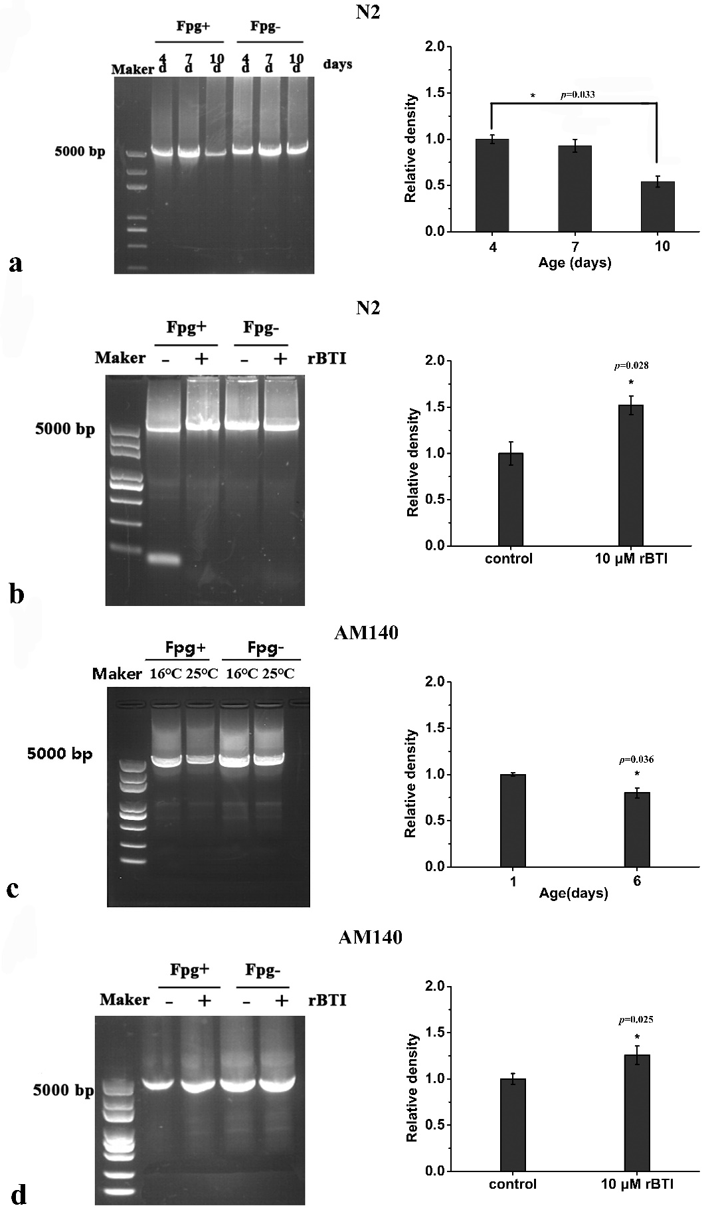

Fig. S1. rBTI decreases the mitochondrial damage in C. elegans. a The content of complete mtDNA treated with or without Fpg from day 4, 7, or 10 N2 worms. The complete mtDNA was decreased significantly in day 10 worms, compared with day 4 worms, p=0.033. b day 10 N2 worms treated with 0, or 10 μM rBTI for 1 day. The complete mtDNA was increased significantly in worms treated with rBTI, compared without rBTI. c day 6 AM140 worms cultured at 16 °C and 25 °C. The complete mtDNA was decreased significantly in worms cultured at 25 °C, compared with worms at 16 °C. d day 6 AM140 worms with 0 or 10 μM rBTI for 1 day at 25 °C. The complete mtDNA was increased significantly in worms treated with rBTI, compared without rBTI. mtDNA species were quantified using Image-J software (right panel). The more serious the mtDNA damage, the less complete the DNA template is. Data represent the means of three independent experiments, and are expressed as mean ± SD. *p< 0.05, **p < 0.01, ***p < 0.001 versus respective controls.

Figure S2
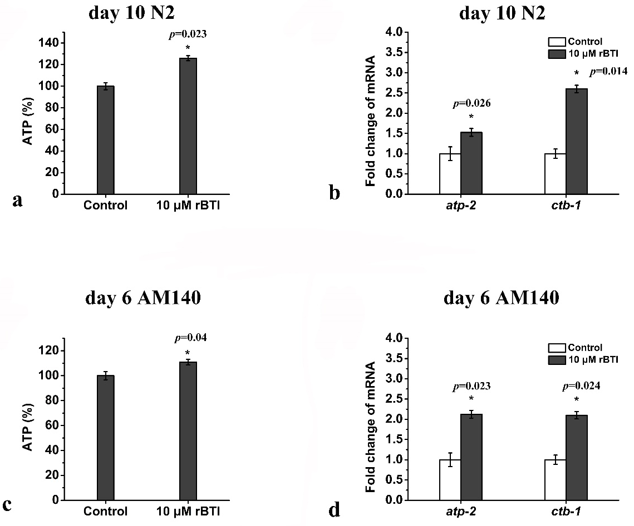

Fig. S2. rBTI enhances mitochondrial function in C. elegans. a ATP content was increased in day 10 N2 worms treated with 10 μM rBTI for 1 day, compared without rBTI. b atp-2, ctb-1 mRNA levels was decreased in day 10 N2 worms treated with 10 μM rBTI for 1 day, compared with worms without rBTI. c ATP content was increased in day 6 AM140 worms treated with 10 μM rBTI for 1 day, compared without rBTI. d atp-2, ctb-1 mRNA levels in day 6 AM140 worms treated with 10 μM rBTI for 1 day, compared without rBTI. mRNA levels were normalized to the internal control act-1. ATP content and transcriptional level of mtDNA can be as the indicators of mitochondrial function. Data represent the mean of three independent experiments, and are expressed as mean ± SD. *p< 0.05, **p < 0.01, ***p < 0.001 versus respective controls.

Figure S3
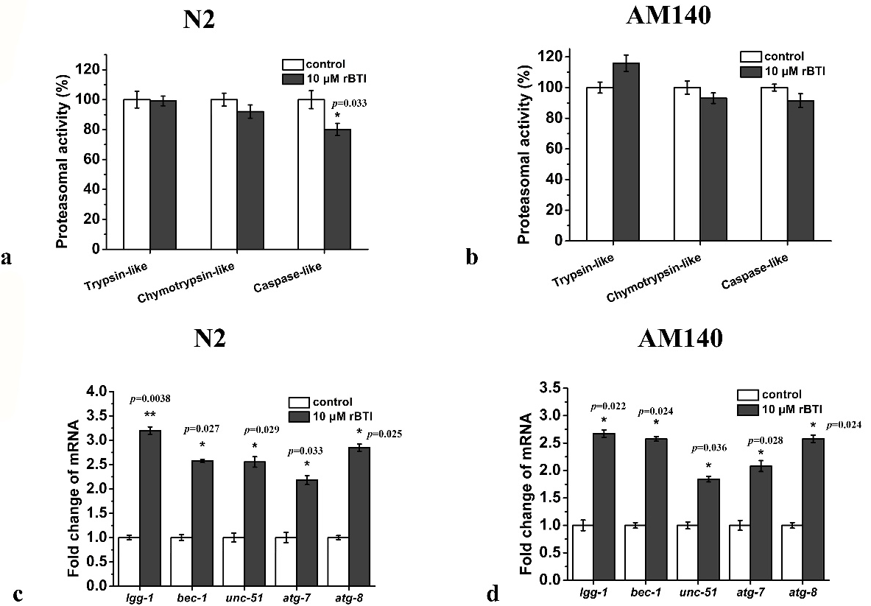

Fig. S3. Autophagy-lysosomal degradation pathway is activated by rBTI. a Analysis of proteasome activity in day 10 N2 worms treated with 0 or 10 μM rBTI. b Analysis of proteasome activity in day 6 AM140 worms treated with 0 or 10 μM rBTI for 1day at 25 °C. Compared with worms without rBTI, proteasome activity was not significantly changed in worms treated with rBTI, compared with worms without rBTI in A and B. c Autophagy-related genes mRNA levels in day 10 N2 worms treated with 0 or 10 μM rBTI for 1day. d Autophagy-related genes mRNA levels in day 6 AM140 worms treated with 0 or 10 μM rBTI for 1 day at 25 °C. Compared with worms without rBTI, autophagy-related genes mRNA levels were not significantly changed in worms treated with rBTI, compared with worms without rBTI in A and B. mRNA levels were normalized to the internal control act-1. Data represent the means of three independent experiments, and are expressed as mean ± SD. *p< 0.05, **p < 0.01, ***p < 0.001 versus respective controls.

Figure S4
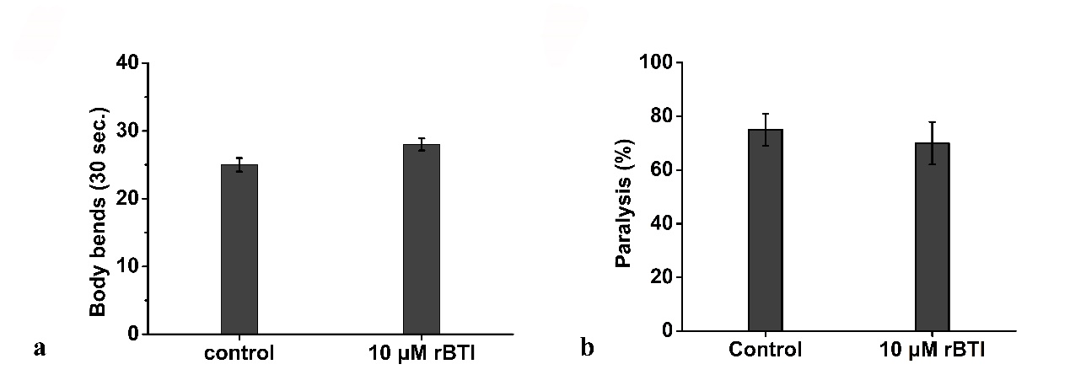

Fig. S4. The autophagy-lysosomal degradation pathway is required for the rBTI-meditated improvement of motility. a Rate of movement of day 10 N2 worms treated with 0 or 10 μM rBTI in the presence of 10 μM chloroquine which is an autophagy inhibitor. Movement rate was not significantly changed in worms treated with rBTI, compared with worms without rBTI. b Proportion of paralyzed day 6 AM140 worms pre-treated with 10 μΜ chloroquine, then treated with 0 or 10 μM rBTI for 1 day at 25 °C. Proportion of paralyzed was not significantly changed in worms treated with rBTI, compared with worms without rBTI. Data represent the means of three independent experiments, and are expressed as mean ± SD. *p< 0.05, **p < 0.01, ***p < 0.001 versus respective controls.

Figure S5

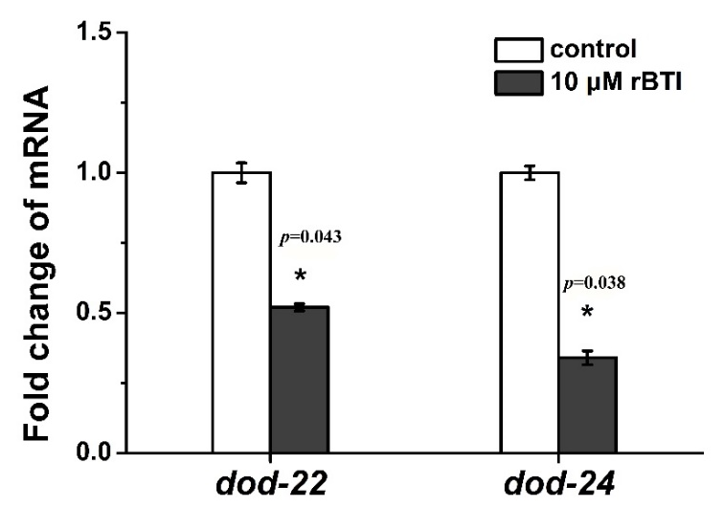

Fig. S5. The mRNA levels of dod-22 and dod-24 in day 10 N2 worms treated with or without 10 μM rBTI for 1 day. mRNA levels were normalized to the internal control act-1. dod-22 and dod-24 are DAF-16 downregulated genes. The mRNA levels of dod-22 and dod-24 were decreased upon rBTI treatment, compared with control group. This indicated that rBTI indeed increased the transcriptional activity of DAF-16 in day 10 N2 worms.

Figure S6

Fig. S6. Fluorescence micrographs of day 6 AM140 (cultured at 16℃ or 25 ℃) were treated with or without 10 μM rBTI treatment for 1 day. AM140 worms is a Q35-YFP (Q35) transgenic strain expressing polyQ35::YFP in body wall muscle cells. 10 μM rBTI decreased polyQ aggregation in AM140 worms cultured at 25℃, compared with worms treated without rBTI.

Figure S7
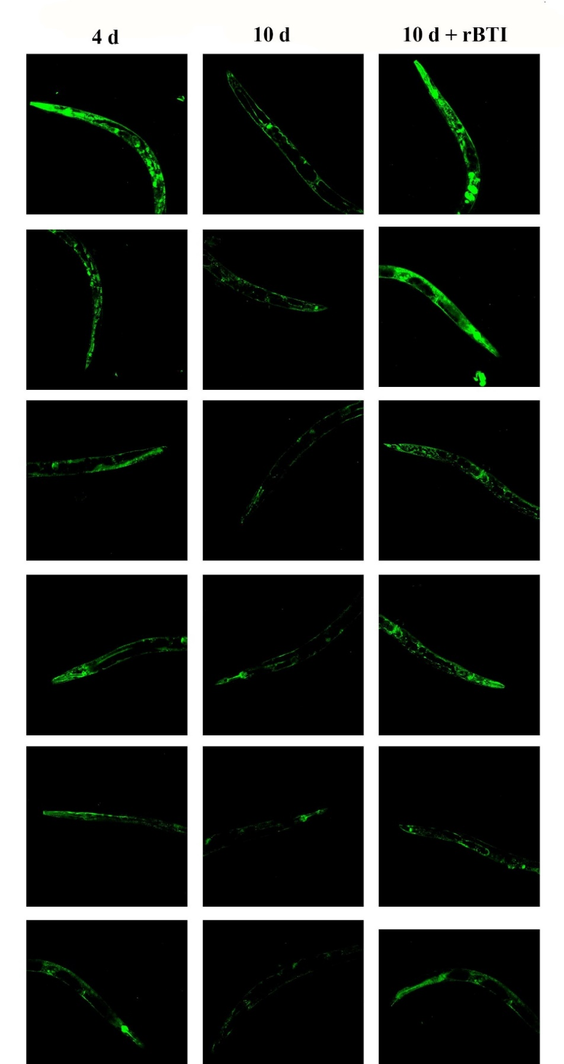

Fig. S7. Fluorescence micrographs of day 4 DA2123 worms and day 10 DA2123 worms treated with or without 10 μM rBTI for 1 day. DA2123 worms is a transgenic strain expressing GFP::LGG-1. 10 μM rBTI increased GFP::LGG-1 punta numbers in day 10 DA2123 worms, compared with worms treated without rBTI.

Figure S8
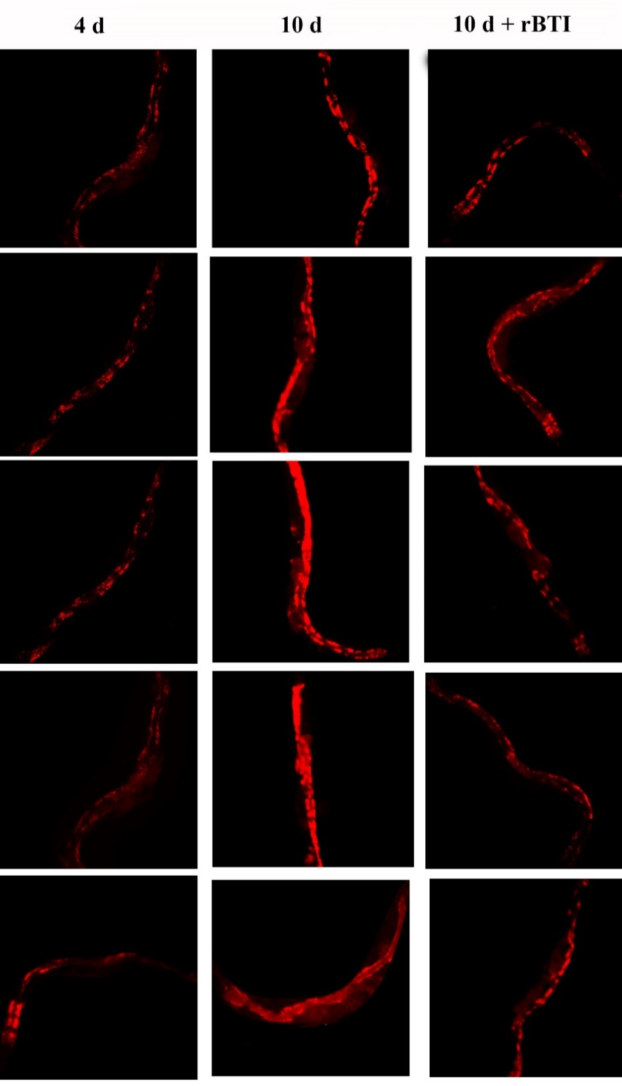

Fig. S8. Fluorescence micrographs of day 4 worms and day 10 N2 worms treated with or without 10 μM rBTI for 1 day. Lysosomes were stained with the fluorescent dye Lyso-Tracker Red. 10 μM rBTI decreased lysosome number in day 10 N2 worms, compared with worms treated without rBTI. This indicated that rBTI increased the autophagy in day 10 N2 worms.

Figure S9
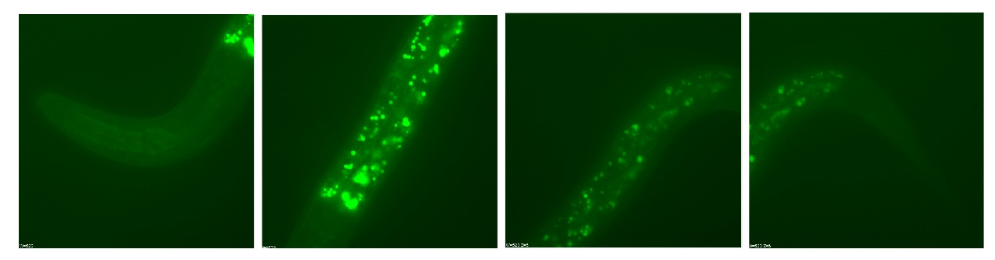

Fig. S9. Fluorescence micrographs of rBTI localization in N2 worms. rBTI was coupled with a fluorescent label (FITC) and the location of rBTI-FITC was detected in N2 worms by fluorescence microscope. The results showed that rBTI-FITC mainly located in the intestinal wall muscle cells.

Figure S10

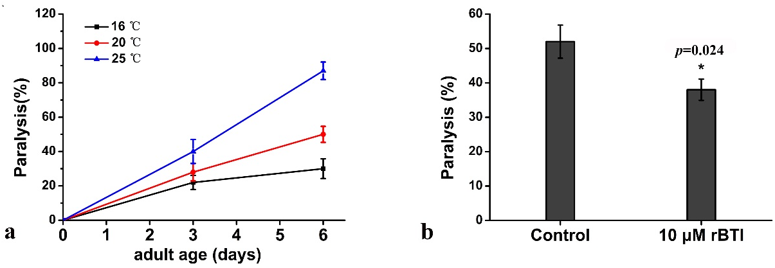

Fig. S10. The effect of rBTI on paralysis of AM140 worms at 20 ℃. a Paralysed worms' proportion of AM140 worms cultured at 16 ℃, 20 ℃ and 25 ℃. b Paralysed worms' proportion of day 6 AM140 worms at 20 ℃ treated with or without 10 μM rBTI. Paralysed day 6 AM140 worms' proportion at 20 °C were significantly declined in worms treated with 10 μM rBTI, compared without rBTI. Data represent the means of three independent experiments (30 worms in each group) and are expressed as mean ± SD. *p< 0.05, **p < 0.01, ***p < 0.001 versus respective controls.

Figure S11
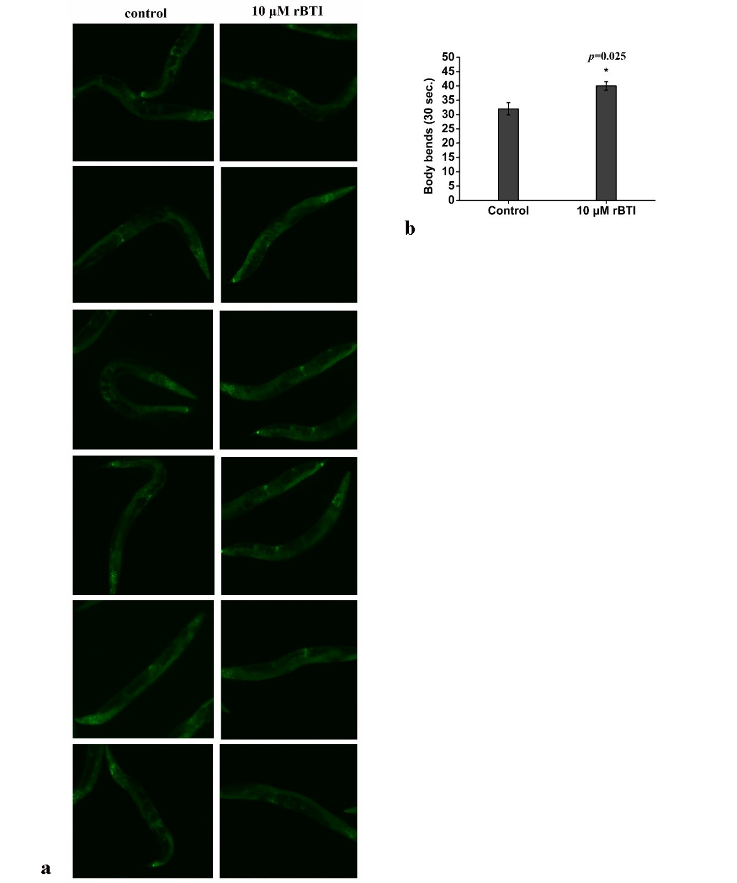

Fig. S11. The effect of rBTI on HLH-30. a Fluorescence micrographs of HLH-30::GFP relocalization in MAH325. Compared with control group, worms treated with 10 μM rBTI did not produces a clear relocalization of HLH-30::GFP to the nuclei of intestinal cells. b Rate of movement in SYD0619 worms treated with or without 10 μM rBTI for 1 day. SYD0619 worms is a strain carrying a deletion in genes hlh-30. Movement rate of 10 day N2 worms significantly increased in worms treated with 10 rBTI, compared without rBTI. This indicated rBTI-mediated these beneficial effect did not through

Supplementary Reference
1. Alavez, S., et al., Amyloid-binding compounds maintain protein homeostasis during ageing and extend lifespan. Nature, 2011. 472(7342): p. 226-9.
2. Reis-Rodrigues, P., et al., Proteomic analysis of age-dependent changes in protein solubility identifies genes that modulate lifespan. Aging Cell, 2012. 11(1): p. 120-7.
3. Weimer, S., et al., D-Glucosamine supplementation extends life span of nematodes and of ageing mice. Nat Commun, 2014. 5: p. 3563.
4. Melov, S., et al., Increased frequency of deletions in the mitochondrial genome with age of Caenorhabditis elegans. Nucleic Acids Res, 1995. 23(8): p. 1419-25.
5. Ho, Y.-S., et al., Selenite Enhances Immune Response against Pseudomonas aeruginosa PA14 via SKN-1 in Caenorhabditis elegans. PLOS ONE, 2014. 9(8): p. e105810.
6. Li, J., K.X. Huang, and W.D. Le, Establishing a novel C. elegans model to investigate the role of autophagy in amyotrophic lateral sclerosis. Acta Pharmacol Sin, 2013. 34(5): p. 644-50.

