Supplementary material

S1. Search strategy: The following strategy was used to search MEDLINE (PubMed):

1. "Pulmonary Disease, Chronic Obstructive"[Mesh]
2. “COPD, Severe Early-Onset” [Supplementary Concept]
3. Pulmonary Emphysema [Mesh]
4. Emphysema [Mesh]
5. #1 OR #2 OR #3 OR #4
6. Bronchoscopy [Mesh]
7. Lung Volume Reduction [Non Mesh]
8. Reduction, Lung Volume [Non Mesh]
9. Volume Reduction, Lung [Non Mesh]
10. Endobronchial valve
11. #6 OR #7 OR #8 OR #9 OR#10
12. Randomized controlled trial [Publication Type]

13. #5 AND #11 AND #12

The MEDLINE strategy will be adapted to the syntax and subject headings of the other databases.

Supplementary Figure 1. Comparison 2. Subgroup analysis. Change in FEV₁ after treatment according to Follow up

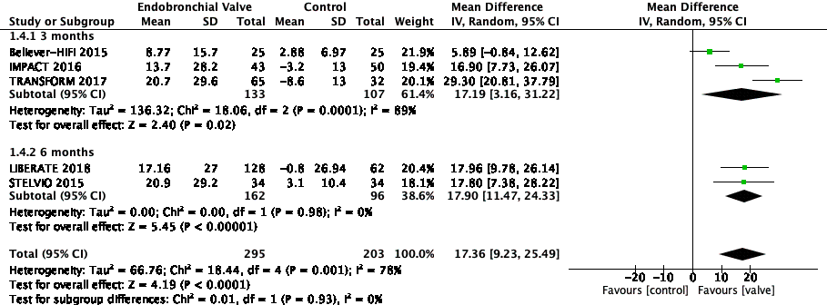

Supplementary Figure 2. Subgroup. Change in FEV1 according to type of control group

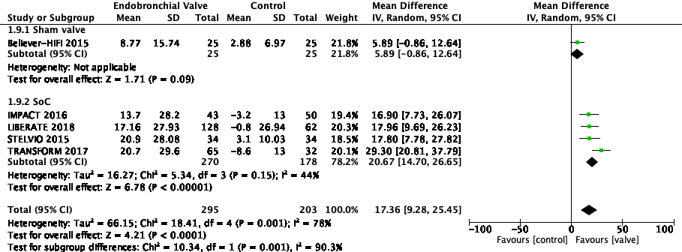

Supplementary figure 3. Relative risk of mortality after intervention

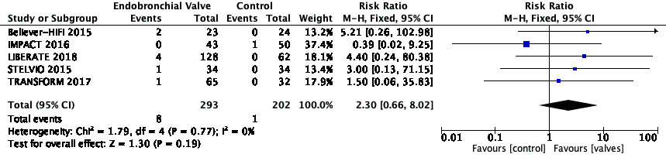

Supplementary figure 4. Subgroup analysis of pneumothorax according to emphysema distribution
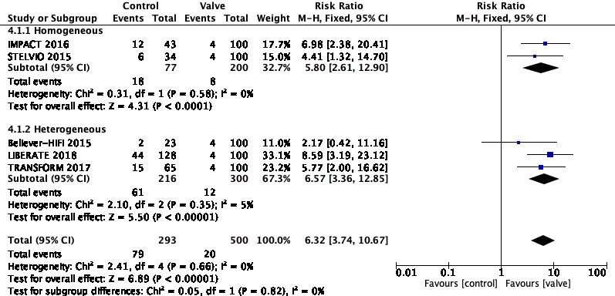

Supplementary figure 5. Funnel plot. Changes in FEV₁

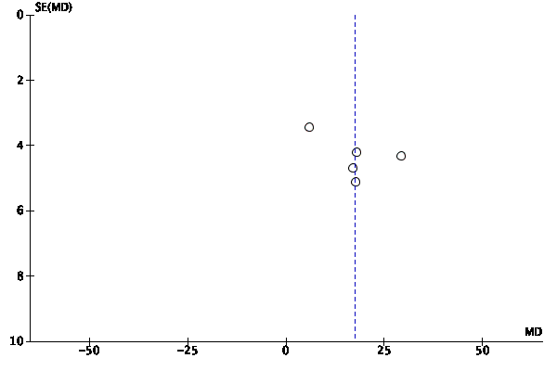

Supplementary figure 6. Funnel plot. Changes in SGRQ

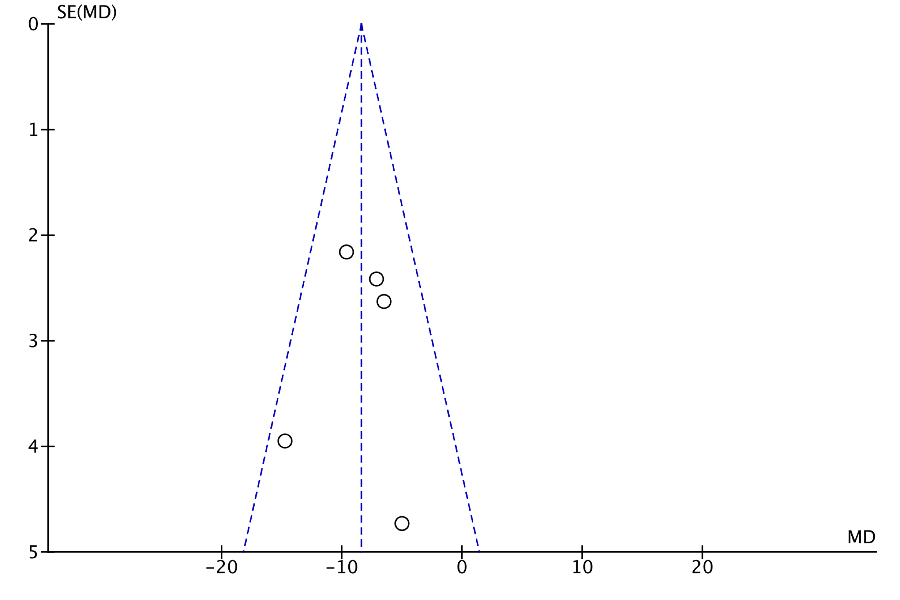

Supplementary figure 7. Funnel plot. Changes in 6MWT

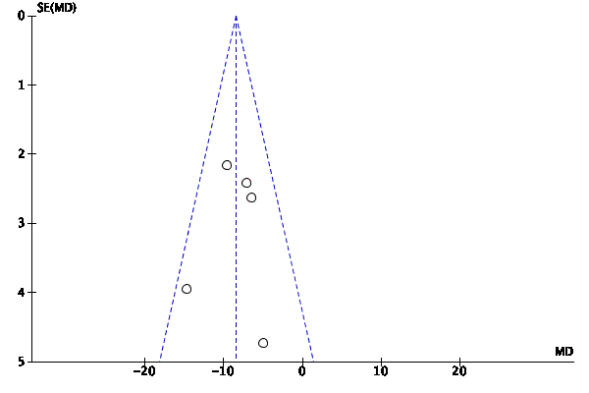

Supplementary figure 8. Funnel plot. Change in RV

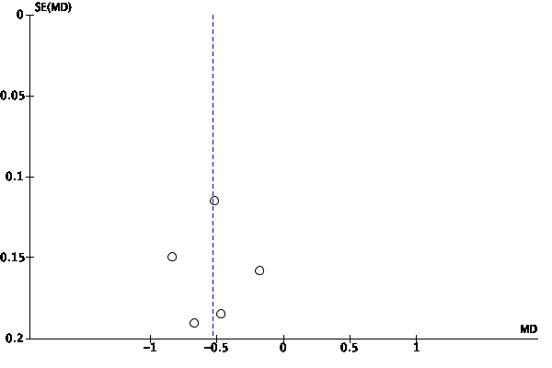

Supplementary figure 9. Funnel plot. Risk of mortality

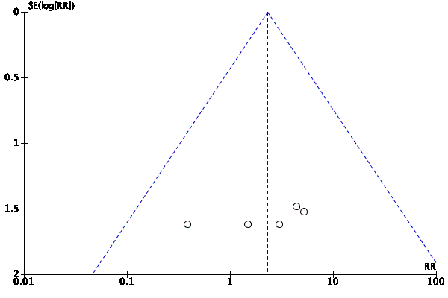
Supplementary figure 10. Funnel plot. Risk of pneumothorax
