**Supplementary Appendix**

This appendix has been provided by the authors to give readers additional information about their work.

Supplement to: Xu Y, ShanthoshJ; Zhou Z, et al. Prevalence of driving and traffic accidents among people with seizures: a systematic review.

**Table e-1** Description of search strategy and results

| **Database** | **Search strategy** | **Number of articles** |
| --- | --- | --- |
| 1) Medline | 1. automobile driving/ | 17240 |
| 2. motor vehicles/ or automobiles/ or motorcycles/ | 12619 |
| 3. accidents, traffic/ | 40121 |
| 4. (vehicle* or automobile* or drive or drives or drove or driving or driver* or licen?e*).tw. | 278578 |
| 5 Licensure/ | 6658 |
| 6. 1 or 2 or 3 or 4 or 5 | 313894 |
| 7. exp epilepsy/ (includes seizures/) | 103160 |
| 8. (epilep* or seizure* or convulsi*).tw. | 168984 |
| 9. 7 or 8 | 187340 |
| 10. 6 and 9 | 2864 |
| Limit 10 to Human | 1742 |
| 2) EMBASE | 1. car driving/ or driver licence/ or driving ability/ | 22057 |
| 2. motor vehicle/ or car/ or motorcycle/ | 22596 |
| 3. traffic accident/ | 58609 |
| 4. (vehicle* or automobile* or drive or drives or drove or driving or driver* or licen?e*).tw. | 565326 |
| 5. 1 or 2 or 3 or 4 | 613061 |
| 6. exp epilepsy/ or "seizure, epilepsy and convulsion"/ or seizure/ | 320013 |
| 7. (epilep* or seizure* or convulsi*).tw. | 288857 |
| 8. 6 or 7 | 377131 |
| 9. 5 and 8 | 7552 |
| Limit 9 to (Human AND Exclude Medline journals) | 885 |
| 3) CINAHL | S1. (MH "Automobile Driving") OR (MH "Motor Vehicles") OR (MH "Automobiles") OR (MH "Accidents, Traffic") OR (MH "Licensure") | 19944 |
| S2. "vehicle*" | 11603 |
| S3. "automobile*" | 6948 |
| S4. "drive" | 7257 |
| S5 "drives" | 1410 |
| S6. "drove" | 457 |
| S7. "driving" | 10531 |
| S8. "driver*" | 6845 |
| S9. "licen?e*" | 7147 |
| S10. or/ S1-S9 | 48778 |
| S11 (MH "Epilepsy+") or (MH "Seizure") or (MH "Convulsions+") | 8706 |
| S12. "epilep*" | 10696 |
| S13. "seizure*" | 10320 |
| S14. "convulsi*" | 1286 |
| S15. or/ S11-S14 | 17332 |
| S18. S10 and S15 | 292 |
| Limit S18 to (Human AND Exclude Medline journals) | 20 |
| 4) PsycINFO | 1. drivers/ or driving behavior/ or exp motor vehicles/ or transportation accidents/ (no “licence/”) | 14064 |
| 2. (vehicle* or automobile* or drive or drives or drove or driving or driver* or licen?e*).tw. | 95181 |
| 3. 1 or 2 | 96568 |
| 4. exp epilepsy/ or exp seizures/ (seizures/ is used for convulsions.) | 32699 |
| 5. (epilep* or seizure* or convulsi*).tw. | 52486 |
| 6. 4 or 5 | 52841 |
| 7. 3 and 6 | 1043 |
| Limit 7 to Human | 614 |
| 5) COCHRANE CENTRAL | 1. Automobile Driving/ | 739 |
| 2. motor vehicles/ or automobiles/ or motorcycles/ | 121 |
| 3. Accidents, Traffic/ | 386 |
| 4. Licensure/ | 30 |
| 5. (vehicle* or automobile* or drive or drives or drove or driving or driver* or licen?e*).tw. | 17443 |
| 6. 1 or 2 or 3 or 4 or 5 | 17672 |
| 7. exp Epilepsy/ (includes seizures/) | 2571 |
| 8. (epilep* or seizure* or convulsi*).tw. | 7734 |
| 9. 7 or 8 | 8008 |
| 10. 6 and 9 | 102 |
| 6) TRID | 1. epilep* OR seizure* OR convulsi* | 415 |
| 2. vehicle* or automobile* or drive or drives or drove or driving or driver* or licence* or license* | 15000 |
| 3. 1 and 2 | 8 |
| 7) PEDro | Advanced search |  |
| 1. Abstract & Title - epilep* vehicle* Subdiscipline: neurology | 0 |
| 2. Abstract & Title - seizure* vehicle* Subdiscipline: neurology | 0 |
| 3. Abstract & Title - convulsi* vehicle* Subdiscipline: neurology | 0 |
| 4. Abstract & Title - epilep* automobile* Subdiscipline: neurology | 0 |
| 5. Abstract & Title - seizure* automobile* Subdiscipline: neurology | 0 |
| 6. Abstract & Title - convulsi* automobile* Subdiscipline: neurology | 0 |
| 7. Abstract & Title - epilep* dr@v* Subdiscipline: neurology | 0 |
| 8. Abstract & Title - seizure* dr@v* Subdiscipline: neurology | 0 |
| 9. Abstract & Title - convulsi* dr@v* Subdiscipline: neurology | 0 |
| 10. Abstract & Title - epilep* licen@e* Subdiscipline: neurology | 0 |
| 11. Abstract & Title - seizure* licen@e* Subdiscipline: neurology | 0 |
| 12. Abstract & Title - convulsi* licen@e* Subdiscipline: neurology | 0 |
| 13. Abstract & Title - epilep* accident* Subdiscipline: neurology | 0 |
| 14. Abstract & Title - seizure* accident* Subdiscipline: neurology | 0 |
| 15. Abstract & Title - convulsi* accident* Subdiscipline: neurology | 0 |
| 8) C2-SPECTR | Search “epilep”, “seizure”, “convulsi” in the pdf file of *Bibliography of CRTs currently in C2-SPECTR* | 0 |
| terms end up with “/” are subject headings; searching conducted on 27 June 2018  TRID is an integrated database that combines the records from TRB’s Transportation Research Information Services (TRIS) Database and the OECD’s Joint Transport Research Centre’s International Transport Research Documentation (ITRD) Database. TRID provides access to more than one million records of transportation research worldwide.  PEDro denotes Physiotherapy Evidence Database. It is a free database of randomized trials, systematic reviews and clinical practice guidelines in physiotherapy, produced by the Centre for Evidence-Based Physiotherapy at The George Institute for Global Health and hosted by Neuroscience Research Australia (NeuRA).  C2-SPECTR denotes the Campbell Collaboration's social, psychological, educational and criminological trials register. It contains entries on randomized and possibly randomized trials. | | |

**Table e-2** Characteristics of the included studies

| **Country year, last name of the first author** | **Case selection** | **Study design** | **Sample size** | **Number of males (%)** | **Minimum age (years)** | **Data collectiond** | **Driving** | **License** | **Traffic accidents** |
| --- | --- | --- | --- | --- | --- | --- | --- | --- | --- |
| Australia 1974, Edwardsa | single centre hospital based | cross-sectional | 150 | 97 (61) | 17 | face to face interview | ✓ | ✓ |  |
| Australia 1999, Unswortha | community based | cross-sectional | 78 |  |  | survey | ✓ |  |  |
| Australia 2018, Xub | community based | cohort | 152 |  | 18 | face to face interview | ✓ |  |  |
| Brazil 2010, Tedrusb | single centre hospital based | cross-sectional | 56 |  |  | survey |  | ✓ | ✓ |
| Brazil 2012, Bicalhoa | multi-centre hospital based | cross-sectional | 144 | 79 (55) | 18 | face to face interview | ✓ | ✓ | ✓ |
| Brazil 2017, Diasc | single centre hospital based | case-control | 91 | 39 (43) | 18 | face to face interview | ✓ |  |  |
| Bulgaria 2013, Vitevab | single centre hospital based | cross-sectional | 70 |  |  | face to face interview | ✓ |  |  |
| Canada 1984, Broughtonb | single centre hospital based | case-control | 60 | 27 (45) |  | survey | ✓ | ✓ | ✓ |
| Canada 2007 McLachlanb | multi-centre hospital based | case-control | 425 | 196 (46) | 16 | survey | ✓ | ✓ | ✓ |
| Canada 2016, Pukac | single centre hospital based | case-control | 78 | 30 (38) | 18 | survey |  | ✓ |  |
| China 2014, Chenb | single centre hospital based | cross-sectional | 657 | 382 (58) | 18 | face to face interview | ✓ |  | ✓ |
| Croatia 1999 & 2011, Bielena | multi-centre hospital based | cross-sectional | 317 |  | 18 | survey | ✓ | ✓ |  |
| Denmark 2001, Lingsa | single centre hospital based | cohort | 514 |  | 18 | registered data |  | ✓ | ✓ |
| European countries 2000, RESt-1a | multi-centre hospital based | cross-sectional | 706 | 370 (52) | 18 | face to face interview |  | ✓ |  |
| Finland 2005, Sillanpaab | derived from population-based | cohort | 81 | 29 (36) | 38 | face to face interview |  | ✓ | ✓ |
| France 1979, Beaussart | community based | cross-sectional | 448 | 370 (83) | "adults" | registered data |  |  | ✓ |
| France 1991, Raimondeau | single centre hospital based | cross-sectional | 100 | 72 (72) | 18 | face to face interview |  |  | ✓ |
| France 1997, Beaussarta | single centre hospital based | cohort | 2102 | 1192 (57) | 18 | survey | ✓ | ✓ | ✓ |
| France 2006, Dupontc | single centre hospital based | cross-sectional | 110 | 56 (51) |  | survey |  | ✓ |  |
| German 1967, Janza | single centre hospital based | cross-sectional | 500 | 329 (66) | 20 | face to face interview | ✓ | ✓ | ✓ |
| German 2009, Elsharkawyc | single centre hospital based | cross-sectional | 86 | 55 (64) | 16 | survey | ✓ |  |  |
| Greece 2014, Zisa | multi-centre hospital based | cross-sectional | 190 | 107 (56) | 18 | survey | ✓ | ✓ |  |
| Hungary 2003, Rajnaa | multi-centre hospital based | cross-sectional | 753 |  | 18 | registered data |  | ✓ |  |
| Ireland 2013, Sullivana | community based | cross-sectional | 95 | 30 (32) | 18 | survey |  | ✓ |  |
| Italy 1978, Manciaa | single centre hospital based | cross-sectional | 143 | 75 (52) | 18 | face to face interview |  | ✓ |  |
| Italy 1980, Quattrinia | single centre hospital based | cross-sectional | 321 | 151 (47) | 18 | survey |  | ✓ | ✓ |
| Italy 2012, Fattoucha | single centre hospital based | cross-sectional | 57 | 26 (46) | 18 | face to face interview | ✓ | ✓ | ✓ |
| Japan 1989, Sasagawab | single centre hospital based | cross-sectional | 114 | 65 (57) | 18 | face to face interview |  | ✓ | ✓ |
| Japan 1991, Hasegawaa | community-based | cross-sectional | 129 |  |  | survey | ✓ | ✓ | ✓ |
| Japan 1990 &1991, Hashimotoa | single centre hospital based | cross-sectional | 98 |  | 20 | face to face interview | ✓ |  | ✓ |
| Japan 1991, Takedaa | multi-centre hospital based | cross-sectional | 3521 | 1849 (53) | 20 | face to face interview | ✓ | ✓ | ✓ |
| Japan 1994, Hashimotob | single centre hospital based | cross-sectional | 67 | 36 (54) | 18 | face to face interview | ✓ | ✓ | ✓ |
| Japan 2000, Wakamotob | single centre hospital based | cohort | 148 | 72 (49) | 20 | phone interview |  | ✓ |  |
| Japan 2004, Inouea | community based | cross-sectional | 1617 |  |  | registered data |  | ✓ |  |
| Japan 2005, Itoa | single centre hospital based | cross-sectional | 162 | 85 (52) | 18 | registered data |  | ✓ |  |
| Japan 2017, Hosoyamac | single centre hospital based | cross-sectional | 85 | 56 (66) | 18 | survey |  | ✓ |  |
| Korea 2011, Nob | multi-centre hospital based | cross-sectional | 179 | 125 (70) | 18 | face to face interview | ✓ | ✓ | ✓ |
| New Zealand 1983, Stanawaya | community based | cross-sectional | 103 | 72 (70) | 15 | face to face interview | ✓ | ✓ |  |
| Slovakia 2010, Martinovea | single centre hospital based | cross-sectional | 193 | 164 (85) |  |  |  | ✓ |  |
| Slovenia 1997, Groselja | single centre hospital based | cross-sectional | 578 | 285 (49) | 18 | face to face interview |  | ✓ |  |
| Sri Lanka 1998, Seneviratnea | single centre hospital based | cross-sectional | 420 | 224 (53) |  | face to face interview | ✓ |  | ✓ |
| Sweden 2003, Lindstenb | community based | cohort | 62 |  | 17 | survey |  | ✓ |  |
| Sweden 2007, Asztelyc | single centre hospital based | cohort | 103 |  | 32 | face to face interview |  | ✓ |  |
| Thailand 2014, Saengsuwana | single centre hospital based | cross-sectional | 203 | 106 (52) | 18 | face to face interview | ✓ |  | ✓ |
| UK 1971, Maxwella | community based | cross-sectional | 384 | 248 (65) | 18 | registered data |  | ✓ |  |
| UK 1993, Dickeya | single centre hospital based | cross-sectional | 104 | 43 (41) | 17 | survey | ✓ | ✓ | ✓ |
| UK 1996, Taylor | community based | case-control | 16396 | 8854 (54) |  | survey |  |  | ✓ |
| UK 2000, Dalrympleb | community based | cross-sectional | 111 | 52 (47) | 16 | survey |  | ✓ |  |
| UK 2003, Reidc | single centre hospital based | cross-sectional | 67 | 34 (51) |  | survey |  | ✓ |  |
| UK 2007, Jacobyb | multi-centre hospital based | randomized controlled trial | 307 | 181 (59) | 16 | survey |  | ✓ |  |
| UK 2011, Chinb | community based | cohort | 65 | 51 (78) | 33 | survey |  | ✓ |  |
| USA 1988, Popkina | multi-centre hospital based | cross-sectional | 460 |  | 16 | registered data |  | ✓ | ✓ |
| USA 1993, Hansotiab | single centre hospital based | cohort | 432 | 220 (51) |  | registered data |  | ✓ | ✓ |
| USA 1996, Wassc | single centre hospital based | cohort | 195 | 111 (57) | 16 | survey + phone interview |  | ✓ | ✓ |
| USA 1997, Reevesc | single centre hospital based | cross-sectional | 112 | 46 (41) |  | survey + phone interview | ✓ |  |  |
| USA 2000, Berga | multi-centre hospital based | cross-sectional | 367 |  | 20 | face to face interview | ✓ | ✓ | ✓ |
| USA 2000, Sirvenc | single centre hospital based | cohort | 363 | 186 (51) | 18 | face to face interview | ✓ |  |  |
| USA 2006, Bautistab | single centre hospital based | cross-sectional | 307 | 129 (42) | 16 | survey | ✓ |  |  |
| USA 2008, Elliottb | community-based | cross-sectional | 213 | 66 (31) |  | survey |  | ✓ | ✓ |
| USA 2011, Peruccab | single centre hospital based | cohort | 63 | 34 (54) | 18 | face to face interview | ✓ |  |  |
| USA 2011, Websterb | single centre hospital based | cross-sectional | 190 | 84 (44) | 18 | face to face interview | ✓ |  | ✓ |
| USA 2012, Tatuma | single centre hospital based | cross-sectional | 147 | 57 (39) | 14 | survey | ✓ | ✓ |  |
| USA 2000 & 2002 & 2013, Jonesc | single centre hospital based | cohort | 75 | 34 (45) | 18 | face to face interview | ✓ | ✓ |  |
| USA 2015, Dawkinsc | single centre hospital based | cross-sectional | 78 | 38 (49) | "adults" | survey | ✓ | ✓ |  |
| USA 2015, Wasadec | single centre hospital based | cohort | 253 | 116 (46) |  | phone interview | ✓ |  |  |
| USA 2017, Bacab | community based | cohort | 361 | 188 (52) |  | face to face interview |  | ✓ |  |
| USA 2017, Maa | community based | cohort | 254 | 145 (57) | 15 | registered data |  | ✓ | ✓ |

aparticipants whose duration of the disease and history of epilepsy-related surgery were unknown (i.e. in Fig 4, 30 studies)

btime since a first seizure or the diagnosis of epilepsy was reported (i.e. in Fig 2, 21 studies)

cparticipants who underwent epilepsy-related surgery (i.e. in Fig 3, 13 studies)

dsurvey includes mailed, emailed or online survey or questionnaire delivered and returned on site



**Fig e-1.** External and internal validity of the included studies

aparticipants whose duration of the disease and history of epilepsy-related surgery were unknown (i.e. in Fig 4, 30 studies)

btime since a first seizure or the diagnosis of epilepsy was reported (i.e. in Fig 2, 21 studies)

cparticipants who underwent epilepsy-related surgery (i.e. in Fig 3, 13 studies)

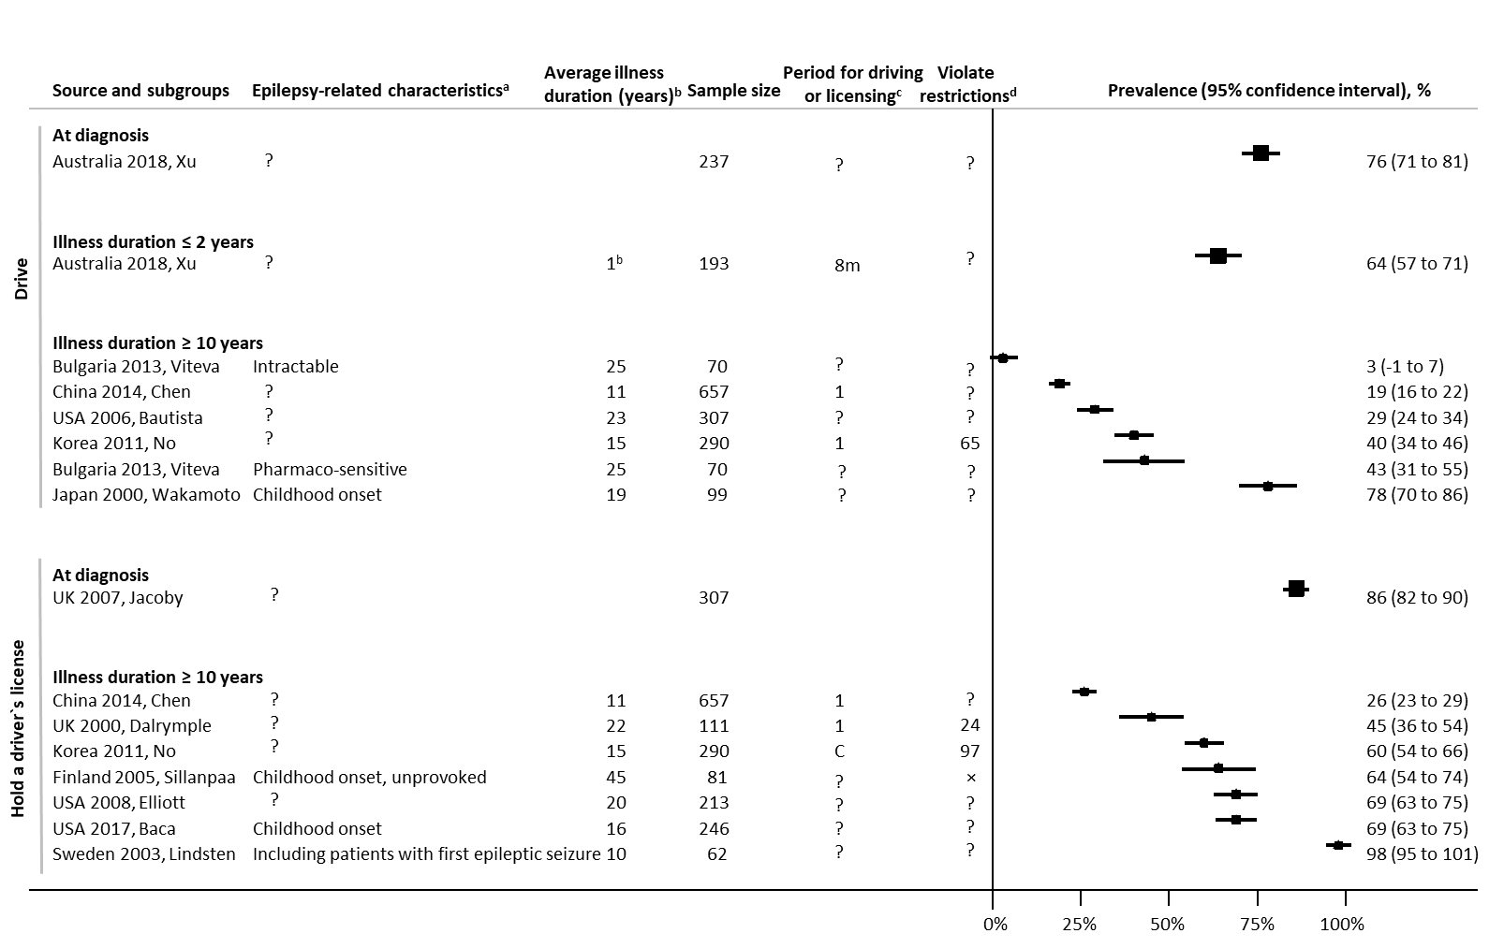

**Fig e-2.** Prevalence of driving and holding a driver`s license among people with seizures, where duration of the illness was reported (*studies with prospective and consecutive recruitment*)

a? denotes no specific epilepsy-related characteristics

ball participants had been diagnosed as epilepsy for 1 year (Australia 2018, Xu); for the other studies, numbers are average years after a first seizure or the diagnosis of epilepsy

c? denote not reported; 8m in the past 8 months; numbers in the past number of years; C current

d? denote not reported; numbers the number of participants who drove or held a driver`s license in violation of restrictions; ×all participants who held a driver`s license were not in violation of restrictions

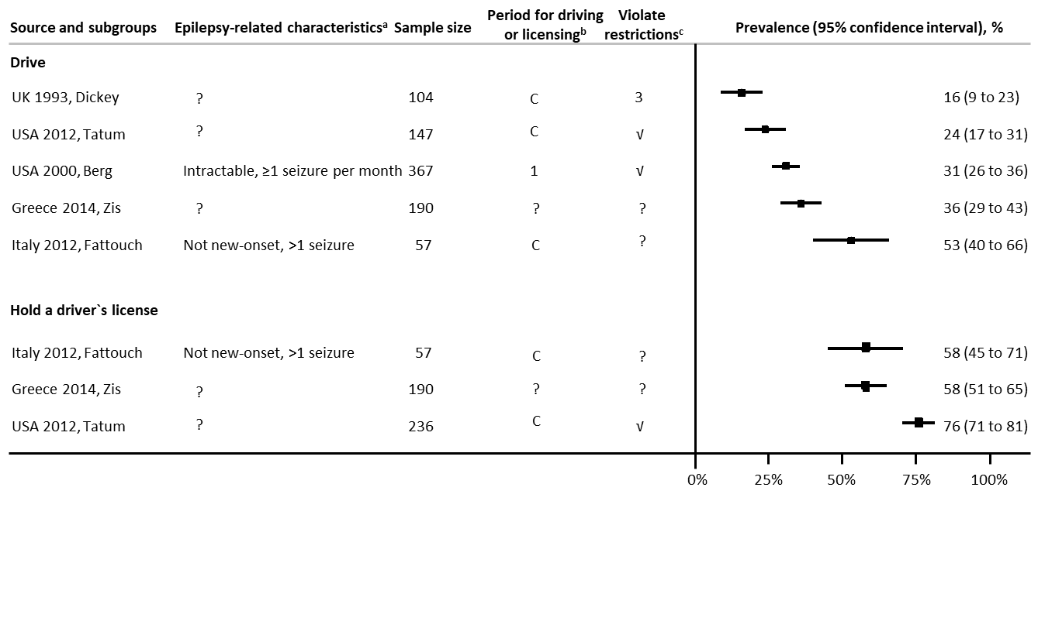

**Fig e-3.** Prevalence of driving or holding a driver`s license among people with seizures, whose duration of being diagnosed or history of surgery were not reported (*studies with prospective and consecutive recruitment*)

a? denotes no specific epilepsy-related characteristics

bC denotes current; 1 in the past one year; ? not reported

c3 denotes three participants drove in violation of restrictions; √all participants who drove or held a driver`s license were in violation of restrictions;.? not reported

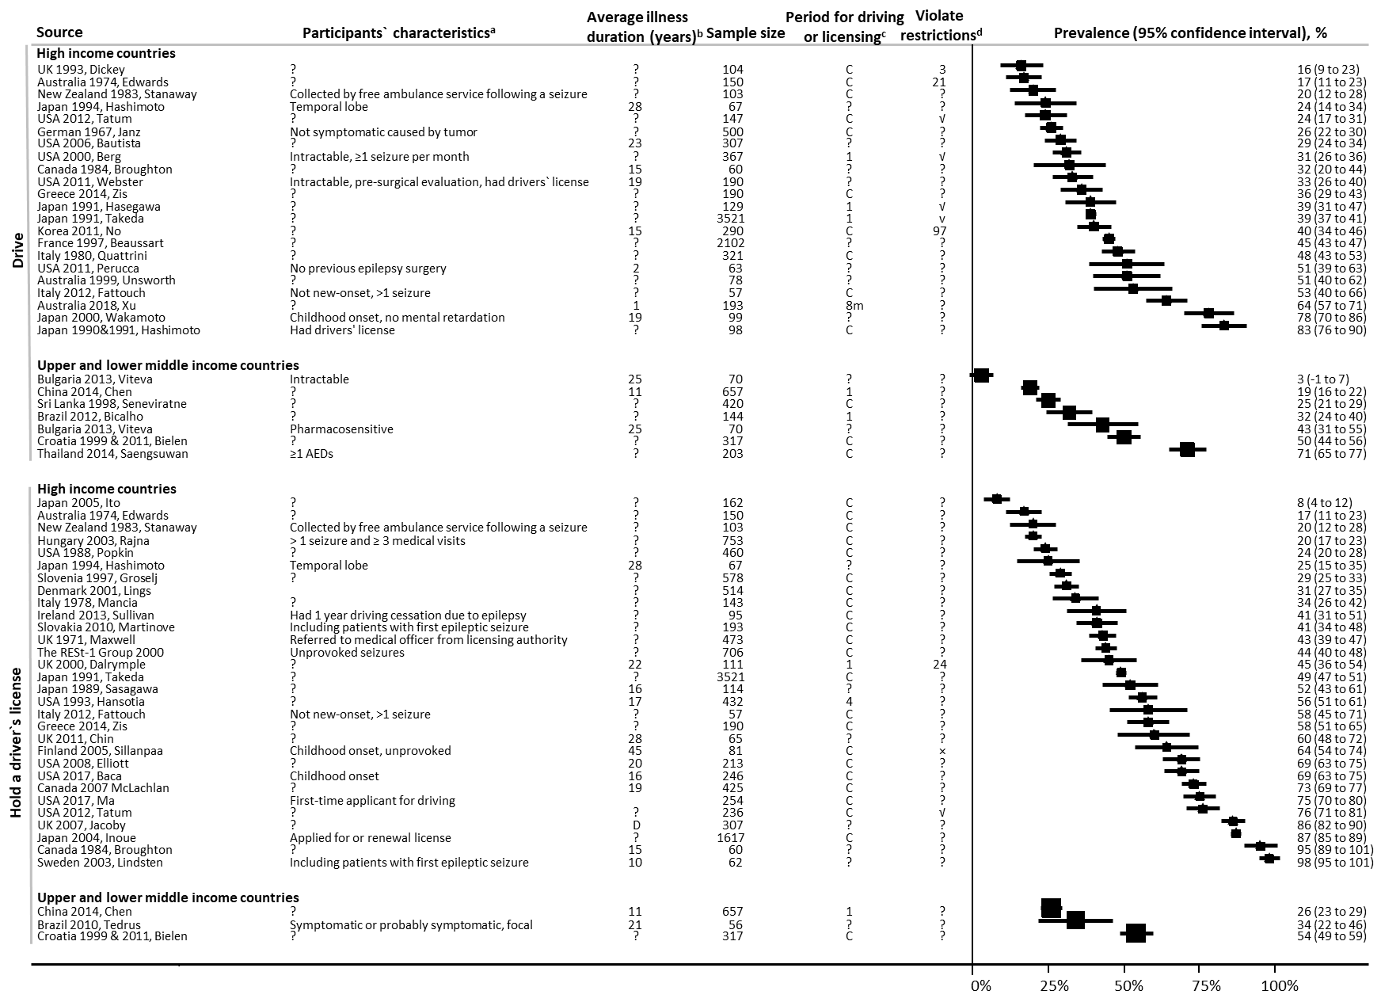

**Fig e-4.** Prevalence of driving and holding a driver`s license among people with seizures by countries` World Bank income levels

a? denotes no specific epilepsy-related characteristics

b? denote not reported; all participants had been diagnosed as epilepsy for 1 year (Australia 2018, Xu); for the other studies, numbers are average years after a first seizure or the diagnosis of epilepsy; D at the time of diagnosis

cC denotes current; ? not reported; numbers in the past number of years; 8m in the past 8 months

dnumbers denote the number of participants who drove or held a driver`s license in violation of restrictions; ? not reported; √ all participants who held a driver`s license were in violation of restrictions; ×all participants who held a driver`s license were not in violation of restrictions

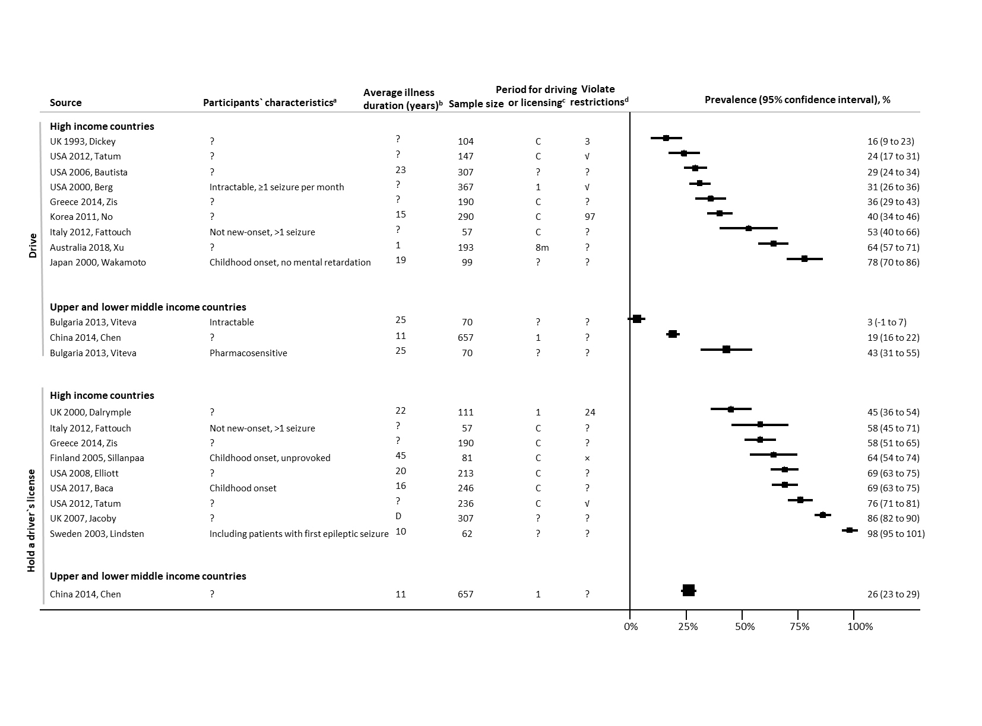

**Fig e-5.** Prevalence of driving and holding a driver`s license among people with seizures by countries` World Bank income levels (*studies with prospective and consecutive recruitment*)

a? denotes no specific epilepsy-related characteristics

b? denote not reported; all participants had been diagnosed as epilepsy for 1 year (Australia 2018, Xu); for the other studies, numbers are average years after a first seizure or the diagnosis of epilepsy; D at the time of diagnosis

cC denotes current; ? not reported; 1 in the past one year; 8m in the past 8 months

dnumbers denote the number of participants who drove or held a driver`s license in violation of restrictions; √all participants who drove or held a driver`s license were in violation of restrictions; ? not reported; ×all participants who held a driver`s license were not in violation of restrictions

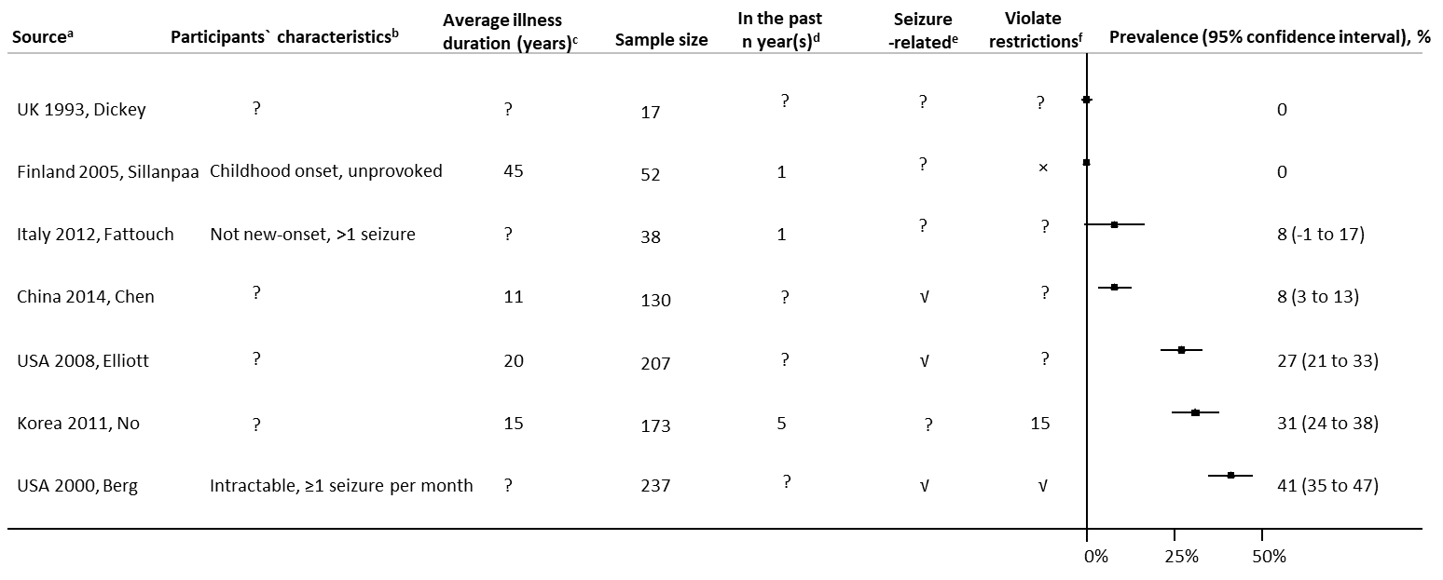

**Fig e-6.** Prevalence of traffic accidents among people with seizures who drove (*studies with prospective and consecutive recruitment*)

aonly one study was conducted in a lower middle income country, China

b? denotes no specific epilepsy- or driving-related characteristics

c? denote not reported; numbers are average years after a first seizure or the diagnosis of epilepsy

d? denotes not reported; numbers represent traffic accidents occurred in the past n years

e? denotes not reported; √ seizure-related

f? denotes not reported; × not in violation; numbers are the number of participants who had traffic accidents that were driving in violation; √ in violation

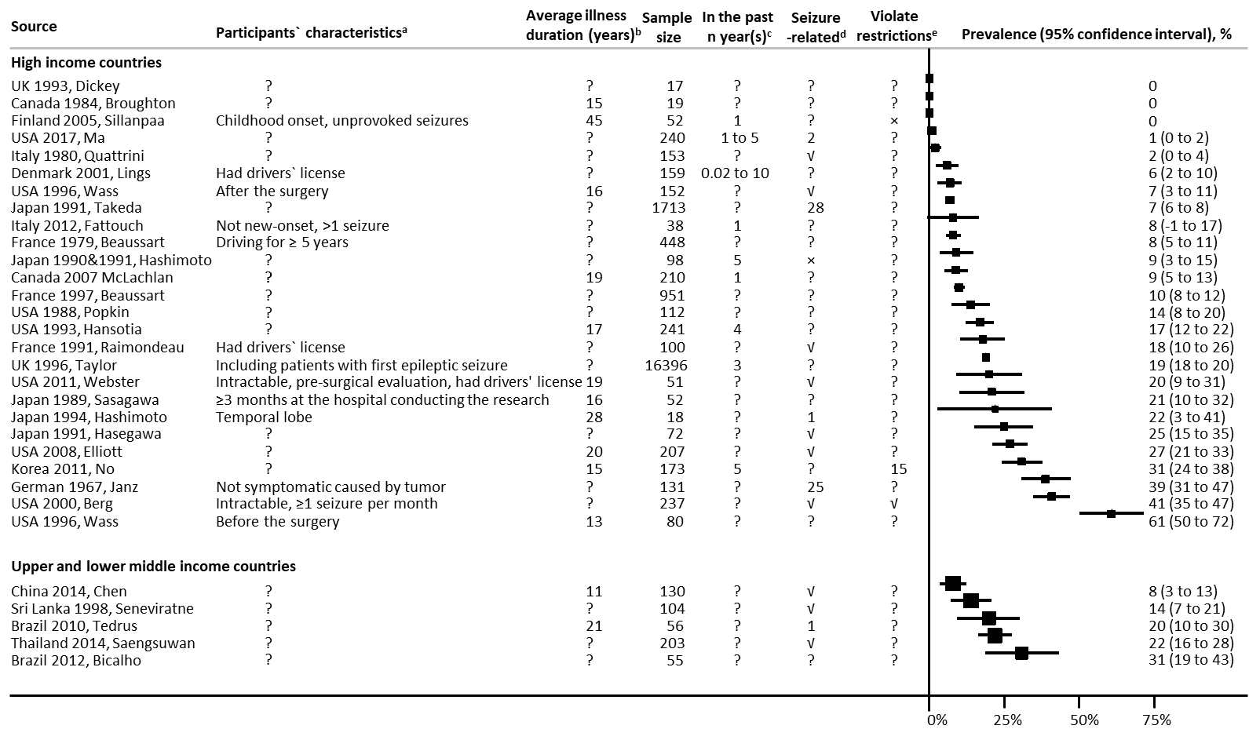

**Fig e-7.** Prevalence of traffic accidents among people with seizures who drove by countries` World Bank income levels

a? denotes no specific epilepsy-related characteristics

b? denotes not reported; numbers are average years after a first seizure or the diagnosis of epilepsy

c? denotes not reported; numbers denote in the past number of years

d? denotes not reported; × not in violation; numbers denote the number of participants who had traffic accidents that were driving in violation of restrictions; √ in violation

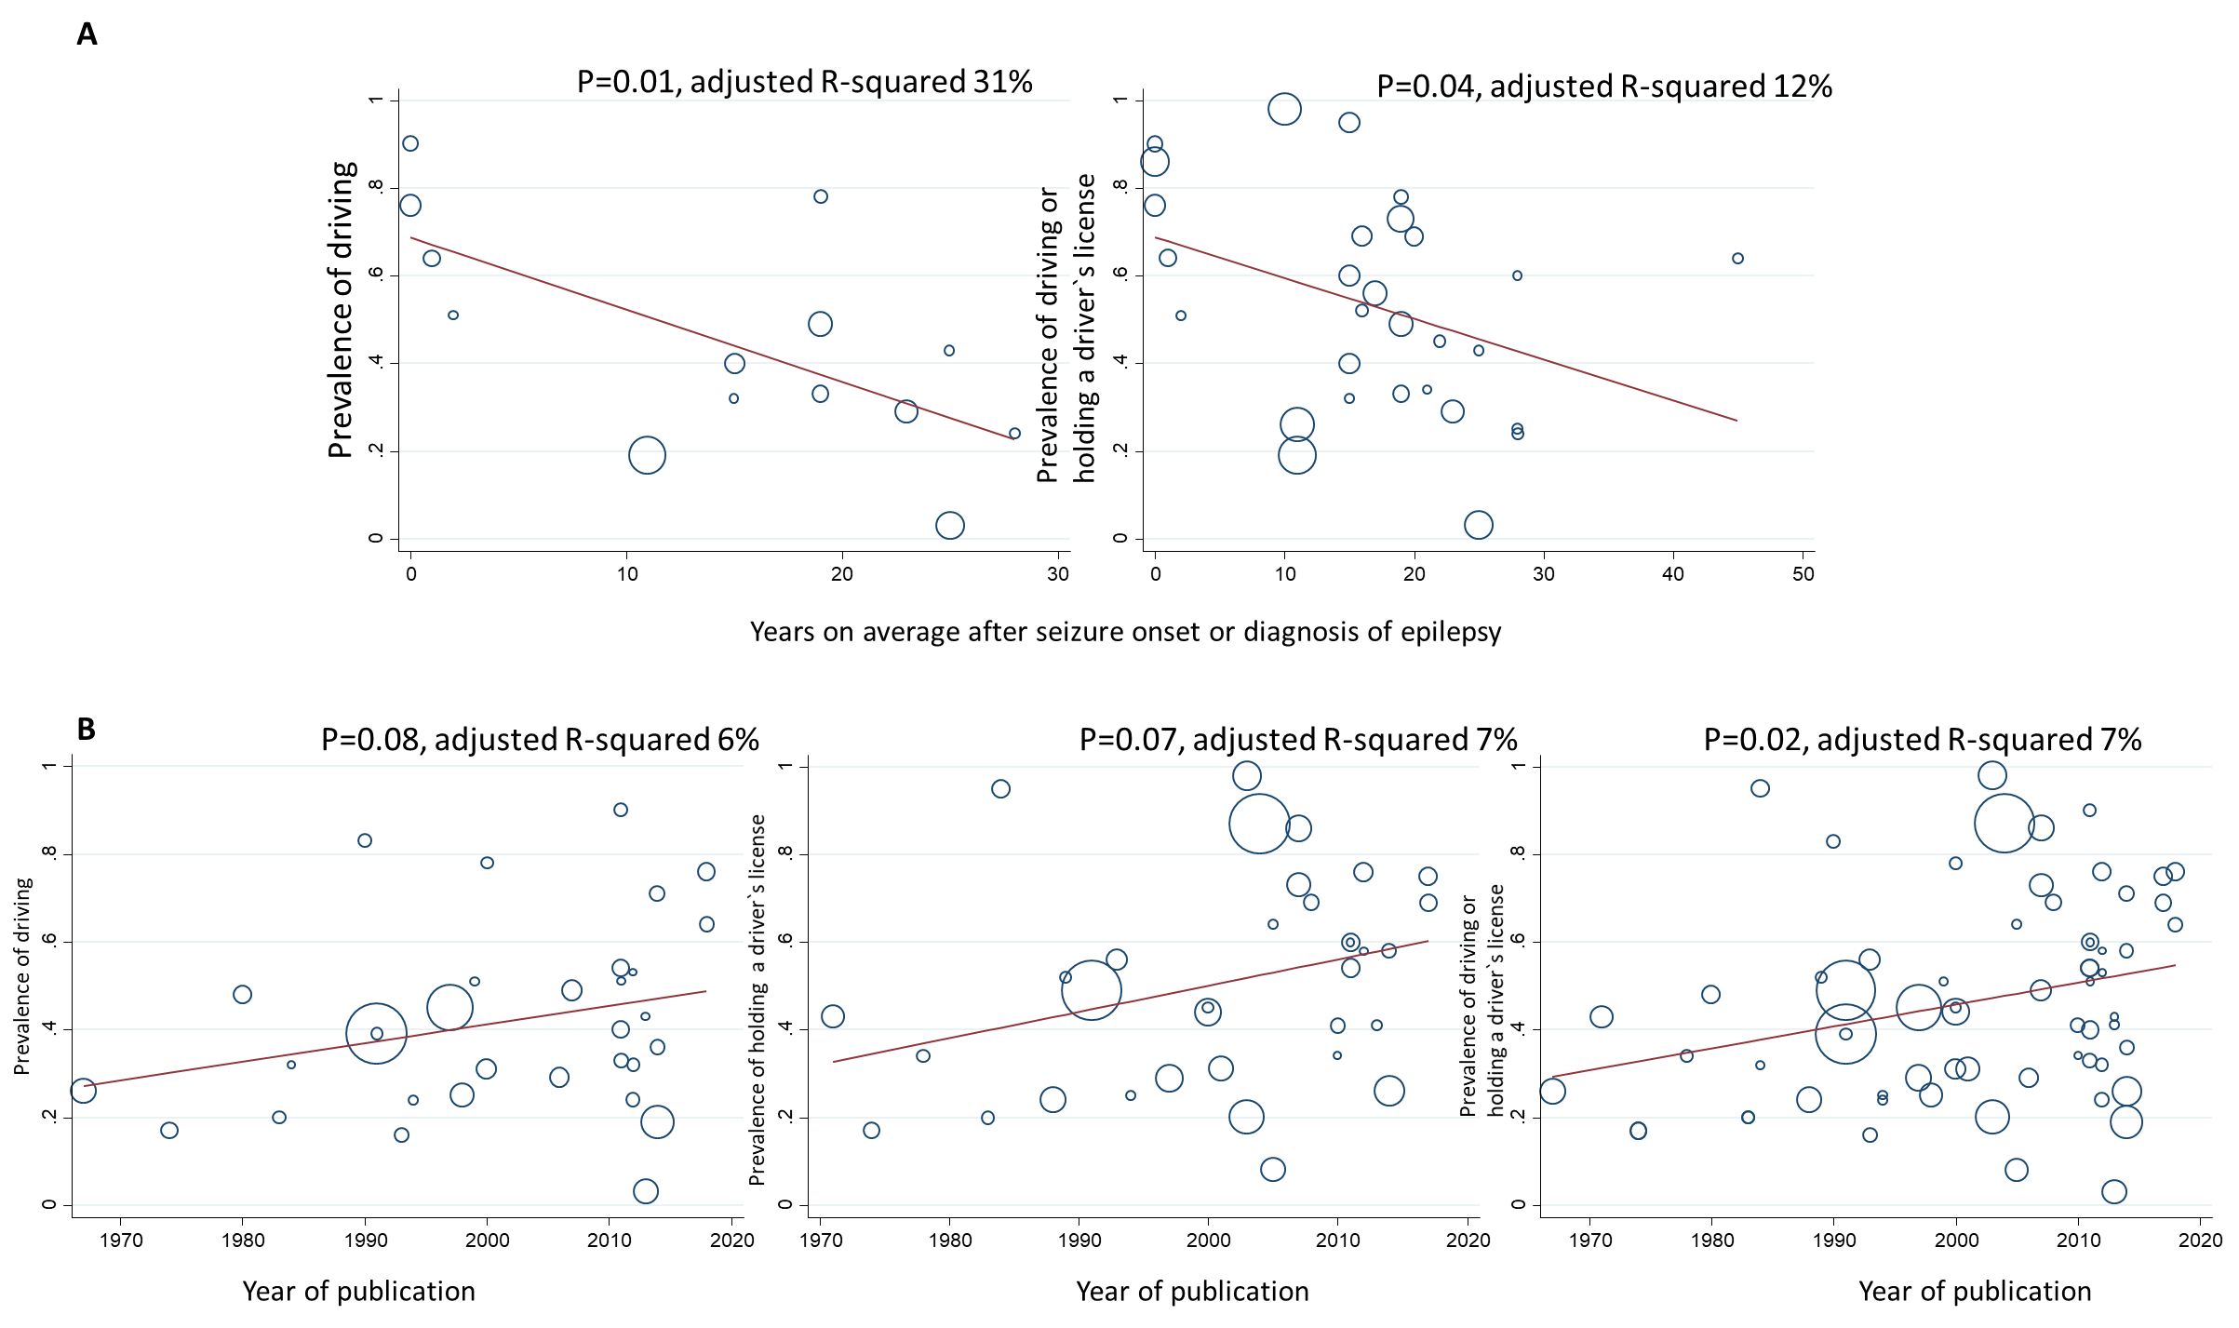

**Fig e-8.** Meta-regression of prevalence of driving and/or holding a driver`s license

Panel A against average duration after the seizure onset or the diagnosis of epilepsy

Panel B against year of publication

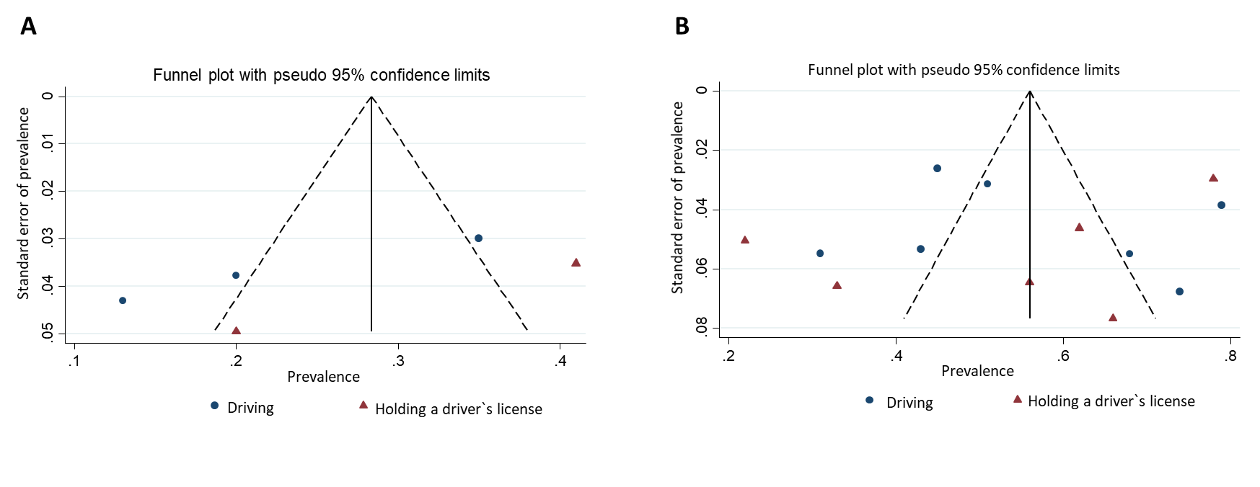

**Fig e-9.** Funnel plot, studies (involving epilepsy-related surgery) reporting prevalence of driving or holding a driver`s license

Panel A before the surgery; Panel B after the surgery

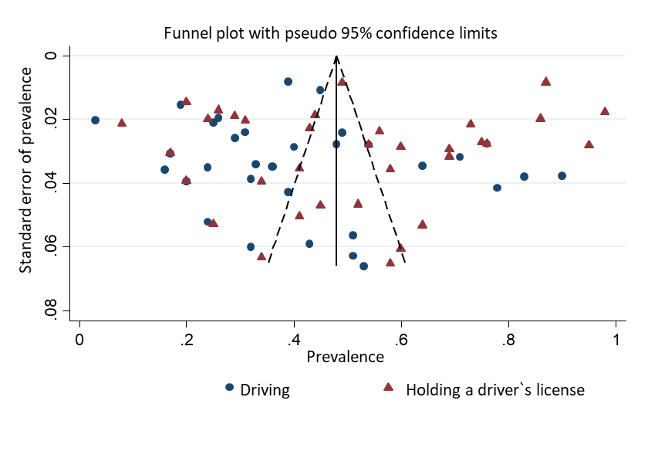

**Fig e-10.** Funnel plot, studies (not involving epilepsy-related surgery) reporting prevalence of driving or holding a driver`s license

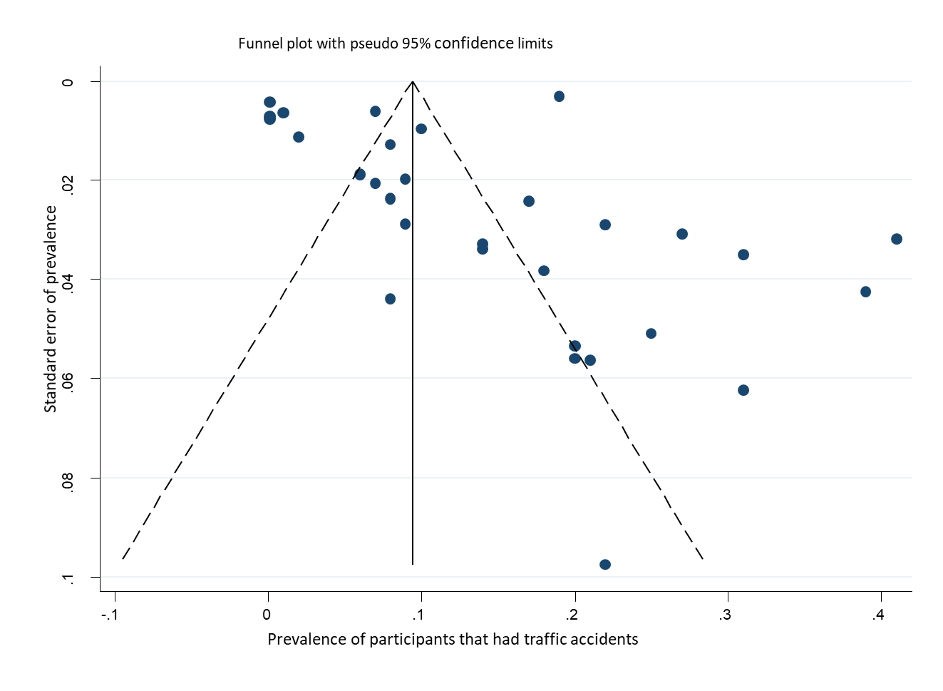

**Fig e-11** Funnel plot, studies reporting prevalence of traffic accidents