Supplementary Table 1: Caries Indices and Tooth/Surface Counts (N=36) using VERDICT and using CARIN with SAS (N=24).

|  |  |  |
| --- | --- | --- |
| **VERDICT Output** | **CARIN Output** | **Description** |
| DMFTdmft | d2mft_a+ d2mft_c | Overall combined tooth score |
| DMFT | d2mft_a | Overall permanent tooth score |
| dmft | d2mft_c | Overall deciduous tooth score |
| DMFSdmfs | d2mfs_a+ d2mfs_c | Overall combined surface score |
| DMFS | d2mfs_a | Overall permanent surface score |
| dmfs | d2mfs_c | Overall deciduous surface score |
| DMFS+I+dmfs+i |  | Overall combined surface + incisal edges score |
| DMFS+I |  | Overall permanent surface + incisal edges score |
| dmfs+i |  | Overall deciduous surface + incisal edges score |
| DT | d2t_a | Decayed permanent tooth score |
| MT | mt_a | Missing permanent tooth score |
| FT | ft_a | Filled permanent tooth score |
| dt | d2t_c | Decayed deciduous tooth score |
| mt | mt_c | Missing deciduous tooth score |
| ft | ft_c | Filled deciduous tooth score |
| DS | d2s_a | Decayed permanent surface score |
| MS | ms_a | Missing permanent surface score |
| FS | fs_a | Filled permanent surface score |
| ds | d2s_c | Decayed deciduous surface score |
| ms | ms_c | Missing deciduous surface score |
| fs | fs_c | Filled deciduous surface score |
| DSI |  | Decayed permanent surface + incisal edges score |
| MSI |  | Missing permanent surface + incisal edges score |
| FSI |  | Filled permanent surface + incisal edges score |
| dsi |  | Decayed deciduous surface + incisal edges score |
| msi |  | Missing deciduous surface + incisal edges score |
| fsi |  | Filled deciduous surface + incisal edges score |
| Tt | currToothCount_c+ currToothCount_a | Overall tooth count |
| t | currToothCount_c | Deciduous tooth count |
| T | currToothCount_a | Permanent tooth count |
| Ss | currSurfaceCount_c+ currSurfaceCount_a | Overall surface count |
| s | currSurfaceCount_c | Deciduous surface count |
| S | currSurfaceCount_a | Permanent surface count |
| Sisi |  | Overall surface + incisal edges count |
| si |  | Deciduous surface + incisal edges count |
| Si |  | Permanent surface + incisal edges count |

Supplementary Table 2: Synthetic Use Case Scenarios VERDICT-Calculated and Validated Caries Indices and Tooth and Surface Counts (N=45)

. 

Supplementary Figures: Synthetic Use Case Scenario Odontograms and Treatment Histories (N=45)

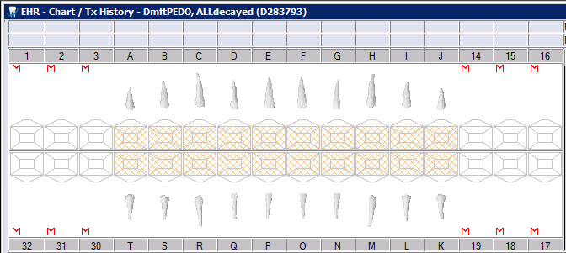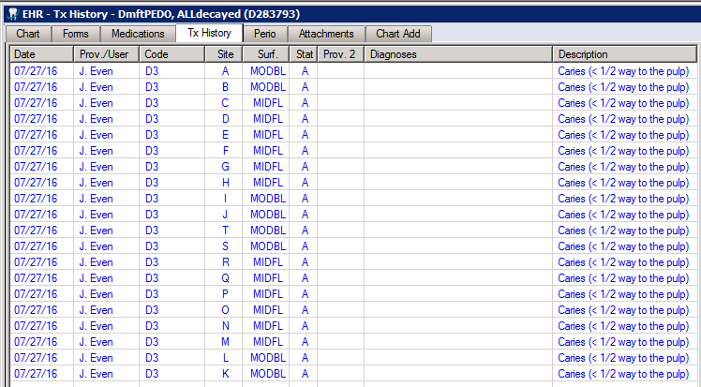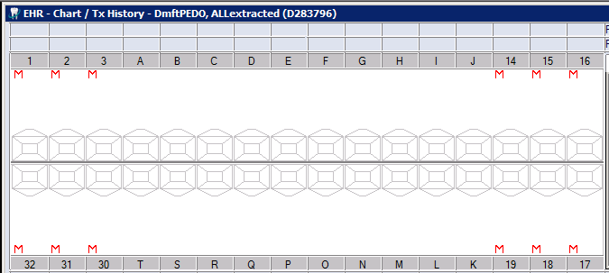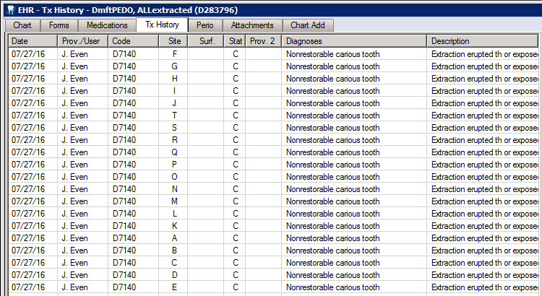

D283793

D283796

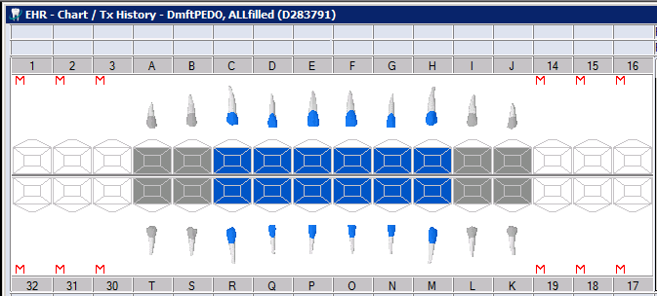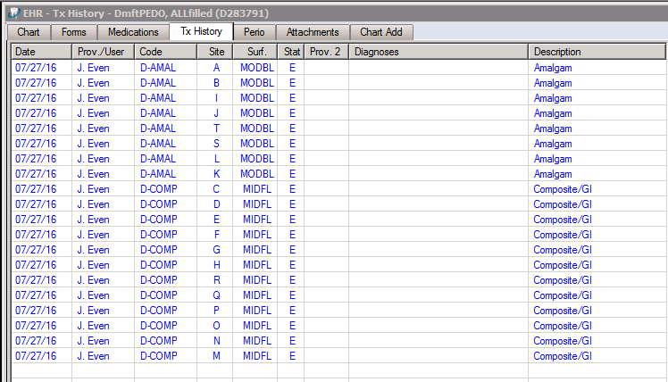

D283791

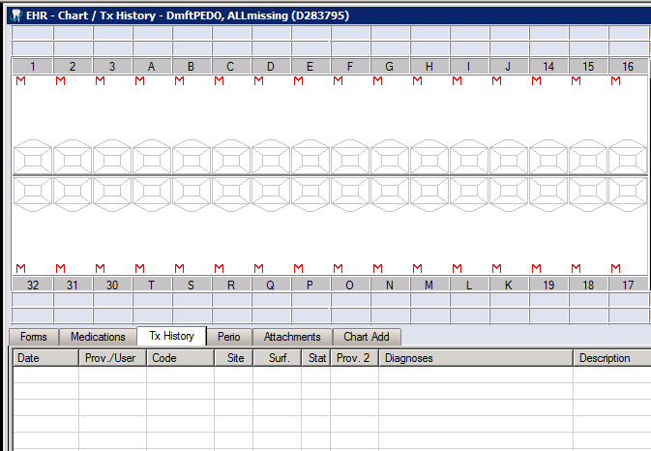

D283795

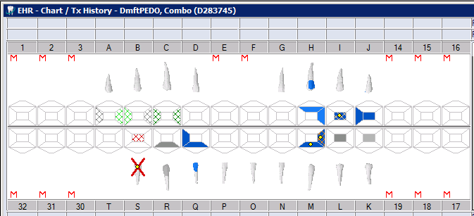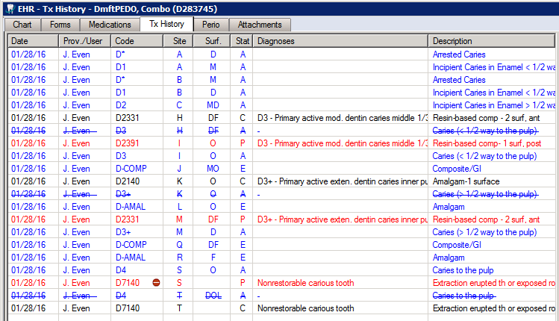

D283745

D283747

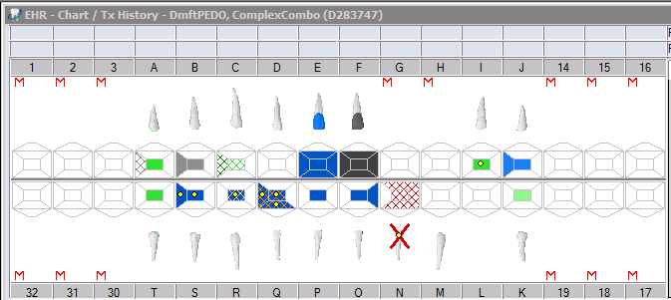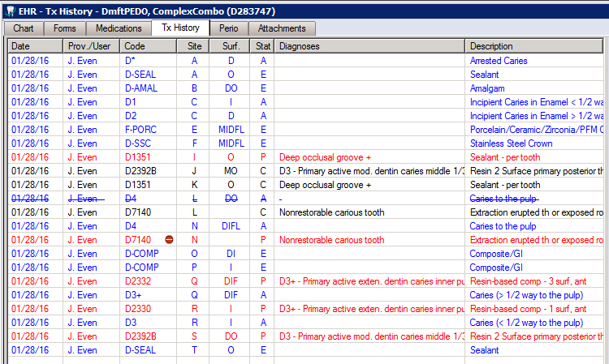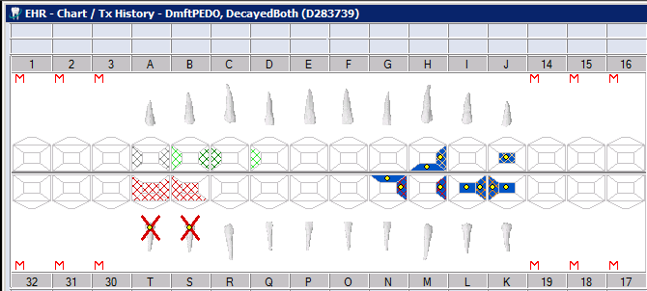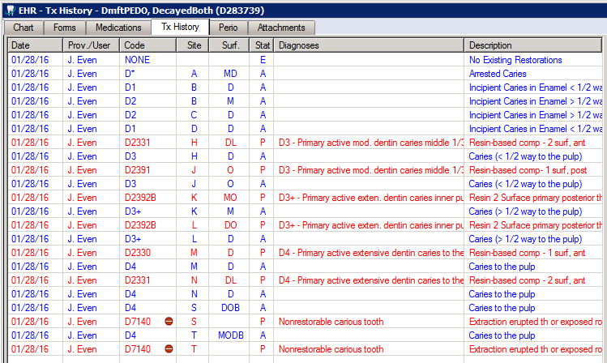

D283739

D283737

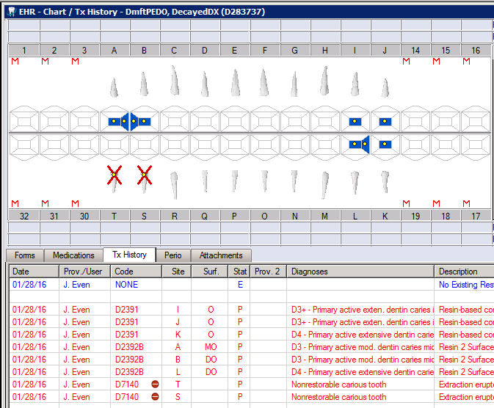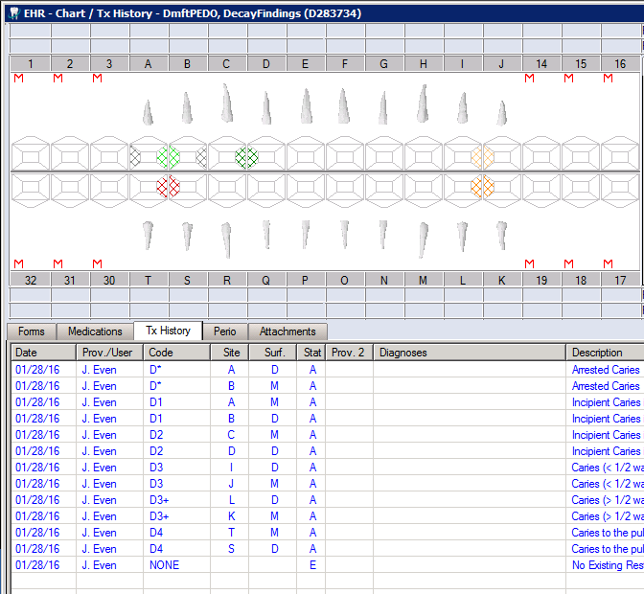

D283734

D283741

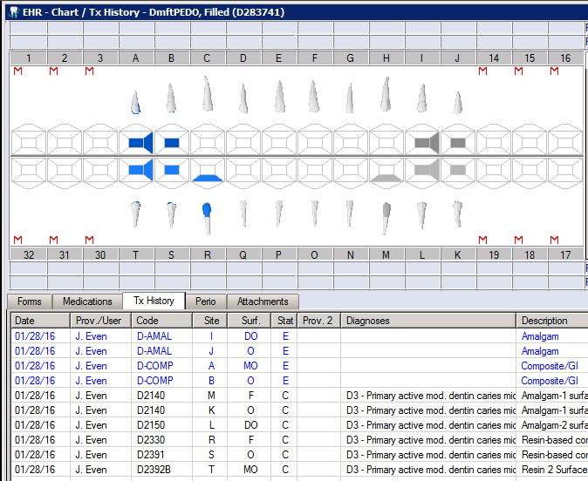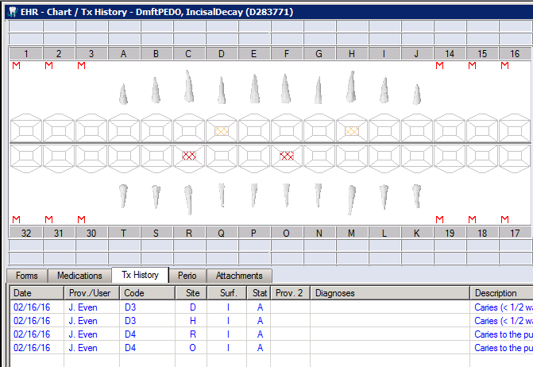

D283771

D283774

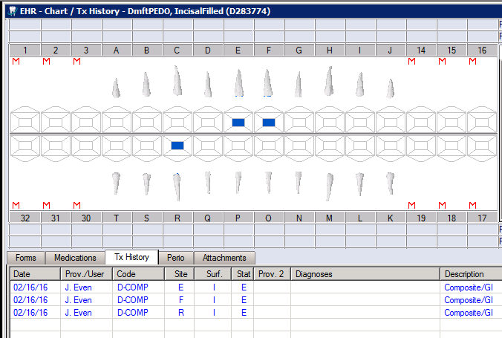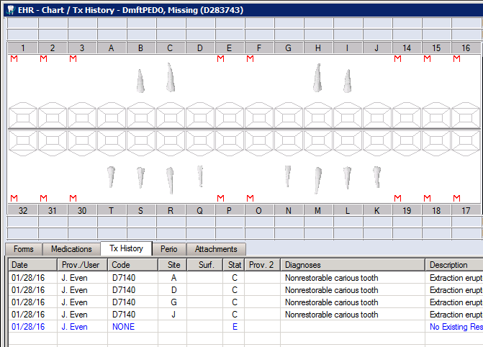

D283743

D283732

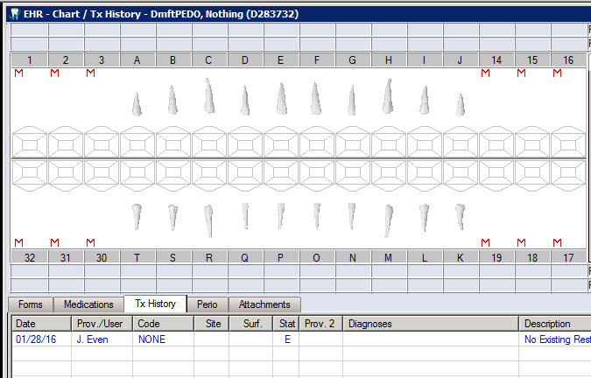

D283892

D283812

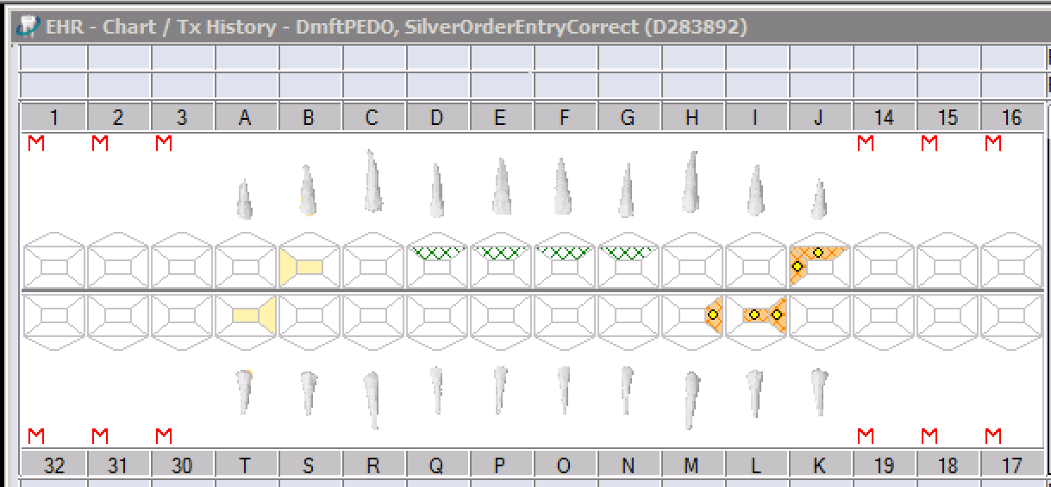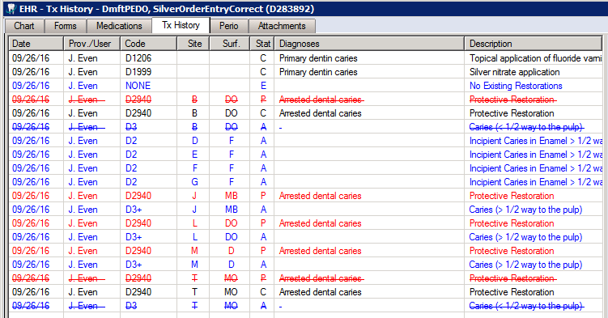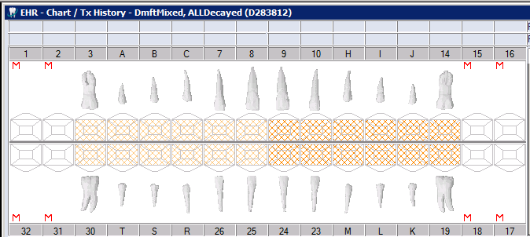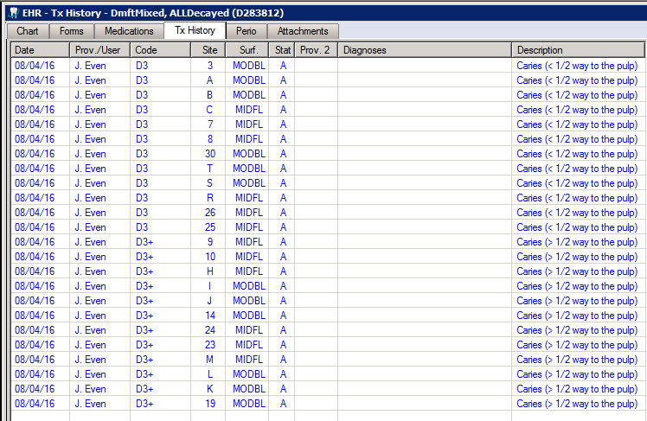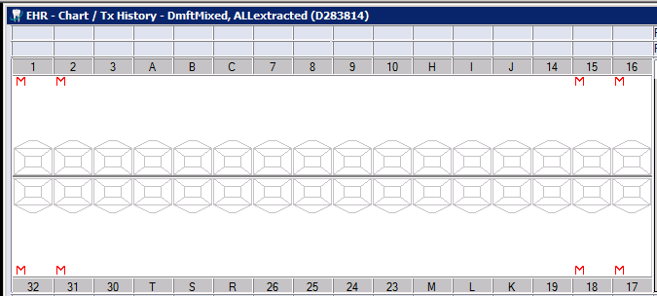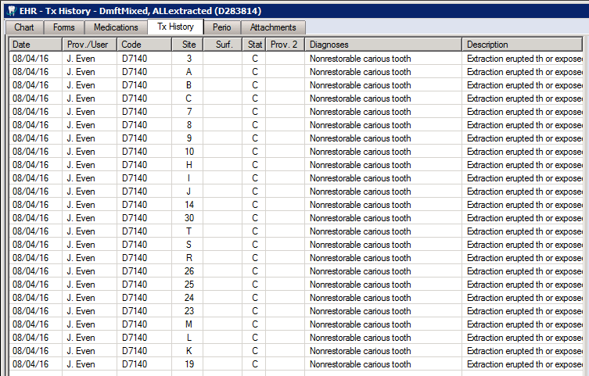

D283814

D283811

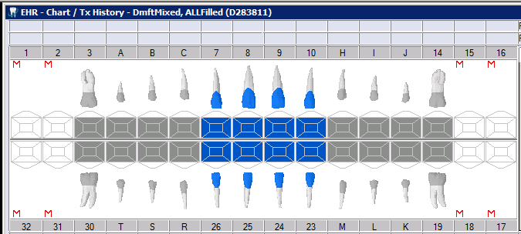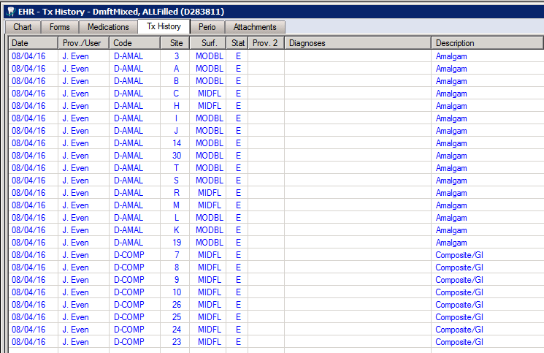

D283813

D283752

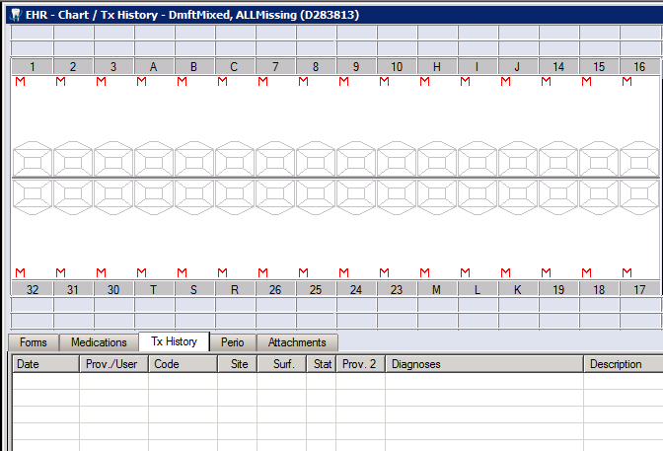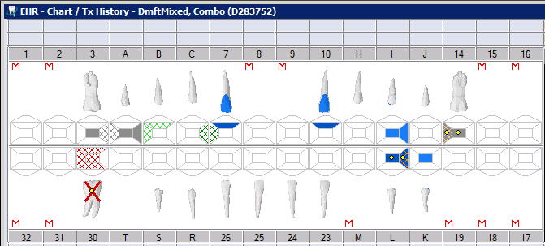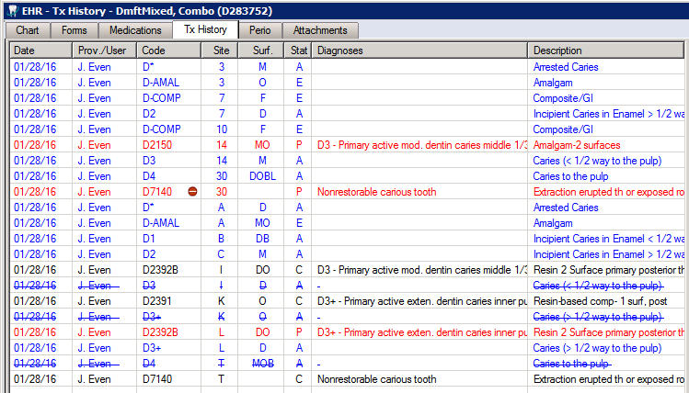

D283754

D283755

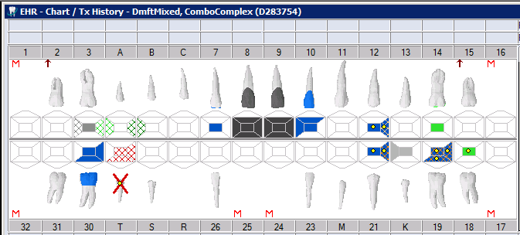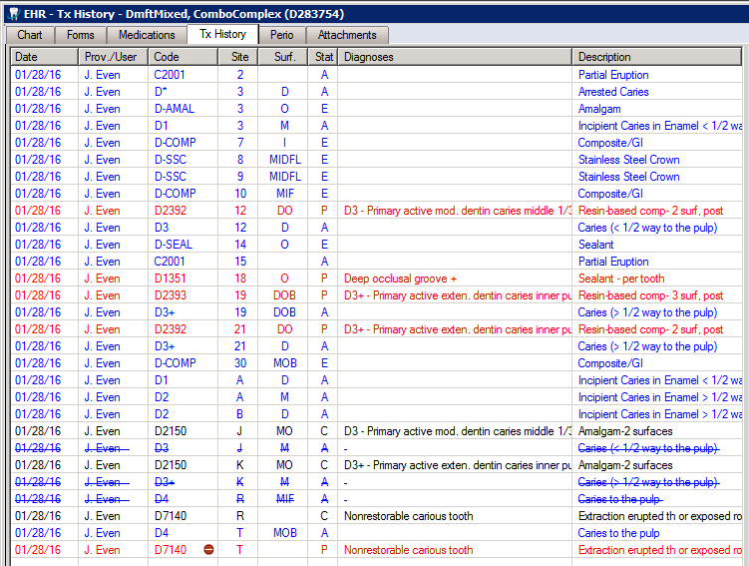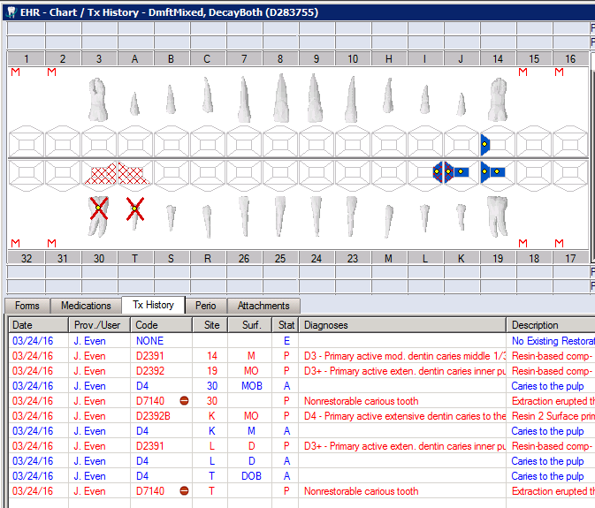

D283753

D283751

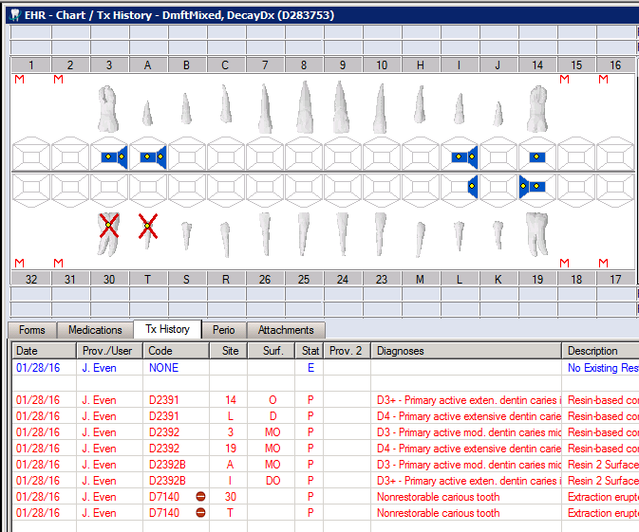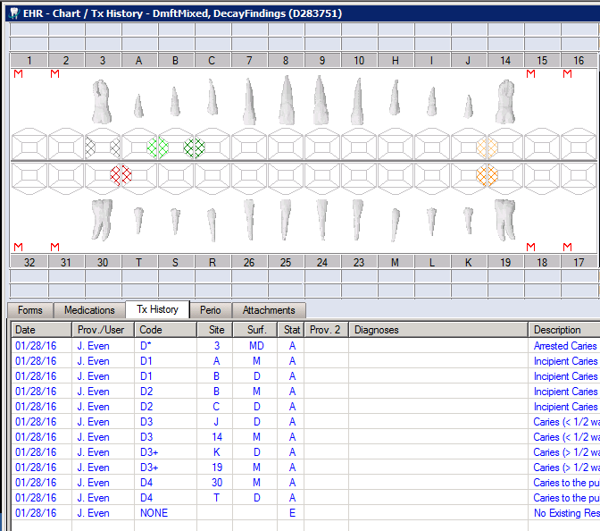

D283748

D283773

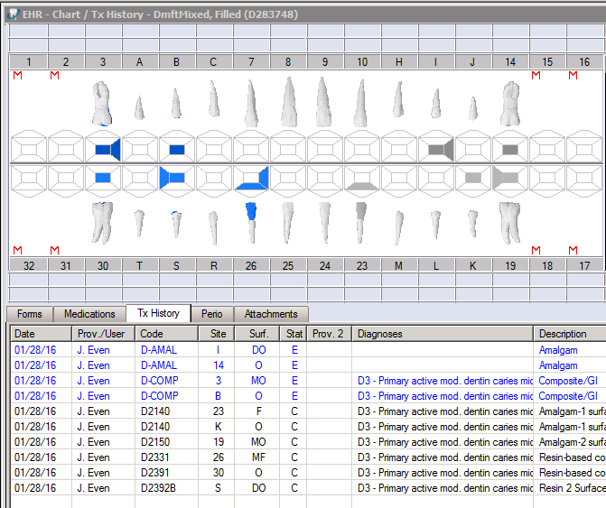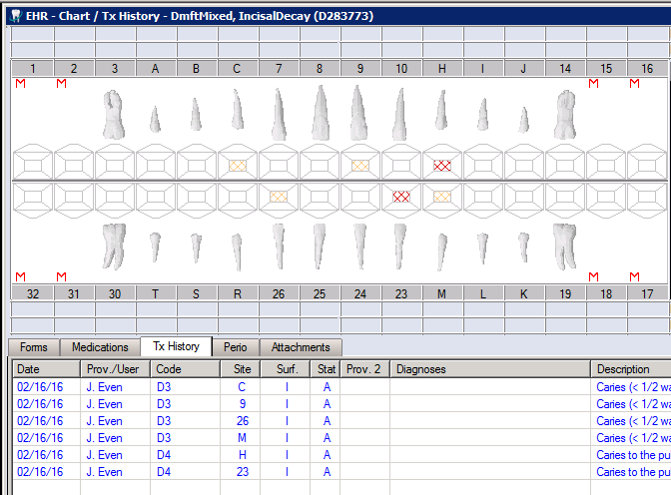

D283775

D283750

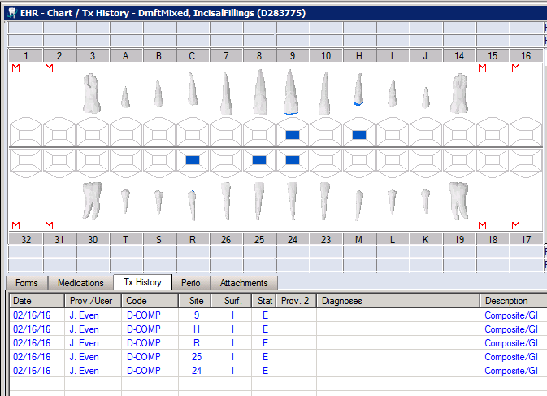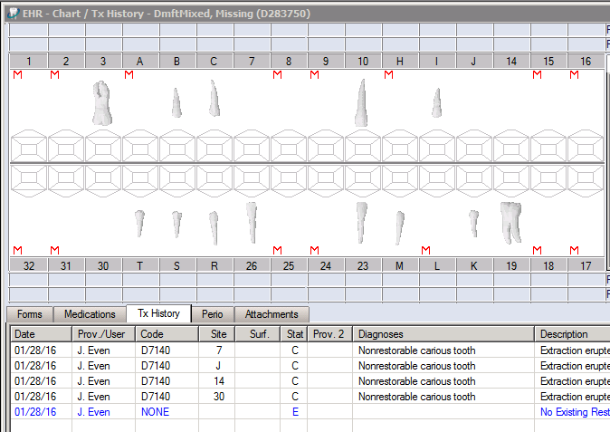

D283749

D283799

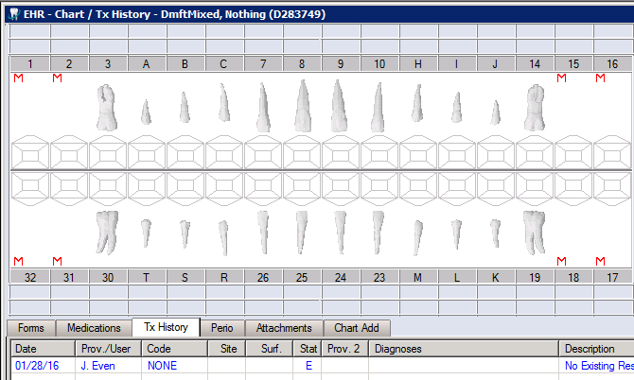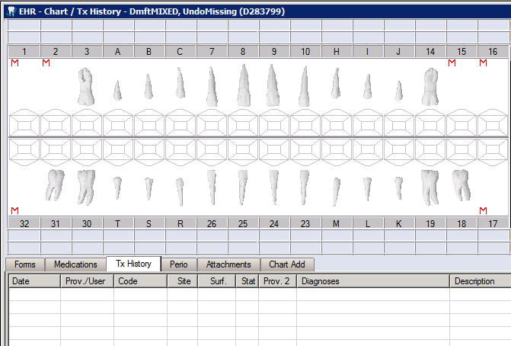

D283794

D283798

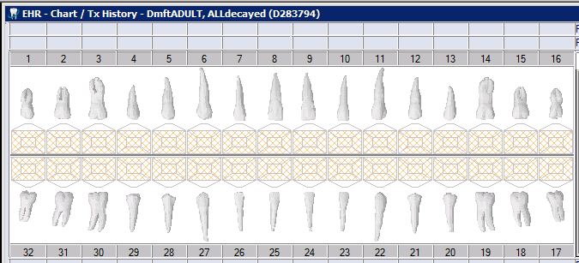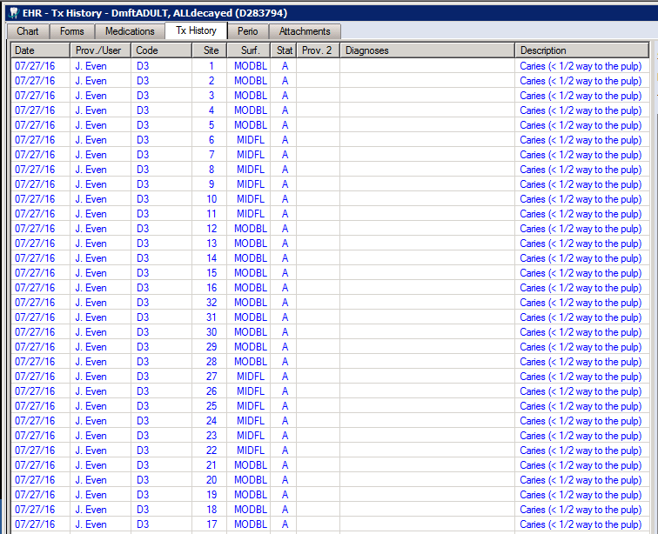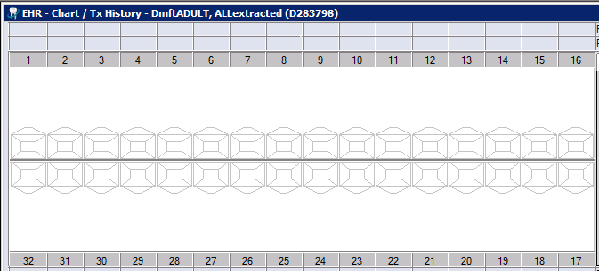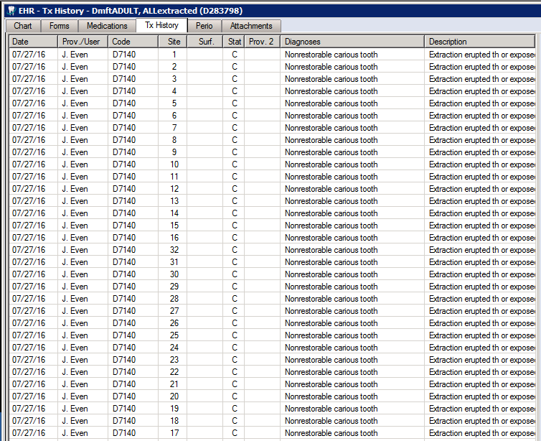

D283792

D283797

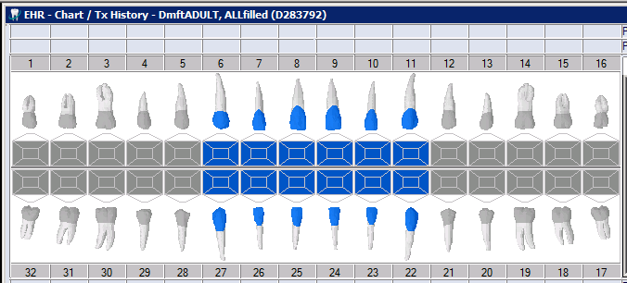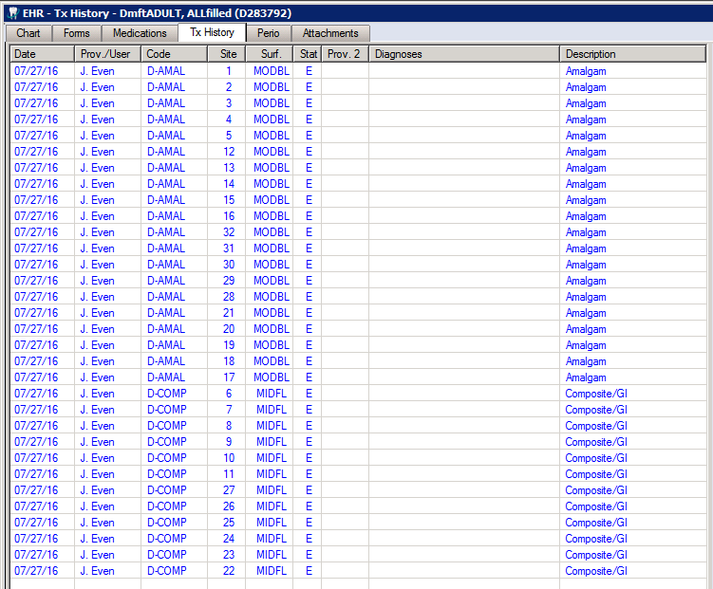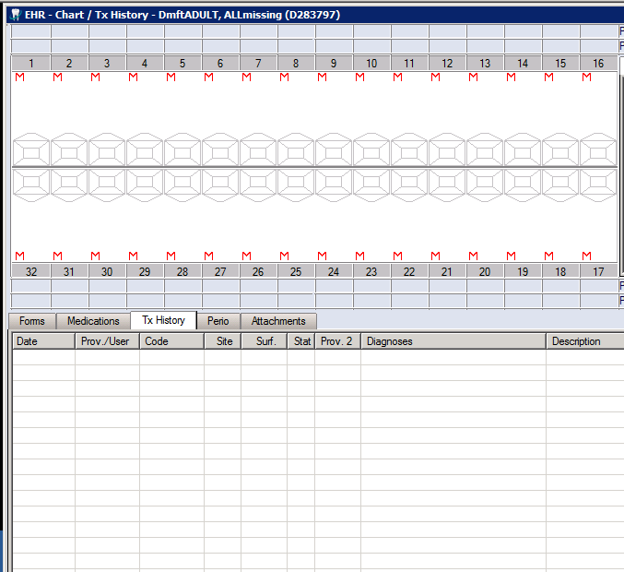

D283891

D283746

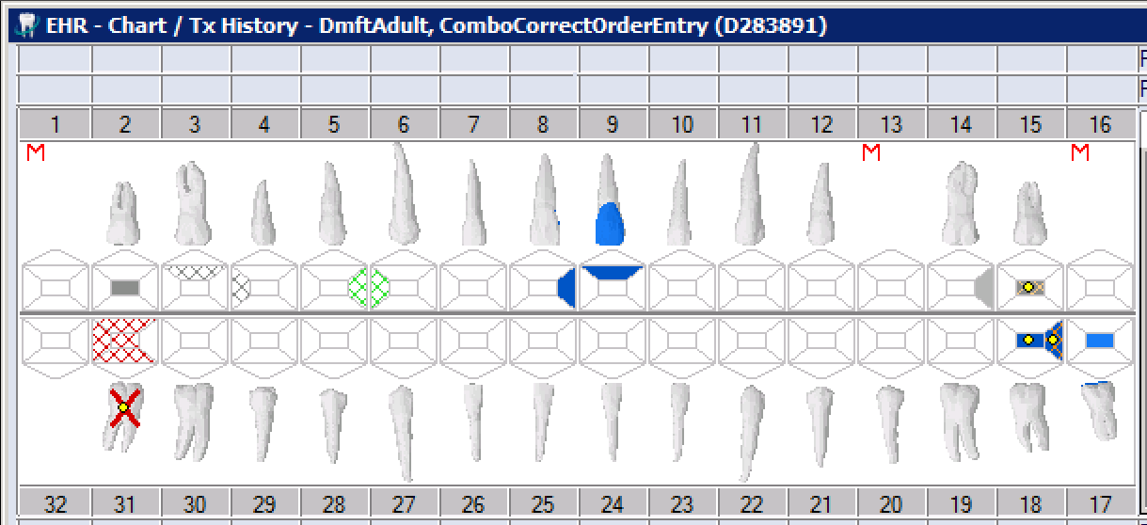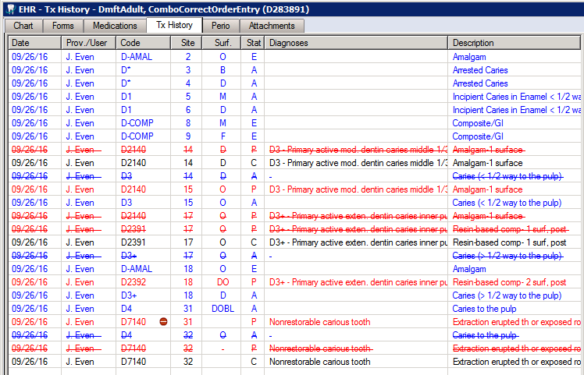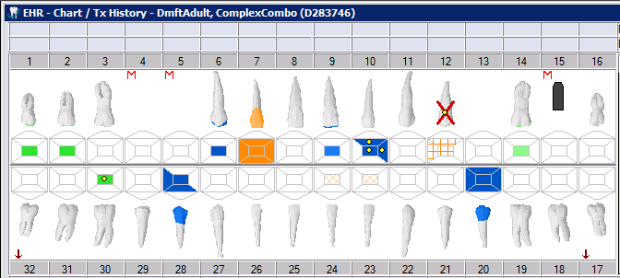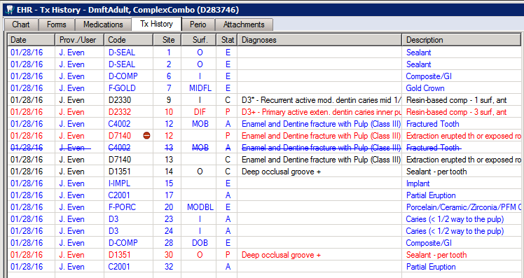

D283738

D283736

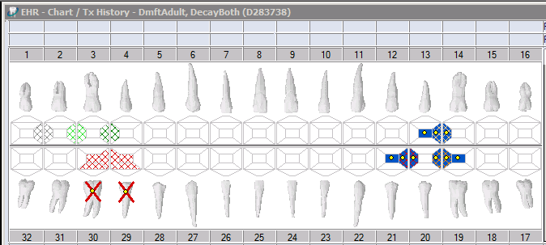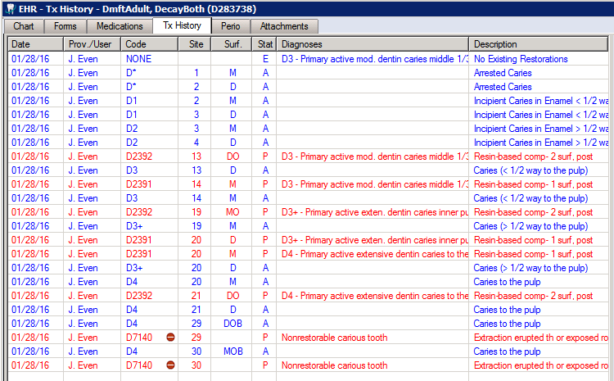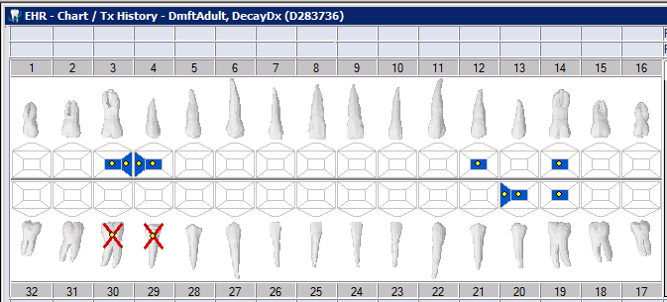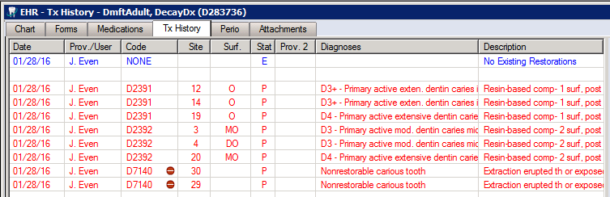

D283735

D283742

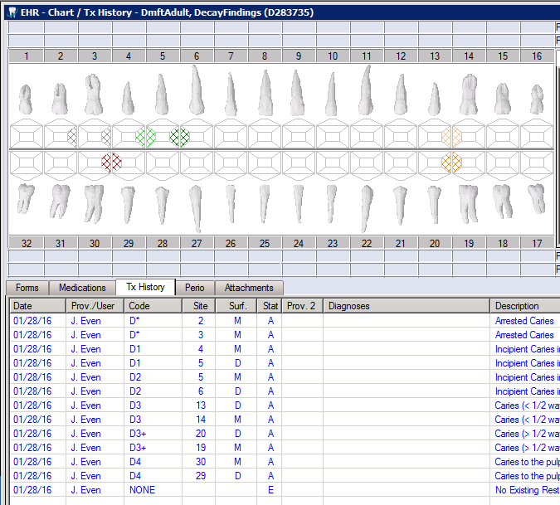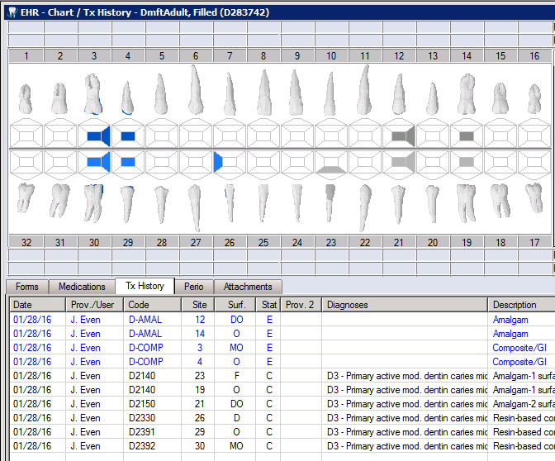

D283772

D283776

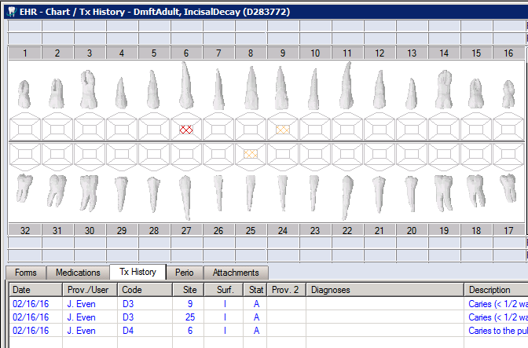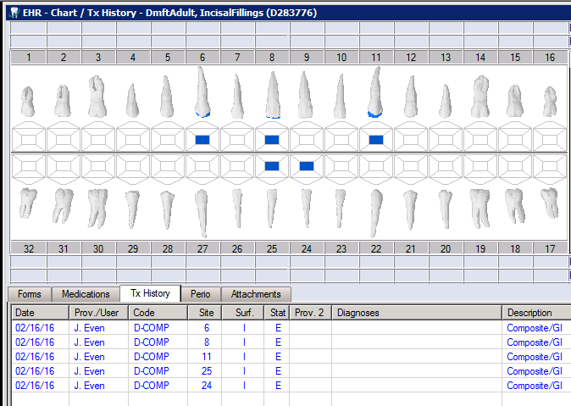

D283740

D283733

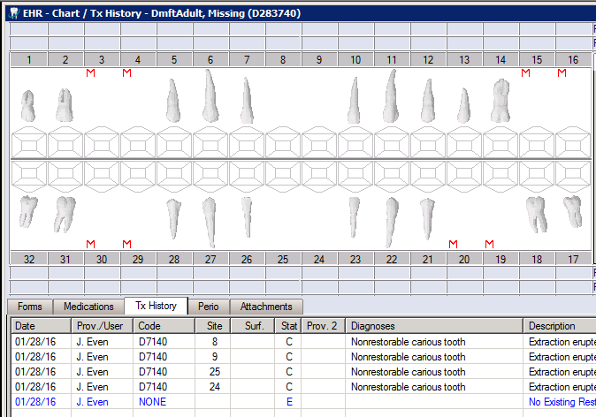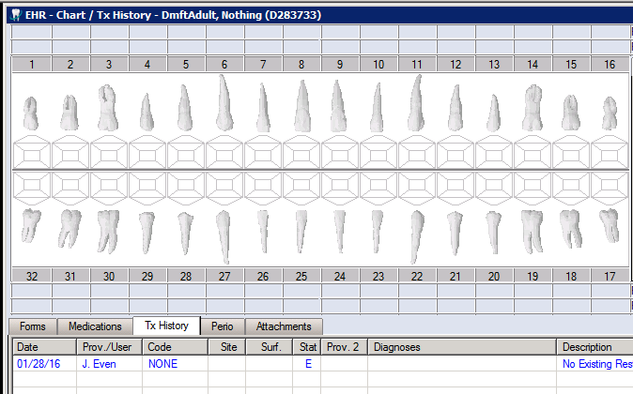

D283815

