Supplementary forest plots (Figures 1 to 5)
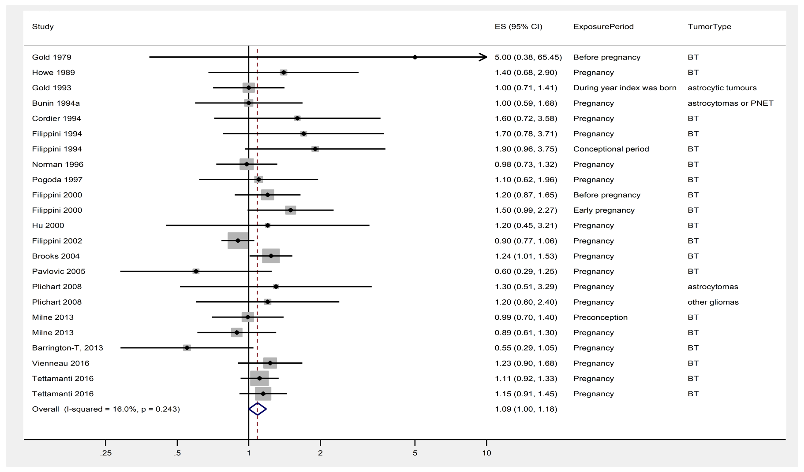

Supplementary figure 1. Forest plot of brain tumor risk estimates for mother’s smoking. Effect estimates (ES) are relative risks (OR, HR, or IRR) with 95% confidence intervals. Meta-analytical effect estimate by DerSimonian-Laird random effects model. Heterogeneity I² and p-value from Cochran's Q test are shown. Tumor type and exposure period are shown in the right columns.
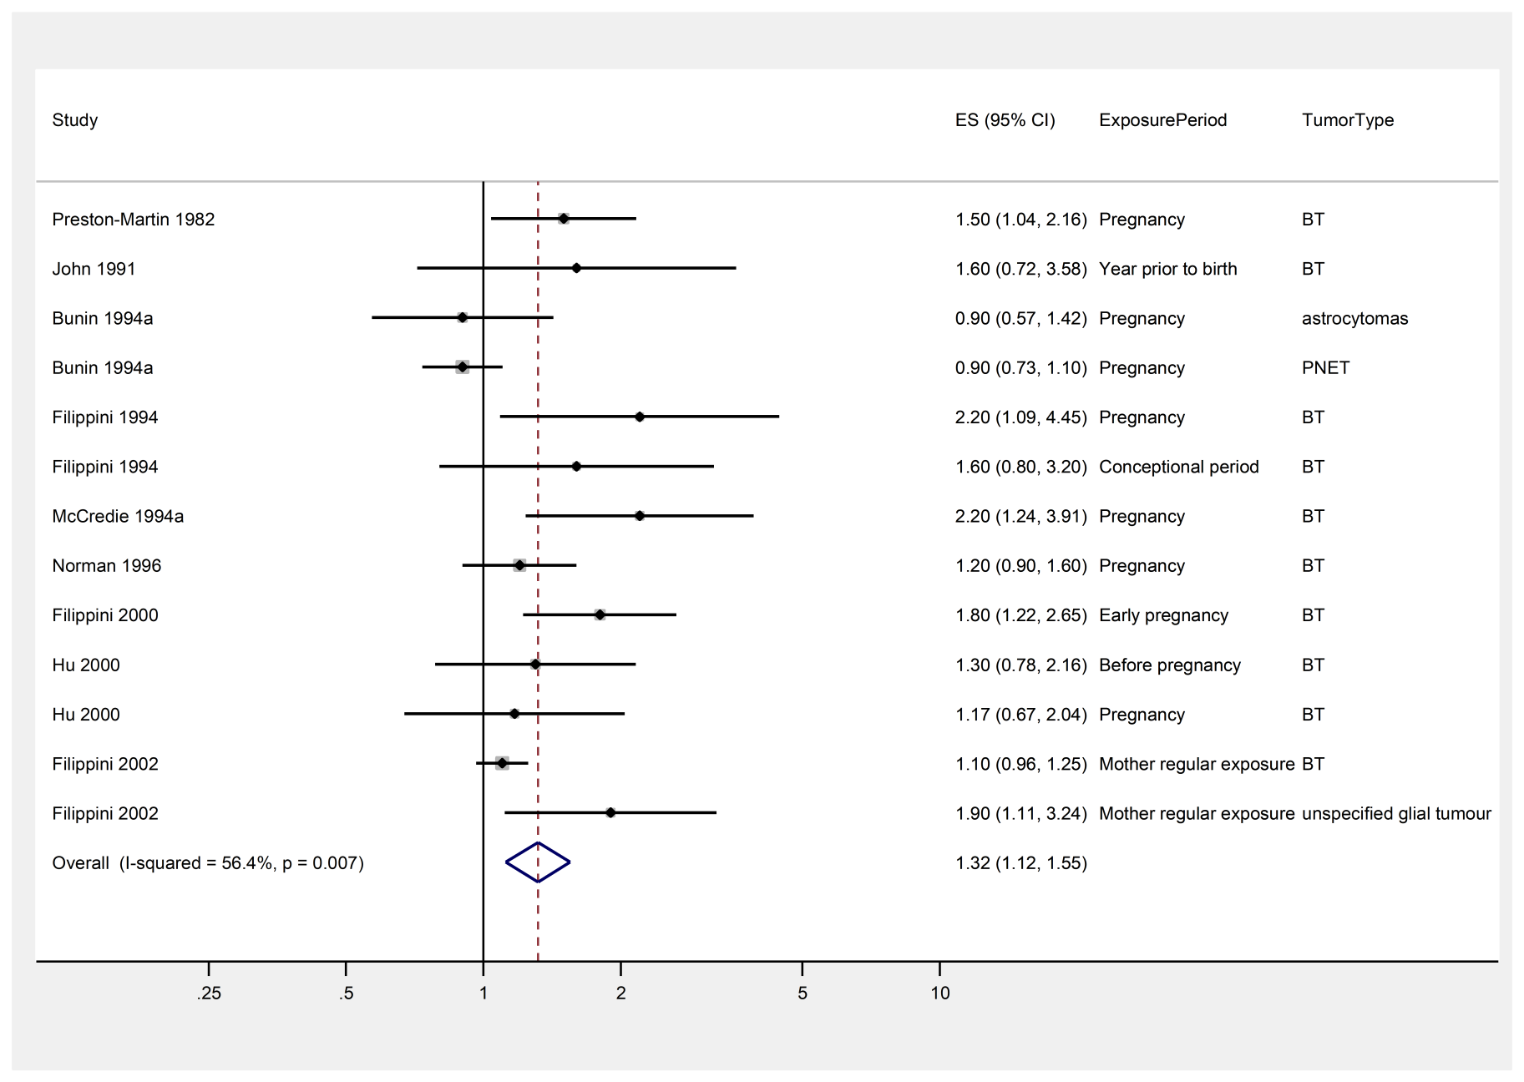
Supplementary figure 2. Forest plot of brain tumor risk estimates for mother*s passive smoking. Effect estimates (ES) are relative risks (OR, HR, or IRR) with 95% confidence intervals. Meta-analytical effect estimate by DerSimonian-Laird random effects model. Heterogeneity I² and p-value from Cochran's Q test are shown. Tumor type and exposure period are shown in the right columns.
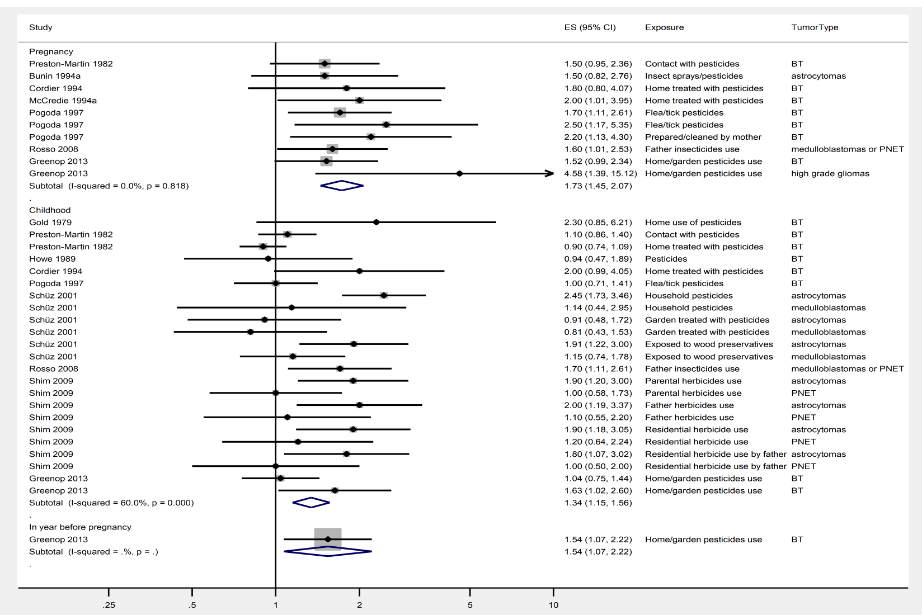
Supplementary figure 3. Forest plots of brain tumor risk estimates stratified by exposure period for pesticides. Effect estimates (ES) are relative risks (OR, HR, or IRR) with 95% confidence intervals. Meta-analytical effect estimate by DerSimonian-Laird random effects model. Heterogeneity I² and p-value from Cochran's Q test are shown. Tumor type and details of exposure are shown in the right columns
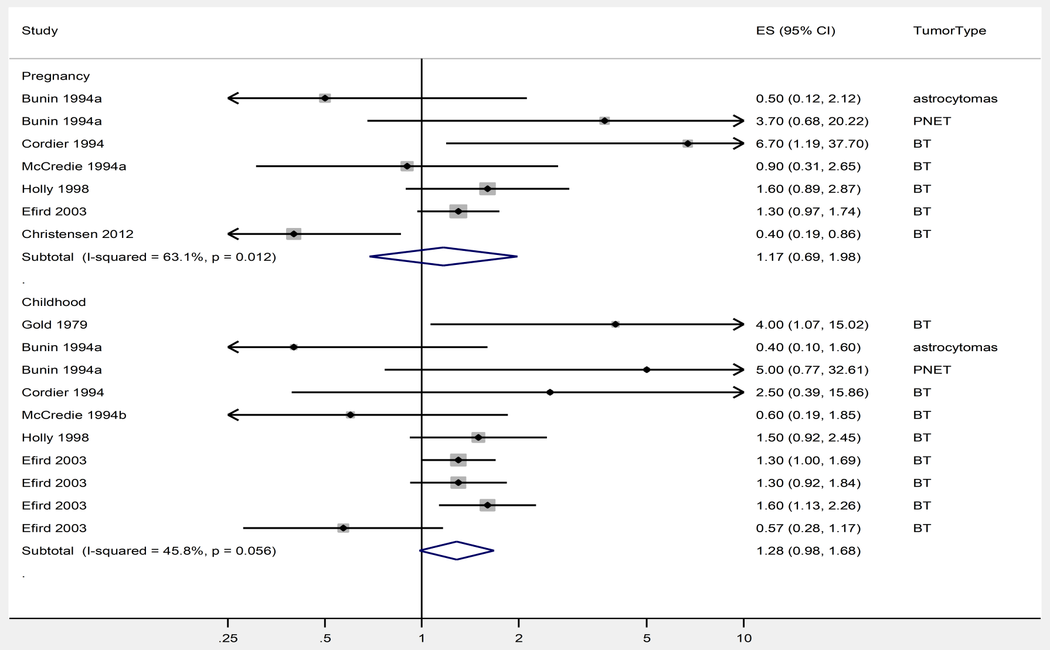
Supplementary figure 4. Forest plots of brain tumor risk estimates stratified by period for living on a farm. Effect estimates (ES) are relative risks (OR, HR, or IRR) with 95% confidence intervals. Meta-analytical effect estimate by DerSimonian-Laird random effects model. Heterogeneity I² and p-value from Cochran's Q test are shown. Tumor type is shown in the right column.
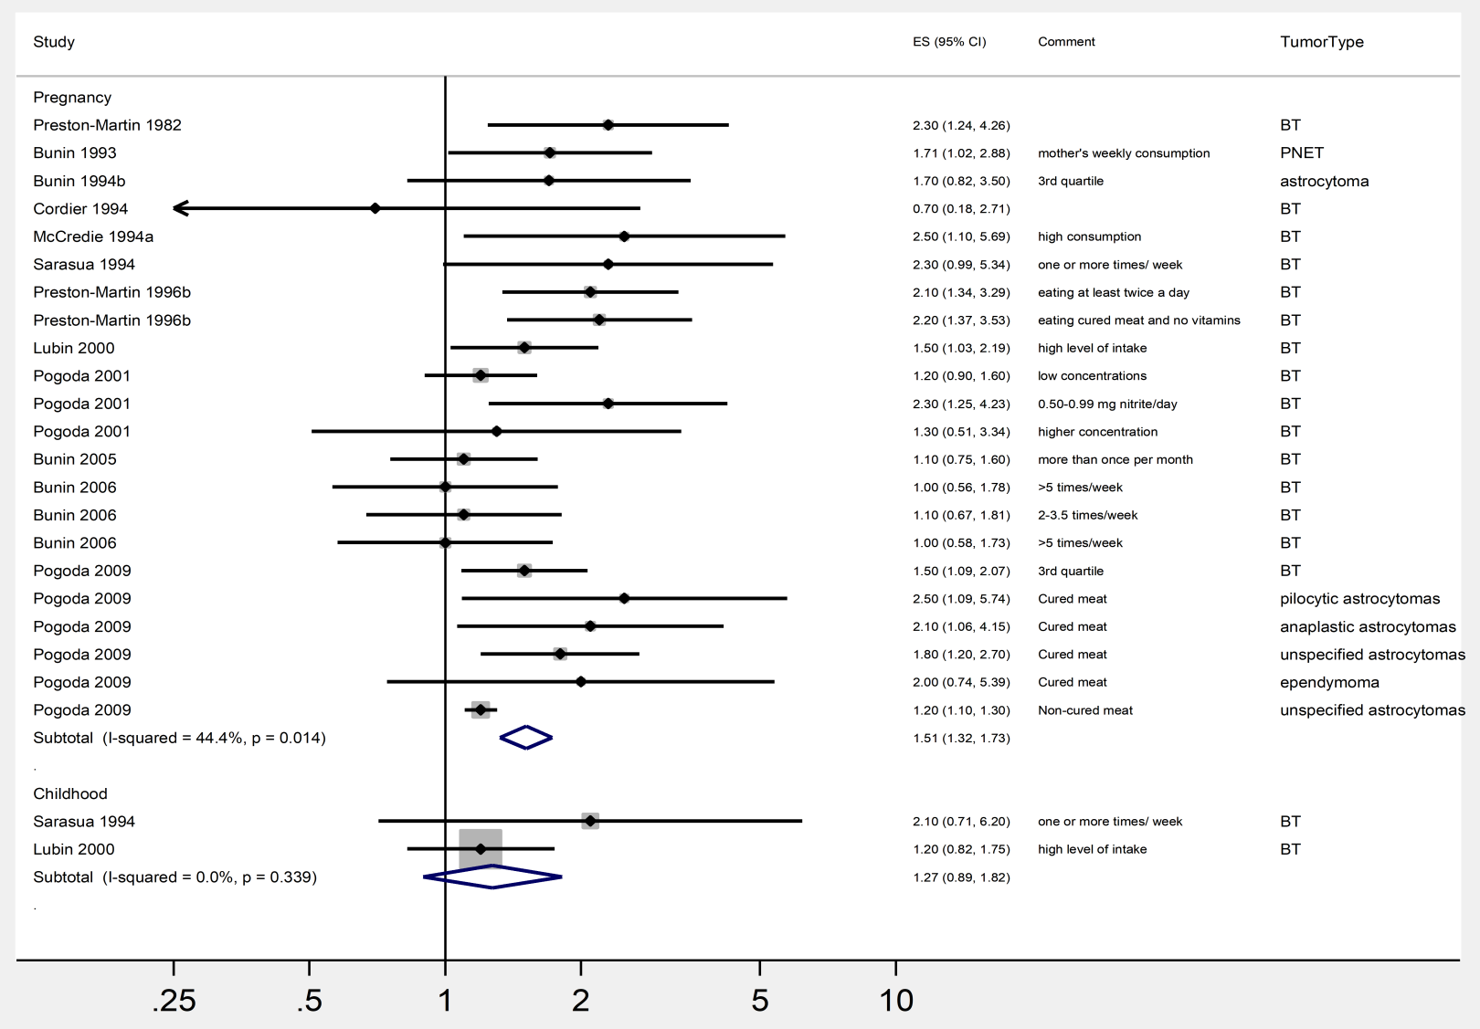
Supplementary figure 5. Forest plots of brain tumor risk estimates stratified by period for meat consumption. Effect estimates (ES) are relative risks (OR, HR, or IRR) with 95% confidence intervals. Meta-analytical effect estimate by DerSimonian-Laird random effects model. Heterogeneity I² and p-value from Cochran's Q test are shown. Tumor type and details of exposure are shown in the right columns.

