**Appendix 1. Search strategies developed for the electronic databases.**

MEDLINE via PUBMED

1. Tooth demineralization (MeSH Terms)
2. dmf index (MeSHTerms)
3. ((tooth OR teeth OR dent*) AND (caries OR carious OR decay OR deminerali* OR cavit*))
4. caries OR “early childhood caries” OR “white spot” OR cavit* OR dmft OR dft OR dmfs OR dfs
5. #1 OR #2 OR #3 OR #4
6. cariostatic agents (MeSH Terms)
7. fluorides (MeSH Terms)
8. fluori*
9. #6 OR #7 OR #8
10. varnish* OR lacquer* OR laquer* OR paint*
11. #9 AND #10
12. “fluoride varnish” OR bifluorid OR cavityshield OR duraflur OR duraphat OR fluorniz OR “fluor protector” OR “prevident varnish” OR thera-flur OR “clinpro white varnish”
13. #11 OR #12
14. #5 AND #13

SCOPUS

1. “fluoride varnish”
2. dental caries
3. Child*
4. #1 AND #2 AND #3

EMBASE

Option “Map to preferred terms in Entrée”

1. “tooth disease”/de
2. “dental caries”/de
3. #1 OR #2
4. “fluoride varnish”/de
5. “child”/de
6. #3 AND #4 AND #5

WEB OF SCIENCE

1. “fluoride varnish”
2. dental caries OR tooth demineralization
3. #1 AND #2

CENTRAL

1. “fluoride varnish” AND “dental caries” OR “tooth demineralization”

LILACS

1. fluoride$ OR fluoruro$ OR fluoreto$
2. varnish$ OR barniz$ OR verniz$
3. dental caries OR carie$ OR carious
4. #1 AND #2 AND #3

BBO (*Bibliografia Brasileira de Odontologia*)

1. fluoride AND varnish AND caries

Open Grey

1. fluoride varnish

Grey Literature Report

1. fluoride varnish

EThOS

1. fluoride varnish

Banco de Teses CAPES

1. “verniz fluoretado”

**Appendix 2. Dental and medical journals handsearched.**

1. Caries Research
2. Community Dentistry & Oral Epidemiology
3. European Archives of Paediatric Dentistry
4. International Journal of Paediatric Dentistry
5. Journal of the American Dental Association
6. Journal of Dental Research
7. Journal of Dentistry for Children
8. Journal of Public Health Dentistry
9. Pediatric Dentistry
10. Pediatrics
11. The Journal of Pediatrics

**Appendix 3. Schematic figure showing the number of studies included in the qualitative and quantitative analyses.**

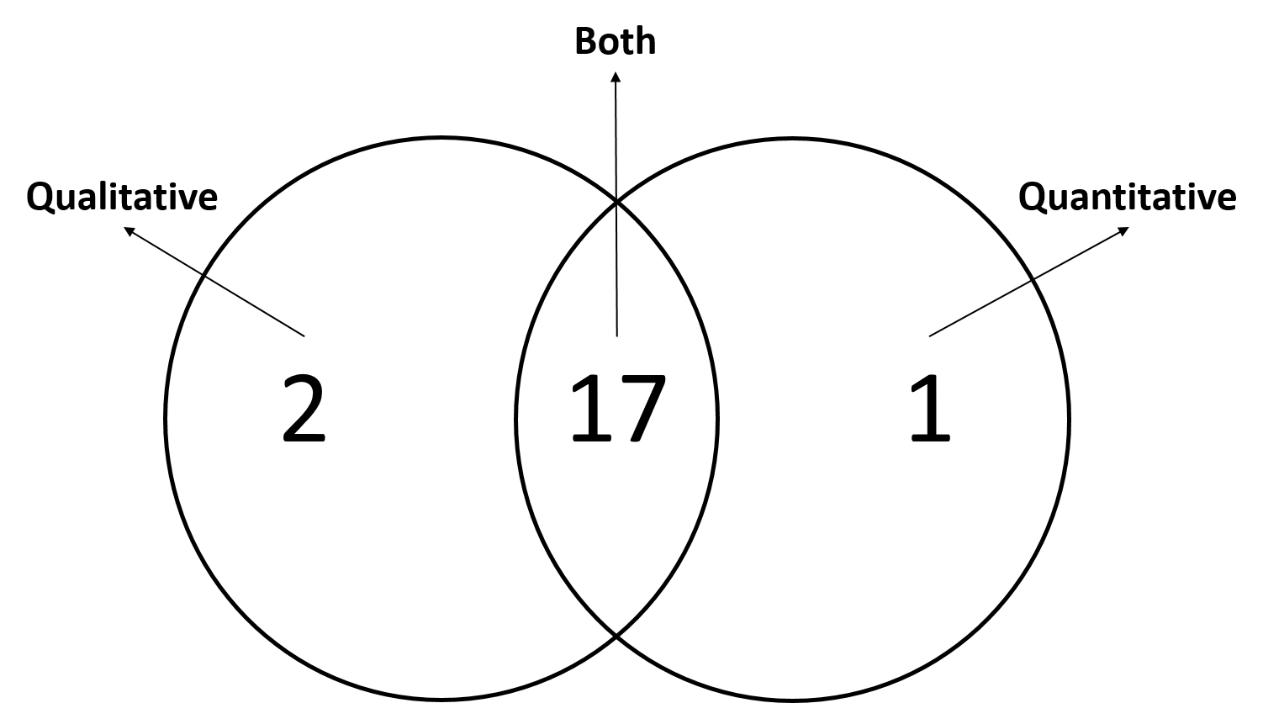

Appendix 4. Adverse effects reported in the included studies.

|  |  |
| --- | --- |
| **Author Year** | **Adverse effects reported** |
| Agouropoulos 2014 | No serious adverse effects were noticed. The smell of the varnish was unpleasant. |
| Anderson 2016 | No serious adverse effects have been reported by practitioners. Some children vomited shortly after the application of the FV. |
| Borutta 2006 | *Not mentioned.* |
| Braun 2016 | *Not mentioned.* |
| Chu 2002 | No adverse effects were observed. |
| Frostell 1991 | *Not mentioned.* |
| Grodzka 1982 | *Not mentioned.* |
| Holm 1979 | *Not mentioned.* |
| Jiang 2014 | No adverse effects were reported by parents. |
| Lawrence 2008 | No adverse effects were reported by parents. Found no case of allergic contact stomatitis and FV was safe when used on children with respiratory and asthmatic conditions. |
| McMahon 2018 | *Not mentioned.* |
| Memarpour 2015 | No adverse effects were reported or observed. |
| Memarpour 2016 | No adverse effects were reported or observed. |
| Muñoz-Millán 2017 | No adverse effects were reported by parents. |
| Oliveira 2014 | Caregivers were asked about adverse effects such as burning sensation in the mouth, nausea, changes in taste and allergies. One child in the control group reported burning in the mouth on the day of application and one caregiver complained about the coloration of her child's teeth shortly after treatment. |
| Petersson 1998 | No adverse effects or allergic reaction were reported during treatment. |
| Slade 2011 | No adverse effects were detected during the study. |
| Tickle 2017 | The authors stated that the adverse effects found would not be related to the use of FV, suggesting that its use is safe in young children. |
| Weintraub 2006 | No adverse effects or safety concerns related to FV were reported by caregivers. |
| Yang 2008 | *Not mentioned.* |

**Appendix 5. Meta-regression analysis.**

Number of obs = 15

REML estimate of between-study variance tau2 = .007423

% residual variation due to heterogeneity I-squared_res = 54.79%

Proportion of between-study variance explained Adj R-squared = 25.87%

With Knapp-Hartung modification

-----------------------------------------------------------------------------------------------------

log_RR | exp(b) Std. Err. t P>|t| [95% Conf. Interval]

------------------------------------------------------------------------------------------------------

Baseline caries | 1.008099 .0049482 1.64 0.124 .9974653 1.018845

------------------------------------------------------------------------------------------------------



**Appendix 6. Publication bias analysis.**



Egger's test for small-study effects:

Regress standard normal deviate of intervention effect estimate against its standard error

Number of studies = 15 Root MSE = 1.077

----------------------------------------------------------------------------------------

Std_Eff | Coef. Std. Err. t P>|t| [95% Conf. Interval]

-------------+----------------------------------------------------------------

slope | .0260772 .0211463 1.23 0.239 -.0196066 .0717611

bias | -1.595772 .390365 -4.09 0.001 -2.439104 -.7524395

------------------------------------------------------------------------------------------

Test of H0: no small-study effects P = 0.001