Supplementary Table1. Animals included in the study. The first table summarises the characteristics of the SIV-infected animals and the second those of the control groups for flow cytometry and mass cytometry.
Group | Treatment | Name | Sex | CMH Haplotype 1 | CMH Haplotype 2 | Age at sampling (years) | Time of infection at sampling | Days under treatment at sampling | Viral load (RNA copies/ml)
CyTOF SIV+ | No | CE355 | Femelle | H2 | H1 | 4.6 | 536 |  | 1.2 x ${10}^{4}$
 |  | CG588 | Male | H1 | Rec:H4-H3 | 4.1 | 536 |  | 1.6 x ${10}^{5}$
Flow cytometry SIV + | No | CBK061 | Male | rec H4H1H2 | rec H2H3 | 4.8 | 288 |  | 3 x${10}^{2}$
 |  | CCB070 | Male | H3 | recH3H4 | 4.5 | 288 |  | 7.1 x ${10}^{4}$
 |  | CCC066 | Male | H1 | H2 | 4.4 | 288 |  | 1.5 x ${10}^{5}$
 |  | BA912K | Male | H1 | H2 | 5.1 | 120 |  | 1.4 x ${10}^{4}$
 |  | BA987H | Male | H4 | H3 | 5.5 | 120 |  | 2.8 x ${10}^{3}$
 |  | BB425F | Male | H1 | rec H2-H5 | 5.5 | 120 |  | 1.2 x ${10}^{5}$
 |  | CCB063 | Male | H1 | recH2-H5 | 4.6 | 120 |  | 1.3 x ${10}^{4}$
 |  | CCB114 | Male | recH3-H4 | H2 | 4.5 | 120 |  | 4.7 x${10}^{4}$
 |  | CCE007 | Male | H1 | H3 | 4.3 | 120 |  | 8.4 x ${10}^{4}$
 | cART | BA736J | Male | rec H1-H2-H1 | H4 | 5.5 | 120 | 92 | < 50
 |  | BA777K | Male | H2 | H1 | 5.0 | 120 | 92 | < 50
 |  | BA922I | Male | H3 | H1 | 6.2 | 120 | 92 | < 50
 |  | BB123J | Male | rec H2-H1 | H3 | 5.5 | 120 | 92 | 2 x ${10}^{2}$
 |  | CA706F | Male | H5 | rec H4-H1H2 | 4.5 | 120 | 92 | < 50
 |  | CCB065 | Male | H3 | H4 | 4.6 | 120 | 92 | < 50

Group | cART | Name | Sex | CMH Haplotype 1 | CMH Haplotype 2 | Age at sampling (years)
CyTOF SIV- control group | No | CBL017 | Femelle | H4 | H5 | 4
 |  | CBL018 | Femelle | H5 | H6 | 4
 |  | CCB059 | Femelle | Null | Null | 3.8
Flow cytometry SIV- control group | No | BA878K | Male | H3 | H2 | 5.5
 |  | BA922J | Male | H1 | H3 | 4.5
 |  | BB9I | Male | H1 | H2 | 6.7
 |  | BB340E | Male | rec H3-H1 | H4 | 6.5
 |  | BB799G | Male | recH3-H5 | recH2-H3 | 4.3
 |  | CA871B | Male | H1 | rec H1-H2-H3 | 5.5
 |  | CA872C | Male | H1 | rec H1-H3 | 4.4
 |  | CB806C | Male | rec H1-H5-H3 | H3 | 4.9
 |  | CCB021 | Male | rec H6-H1 | H2 | 4.6

Supplementary Table 2. Antibody panel used for mass cytometry analysis
Metal | Antibody | Supplier | catalogue # | clone | Concentration µg/well
141Pr | CD66 (a, b, c, e) | Miltenyi | 130-095-212 | TET2 | 0.15
142Nd | HLA-DR | BD | 555810 | L243 | 0.125
143Nd | CD3 | BD | 551916 | SP34.2 | 1.5
144Nd | CD64 | BD | 555525 | 10.1 | 1
145Nd | CD8 | BD | 557084 | RPAT8 | 0.5
146Nd | CD45 | BD | 552566 | D058-1283 | 0.25
147Sm | CD123 | BD | 554527 | 7G3 | 0.5
148Nd | Granzyme B | AbD serotec | M1755 | GB11 | 0.5
149Sm | CD11a | BD | 555382 | HI111 | 0.5
150Nd | CD11b | BD | 555386 | ICRF144 | 0.5
151Eu | CD38 | Stem cell | ab131420 | AT-1 | 0.75
152Sm | CD16 | BD | 555404 | 3G8 | 1.35
153Eu | CD23 | B. Coulter | IMBULK1 | 9P25 | 1.35
154Sm | CD86 | BD | 555663 | IT2.2 | 1.25
155 | CD32 | BD | 557333 | FLI8.26 | 0.5
156Gd | CD162 | BD | 556053 | KPL-1 | 0.75
159Tb | CCR7 (CD197) | biolegend | 353237 | G043H7 | 0.5
160Gd | CD5 | biolegend | 300627 | UCHT2 | 0.5
161Dy | CD1c | Biotechne | AF5910 | AF5910 | 0.5
162 | CX3CR1 | Ozyme | 341602 | 2A9-1 | 0.75
163Dy | CD34 | BD | 3163014B | 563 | 0.75
164Dy | CD184 (CXCR4) | BD | 555972 | 12G5 | 0.5
165Ho | CD39 | Ebioscience | 14-0399-82 | eBioA1 | 0.5
166Er | CD195 (CCR5) | BD | 556041 | 3A9 | 0.5
167Er | CD28 | BD | 555726 | CD28.2 | 1.35
168Er | CD11c | Biolegend | 301639 | 3.9 | 1.25
170Er | CD14 | BD | 555396 | M5E2 | 0.75
171Yb | CD4 | BD | 550625 | L200 | 1.25
172 | CD25 | Miltenyi | 130-091-235 | 4E3 | 1.25
173Yb | CD141 | DVS | 3173002B | 1A4 | 0.5
174Yb | CD20 | BD | 556631 | 2H7 | 1
175 | Perforin | Mabtech | 3465-5-250 | PF-344 | 1.25
176 | CD205 | BD | 558531 | MG38 | 0.75

Supplementary Table 3. Number of acquired events per sample on CyTOF

Animal | Compartment | Acquired events
CBL017 | Blood | 317,675
CBL017 | Bone marrow | 509,874
CBL018 | Blood | 209,830
CBL018 | Bone marrow | 576,440
CCB059 | Blood | 321,771
CCB059 | Bone marrow | 429,870
CE355 | Blood | 340,246
CE355 | Bone marrow | 608,157
CG588 | Blood | 242,474
CG588 | Bone marrow | 529,787

Supplementary Table 4. Cell population definitions
Cell population | Markers
T cells | CD3+
NK cells | CD3- CD8+
B lymphocytes | CD20+ HLA-DR+
Monocytes | CD14+ HLA-DR+
cDC | CD14- HLA-DR+ CD11c+ CD16+
pDC | CD123+ HLA-DR+
Basophil | CD66- CD123+ HLA-DR-
Neutrophil | CD66+
Pre-neutrophils | CD66-low CD45-low CD32- CD11b- CXCR4+
Immature neutrophils | CD66-high CD45-mid CD32-mid CD11b- CXCR4+
Mature neutrophils | CD66-high CD45-high CD32-high CD11b+ CXCR4-

Supplementary Table 5. Antibody panel used for phenotypic analysis and phagocytosis assay
Antibody | Clone | Fluor | Laser-filtre | Provider | Reference
Live/Dead |  |  | 355-450/50 | Life Techno
CD64 | 10.1 | BUV737 | 355-740/35 | BD | 564425
CD11b | ICRF44 | V450 | 405-450/50 | BD | 560480
CD3 | SP34.2 | BV650 | 405-660/20 | BD | 563916
CD8a | RPAT8 |  |  | BD | 563821
CD20 | 2H7 |  |  | BD | 563780
CD62L | SK11 | BV711 | 405-710/50 | BD | 565040
CD32abc | FLI8.26 | BV786 | 405-780/60 | BD | 564840
CD14 | M5E2 | FITC | 488-530/30 | BD | 555397
CD16 | 3G8 | PerCP-Cy5,5 | 488-695/40 | BD | 560717
CDw125 | A14 | PE | 561-585/15 | BD | 555902
CXCR4 | 12G5 | PE-Dazzle 594 | 561-610/20 | Biolegend | 329732
CD89 | A59 | PE-Cy7 | 561-780/60 | Biolegend | 354108
HLA-DR | L234 | AF700 | 640-730/45 | Biolegend | 307626
CD66 | TET2 | APC-Vio770 | 640-780/60 | Miltenyi | 130-101-132
pHrodo |  | FITC | 488-530/30 | Thermo

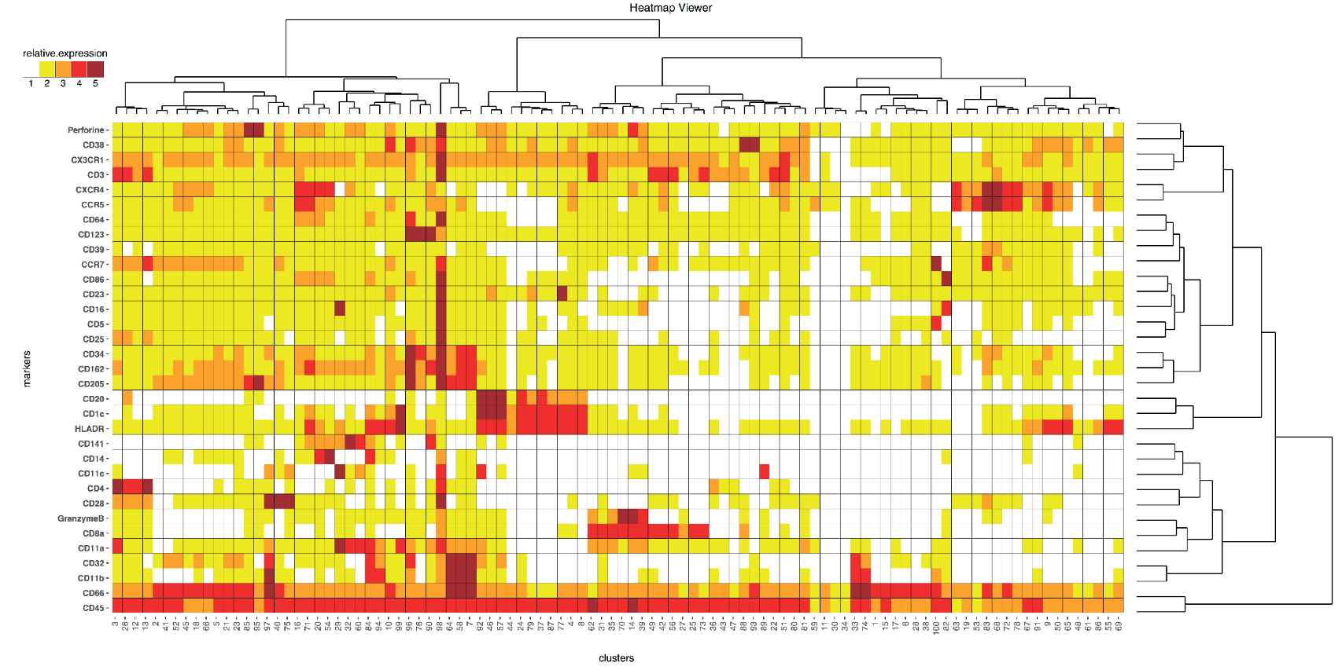
Supplementary Figure 1. Heatmap and hierarchical clustering of the 100 cell clusters obtained after SPADE analysis. The mean of the median marker expression of cells contained in each node was used to assign the expression of each marker to one of the five categories. Data for individuals with less than 50 events in a given node were excluded from the calculation to avoid biasing the phenotypic characterization of these small cell nodes. Hierarchical clustering was performed using the Euclidean metric and complete linkage method we recently published.

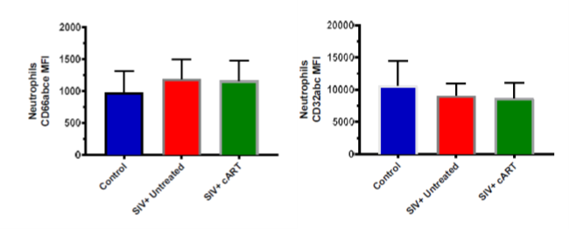
Supplementary Figure 2. CD66 and CD32 MFI in early chronic-phase neutrophils. There were no significant differences between groups in terms of CD66 and CD32a expression.

