Drug use and
prevention programs
in the Berlin party scene

Paper-and-pen questionnaire

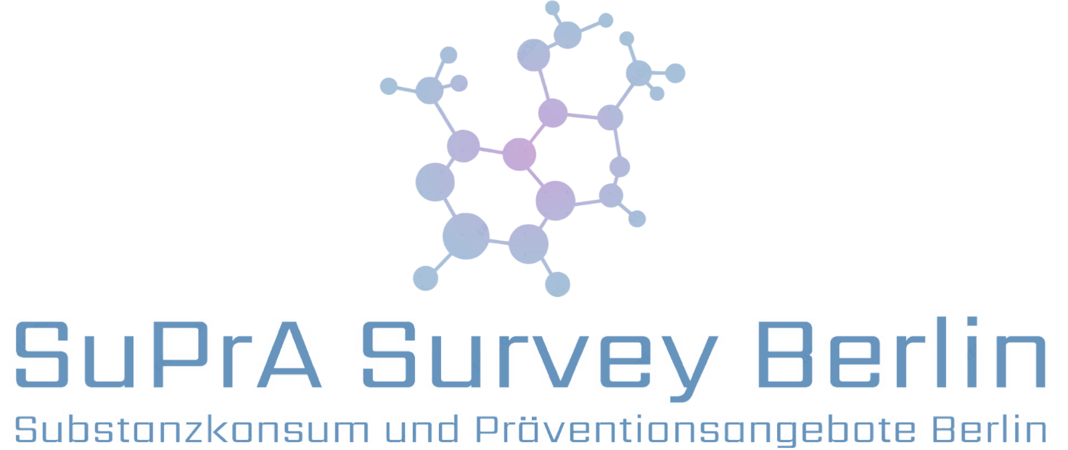

Dear participant,

thank you for your participation in our survey. We aim to find out if there is need for more support concerning drug use in the Berlin party scene (education, counseling, "drug checking", etc.). In order to adapt to your needs, we will ask some questions about yourself and your drug use.
Even if you do not use illegal drugs you can fill out this questionnaire.

We assure you that your anonymity will be preserved at all times. Your answers will not be linked to your name or email address.

The completion of this questionnaire should take no more than 5-10 minutes.

At the end of the questionnaire you will receive some information on drug use in Berlin. In addition, 10 Amazon gift cards with a worth of €20 each will be raffled off among all participants.

By completing the questionnaire, you confirm and agree to the further processing and evaluation of your anonymously collected data.

1. Please specify your age in years.

2. Please specify your Sex.
Female
Male
Other:

3. Please specify your current type of stay in Berlin.
Living in Berlin (minimum 4 weeks stay necessary)
Tourist
Other:

4. Please specify your highest successfully completed level of education.
No educational qualifications
School (to age 16)
School (to age 18)
Vocational training

University degree

5. What is your current occupation?
School
Apprenticeship

Study
Employed

Self-employed
Unemployed
Other:

6. What sexual orientation do you identify with?
Heterosexual
Homosexual
Bisexual

Other:

7. Have you ever used one of the following drugs?
Please mark where applicable. Multiple answers possible.
Please do NOT state medication prescribed by a physician.
 | Within the last month | Within the last 12 months | Once  already | Never
Cocaine
Amyl nitrites (Poppers, Snappers)
GHB/GBL ("G", Liquid Ecstasy, Gamma)
Amphetamine (Speed, Fet, Powder)
Alpha-Ciatylglutarate
Benzodiazepines (Valium®, Xanax®, Ativan®)
Methamphetamine (Crystal Meth, Ice)
Opiate based painkillers
(Oxycodone, Hydromorphone)
Neuro Enhancer (Adderal®)
Cannabis (Pot, Marijuana, Weed)
Heroin
Methanoltenside
MDMA (Ecstasy, XTC, Molly)
LSD (Acid)
Alcohol
Synthetic cathinones ("Bath Salts",
MMC, MDMC, MDPV)
Ketamine ("K", "Special K")
Synthetic cannabinoids ("Spice")
Psilocybin (Magic Mushrooms, Shrooms)

8. Please name – if applicable – any other drugs you have used.

9. Which three drugs – other than alcohol and nicotine – do you use most frequently?
(1 = the most)
1.
2.
3.

Why do you use them?
Please refer to the order of your most frequently used drugs.
Drug No. 1
Drug No. 2
Drug No. 3

At what age did you first use them?
Please refer to the order of your most frequently used drugs.
Drug No. 1
Drug No. 2
Drug No. 3

10. Do you want to reduce your use of drug 1-3 in the coming 12 months?
Please refer to the order of your most frequently used drugs.
 | Yes | No
Drug No. 1
Drug No. 2
Drug No. 3

11. How do you assess the general impact of another person if she/he
Explanation: occasionally = once a month or less, regularly = once a week or more
 | Very  negative |  |  | Very  positive
…occasionally uses Amphetamine (Speed, Powder)?
…regularly uses Amphetamine (Speed, Powder)?
…occasionally uses GHB/GBL (“G”, Liquid Ecstasy)?
…regularly uses GHB/GBL (“G”, Liquid Ecstasy)?
…occasionally uses MDMA (Ecstasy, XTC, Molly)?
…regularly uses MDMA (Ecstasy, XTC, Molly)?
…occasionally uses Ketamine (“K”, “Special K”)?
…regularly uses Ketamine (“K”, “Special K”)?
…occasionally uses Cocaine?
…regularly uses Cocaine?
…occasionally uses Cannabis (Pot, Marijuana, Weed)?
…regularly uses Cannabis (Pot, Marijuana, Weed)?
…occasionally drinks Alcohol?
…regularly drinks Alcohol?

12. Have you ever felt like you ought to cut down on your drinking or drug use?
Yes
No

13. Have you ever been annoyed by people criticizing your drinking or drug use?
Yes
No

14. Have you ever felt bad or guilty about your drinking or drug use?
Yes
No

15. Have you ever had a drink or used drugs first thing in the morning to steady your nerves, e.g. get rid of a hangover, or get the day started?
Yes
No

16. Have you ever been diagnosed with any psychiatric condition (including addiction disorders)?
No
Yes, which?:

17. Do you feel the need for or are you interested in advice on handling your drug use?
Yes
No

18. Please rate on the following scale how reasonable you consider the given prevention/ help programs.
 | Not reasonable  at all |  |  | Very  reasonable |  | Don’t know
permanent consulting centers in Berlin
which offer free drug counselling if required
(Mobile) drug checking for purity (pill testing)
Websites and forums informing about drug use
Training youth workers and teachers
Training the party scene’s staff
in dealing with drug use
MSM (men who have sex with men) counseling regarding their drug use.
Counseling and support “on site”
(festival, club, waiting in line, etc.)
Encouraging responsible drug use
(“Safer Use”) and accepting drug counselling
Drug education in schools

19. What are your expectations from a prevention program/offer of help or what would you wish from one?

If you would like to receive the results of the survey and/or wish to participate in the raffle, please state your email address in the list provided by one of our team members. You can also write an email to:

drugsurvey@charite.de

Would you like to tell us something?

Some information on drug use in Berlin can be found on the next page.

Some information on drug use in Berlin can be found on the next page.

The following graph is based on results of a German-wide survey on drug use. It shows how many Berliners have at least once used a certain drug in 2012 (12-month prevalence). Different age groups are distinguished.

This gives you an insight into which drugs are most widespread in your age group and how many Berliners use drugs in general.

None
Cannabis
Ecstasy
Cocaine

Thank you very much for your participation!

Senatsverwaltung für Gesundheit und Soziales (2014): Drogen und Sucht in Berlin, Situationsbericht 2014

