Supplementary Material

Results of manipulation check
We calculated an independent t-test between the altruistic behavior toward an opponent with and without obesity among participated who recognized the manipulation and those who did not recognized it. Among participant who did not recognize the manipulation, we found no significant differences in altruistic behavior toward divergent weight groups (t(61)=0.12, p=0.90). Among participant who did recognize the manipulation, we found significant differences in altruistic behavior toward divergent (t(105)=-1.94, p=0.0276). However, after Bonferroni corrections this result remained insignificant. The results are displayed in the supplementary figure below.

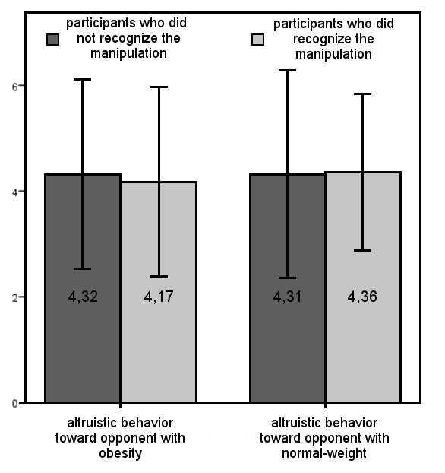
Supplementary Figure. Altruistic behavior toward divergent weight groups among participant who did or did not recognize the experimental manipulation
In addition, we calculated two independent t-tests to investigate if altruistic behavior toward divergent weight groups differs between those participants who did recognize the manipulation and those participants who did not recognize it. We found no significant differences in altruistic behavior toward people with obesity (t(166)=0.5262, p=0.5994) nor toward people without obesity (t(166)=-0.1601, p=0.8730) among participants wo did or did not recognize the manipulation.

