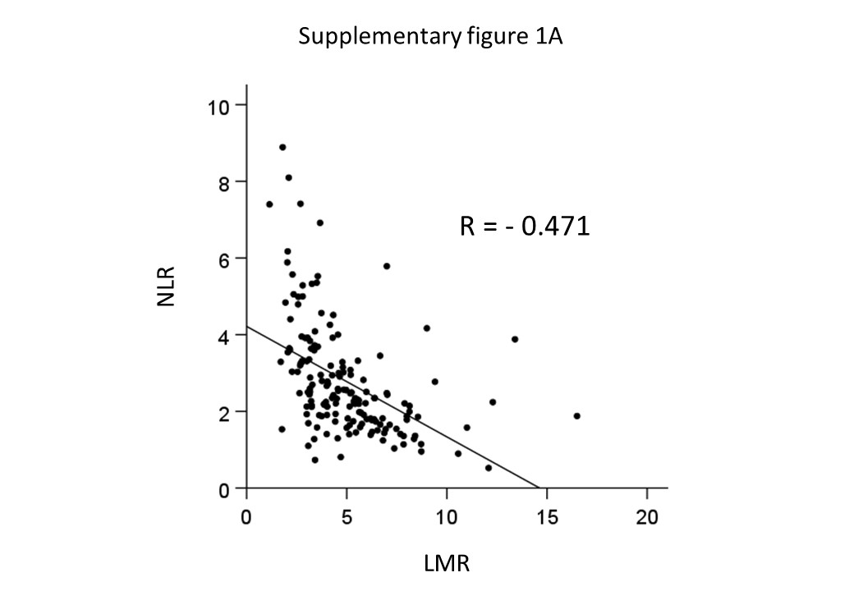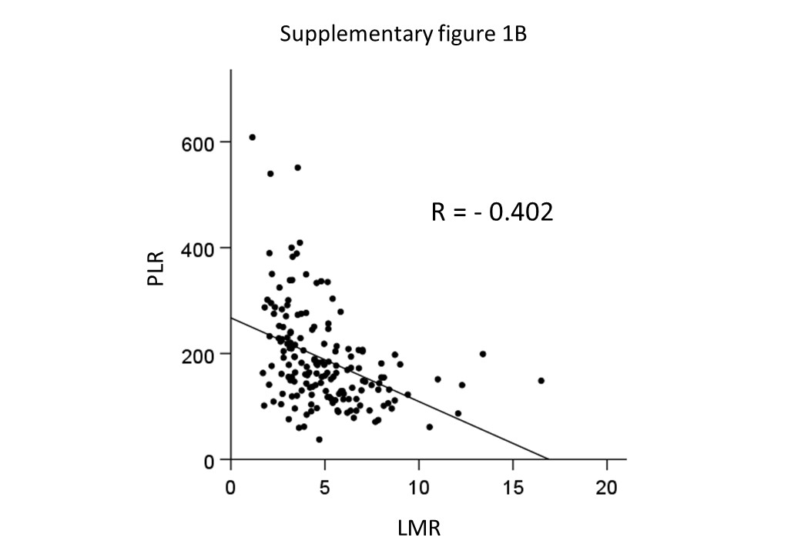
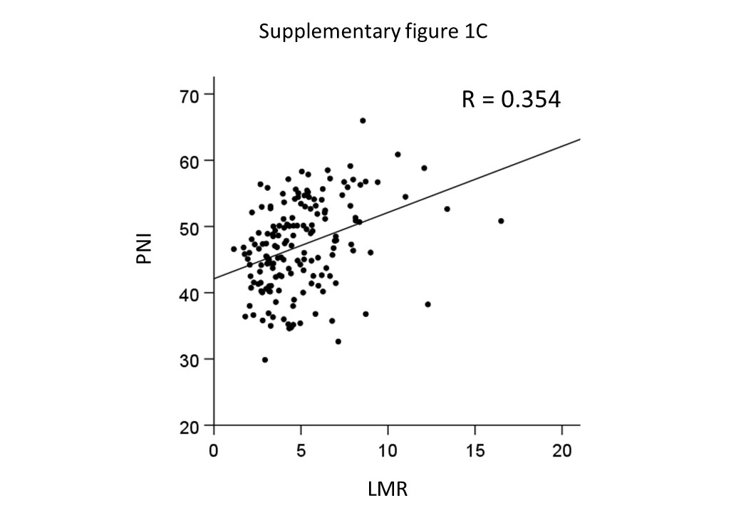
Supplementary figure 1: (A) Correlation between LMR and NLR, (B) LMR and PLR, (C) LMR and PNI.
Supplementary table 1. Univariate and multivariate analysis in 165 patients with resected pancreatic head carcinoma (NLR).
 |  | No. of patients | Survival (%) |  | p | Multivariate
Variable |  |  | 1-year | 2-year | (Log-rank test) | Hazard ratio (95% CI) | p
NLR |  |  |  |  | 0.046 |  | 0.020
 | < 3.2 | 117 | 66.1 | 39.8 |  | 1.00
 | ≥ 3.2 | 48 | 51.5 | 32.3 |  | 1.64 (1.08-2.49)
CEA (ng/dl) |  |  |  |  | 0.120
 | ≤ 5.0 | 121 | 58.6 | 34.3
 | > 5.0 | 40 | 71.1 | 43.3
CA19-9 (U/ml) |  |  |  |  | 0.057
 | < 37 | 40 | 74.7 | 46.1
 | ≥ 37 | 120 | 56.7 | 32.7
Portal vein resection |  |  |  |  | <0.001
 | None | 61 | 80.4 | 56.7
 | Resected | 104 | 51.3 | 26.0
Size (cm) |  |  |  |  | 0.069
 | ≤ 2.0 | 19 | 94.4 | 63.8
 | > 2.0 | 146 | 57.6 | 33.9
Lymphatic invasion |  |  |  |  | 0.001 |  | 0.015
 | Absent | 14 | 92.3 | 92.3 |  | 1.00
 | Present | 151 | 59.1 | 31.9 |  | 3.23 (1.25-8.32)
Venous invasion |  |  |  |  | <0.001 |  | 0.011
 | Absent | 69 | 76.1 | 54.6 |  | 1.00
 | Present | 96 | 51.0 | 23.3 |  | 1.78 (1.14-2.79)
Perineural invasion |  |  |  |  | 0.001
 | Absent | 14 | 100.0 | 90.0
 | Present | 151 | 58.4 | 32.9
Anterior serosal infiltration |  |  |  |  | 0.003
 | Absent | 85 | 70.7 | 45.1
 | Present | 80 | 52.0 | 28.3
Retroperitoneal invasion |  |  |  |  | <0.001
 | Absent | 52 | 78.4 | 61.3
 | Present | 113 | 54.6 | 26.5
Bile duct invasion |  |  |  |  | 0.135
 | Absent | 60 | 68.6 | 44.7
 | Present | 105 | 58.2 | 33.2
Duodenal invasion |  |  |  |  | 0.428
 | Absent | 80 | 63.5 | 42.6
 | Present | 85 | 60.4 | 32.2
Plexus invasion |  |  |  |  | <0.001
 | Absent | 104 | 70.4 | 47.5
 | Present | 61 | 48.4 | 20.5
PV/SMV invasion |  |  |  |  | <0.001
 | Absent | 106 | 72.2 | 45.6
 | Present | 59 | 44.3 | 23.2
Lymph node metastasis |  |  |  |  | 0.002
 | Absent | 54 | 72.5 | 53.9
 | Present | 111 | 56.8 | 29.4
Surgical margin |  |  |  |  | <0.001 |  | <0.001
 | Negative | 130 | 73.5 | 45.5 |  | 1.00
 | Positive | 35 | 19.5 | 7.8 |  | 3.01 (1.90-4.77)
Expressed as N (%) or median (range), NLR: neutrophil-to-lymphocyte ratio, PV: portal vein, SMV: superior mesenteric vein

Supplementary table 2. Univariate and multivariate analysis in 165 patients with resected pancreatic head carcinoma (PLR).
 |  | No. of patients | Survival (%) |  | p | Multivariate
Variable |  |  | 1-year | 2-year | (Log-rank test) | Hazard ratio (95% CI) | p
PLR |  |  |  |  | 0.014 |  | <0.001
 | < 250 | 132 | 65.1 | 39.1 |  | 1.00
 | ≥ 250 | 33 | 49.0 | 30.8 |  | 2.33 (1.48-3.66)
CEA (ng/dl) |  |  |  |  | 0.120
 | ≤ 5.0 | 121 | 58.6 | 34.3
 | > 5.0 | 40 | 71.1 | 43.3
CA19-9 (U/ml) |  |  |  |  | 0.057
 | < 37 | 40 | 74.7 | 46.1
 | ≥ 37 | 120 | 56.7 | 32.7
Portal vein resection |  |  |  |  | <0.001
 | None | 61 | 80.4 | 56.7
 | Resected | 104 | 51.3 | 26.0
Size (cm) |  |  |  |  | 0.069
 | ≤ 2.0 | 19 | 94.4 | 63.8
 | > 2.0 | 146 | 57.6 | 33.9
Lymphatic invasion |  |  |  |  | 0.001 |  | 0.019
 | Absent | 14 | 92.3 | 92.3 |  | 1.00
 | Present | 151 | 59.1 | 31.9 |  | 3.08 (1.21-7.85)
Venous invasion |  |  |  |  | <0.001 |  | 0.008
 | Absent | 69 | 76.1 | 54.6 |  | 1.00
 | Present | 96 | 51.0 | 23.3 |  | 1.82 (1.17-2.84)
Perineural invasion |  |  |  |  | 0.001
 | Absent | 14 | 100.0 | 90.0
 | Present | 151 | 58.4 | 32.9
Anterior serosal infiltration |  |  |  |  | 0.003
 | Absent | 85 | 70.7 | 45.1
 | Present | 80 | 52.0 | 28.3
Retroperitoneal invasion |  |  |  |  | <0.001
 | Absent | 52 | 78.4 | 61.3
 | Present | 113 | 54.6 | 26.5
Bile duct invasion |  |  |  |  | 0.135
 | Absent | 60 | 68.6 | 44.7
 | Present | 105 | 58.2 | 33.2
Duodenal invasion |  |  |  |  | 0.428
 | Absent | 80 | 63.5 | 42.6
 | Present | 85 | 60.4 | 32.2
Plexus invasion |  |  |  |  | <0.001
 | Absent | 104 | 70.4 | 47.5
 | Present | 61 | 48.4 | 20.5
PV/SMV invasion |  |  |  |  | <0.001
 | Absent | 106 | 72.2 | 45.6
 | Present | 59 | 44.3 | 23.2
Lymph node metastasis |  |  |  |  | 0.002
 | Absent | 54 | 72.5 | 53.9
 | Present | 111 | 56.8 | 29.4
Surgical margin |  |  |  |  | <0.001 |  | <0.001
 | Negative | 130 | 73.5 | 45.5 |  | 1.00
 | Positive | 35 | 19.5 | 7.8 |  | 3.53 (2.21-5.64)
Expressed as N (%) or median (range), PLR: platelet-to-lymphocyte ratio, PV: portal vein, SMV: superior mesenteric vein

Supplementary table 3. Univariate and multivariate analysis in 165 patients with resected pancreatic head carcinoma (PNI).
 |  | No. of patients | Survival (%) |  | p | Multivariate
Variable |  |  | 1-year | 2-year | (Log-rank test) | Hazard ratio (95% CI) | p
PNI |  |  |  |  | 0.008 |  | 0.047
 | < 38 | 18 | 48.5 | 8.3 |  | 1.80 (1.01-3.22)
 | ≥ 38 | 147 | 63.7 | 40.8 |  | 1.00
CEA (ng/dl) |  |  |  |  | 0.120
 | ≤ 5.0 | 121 | 58.6 | 34.3
 | > 5.0 | 40 | 71.1 | 43.3
CA19-9 (U/ml) |  |  |  |  | 0.057
 | < 37 | 40 | 74.7 | 46.1
 | ≥ 37 | 120 | 56.7 | 32.7
Portal vein resection |  |  |  |  | <0.001
 | None | 61 | 80.4 | 56.7
 | Resected | 104 | 51.3 | 26.0
Size (cm) |  |  |  |  | 0.069
 | ≤ 2.0 | 19 | 94.4 | 63.8
 | > 2.0 | 146 | 57.6 | 33.9
Lymphatic invasion |  |  |  |  | 0.001 |  | 0.024
 | Absent | 14 | 92.3 | 92.3 |  | 1.00
 | Present | 151 | 59.1 | 31.9 |  | 2.94 (1.15-7.49)
Venous invasion |  |  |  |  | <0.001 |  | 0.019
 | Absent | 69 | 76.1 | 54.6 |  | 1.00
 | Present | 96 | 51.0 | 23.3 |  | 1.73 (1.10-2.72)
Perineural invasion |  |  |  |  | 0.001
 | Absent | 14 | 100.0 | 90.0
 | Present | 151 | 58.4 | 32.9
Anterior serosal infiltration |  |  |  |  | 0.003
 | Absent | 85 | 70.7 | 45.1
 | Present | 80 | 52.0 | 28.3
Retroperitoneal invasion |  |  |  |  | <0.001
 | Absent | 52 | 78.4 | 61.3
 | Present | 113 | 54.6 | 26.5
Bile duct invasion |  |  |  |  | 0.135
 | Absent | 60 | 68.6 | 44.7
 | Present | 105 | 58.2 | 33.2
Duodenal invasion |  |  |  |  | 0.428
 | Absent | 80 | 63.5 | 42.6
 | Present | 85 | 60.4 | 32.2
Plexus invasion |  |  |  |  | <0.001
 | Absent | 104 | 70.4 | 47.5
 | Present | 61 | 48.4 | 20.5
PV/SMV invasion |  |  |  |  | <0.001
 | Absent | 106 | 72.2 | 45.6
 | Present | 59 | 44.3 | 23.2
Lymph node metastasis |  |  |  |  | 0.002
 | Absent | 54 | 72.5 | 53.9
 | Present | 111 | 56.8 | 29.4
Surgical margin |  |  |  |  | <0.001 |  | <0.001
 | Negative | 130 | 73.5 | 45.5 |  | 1.00
 | Positive | 35 | 19.5 | 7.8 |  | 2.98 (1.89-4.71)
Expressed as N (%) or median (range), PNI: prognostic nutritional index, PV: portal vein, SMV: superior mesenteric vein

