Supplementary Table 1. Age and multivariable-adjusted Cox proportional hazards regression for death-censored graft loss by the presence and severity of AAC.
 | Kidney graft loss  HR (95%CI) | Pancreas graft loss  HR (95%CI) | Any graft loss  HR (95%CI)
Age-adjusted
Presence of AAC (any)
No AAC (AAC24 score 0) | 1 (reference) | 1 (reference) | 1 (reference)
Any AAC (AAC24 score 1-24) | 1.26 (0.73-2.19) | 1.15 (0.47-2.83) | 1.19 (0.73-1.93)
Severity of AAC
No AAC (AAC24 score 0) | 1 (reference) | 1 (reference) | 1 (reference)
Moderate AAC (AAC24 score 1-7) | 1.00 (0.52-1.92) | 0.99 (0.35-2.83) | 0.91 (0.51-1.63)
High AAC (AAC24 score ≥8) | 1.90 (0.92-3.79) | 1.54 (0.45-5.19) | 1.85 (1.00-3.42)
P for trend† | 0.085 | 0.506 | 0.055
Multivariable-adjusted
Presence of AAC (any)
No AAC (AAC24 score 0) | 1 (reference) | 1 (reference) | 1 (reference)
Any AAC (AAC24 score 1-24) | 1.27 (0.73-2.18) | 1.29 (0.51-3.26) | 1.24 (0.76-2.03)
Severity of AAC
No AAC (AAC24 score 0) | 1 (reference) | 1 (reference) | 1 (reference)
Moderate AAC (AAC24 score 1-7) | 1.00 (0.52-1.94) | 1.10 (0.38-3.18) | 0.96 (0.53-1.72)
High AAC (AAC24 score ≥8) | 1.90 (0.93-3.87) | 1.62 (0.47-5.67) | 1.94 (1.04-3.27)
P for trend† | 0.080 | 0.453 | 0.040
Abbreviations: AAC; Abdominal aortic calcification, CV; Cardiovascular event, HR; hazard ratio. * Cox proportional hazards regression analyses. Values in bold p<0.05 compared to recipient with no AAC. †P values are a trend test using the median values of each AAC category in the Cox proportional hazards models. Adjusted for age and smoking history.

Supplementary Table 2. Competing risk analysis for CV events and graft loss by the presence and severity of abdominal aortic calcification (AAC) accounting for the risk of non-CV or non-graft loss associated death.
 | Age-adjusted  SHR (95% CI) | Multivariable-adjusted SHR (95% CI)
Presence of AAC
CVD event, (n=46)*
No AAC (AAC24 score 0) | 1 (reference) | 1 (reference)
Any AAC (AAC24 score 1-24) | 2.42 (1.20-4.88) | 2.15 (1.02-4.52)
Kidney graft loss, (n=60)†
No AAC (AAC24 score 0) | 1 (reference) | 1 (reference)
Any AAC (AAC24 score 1-24) | 1.27 (0.72-2.27) | 1.27 (0.71-2.23)
Any graft loss, n=80†
No AAC (AAC24 score 0) | 1 (reference) | 1 (reference)
Any AAC (AAC24 score 1-24) | 1.26 (0.77-2.08) | 1.31 (0.79-2.16)
Severity of AAC
CVD event, (n=46)*
No AAC (AAC24 score 0) | 1 (reference) | 1 (reference)
Moderate AAC (AAC24 score 1-7) | 1.82 (0.82-3.96) | 1.74 (0.77-3.90)
High AAC (AAC24 score ≥8) | 3.49 (1.54-7.92) | 3.02 (1.22-7.48)
Kidney graft loss, (n=60)†
No AAC (AAC24 score 0) | 1 (reference) | 1 (reference)
Moderate AAC (AAC24 score 1-7) | 1.06 (0.54-2.10) | 1.06 (0.54-2.07)
High AAC (AAC24 score ≥8) | 1.71 (0.84-3.47) | 1.70 (0.83-3.45)
Any graft loss, (n=80)†
No AAC (AAC24 score 0) | 1 (reference) | 1 (reference)
Moderate AAC (AAC24 score 1-7) | 0.98 (0.53-1.79) | 1.02 (0.56-1.85)
High AAC (AAC24 score ≥8) | 1.89 (1.01-3.54) | 1.98 (1.04-3.75)
Abbreviations: AAC; Abdominal aortic calcification, CV; Cardiovascular, SHR; sub-distribution hazard ratio. *Competing risk (non-CV death) analyses were adjusted for age or age, gender, smoking history, dialysis vintage, transplant type and diabetes. Values in bold P<0.05 compared to kidney or SPK recipients with no AAC. †Competing risk (non-graft loss associated death).

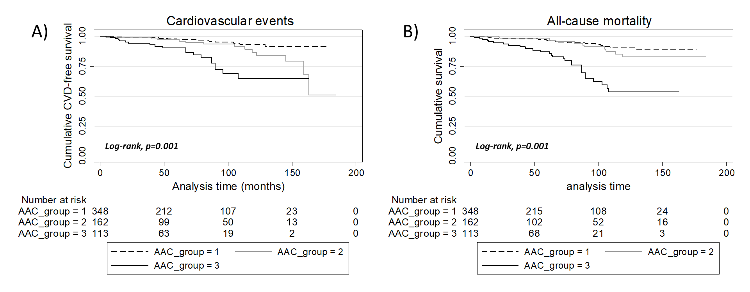
Supplementary Figure 1 Kaplan Meier Survival plots by the severity of AAC (low, n=348, moderate n=162 and high n=113) for a) cardiovascular (CV) events and b) any death. Vertical lines indicate censored individuals.

