Appendix 2 Equipment setups for mannequin training of selective fetoscopic laser photocoagulation with the conventional box trainer (BT) and the fetoscopic surgical simulator (FSS) at Faculty of Medicine Siriraj Hospital. (Nd-YAG = neodymium-doped yttrium aluminum garnet, Fr = French)
 | Box trainer (BT) | Fetoscopic surgical simulator (FSS)
Equipments | Basic equipment  Light source, videoscopic visual system, and camera (Karl Storz, Brussels, Belgium)  Rod lens endoscope (outer diameter 2 mm.) (Karl Storz, Brussels, Belgium)  Inner sheath (30 degrees of deflection) (Karl Storz, Brussels, Belgium)  Outer sheath (11.5 Fr.) (Karl Storz, Brussels, Belgium)  Teflon cannula (Cook Medical, Bloomington, IN, USA)  Ultrasound machine with gel  Gauzes, surgical blades (for cutting ultrasound skin), disposable gloves, aprons  Additional equipment  Nd-YAG laser generator (i.e. Dornier Medilas fibertomTM 8100) or diode laser generator (i.e. Diode Medilas D Multibeam) (Dornier Medizin Technik, Germering, Germany) with a separate high-voltage power outlet  Laser fibers size 400- and 600-µm for use with 30° and 0° fetoscopes, respectively (Dornier Medizin Technik, Germering, Germany)  Laser fiber ceramic cutter (Dornier Medizin Technik, Germering, Germany)  Safety eyewear (Karl Storz, Brussels, Belgium)  Cleaned human placentae with cords trimmed to the manageable length from seronegative women (collected within 2 days before the training to minimize tissue degradation and refrigerated at 4°C, no freezing, until the time of use)  A standard, plastic storage box (12 x 8 x 6 inches)  Plastic tray, 13 x 10 inches | Basic equipment  Light source, videoscopic visual system, and camera (Karl Storz, Brussels, Belgium)  Rod lens endoscope (outer diameter 2 mm.) (Karl Storz, Brussels, Belgium)  Inner sheath (30 degrees of deflection) (Karl Storz, Brussels, Belgium)  Outer sheath (11.5 Fr.) (Karl Storz, Brussels, Belgium)  Teflon cannula (Cook Medical, Bloomington, IN, USA)  Ultrasound machine with gel  Gauzes, disposable gloves, aprons  Additional equipment  The patented FSS diameter 14 inches.
Preparation | A cleaned human placenta is attached on the inside.  The BT is carefully filled with tap water to avoid air trapped on the inside before use.  The BT is sealed with a watertight lock cover, with a wide window cut out and replaced with ultrasound-transparent rubber "skin" stitched to its margins. | The FSS is set up on its base.  The FSS is carefully filled with tap water to avoid air trapped on the inside before use.
Training | 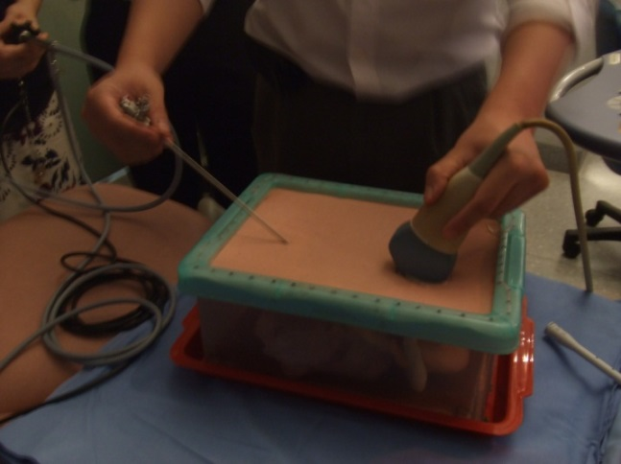 | 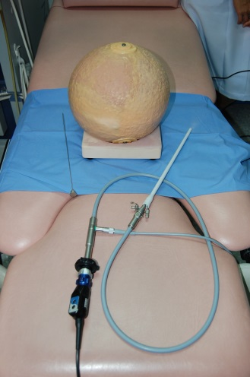
Pictures from simulation | 