Supplemental Materials
Diffusion-Weighted Imaging Patterns According to the Right-to-Left Shunt Amount in Cryptogenic Stroke

Online Suppl. table 1. Baseline characteristics of the cohort (n = 100)
Demographic and clinical factors
Age, y [IQR] | 58 ± 13
Male sex, % | 75 (75)
Hypertension, % | 54 (54)
Diabetes, % | 20 (20)
Hyperlipidemia, % | 13 (13)
Current smoking, % | 39 (39)
History of stroke, % | 15 (15)
Initial NIHSS [IQR] | 3 ± 3
RoPE score, [IQR] | 3 ± 2
Radiological findings
DWI volume, mL [IQR] | 7.89 ± 14.85
Number of DWI lesion, [IQR] | 3 ± 5
Number of large (>1cm) DWI lesion, [IQR] | 1 ± 1
DWI lesion location, %
Only subcortical | 39 (39)
Cortico-subcortical | 20 (20)
Only cortical | 41 (41)
Involved vascular territory, %
Anterior cerebral artery | 3 (3)
Middle cerebral artery | 38 (38)
Vertebrobasilar artery | 38 (38)
Multiple territories | 22 (22)
DWI lesion pattern, %
Single territory single lesion | 47 (47)
Single territory multiple lesion | 31 (31)
Multiple territory small scattered lesion | 15 (15)
Multiple territory large and small lesion | 7 (7)
SBI, %
No | 61 (61)
Single | 15 (15)
Multiple | 24 (24)
SBI in lacunar areas, % | 27 (27)
SBI in non-lacunar areas, % | 13 (13)
Sonographic findings
ICC, %
0 | 41 (41)
1-20 | 37 (37)
>20 or no curtain | 4 (4)
Curtain | 18 (18)
Constant PFO, % | 43 (73)
NIHSS = National Institutes of Health Stroke Scale, RoPE = Risk of Paradoxical Embolism, DWI = Diffusion-weighted imaging, SBI = Silent brain infarct, ICC = International consensus criteria, PFO = Patent foramen ovale

Online Suppl. figure 1. Distributions of DWI lesion patterns according to the amounts of right-to-left shunt on transcranial Doppler sonography.
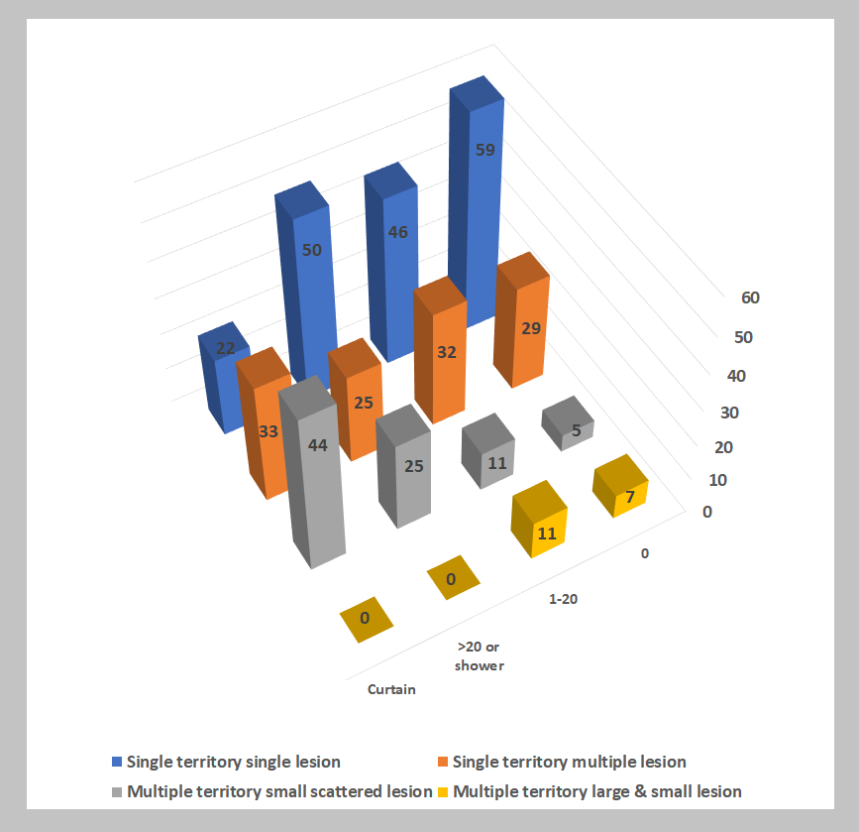
Among four different DWI lesions types based on the vascular territory and number of lesions, patients with higher right-to-left shunt (RLS) amounts showed high frequencies of multiple territory small scattered lesion patterns (P for trend = 0.024). While, patients with smaller RLS amounts frequently showed single territory single lesion patterns.

