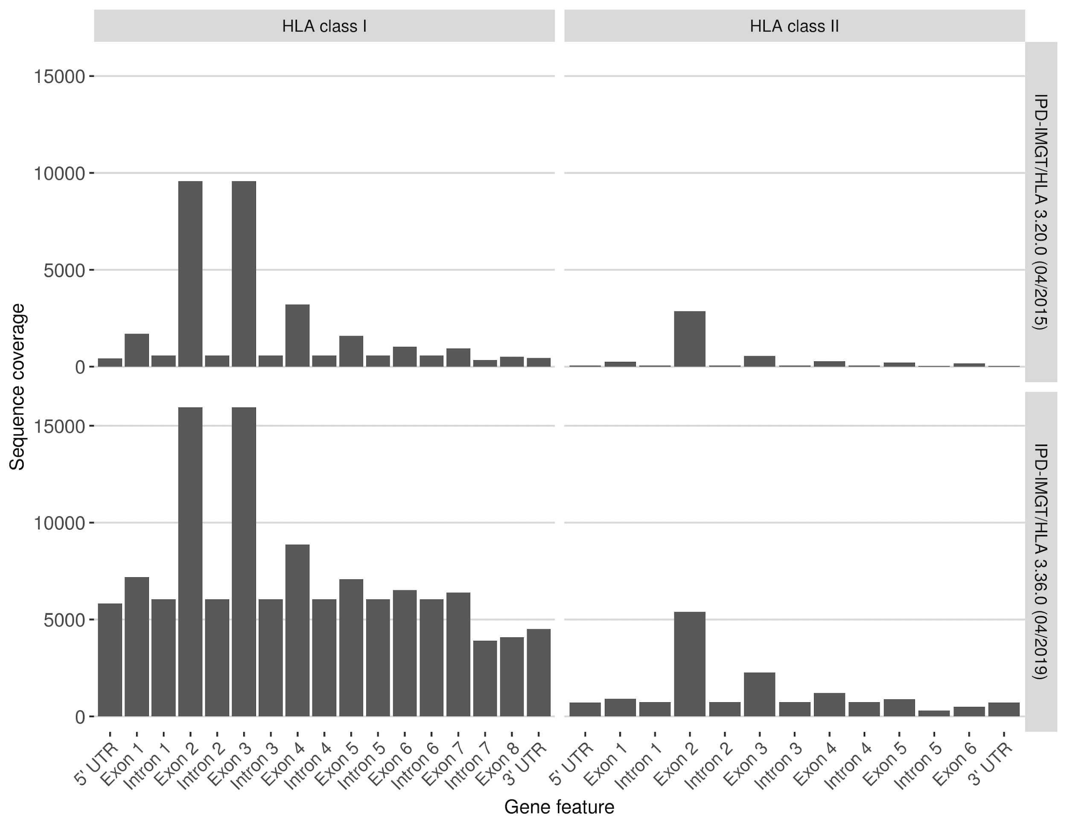

Supplementary Figure 1. Varying sequence coverage of different gene features of class I (HLA-A, -B, -C) and class II (HLA-DRB1, -DQB1, -DPB1) HLA genes in the IPD-IMGT/HLA releases 3.20.0 (2015) and 3.36.0 (2019). Exons 2 and 3 in class I genes and exon 2 in class 2 genes are mandatory for submission to IPD-IMGT/HA.

Supplementary Table 1: An overview over currently available HLA genotyping software.
Tool | Resolution | Licence | Input Data | Source
ALPHLARD(-NT) [35] | Class I + II; 3-field | Not available | WGS, WES | Not available
ATHLATES [72] | Class I + II; 3-field | Academic non-commercial use only | WES | https://www.broadinstitute.org/viral-genomics/athlates
GenDx NGSengine | Class I + II; 4-field | Commercial | targeted data | https://www.gendx.com/products/ngsengine
HLA*PRG:LA [80,83] | Class I + II; 3-field | Open source | WGS, WES, targeted data | https://github.com/DiltheyLab/HLA-LA
HLA-HD [99] | Class I + II; up to 3-field | Academic non-commercial use only | WES | https://www.genome.med.kyoto-u.ac.jp/HLA-HD/
HLA-Vbseq [71] | Class I + II; 2-field | Academic non-commercial use only | WGS | http://nagasakilab.csml.org/hla/
HLAssign [100] | Class I + II; 3-field | Open source | Targeted HLA enrichment /wo PCR | https://www.ikmb.uni-kiel.de/resources/download-tools/software/hlassign
HLAforest [69] | Class I + II; 2-field | Academic non-commercial use only | RNA-seq | https://github.com/FNaveed786/hlaforest
HLAminer [101] | Class I;  up to 2-field | Academic non-commercial use only | RNA-seq, WGS, WES | https://github.com/warrenlr/HLAminer
HLAProfiler [102] | Class I + II; 2-field | Academic non-commercial use only | RNA-seq | https://github.com/ExpressionAnalysis/HLAProfiler
HLAreporter [85] | Class I + II; 2-field | Open source | WES | http://paed.hku.hk/genome/software.html
HLAscan [36] | Class I + II;  2-field | Open source | WGS, WES, targeted data | http://www.genomekorea.com/display/tools/HLA_SCAN
Kourami[86] | Class I + II; 3-field | Open source | WGS | https://github.com/Kingsford-Group/kourami
neXtype [7] | Class I + II;  up to 3-field | In-house only | Exon amplicons | Not available
Omixon HLA Twin | Class I + II; 4-field | Commercial | targeted data | https://www.omixon.com/products/hla-twin/
OptiType [79,82] | Class I + II; 2-field | Open source | WGS,WES, RNA-seq | https://github.com/FRED-2/OptiType
PHLAT [70,103] | Class I + II; 2-field | Academic non-commercial use only | WES, RNA-seq | https://sites.google.com/site/phlatfortype/
Polysolver [104] | Class I + II;  2-field | Academic non-commercial use only | WES | https://software.broadinstitute.org/cancer/cga/polysolver
seq2HLA [68] | Class I + II;  1-field | Open source | RNA-seq | https://bitbucket.org/sebastian_boegel/seq2hla
xHLA [41] | Class I + II;  2-field | Academic non-commercial use only | WGS, WES | https://github.com/humanlongevity/HLA

Additional References

99 Kawaguchi S, Higasa K, Shimizu M, Yamada R, Matsuda F. HLA-HD: an accurate HLA typing algorithm for next-generation sequencing data. Hum Mutat. 2017 Jul;38(7):788–97.
100 Wittig M, Anmarkrud JA, Kässens JC, Koch S, Forster M, Ellinghaus E, et al. Development of a high-resolution NGS-based HLA-typing and analysis pipeline. Nucleic Acids Res. 2015 Jun;43(11):e70–70.
101 Warren RL, Choe G, Freeman DJ, Castellarin M, Munro S, Moore R, et al. Derivation of HLA types from shotgun sequence datasets. Genome Med. 2012 Dec;4(12):95.
102 Buchkovich ML, Brown CC, Robasky K, Chai S, Westfall S, Vincent BG, et al. HLAProfiler utilizes k-mer profiles to improve HLA calling accuracy for rare and common alleles in RNA-seq data. Genome Med. 2017 Sep;9(1):86.
103 Bai Y, Wang D, Fury W: PHLAT: Inference of High-Resolution HLA Types from RNA and Whole Exome Sequencing. New York: Humana Press; 2018. pp. 193–201.
104 Shukla SA, Rooney MS, Rajasagi M, Tiao G, Dixon PM, Lawrence MS, et al. Comprehensive analysis of cancer-associated somatic mutations in class I HLA genes. Nat Biotechnol. 2015 Nov;33(11):1152–8.

