**Supplement information**

**Fig. S1**. Flow chart of the study selection process and literature search result.

**Fig. S2A.** Subgroup analysis by study location of the association between EBV infection and increased BC risk.

**Fig. S2B.** Subgroup analysis by tissue type of the association between EBV infection and increased BC risk.

**Fig. S3.** Sensitivity analyses by omitting each study by turn.

**Fig. S4.** Funnel plot for publication bias analysis

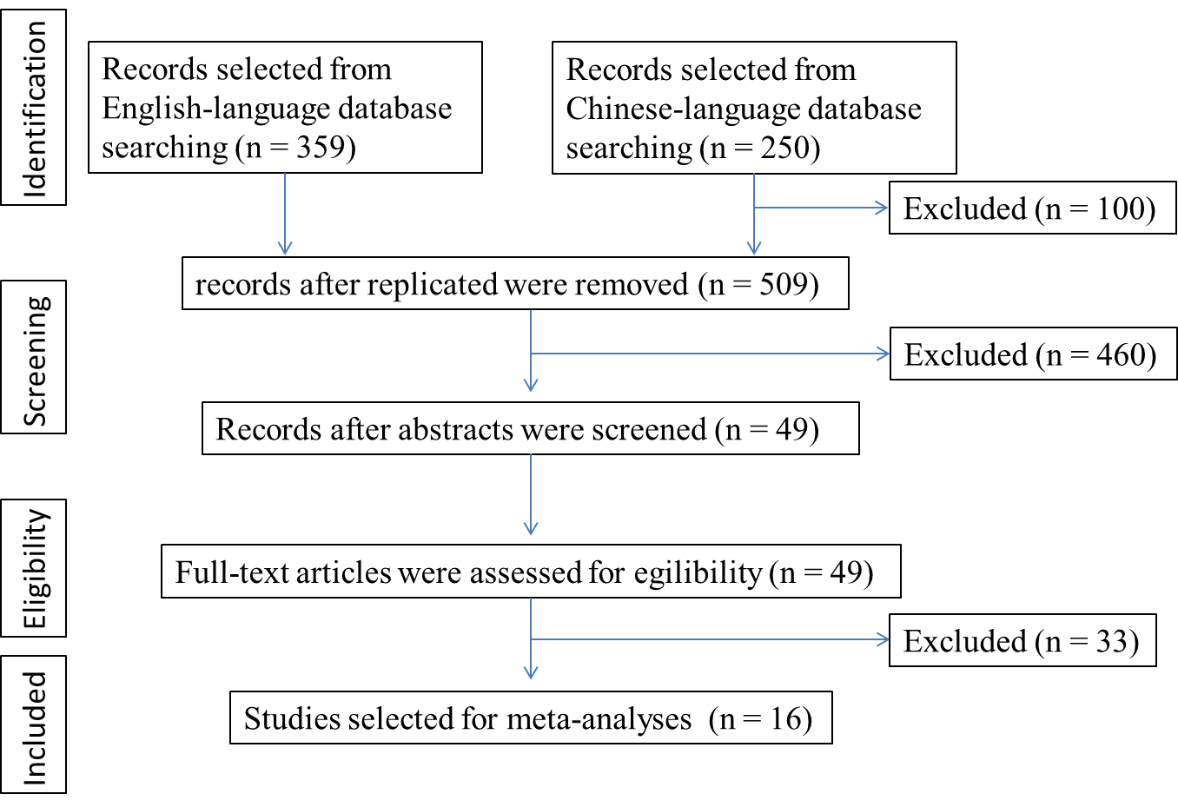

**Fig. S1**



**Fig. S2A**



**Fig. S2B**



**Figure S3**



**Figure S4**