**Online supplementary material**

***T*2 mapping as a tool for assessment of dental pulp response to caries progression - *in vivo* MRI study**

Ksenija Cankar1*, Jernej Vidmar1,2,3, Lidija Nemeth3, Igor Serša1,4

*1Institute of Physiology, University of Ljubljana, Medical Faculty, Slovenia*

*2Institute of Radiology, University Medical Center Ljubljana, Ljubljana, Slovenia*

*3Department of Dental Diseases and Normal Dental Morphology, Faculty of medicine, University of Ljubljana, Slovenia*

*4Jožef Stefan Institute, Ljubljana, Slovenia*

**Short tittle:** *T*2 mapping of caries

*Corresponding author:

Ksenija Cankar,

University of Ljubljana, Medical Faculty

Institute of Physiology

Zaloška 4,

Ljubljana 1000, Slovenia

Tel: +386 1 543 7500

Fax: +386 1 543 7501

E-mail: [ksenija.cankar@mf.uni-lj.si](mailto:ksenija.cankar@mf.uni-lj.si)

**Keywords:** dental pulp; caries; MRI; *T*2 mapping; ICDAS

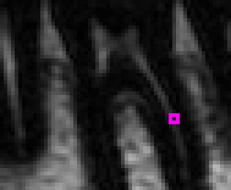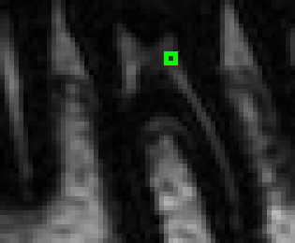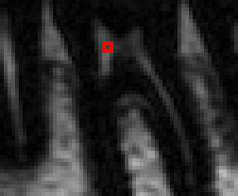**Fig. S1:** Examples of *T*2 signal decay best fit curves to the experimental data for three different randomly selected pixels indicated by colored boxes in the *T*2–weighted images. Corresponding *T*2 values are different and have also significantly different errors that depend on the fit quality.



*Si,j*(*TE*) = 145 exp(-*TE* / 215 ms)  
*T*2 = 215 ± 75 ms, R2 = 0.707

*TE* (ms)

*S* (a.u.)



*Si,j*(*TE*) = 115 exp(-*TE* / 117 ms)  
*T*2 = 117 ± 34 ms, R2 = 0.816

*TE* (ms)

*S* (a.u.)



*S* (a.u.)

*TE* (ms)

*Si,j*(*TE*) = 94 exp(-*TE* / 74 ms)  
*T*2 = 74 ± 9 ms, R2 = 0.965

**Fig. S2:** An X-ray image (a) and the corresponding *T*2-weighetd image of the same tooth with a metallic (dental amalgam) restoration (b). The restoration has practically no effect on the signal reception from the dental pulp region. The images are of one of the volunteers of the study. The dental implant was placed only after MRI was completed.

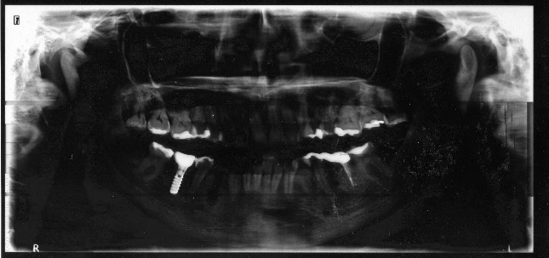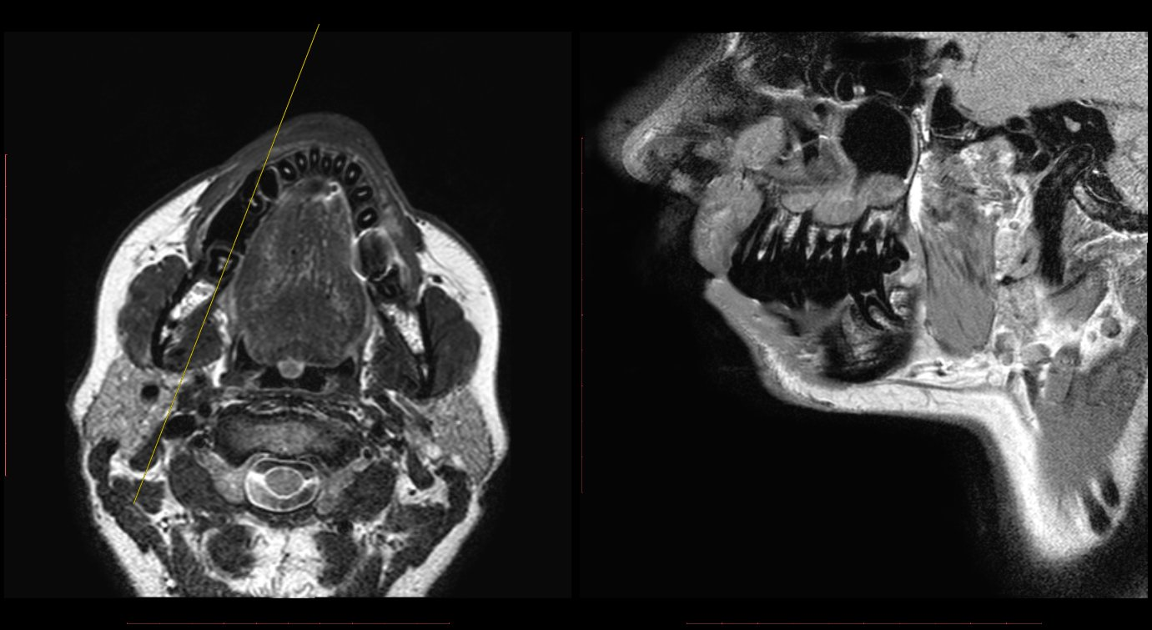

R

R

R

R

**Table S1:** Dental pulp *T*2 value depth profiles of all teeth included in the study. The table of 74 samples is divided between single-rooted teeth (first half of the table, 34 samples) and molars (second half of the table, 40 samples). Within each of the halves teeth are ordered by the increasing ICDAS score. Tooth position is given by a two-digit number according to the tooth numbering system.

|  |  |  |  |  |  |  |  |  |  |  |  |  |  |  |  |  |  |  |  |  |
| --- | --- | --- | --- | --- | --- | --- | --- | --- | --- | --- | --- | --- | --- | --- | --- | --- | --- | --- | --- | --- |
| Teeth | | | T2 values [ms] | | | | | | | | | | | | | | | | | |
| type | position | ICDAS score | Depth [mm] | | | | | | | | | | | | | | | | | |
| 0.57 | 1.14 | 1.71 | 2.29 | 2.86 | 3.43 | 4.00 | 4.57 | 5.14 | 5.71 | 6.29 | 6.86 | 7.43 | 8.00 | 8.57 | 9.14 | 9.71 | 10.29 |
| Single rooted teeth | 33 | 0 | 114 | 208 | 178 | 126 | 123 | 148 | 124 | 174 |  |  |  |  |  |  |  |  |  |  |
| 34 | 0 | 96 | 143 | 156 | 142 | 164 | 138 | 129 | 100 | 101 | 76 |  |  |  |  |  |  |  |  |
| 35 | 0 | 114 | 141 | 93 | 145 | 147 | 208 | 104 |  |  |  |  |  |  |  |  |  |  |  |
| 35 | 0 | 158 | 146 | 212 | 154 | 147 | 166 | 135 | 154 | 104 |  |  |  |  |  |  |  |  |  |
| 24 | 0 | 121 | 128 | 153 | 124 | 113 | 105 | 115 | 163 | 155 | 108 |  |  |  |  |  |  |  |  |
| 34 | 0 | 150 | 152 | 164 | 172 | 163 | 167 | 225 | 270 | 241 | 256 | 229 |  |  |  |  |  |  |  |
| 35 | 0 | 114 | 162 | 152 | 162 | 177 | 166 | 165 | 174 | 154 | 146 | 148 | 79 | 112 |  |  |  |  |  |
| 34 | 0 | 251 | 200 | 209 | 241 | 196 | 183 | 137 | 200 | 221 | 142 | 126 | 97 |  |  |  |  |  |  |
| 35 | 0 | 128 | 156 | 203 | 192 | 122 | 129 | 146 | 157 | 141 | 186 | 132 | 138 | 134 | 201 | 209 |  |  |  |
| 43 | 0 | 87 | 145 | 227 | 126 | 152 | 183 | 109 |  |  |  |  |  |  |  |  |  |  |  |
| 23 | 1 | 85 | 83 | 84 | 61 | 128 | 61 | 118 | 96 | 72 |  |  |  |  |  |  |  |  |  |
| 12 | 1 | 147 | 72 | 85 | 88 | 179 | 135 | 139 | 162 | 159 | 196 | 264 | 178 | 132 | 113 | 164 | 98 |  |  |
| 44 | 1 | 94 | 136 | 120 | 114 | 128 | 96 | 96 | 117 | 116 | 206 | 118 |  |  |  |  |  |  |  |
| 45 | 1 | 149 | 137 | 143 | 137 | 150 | 149 | 166 | 100 | 107 |  |  |  |  |  |  |  |  |  |
| 23 | 2 | 75 | 106 | 118 | 119 | 132 | 110 | 124 | 149 | 133 | 200 | 150 | 123 | 103 | 82 | 77 | 88 | 72 | 81 |
| 13 | 2 | 215 | 215 | 103 | 71 | 74 | 212 | 158 | 96 |  |  |  |  |  |  |  |  |  |  |
| 34 | 2 | 129 | 142 | 131 | 143 | 111 | 140 | 173 | 114 | 110 | 147 | 134 | 73 |  |  |  |  |  |  |
| 24 | 2 | 127 | 175 | 155 | 119 | 164 | 137 | 144 | 133 | 163 | 261 | 174 | 95 | 88 |  |  |  |  |  |
| 33 | 3 | 155 | 152 | 137 | 186 | 234 | 173 | 117 | 127 | 143 | 115 | 118 | 98 | 144 | 105 | 81 | 78 | 88 | 74 |
| 23 | 3 | 128 | 188 | 228 | 160 | 126 | 124 | 114 | 157 | 165 | 119 | 121 | 130 | 125 | 111 | 96 | 85 | 100 | 113 |
| 45 | 3 | 104 | 133 | 153 | 151 | 143 | 128 | 118 | 203 | 219 | 139 |  |  |  |  |  |  |  |  |
| 14 | 3 | 54 | 90 | 129 | 125 | 112 | 112 | 118 | 125 | 126 | 91 |  |  |  |  |  |  |  |  |
| 35 | 4 | 126 | 157 | 193 | 111 | 141 | 201 | 148 | 169 | 134 | 128 |  |  |  |  |  |  |  |  |
| 25 | 4 | 112 | 140 | 145 | 145 | 131 | 127 | 141 | 142 |  |  |  |  |  |  |  |  |  |  |
| 25 | 4 | 188 | 124 | 138 | 132 | 120 | 132 | 133 | 150 | 224 | 158 | 67 | 67 | 56 |  |  |  |  |  |
| 35 | 5 | 87 | 92 | 176 | 124 | 79 | 75 | 90 | 71 | 106 | 105 | 108 | 114 |  |  |  |  |  |  |
| 13 | 5 | 62 | 44 | 67 | 58 | 124 | 102 | 74 | 99 |  |  |  |  |  |  |  |  |  |  |
| 24 | 5 | 107 | 124 | 144 | 124 | 149 | 183 | 141 | 115 | 154 | 125 | 68 | 47 | 99 | 81 | 121 | 96 |  |  |
| 23 | 6 | 72 | 102 | 118 | 113 | 109 | 88 | 117 | 94 | 95 | 121 | 148 | 144 | 184 | 122 | 90 | 98 | 88 | 67 |
| 13 | 6 | 113 | 108 | 194 | 185 | 128 | 145 | 179 | 84 |  |  |  |  |  |  |  |  |  |  |
| 23 | 6 | 22 | 26 | 16 | 26 | 29 | 48 | 50 | 55 | 52 | 40 | 39 | 36 | 37 | 39 | 29 | 33 | 36 | 27 |
| 33 | 6 | 39 | 68 | 77 | 89 | 76 | 74 | 75 | 52 | 47 | 41 | 35 | 19 |  |  |  |  |  |  |
| 34 | 6 | 45 | 47 | 64 | 75 | 84 | 88 | 100 | 95 | 83 | 74 | 63 | 66 | 56 | 38 | 30 |  |  |  |
| 35 | 6 | 38 | 59 | 82 | 93 | 94 | 133 | 114 | 81 | 84 | 67 | 57 | 55 | 46 | 33 | 44 |  |  |  |
| Molars | 37 | 0 | 255 | 203 | 182 | 139 | 87 | 94 | 91 | 82 |  |  |  |  |  |  |  |  |  |  |
| 27 | 0 | 73 | 137 | 267 | 136 | 154 | 187 | 146 | 120 | 93 | 134 | 124 | 67 | 44 | 118 | 43 | 76 |  |  |
| 36 | 0 | 158 | 192 | 110 | 123 | 99 | 106 | 101 | 112 | 95 | 78 | 40 | 75 | 60 | 49 |  |  |  |  |
| 37 | 0 | 142 | 234 | 213 | 147 | 152 | 136 | 120 | 89 | 91 | 112 | 158 | 94 | 65 |  |  |  |  |  |
| 26 | 0 | 145 | 132 | 220 | 237 | 234 | 149 | 142 | 140 | 129 | 162 |  |  |  |  |  |  |  |  |
| 37 | 0 | 164 | 131 | 108 | 92 | 106 | 97 | 123 | 119 | 77 | 64 | 79 | 41 |  |  |  |  |  |  |
| 36 | 0 | 95 | 109 | 136 | 143 | 128 | 122 | 102 | 117 | 77 | 87 | 97 | 63 |  |  |  |  |  |  |
| 37 | 0 | 149 | 144 | 121 | 138 | 128 | 119 | 140 | 86 | 77 | 256 | 67 | 78 | 129 |  |  |  |  |  |
| 27 | 0 | 57 | 172 | 270 | 253 | 254 | 236 | 171 | 219 | 135 | 112 | 116 |  |  |  |  |  |  |  |
| 28 | 0 | 183 | 234 | 269 | 272 | 270 | 272 | 238 | 261 | 250 | 165 |  |  |  |  |  |  |  |  |
| 36 | 0 | 112 | 117 | 152 | 172 | 126 | 207 | 159 | 152 | 128 | 144 | 108 | 110 | 130 |  |  |  |  |  |
| 37 | 0 | 190 | 222 | 259 | 192 | 199 | 194 | 157 | 181 | 132 | 193 | 99 | 120 |  |  |  |  |  |  |
| 38 | 0 | 209 | 226 | 258 | 259 | 251 | 189 | 127 | 84 | 80 | 111 | 154 |  |  |  |  |  |  |  |
| 17 | 1 | 95 | 187 | 255 | 220 | 269 | 231 | 243 | 164 | 135 | 81 |  |  |  |  |  |  |  |  |
| 48 | 1 | 97 | 159 | 155 | 139 | 137 | 104 | 140 | 120 | 139 | 125 | 132 | 135 | 153 | 147 | 146 | 119 |  |  |
| 38 | 1 | 145 | 180 | 207 | 192 | 223 | 219 | 143 |  |  |  |  |  |  |  |  |  |  |  |
| 47 | 1 | 187 | 232 | 255 | 222 | 207 | 245 | 187 |  |  |  |  |  |  |  |  |  |  |  |
| 18 | 2 | 95 | 198 | 184 | 165 | 159 | 245 | 187 | 127 |  |  |  |  |  |  |  |  |  |  |
| 38 | 2 | 147 | 160 | 198 | 230 | 208 | 158 | 139 | 140 | 126 | 87 | 55 |  |  |  |  |  |  |  |
| 28 | 2 | 84 | 232 | 170 | 193 | 266 | 270 |  |  |  |  |  |  |  |  |  |  |  |  |
| 37 | 2 | 161 | 165 | 158 | 147 | 140 | 152 | 149 | 150 | 134 | 116 | 148 | 143 |  |  |  |  |  |  |
| 27 | 2 | 85 | 145 | 234 | 158 | 217 | 116 | 104 | 82 | 83 | 55 |  |  |  |  |  |  |  |  |
| 46 | 2 | 118 | 163 | 171 | 190 | 143 | 166 | 221 |  |  |  |  |  |  |  |  |  |  |  |
| 47 | 3 | 80 | 110 | 125 | 102 | 110 | 78 | 93 |  |  |  |  |  |  |  |  |  |  |  |
| 48 | 3 | 143 | 172 | 223 | 220 | 183 | 139 | 140 | 178 |  |  |  |  |  |  |  |  |  |  |
| 27 | 3 | 227 | 165 | 200 | 246 | 153 | 225 | 115 |  |  |  |  |  |  |  |  |  |  |  |
| 36 | 3 | 194 | 205 | 179 | 133 | 208 | 101 | 64 |  |  |  |  |  |  |  |  |  |  |  |
| 47 | 3 | 142 | 162 | 204 | 166 | 157 | 131 | 128 | 122 | 58 | 68 | 96 | 89 | 78 |  |  |  |  |  |
| 36 | 3 | 142 | 157 | 146 | 139 | 110 | 79 | 60 |  |  |  |  |  |  |  |  |  |  |  |
| 48 | 3 | 136 | 168 | 235 | 254 | 224 | 230 | 257 | 171 | 204 | 133 |  |  |  |  |  |  |  |  |
| 46 | 4 | 173 | 147 | 182 | 218 | 167 | 121 | 97 | 99 | 105 | 107 | 100 |  |  |  |  |  |  |  |
| 26 | 4 | 205 | 161 | 182 | 182 | 127 | 78 | 110 | 116 | 77 | 37 | 102 | 134 | 60 |  |  |  |  |  |
| 27 | 4 | 111 | 179 | 218 | 221 | 104 | 66 |  |  |  |  |  |  |  |  |  |  |  |  |
| 16 | 5 | 94 | 145 | 204 | 135 | 165 | 165 | 148 | 123 | 90 | 142 | 147 | 79 | 115 | 165 |  |  |  |  |
| 46 | 5 | 110 | 104 | 88 | 128 | 110 | 114 | 94 | 98 |  |  |  |  |  |  |  |  |  |  |
| 17 | 5 | 105 | 134 | 134 | 178 | 169 | 107 | 102 | 161 | 244 | 269 | 123 |  |  |  |  |  |  |  |
| 18 | 5 | 56 | 93 | 152 | 226 | 185 | 153 | 151 |  |  |  |  |  |  |  |  |  |  |  |
| 36 | 6 | 38 | 48 | 43 | 52 | 71 | 50 | 33 | 40 | 43 | 56 | 54 | 33 |  |  |  |  |  |  |
| 37 | 6 | 31 | 40 | 42 | 59 | 92 | 164 | 86 | 52 | 40 | 46 | 33 | 44 | 29 |  |  |  |  |  |
| 37 | 6 | 160 | 135 | 214 | 261 | 170 | 119 | 103 |  |  |  |  |  |  |  |  |  |  |  |