Table S1. cfDNA testing at Visit 1 and 2
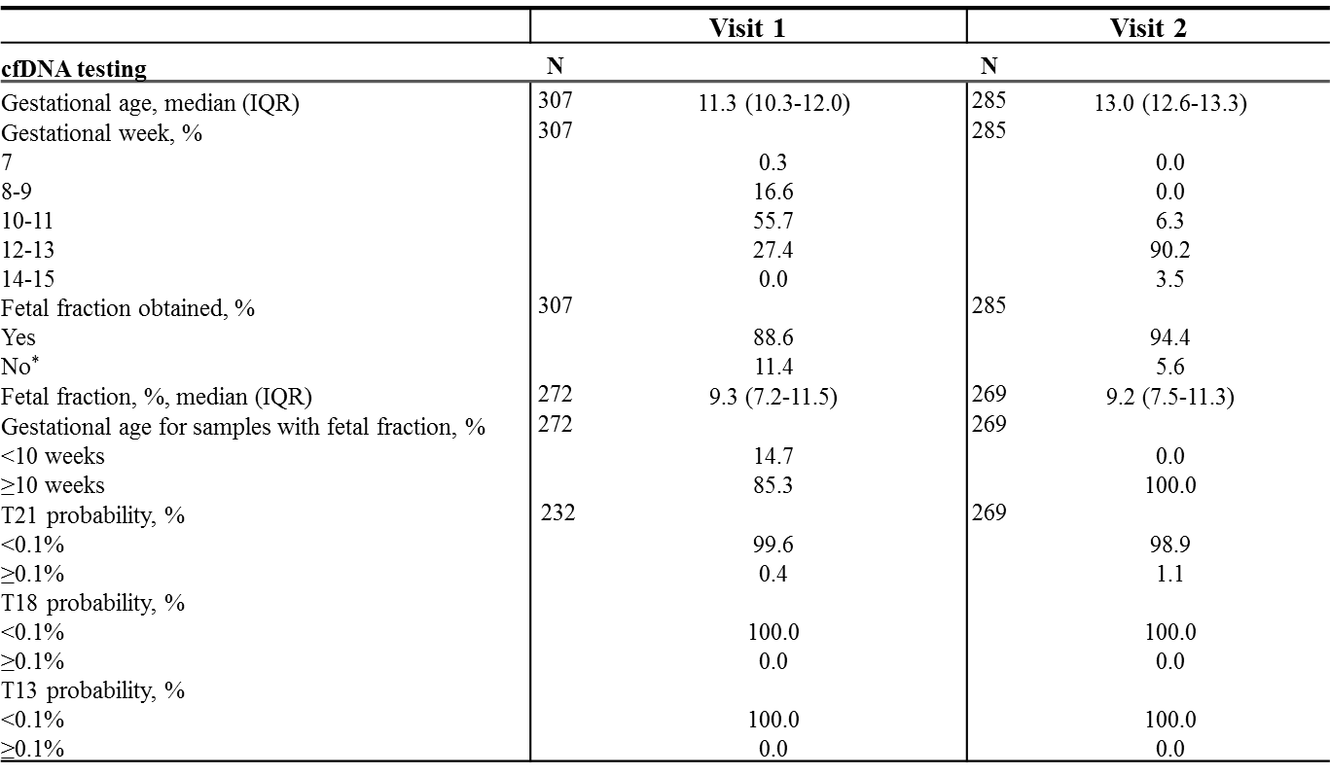
Table includes samples collected at Visit 1 and 2 from women with a live singleton fetus at the first trimester ultrasound examination (n=309). *Fetal fraction <4% in 10 samples (7 at Visit 1 and 3 at Visit 2).

