Table S2. Odds of fetal fraction ≥4% according to gestational age and maternal body mass index.
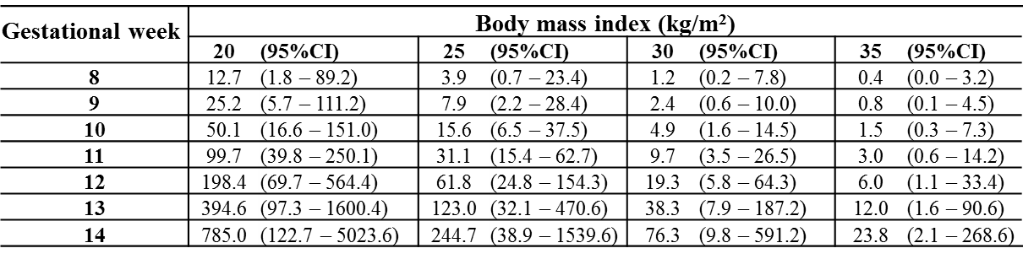
The table is based on samples collected from euploid pregnancies (n=542 samples).

