Table S3. Change in fetal fraction per day
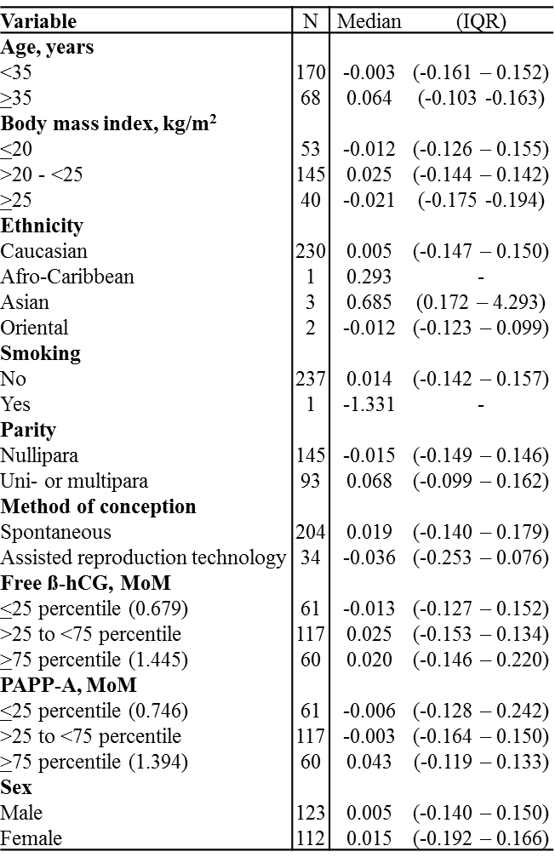
The table includes pregnancies with two samples with a fetal fraction at or above 4% (n=238).

