Table S4. Univariable analysis of patient-specific associations with change in fetal fraction per days between blood sampling ((fetal fraction at Visit 2 – fetal fraction at Visit 1)/ (gestational age at Visit 2 – gestational age at Visit 1))
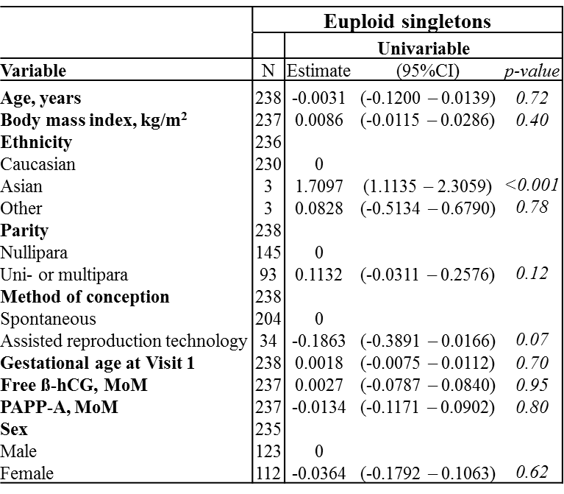
The table includes pregnancies with two samples with a fetal fraction at or above 4% (n=238). Smoking status was excluded due to numbers (non-smokers, n=1).

