Figure S1. Flowchart of recruitment

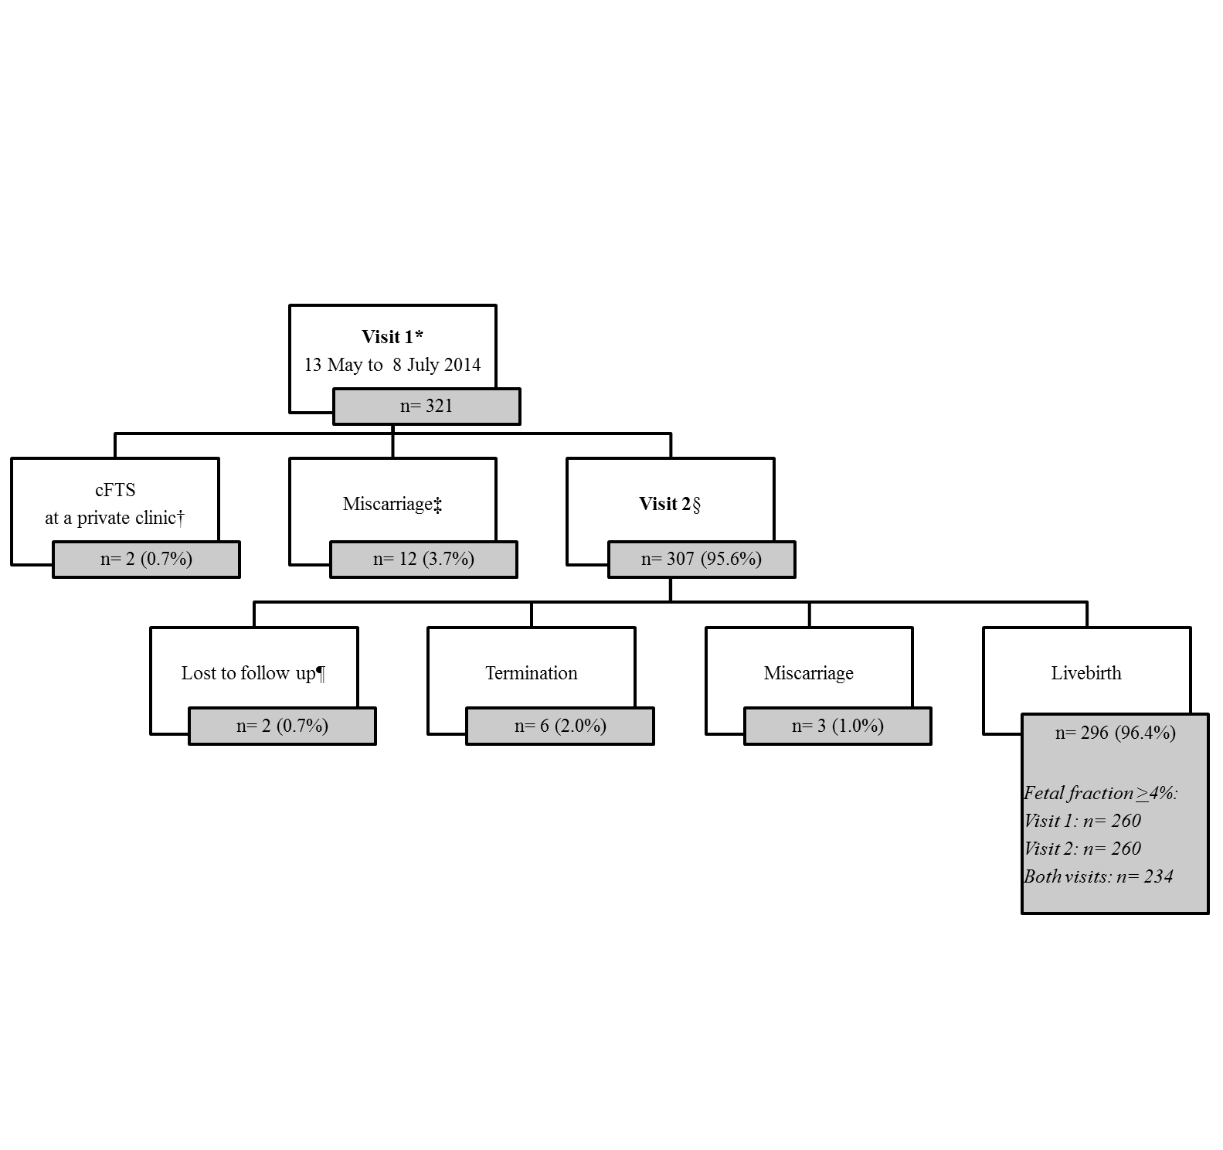

*Visit 1: Blood collection for biochemical markers (PAPP-A and β-hCG) and 1st cfDNA testing (n=321).
†Livebirth (n=2).
‡Seven miscarriages diagnosed before Visit 2 and five diagnosed at Visit 2.
§Visit 2: Combined first trimester risk assessment AND 2nd cfDNA testing (n=290), and only cFTS (n=17).
Missing 2nd cfDNA testing is caused by transport (n=4), cFTS at another hospital (n=6), changing date of appointment for cFTS (n=6), and declining 2nd blood collection (n=1).
¶Lost to follow up (n=2), one due to emigration.

