

Figure 1. Flow chart

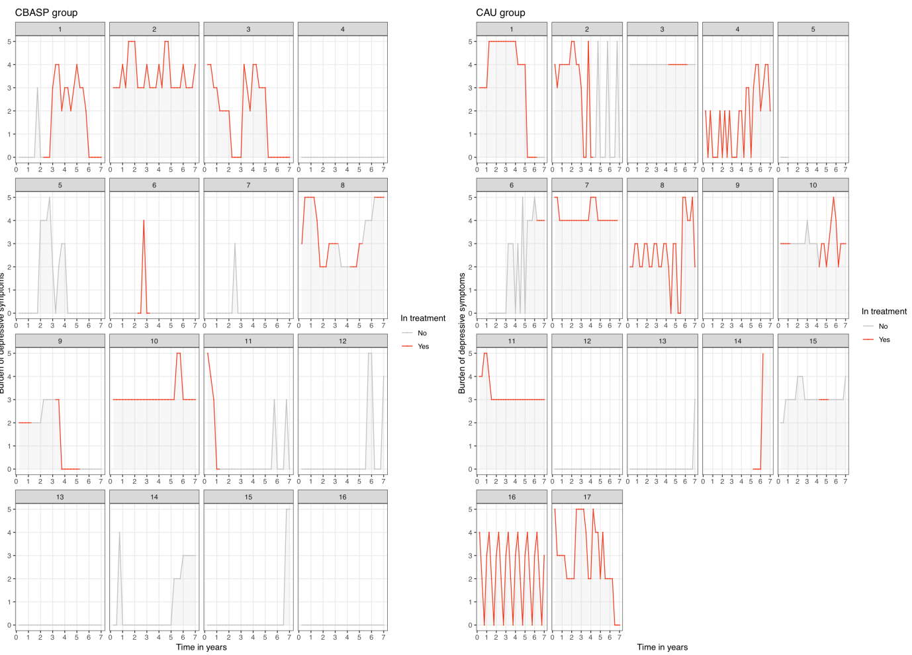

Figure 2: Presence and severity of depressive symptoms during 7-year follow-up, shown per participant.   
Note: Grey areas indicate presence of depressive symptoms. Burden ranging from 0: no burden to 5: high burden of symptoms.

Table 1. Differences in Demographic, Social and Clinical Characteristics for the FU group and the Non-FU group at baseline

|  |  |  |  |
| --- | --- | --- | --- |
|  | FU  (n=39) | Non-FU  (n=100) | *P* a |
| Female (%) | 54 | 62 | .44 |
| Age, mean ± SD, y | 43 (10.6) | 41 (10.5) | .22 |
| Education mean ± SD, y | 13 (2.9) | 12 (3.6) | .27 |
| Married or cohabiting (%) | 36 | 18 | .13 |
| Employment status (%)  Full time paid work (>32h)  Part time paid work (3 to 32h)  Unemployed / Seeking work / Registered sick / Disabled / Retired | 26  33  41 | 31  27  42 | .71 |
| Age of onset, mean ± SD, y | 25 (14.1) | 24 (12.4) | .60 |
| Antidepressant medication use (%) | 74 | 60 | .12 |
| Previous mental health treatment (%) (secondary or tertiary care) | 90 | 79 | .21 |
| Severity depressive symptoms (IDS score: 0-84), mean ± SD | 42.7 (10.2) | 42.2 (10.5) | .79 |
| Comorbid anxiety disorder (current) (%) | 62 | 57 | .70 |
| Childhood trauma (before age 16) (%) | 62 | 73 | .22 |

a Comparison between the FU and non-FU group, using Chi square likelihood ratio statistics (categorical variables) and ANOVA analyses (continuous variables).

Abbreviations: IDS = Inventory of Depressive Symptomatology.

Table 2. Outcomes of CBASP versus CAU for Persistent Depression on the IDS

|  |  |  |  |  |  |  |
| --- | --- | --- | --- | --- | --- | --- |
| CBASP | | | | | |  |
|  | Week 0 | Week 8 | Week 16 | Week 32 | Week 52 | Follow up |
| IDS scores LOC, mean (SD) (N) | 40.8 (10.0)  (n=67) | 33.9 (12.8)  (n=55) | 30.4 (14.3)  (n=53) | 28.3 (14.3)  (n=49) | 24.1 (14.1)  (n=51) | 19.5 (12.8)  (n=19) |
| IDS scores completers, mean (SD) (N) | 39.8 (8.9)  (n=19) | 32.7 (13.7)  (n=19) | 27.4 (13.1)  (n=19) | 23.7 (12.7)  (n=19) | 19.6 (10.8)  (n=19) | 19.5 (12.8)  (n=19) |
| Effect sizes completers (within group) | - | 0.60 | 0.84 | 1.01 | 1.37 | 1.87 |
| CAU | | | | | |  |
|  | Week 0 | Week 8 | Week 16 | Week 32 | Week 52 | Follow up |
| IDS scores, mean (SD) (N) | 43.8 (10.6)  (n=72) | 36.8 (15.0)  (n=60) | 33.6 (16.2)  (n=57) | 31.5 (14.6)  (n=45) | 32.0 (14.5)  (n=53) | 30.4 (15.6)  (n=20) |
| IDS scores completers, mean (SD) (N) | 45.6 (10.7)  (n=20) | 39.2 (14.6)  (n=18) | 34.4 (13.5)  (n=17) | 29.3 (13.3)  (n=16) | 32.2 (13.8)  (n=19) | 30.4 (15.6)  (n=20) |
| Effect sizes completers (within group) | - | 0.54 | 0.75 | 0.96 | 0.93 | 1.02 |
| Effect sizes (between groups) | - | -0.21 | -0.21 | -0.22 | -0.55 | -0.70 |

Abbreviations: NA = not applicable; IDS = Inventory of Depressive Symptomatology.